

**Fellowship course**

**Week 15 – Extras**

**WRITTEN EXAMINATION**

**SHORT ANSWER QUESTIONS**

EXAMINATION TIME: 30 Minutes

**Question 1 (13 marks) 6 minutes**

A 45 year old female presents with a sudden onset of isolated left facial droop.

1. List seven (7) differential diagnosis for this presentation (each to be from a different pathological process). (7 marks)
2. _______________________________________________________________________
3. _______________________________________________________________________
4. _______________________________________________________________________
5. _______________________________________________________________________
6. _______________________________________________________________________
7. _______________________________________________________________________
8. _______________________________________________________________________

**Question 1 (continued)**

You assess the patient to have a lower motor neurone, isolated, CN VII palsy.

1. List three (3) medications that you may prescribe for this condition. Provide one (1) justification for each choice. (6 marks)

|  |  |  |
| --- | --- | --- |
|  | **Medication**  **(3 marks)** | **Justification**  **(3 marks)** |
| 1. |  |  |
| 2. |  |  |
| 3. |  |  |

**Question 2 (11 marks) 6 minutes**

A 25 year old male presents to the emergency department after a motorcycle collision. His only complaint is severe left arm pain.

**A left forearm X-ray is taken.**

1. State three (3) abnormal findings shown in this X-ray. (3 marks)
2. _______________________________________________________________________
3. _______________________________________________________________________
4. _______________________________________________________________________
5. List four (4) early complications that would require urgent intervention. (4 marks)
6. _______________________________________________________________________
7. _______________________________________________________________________
8. _______________________________________________________________________
9. _______________________________________________________________________

**Question 2 (continued)**

1. List four (4) late complications associated with this injury. (4 marks)
2. _______________________________________________________________________
3. _______________________________________________________________________
4. _______________________________________________________________________
5. _______________________________________________________________________

**Question 2**



**Question 3 (18 marks) 9 minutes**

A 78 year old man is brought to your emergency department after a syncopal event at home. His only past medical history is of congestive cardiac failure, and he is unable to remember his medications.

**An ECG is taken.**

1. State five (5) abnormal findings in this ECG. (5 marks)
2. _______________________________________________________________________
3. _______________________________________________________________________
4. _______________________________________________________________________
5. _______________________________________________________________________
6. _______________________________________________________________________

**Question 3 (continued)**

1. List four (4) different medications (each to be from a different pharmacological class) that may be causative agents for these findings in this patient. (4 marks)
2. _______________________________________________________________________
3. _______________________________________________________________________
4. _______________________________________________________________________
5. _______________________________________________________________________

**Question 3 (continued)**

It is confirmed that the patient has been non-compliant with his medications for the last 3

months. His venous blood gases show normal electrolytes.

His vital signs are:

|  |  |  |
| --- | --- | --- |
| BP | 60/55 | mmHg |
| RR | 26 | /min |
| Sats | 97% | RA |
| Temperature | 36.2 | oC |
|  |  |  |

1. List three (3) treatment options that may improve this patients’ haemodynamic state. Provide one (1) important pro and one (1) important con for each of these methods in this patient. (9 marks)

|  |  |  |  |
| --- | --- | --- | --- |
|  | **Treatment option**  **(3 marks)** | **Pro**  **(3 marks)** | **Con**  **(3 marks)** |
| **1.** |  |  |  |
| **2.** |  |  |  |
| **3.** |  |  |  |

Question 3

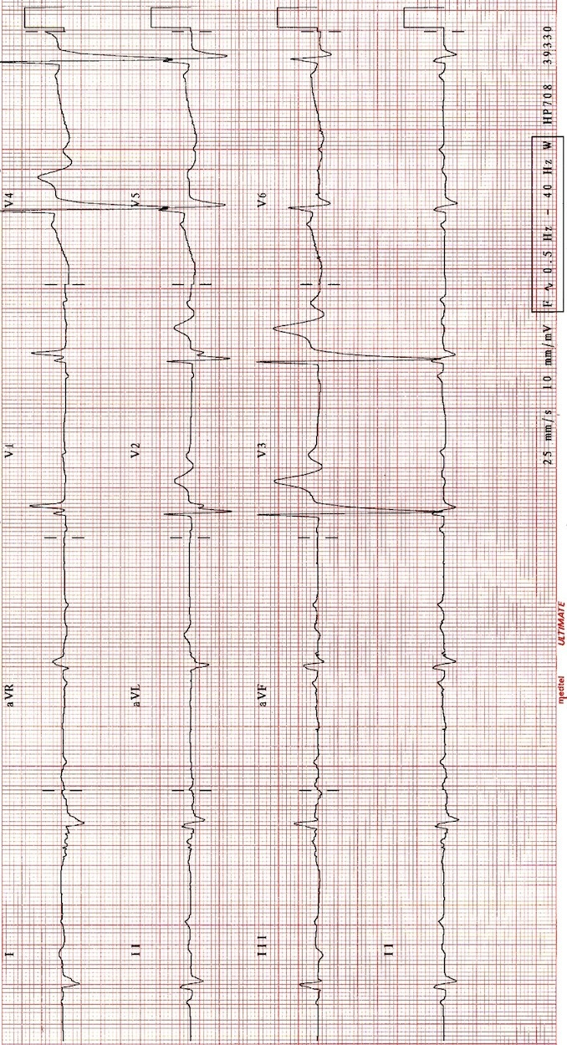

**Question 4 (11 marks) 6 minutes**

1. List the three (3) criteria that are required in the CDC (Centre for Disease Control and Prevention) definition of an AIDS case. (3 marks)
2. _______________________________________________________________________
3. ________________________________________________________________________
4. ________________________________________________________________________

**Question 4 (continued)**

1. Complete the table below with respect to HIV infection, by listing one (1) clinical feature and CD4 count range for each stage of HIV infection. (8 marks)

|  |  |  |
| --- | --- | --- |
| **World Health Organisation clinical stage** | **Clinical feature**  **(4 marks)** | **CD4 count range**  **(4 marks)** |
| **1** |  |  |
| **2** |  |  |
| **3** |  |  |
| **4** |  |  |

**Question 5 (15 marks) 6 minutes**

A mother presents with her very distressed 18 month old child. The mother is concerned that the child may have eaten powder detergent from the dishwasher, 30 minutes ago.

1. List five (5) features of toxicity of this ingestion. (5 marks)
2. _______________________________________________________________________
3. _______________________________________________________________________
4. _______________________________________________________________________
5. _______________________________________________________________________
6. _______________________________________________________________________
7. What is the specific decontamination that is required if particular matter is found in the mouth? (1 mark)

_________________________________________________________________________

1. What is the treatment of choice if toxicity is suspected. (1 mark)

_________________________________________________________________________

**Question 5 (continued)**

After complete assessment, the child appears to have isolated ocular exposure to the washing powder.

1. Other than referral to Ophthalmology, list (5) steps in the management of this exposure. (5 marks)
2. _______________________________________________________________________
3. _______________________________________________________________________
4. _______________________________________________________________________
5. _______________________________________________________________________
6. _______________________________________________________________________
7. List three (3) indications for urgent Ophthalmological referral. (3 marks)
8. _______________________________________________________________________
9. _______________________________________________________________________
10. _______________________________________________________________________