Fellowship course
Week 15

WRITTEN EXAMINATION
SHORT ANSWER QUESTIONS

EXAMINATION TIME: 66 Minutes

Question 1 (16 marks) 6 minutes

A 23 year old presents with a generalised tonic, clonic seizure.

- Define status epilepticus. (2 marks)

________________________________________________________________________
_________________________________________________________________________

- List eight (8) possible causes for his seizure. (8 marks)

- _______________________________________________________________________
- _______________________________________________________________________
- _______________________________________________________________________
- _______________________________________________________________________
- _______________________________________________________________________
- _______________________________________________________________________
- _______________________________________________________________________
- _______________________________________________________________________

Question 1 (continued)

You have IV access.
- Assuming the seizure continues, despite your treatment, list the agents and dose that you would administer at the specific time frames stated in the table below. (6 marks)
Time since onset of seizure | Agents to be administered  (include doses)  (6 marks)
0 min
(2 marks)

5 min
(1 mark)

10 min
(2 marks)

20 minute
(1 mark)

Question 2 (14 marks) 6 minutes

A 40 year old male self presents to your Emergency Department which is located in a regional centre, with no cardiology facilities on site. The nearest Cardiology service is 90 minutes away by road. He has a history of chest pain for the last 30 minutes.
His observations are:
BP 140/ 60 mmHg
RR 18 bpm
Oxygen saturation 98% Room air

An ECG is taken on arrival (with pain):

Question 2 (continued)
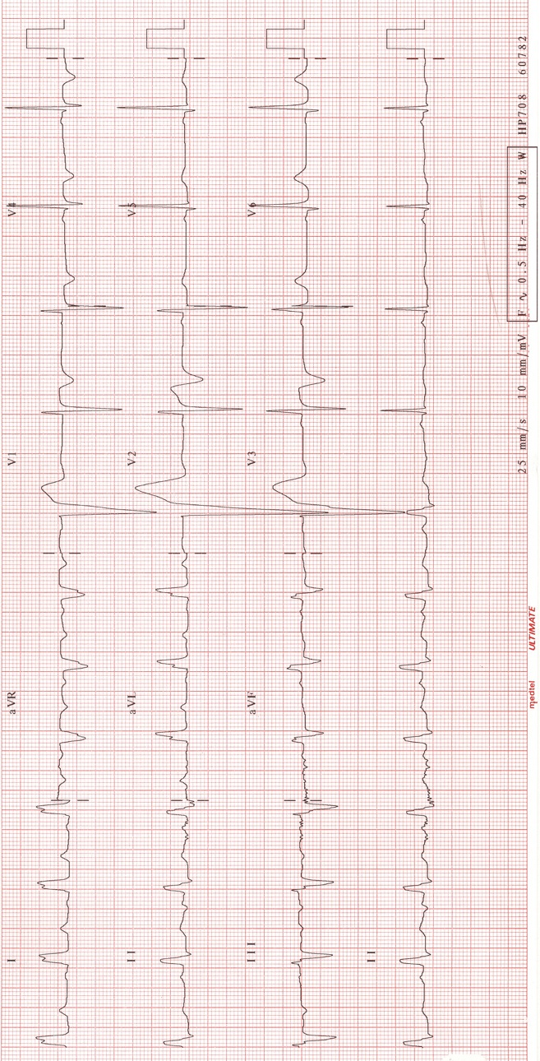

Question 2 (continued)
- State two (2) abnormalities shown on this ECG. (2 marks)

- _______________________________________________________________________
- _______________________________________________________________________

- What is the significance of these findings? State two (2) points of significance. (2 marks)

- _______________________________________________________________________
- _______________________________________________________________________

Question 2 (continued)

- Assuming no contraindications and no further complications of his condition, list five (5) medications that you would use for this patient. Provide doses for each. (10 marks)
 | Medication  (5 marks) | Dose  (5 marks)
1.
2.
3.
4.
5.

Question 3 (13 marks) 6 minutes

A 67 year old man is brought in by his wife from home. He has been increasingly short of breath and unsteady on his feet over the past week. His has no significant past history and takes no medications.

Selected serum biochemical results are taken.

- Provide one (1) calculation to help you to interpret these results. (1 mark)

Derived value 1: _____________________________________________________________
___________________________________________________________________________
- Interpret these results in the setting of this scenario. List three (3) points of interpretation. (3 marks)

- ________________________________________________________________________
- ________________________________________________________________________
- ________________________________________________________________________

- List three (3) likely differential diagnoses for this presentation. (3 marks)

- ________________________________________________________________________
- ________________________________________________________________________
- ________________________________________________________________________

Question 3 (continued)

- List three (3) urgent, key investigations that you would order for this patient. State one (1) justification for each choice. (6 marks)

 | Investigation  (3 marks) | Justification  (3 marks)
1
2
3

Question 3

Serum biochemistry

Reference range

Na⁺ 145 mmol/l 134-146
K⁺ 8.0 mmol/l 3.4- 5.0
Cl⁻ 107 mmol/l 98- 106
Bicarbonate 5 mmol/l 22- 28
Urea 63.2 mmol/l 2.5- 6.4
Creatinine 3.40 mmol/l 0.05- 0.1

Question 4 (14 marks) 6 minutes
A 65 year old man presents with abdominal distension and pain. The patient is noted to have free fluid on an Emergency Department screening ultrasound.
An aspirate of peritoneal fluid is taken.

- State the most likely diagnosis. (1 mark)
________________________________________________________________________

- List five (5) likely causes for this condition. (5 marks)

- ______________________________________________________________________
- ______________________________________________________________________
- ______________________________________________________________________
- ______________________________________________________________________
- ______________________________________________________________________

Question 4 (continued)

- List four (4) key pathological investigations that you would perform in the emergency department. Provide one (1) justification for your choice. (8 marks)

Investigation  (4 marks) | Justification  (4 marks)
1.

2.

3.

4.

Question 4

Peritoneal fluid

Appearance dark brown
White blood cell count 1500
Polymorph count 1000
Glucose 0.1 mg/Dl
LDH 450
Albumin 36 g/dL
Serum Albumin 34 g/dL

Question 5 (12 marks) 6 minutes
A 46 year man is brought to your emergency department with suspected alcohol withdrawal.
- List seven (7) of the 10 scale domains that form the Alcohol Withdrawal Assessment Scale. (7 marks)

- _______________________________________________________________________
- _______________________________________________________________________
- _______________________________________________________________________
- _______________________________________________________________________
- _______________________________________________________________________
- _______________________________________________________________________
- _______________________________________________________________________

Question 5 (continued)

A 35 year old male is identified as having “very severe” alcohol withdrawal.

- State five (5) key management steps for this patient over the next 1 hour. (5 marks)

- _______________________________________________________________________
- _______________________________________________________________________
- _______________________________________________________________________
- _______________________________________________________________________
- _______________________________________________________________________

Question 6 (12 marks) 6 minutes
A 26 year old male presents four hours following a recreational drug binge. A friend reports that he has been using large doses of "ICE".
- List four examination findings that may be seen with ICE use. (4 marks)

- _______________________________________________________________________
- _______________________________________________________________________
- _______________________________________________________________________
- _______________________________________________________________________

The patient refuses to remain for assessment. You are required to chemically sedate the
patient.

- List your preferred drug regime in this situation, for the stated circumstances (include drug, dose and route): (3 marks)

- Will accept oral treatment________________________________________________
________________________________________________________________________
- Refuses oral medication, moderate degree of agitation________________________
________________________________________________________________________
- Refuses oral medication, going “nuts” ______________________________________
_______________________________________________________________________

Question 6 (continued)

The patient is sedated. Physical restraint is not required. Your complete assessment detects
no organic pathology.

- List five (5) steps principles for the ongoing care of this patient. (5 marks)

- _____________________________________________________________________
- _____________________________________________________________________
- _____________________________________________________________________
- _____________________________________________________________________
- _____________________________________________________________________

Question 7 (12 marks) 6 minutes

A 35 year old man presents with a painful R forearm. He has a history of IV drug use.

A photograph of the man is taken.

- What is the diagnosis? (1 mark)

________________________________________________________________________

- State three (3) findings in this photograph to support this diagnosis. (3 marks)

- ________________________________________________________________________
- ________________________________________________________________________
- ________________________________________________________________________

- List four (4) key investigations for this patient. (4 marks)

- ________________________________________________________________________
- ________________________________________________________________________
- ________________________________________________________________________
- ________________________________________________________________________

Question 7 (continued)

- List four (4) definitive treatment options for this patient. (4 marks)

- ________________________________________________________________________
- ________________________________________________________________________
- ________________________________________________________________________
- ________________________________________________________________________

Question 7

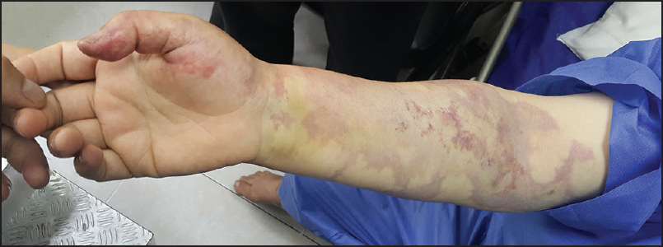

Question 8 (15 marks) 6 minutes

A 25 year old Emergency Department nurse sustains a needle stick from a used venepuncture needle from a known patient in the Emergency Department.
The details of the exposure are obtained and documented.

- Other than details of the exposure, list six (6) key features in history that you would seek from this nurse. (6 marks)

- ______________________________________________________________________
- _____________________________________________________________________
- _____________________________________________________________________
- ______________________________________________________________________
- ______________________________________________________________________
- ______________________________________________________________________
The source is identified as having Hepatitis B, Hepatitis C and HIV.
- List the approximate risk of transmission of each virus for this patient (3 marks)

Virus | Risk of transmission (%)  (3 marks)
Hepatitis B
Hepatitis C
HIV

Question 8 (continued)

- Complete the table below, stating the time course of required serologicial testing for this patient. (6 marks)

Serological  Test | Timeframe of test  (6 marks)
Hepatitis B
Hepatitis C
HIV

Question 9 (18 marks) 9 minutes

- Define psychosis. (1 mark)

________________________________________________________________________

- List the five (5) DSM IV criteria for the diagnosis of Schizophrenia. (5 marks)
- ______________________________________________________________________
- ______________________________________________________________________
- ______________________________________________________________________
- ______________________________________________________________________
- ______________________________________________________________________

Question 9 (continued)
You are providing medical assistance at triage on a busy Sunday night. A 34 year old male presents to triage. He appears intoxicated, agitated and has pressure of speech. He requests excision of a lesion on his forehead that has been present for over 20 yrs. During the discussion, he suddenly pulls out a knife and declares that if we don’t cut out this thing, he’ll do it himself. The triage nurse has requested he hand over the knife and he states “You will have to fight me for it”.

- Define this situation. (1 mark)

_________________________________________________________________________

- List five (5) features of his presentation that raise concerns about immediate violence. (5 marks)

- ______________________________________________________________________
- ______________________________________________________________________
- _____________________________________________________________________
- ______________________________________________________________________
- _______________________________________________________________________

Question 9 (continued)
The patient is disarmed and requires physical and chemical restraint to allow assessment.
No drug/medication history is available.

- List your preferred initial pharmacological treatment with dose range and route of administration in the case of:

- Patient being compliant with medication administration: (3 marks)

Drug/s  (1 mark) | Route  (1 mark) | Initial dose  (1 mark)

- Patient being non- compliant with medication administration: (3 marks)

Drug/s  (1 mark) | Route  (1 mark) | Initial dose  (1 mark)

Question 10 (27 marks) 9 minutes

- List five (5) conditions that must be met to allow the paracetamol nomogram to be utilised. (5 marks)

- _______________________________________________________________________
- _______________________________________________________________________
- _______________________________________________________________________
- _______________________________________________________________________
- _______________________________________________________________________

- State the accepted threshold dose for paracetamol induced hepatic injury. (1 mark)

___________________________________________________________________________

- State the accepted biochemical definition for paracetamol induced hepatic injury. (1 mark)

___________________________________________________________________________

Question 10 (continued)

A 26 year old presents following a stated paracetamol overdose.
Provide your investigative and specific treatment strategy for each of the circumstances listed below. Utilise either a list or flow chart in your answer.

- 20 standard release tablets taken 5 hours ago, 10 taken 4 hours ago and 10 taken 2 hours ago. (4 marks)

- 30 standard release tablets taken an unknown time ago. (5 marks)

Question 10 (continued)

- 30 slow release tablets taken 3 hours ago. (6 marks)

- 200 standard release tablets taken 4 hours ago. (5 marks)

