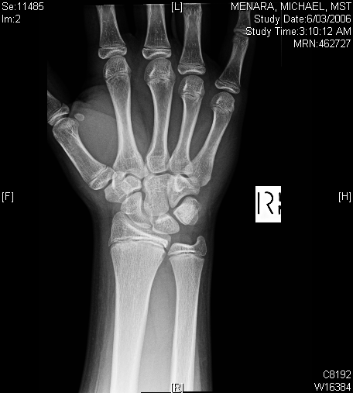
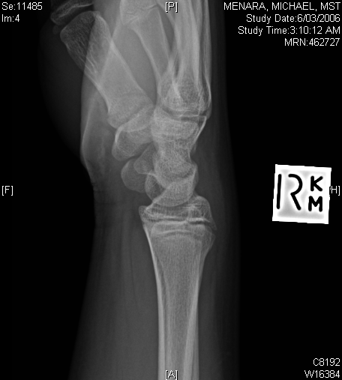
CASE 1: 14 year old FOOSH off push bike.
1. Is there an abnormality?
2. How would you manage this child? Plaster? Follow up?
3. What resources are available to help you with Paediatric fracture management?
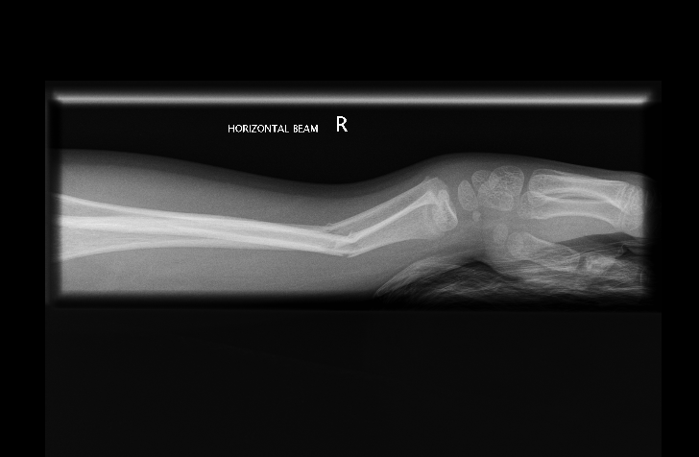
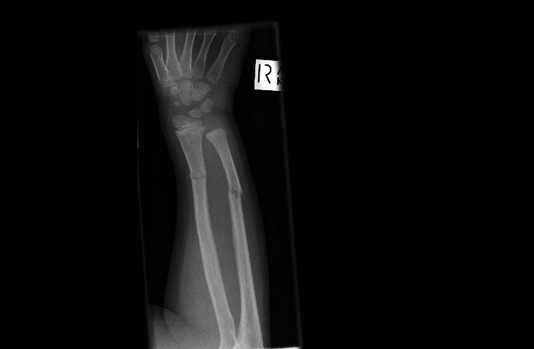CASE 2: FOOSH. Dinner fork deformity.
- Describe the fractures
- How do you check neurovascularly intact?
- How would you manage (analgesia, sedation, reduction, follow up)?

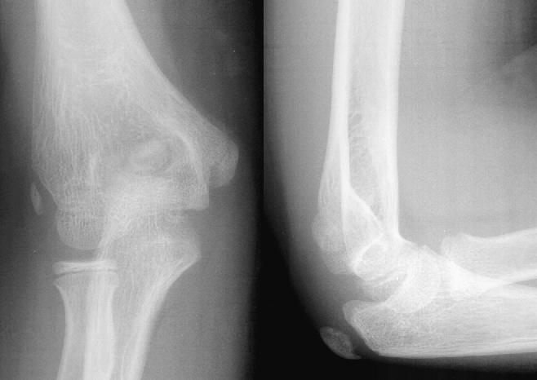
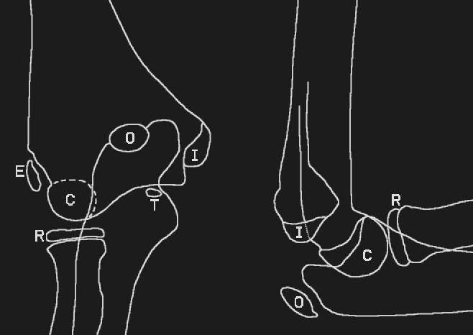
CASE 3: Normal elbow anatomy:
- What is CRITOE?
- What are the anatomical relationships/ features you look for in an elbow XR?
- What is the relevance of an anterior +/- posterior fat pad?

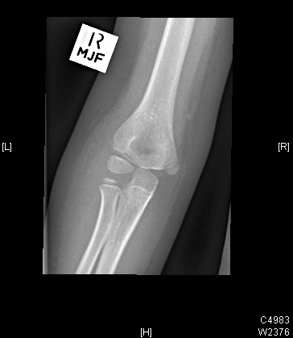
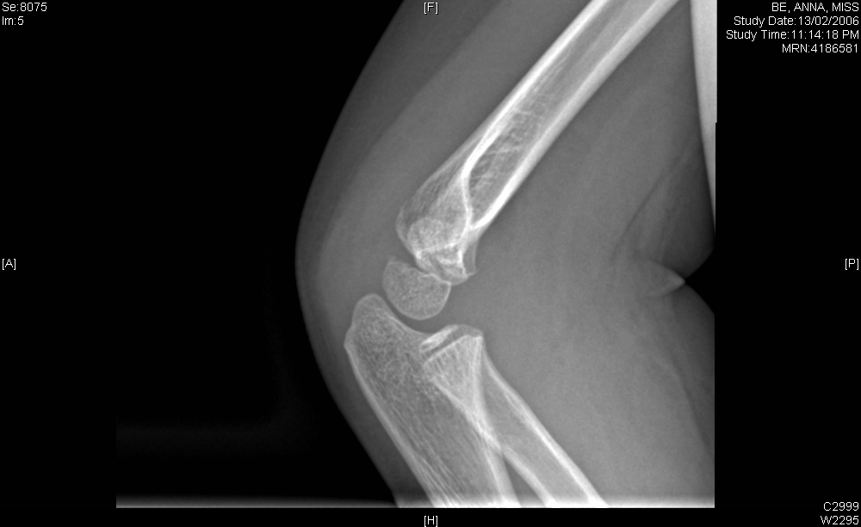

CASE 4: Girl presents after fall off skateboard onto elbow:
- How old is she? (CRITOE)
- What is her injury? Classification?
- How would you mange her?
- When would you refer a child with this type of fracture?

CASE 5: Fall off flying fox
- Describe fracture
- What would your ED management be?
- If you could not feel a pulse what would you
  - be concerned about?
  - do?
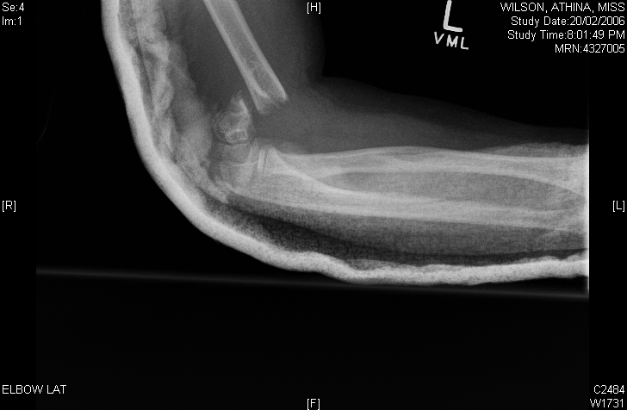
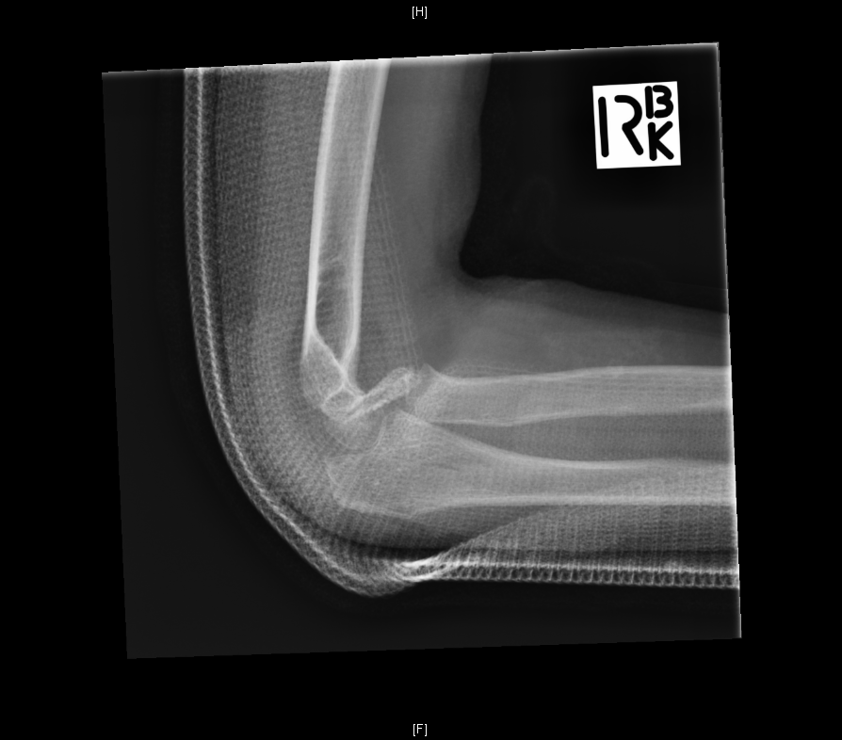

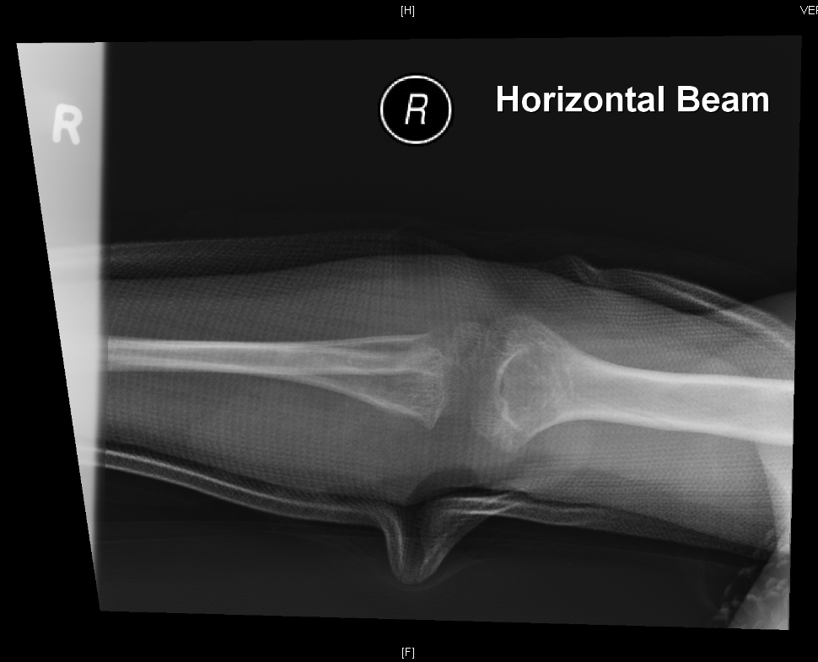
CASE 6: 5 year old FOOSH from Monkey Bars. Painful elbow.
1. Describe the XR?
2. Describe your management?

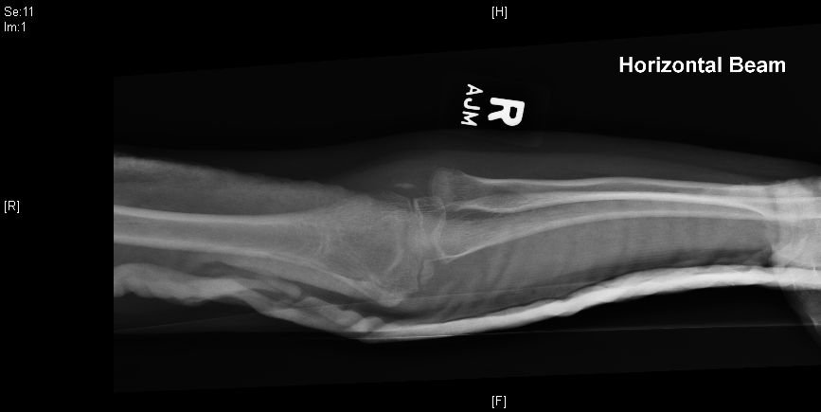

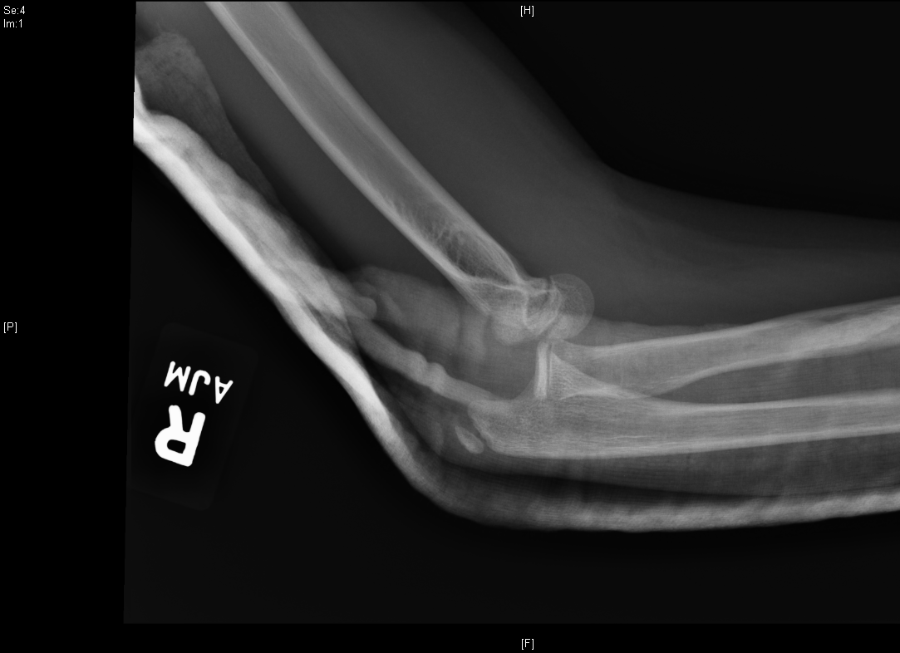

CASE 7: 11 year old girl fall from trampoline
1. How would you describe XR?
2. What injury is commonly associated with this injury (and is seen here)?
3. What would your management be? (Describe analgesia, sedation, reduction, follow up)

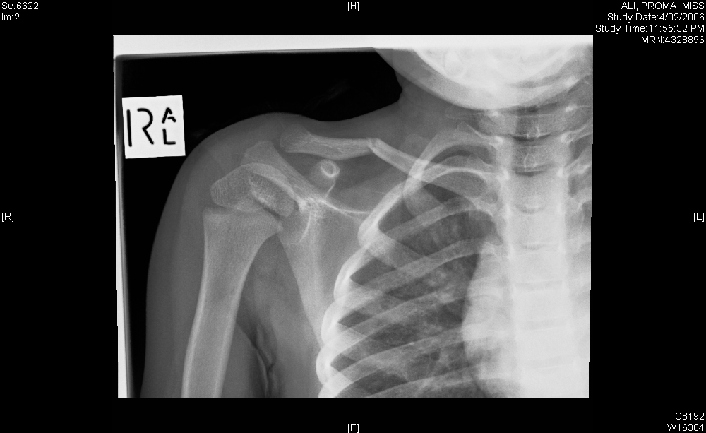

CASE 8: 18 month old fall from couch onto hard floor:
- How would you manage this injury?

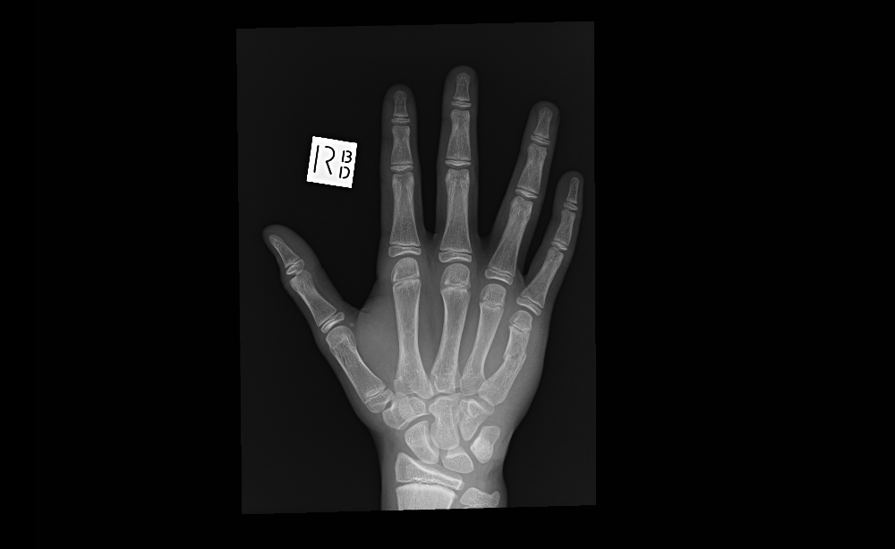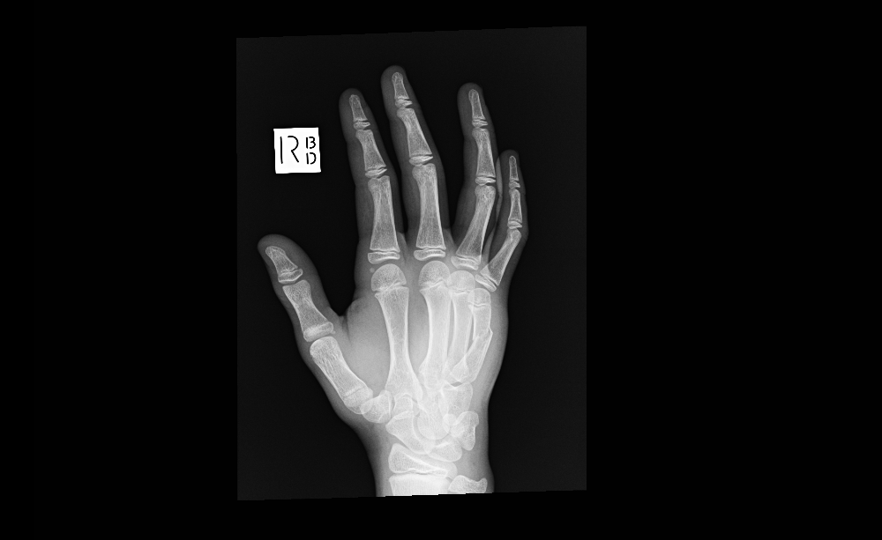

CASE 9: 14 year old boy punched a ‘wall’…
- What are the important points on examination?
- How would you manage this injury?

