Small Group Tutorial – Stroke and Migraine

1. An 88yo man presents 1 hr post onset of dense right-sided hemiparesis and dysphasia.
E3V3M4, HR 115 AF, BP 210/130, RR 12, 92%RA

a. Outline your assessment and initial management
b. Indications and contraindications for thrombolysis

2. A 55 yr old woman presents to your ED following a collapse with LOC. On arrival in the ED she is vomiting and has a GCS of 7 (E1, V2, M4). She is intubated prior to transfer to CT.
Her observations on return from CT are as follows:

HR 60, BP 190/120, Sats 100% on 100%FiO2, Temp 37

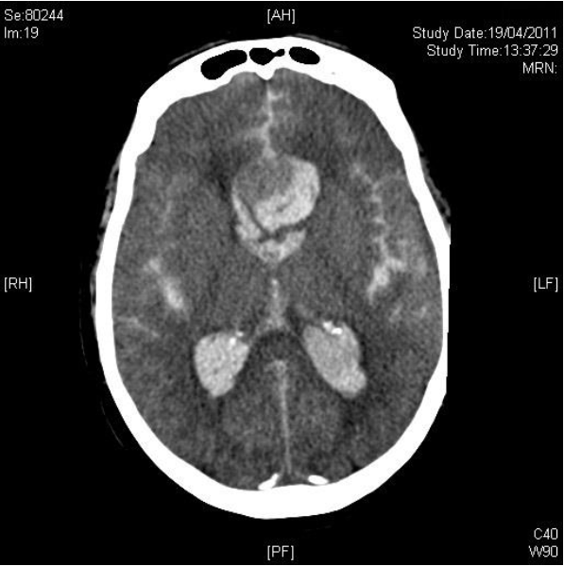

- Describe and interpret her CT.
- Outline your management priorities.

3. a. Describe the TIA mimics and clinical features that help distinguish between them and
TIA/stroke.
Ref: Nadarajan. Transient ischaemic attacks: mimics and chameleons. Practical Neurology 2014. (attached)

b. What is transient global amnesia?

4. Discuss the treatment options available for acute migraine presenting to the ED.

New Format FE SAQ

For those of you considering the FE next year, we have tried to give some rough examples of new format SAQs. These are not from ACEM, so there may be some variation to the wording, but give them a shot and let us know what you think.

1. An 78yo man presents 1 hr post onset of dense right-sided hemiparesis and dysphasia.

- List 5 features of history that will determine whether this patient is suitable for thrombolysis. Justify your reasons (5 marks)
- List and justify what investigations you would perform immediately (3 marks)
- What are the contraindications to thrombolysis (3 marks)
- The patient is thrombolysed. 2 hours post thrombolysis he drops his GCS to 11. An urgent CTB demonstrates at large ICH. Outline your immediate management priority (3 marks)

2. A 35 year old presents to the ED with a severe headache

a) list the 4 most clinically relevant differentials
b) For each differential describe what feature of history and examination that would support the diagnosis
c) The patient is diagnosed with a migraine. Outline 5 treatments you would consider and justify your reasons

3. A 55 yr old woman presents to your ED following a collapse with LOC. On arrival in the ED she is vomiting and has a GCS of 7 (E1, V2, M4). She is intubated prior to transfer to CT.
Her observations on return from CT are as follows:

HR 60, BP 190/120, Sats 100% on 100%FiO2, Temp 37

Her CT is shown (above – please refer to CT slice above)

- What is the diagnosis
- What features of the CT support this diagnosis
- Describe your main management priorities. For each management decision please outline your expected outcome

