SAQ practice MH week 2 – orthopaedics and trauma

1. A 19 year old man has presented to your rural ED after falling on to his out-stretched hand while playing basketball.

He is complaining of wrist pain. There are no wounds visible.

AP and lateral xrays of his wrist are given.
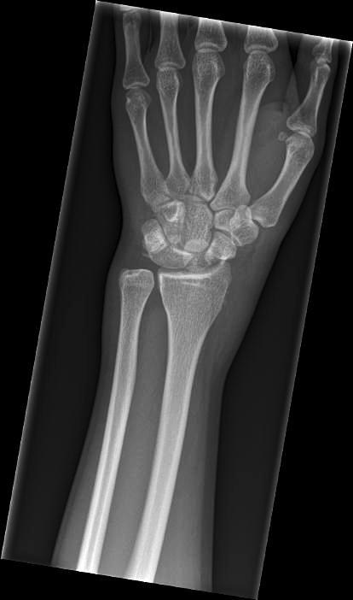
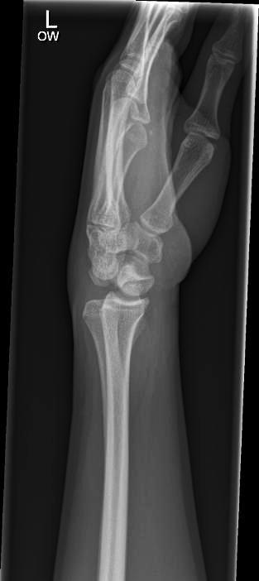
1. List the 2 main abnormalities shown on the xrays. (2 marks)

_____________________________________________________________________

2. List the 2 mot serious possible immediate complications of this injury (2 marks)

_____________________________________________________________________

You have elected to perform a Bier’s block in your management of this injury.

3. List the steps involved in performing a Birer’s block, including drugs, doses and end-points where appropriate. ( 6 marks)

_____________________________________________________________________

_____________________________________________________________________

2. A 56 year old man has been brought to your tertiary ED after a motorcycle accident.
His pelvic xray is given.
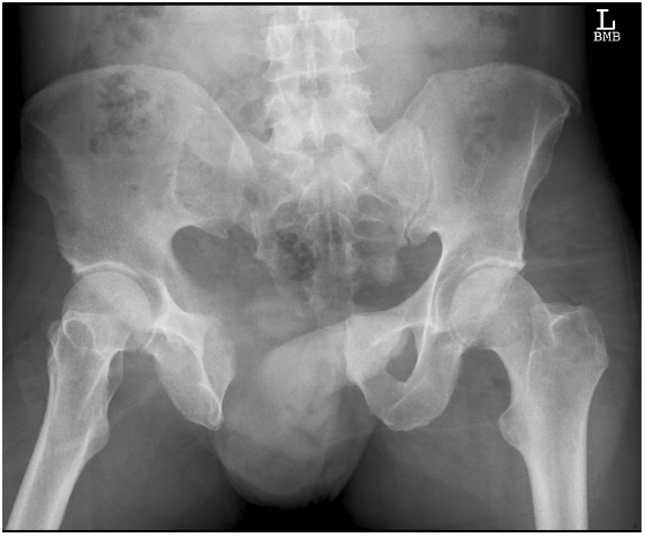

1. Classify his pelvic injury based on the Xray provided. (2 marks)

_________________________________________________________________

2. List 4 possible methods of arresting the blood loss from his pelvic injury.
(4 marks)

CT scans have revealed active arterial haemorrhage related to his pelvic injury, but no other
obvious injuries.

His vital signs are:
GCS 14 E4 V4 M6
Pulse 135 /min
BP 70/40 mmHg
O2 saturation 98% 6L O2 via mask
Temp 36.5 degrees

3. In point form, list your principles of his fluid resuscitation while he is awaiting
definitive management of his pelvic injury. (5 marks)
__________________________________________________________________________
__________________________________________________________________________
__________________________________________________________________________
__________________________________________________________________________
__________________________________________________________________________
__________________________________________________________________________
__________________________________________________________________________
__________________________________________________________________________
__________________________________________________________________________
__________________________________________________________________________
__________________________________________________________________________

SAQ 3

A 29 year old man has been brought to your hospital after being hit to the head by a baseball bat.
He has no prior medical history.
His vital signs on arrival to the ED are:
GCS 11 E2 V2 M5
Pulse 110 /min
BP 110/65 mmHg
O2 sats 99% 6L O2 via mask
A CT scan of his head has been performed.

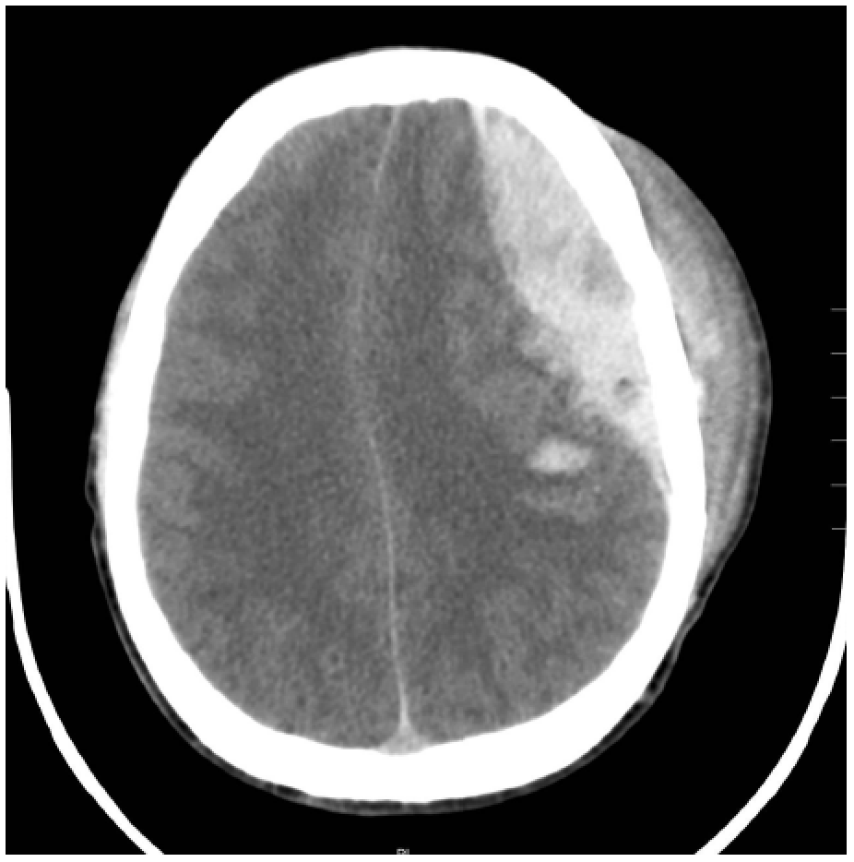

1. List 5 abnormalities on the CT slice. (5 marks)
________________________________________________________________________________
________________________________________________________________________________
________________________________________________________________________________
________________________________________________________________________________
________________________________________________________________________________
2. List your treatment priorities in the ED. Where appropriate, give end-points. (9 marks)
________________________________________________________________________________
________________________________________________________________________________
________________________________________________________________________________
________________________________________________________________________________
________________________________________________________________________________
________________________________________________________________________________
________________________________________________________________________________
________________________________________________________________________________
________________________________________________________________________________
________________________________________________________________________________

SAQ 4

A 45 year old man has been brought to your ED by ambulance after being stabbed once in the right side of the chest.
On arrival, his vital signs are:
GCS 15 E4 V4 M6
Pulse 120 /min
BP 85/40 mmHg
O2 sats 94% 15L O2 via non-rebreather mask

A chest Xray has been performed.

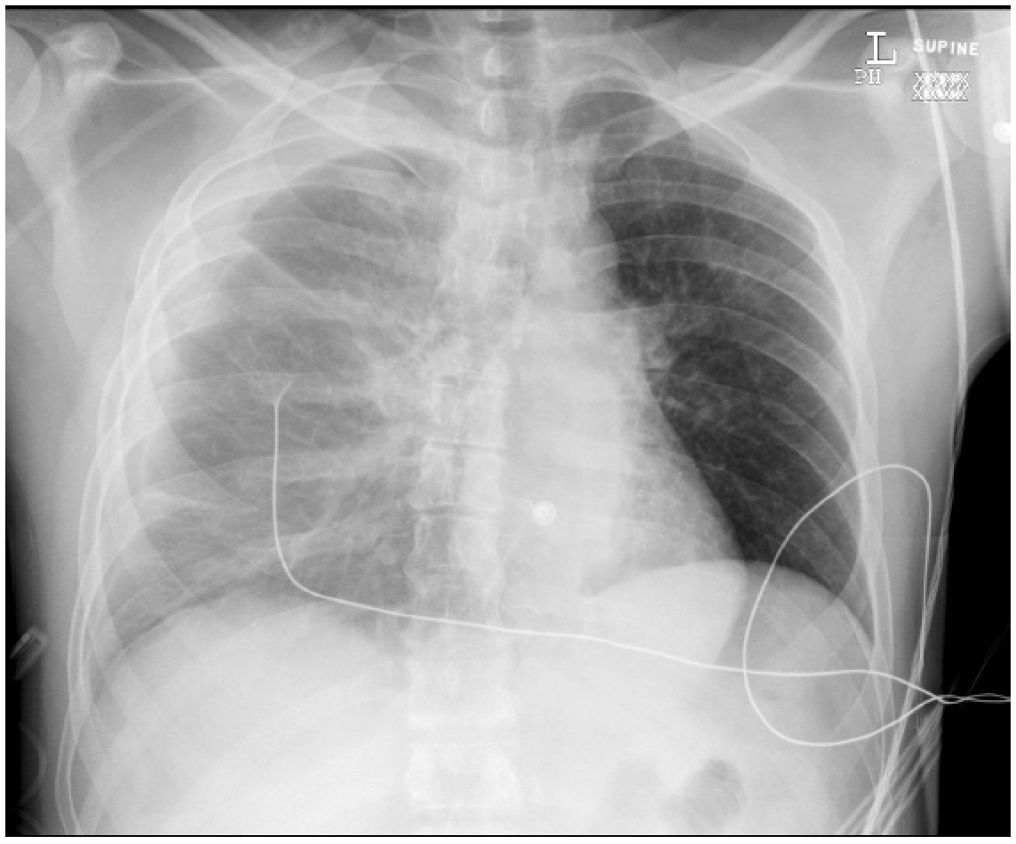

1. Give the main abnormality on the chest Xray, with supporting evidence. (3 marks)
______________________________________________________________________________

______________________________________________________________________________

____________________________________________________________________________

2. List the steps involved in inserting an intercostal catheter in this patient. (9 marks)

_____________________________________________________________________________

_____________________________________________________________________________

_____________________________________________________________________________

____________________________________________________________________________

__________________________________________________________________________

____________________________________________________________________________

______________________________________________________________________________

______________________________________________________________________________

______________________________________________________________________________

______________________________________________________________________________

______________________________________________________________________________

______________________________________________________________________________

Question 5
A 25 year-old male involved in a motorbike accident was brought to the ED at a tertiary level centre. A trauma series was performed with a normal CXR and C-spine Xray. The following radiological imaging was undertaken.
Vital signs are: RR 20 sat 99% on room air HR 115 BP 80/50 GCS 15
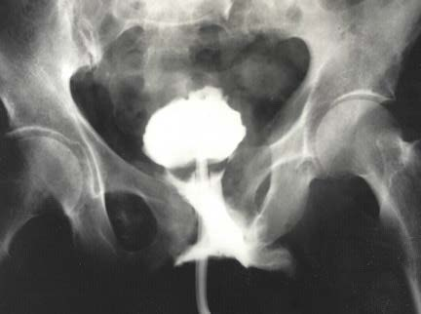
1. List the abnormalities on this Xray (2 marks)
1
2

2. What clinical signs are associated with this injury on examination (1 mark)
1
2
3

3. Give the 4 most likely causes of hypotension in this patient (2 marks)
1
2
3
4

4. List the five most important treatment and disposition priorities, as the team leader, in treating this patient’s hypotension. Give details (5 marks)
1

2

3

4

5

SAQ 6
A 42 year old man fell off his bicycle when travelling at 20km/h. He complained of left forearm pain. He had the following X-rays taken.
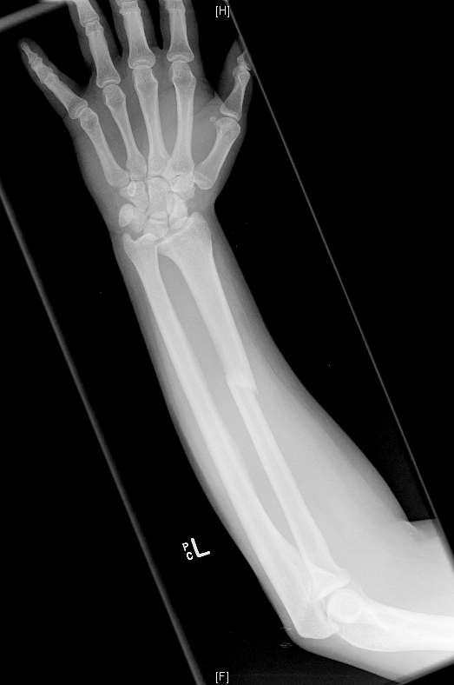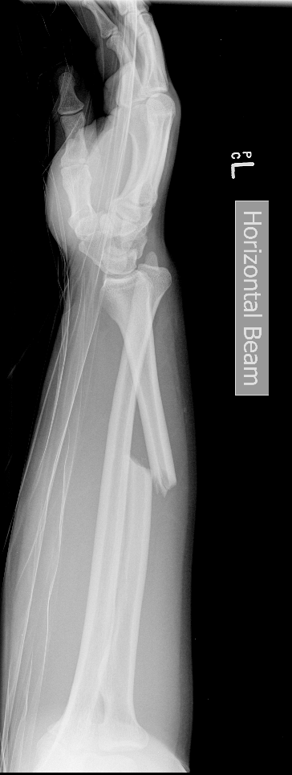

1. What are the abnormalities on the X-ray? (2 marks)

2. List the 2 most likely nerve injuries (2 marks)

1

2

3. Your registrar decides to perform procedural sedation. Outline your checklist with details of each of the major area. (6 marks)

1

2

3

4

5

6

SAQ 7
A 5 year old boy has been brought to your emergency department after a road traffic accident. He has had a blood transfusion commenced by the retrieval service for haemorrhagic shock. The second unit has already been commenced.

1. What is the definition of massive transfusion in this child? (2 marks)

2. List eight potential complications of massive transfusion for this child (4 marks)

1

2

3

4

5

6

7

8

3. If he was to have a cardiac arrest. What are the 4 likely causes (4 marks)

1

2

3

4

Question 8
A 20yo male attends with a grossly swollen painful hand from a punching injury at 36 hours. There is broken skin over the 3rd MCP joint.
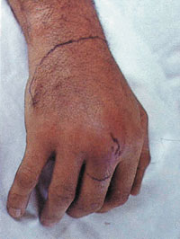
- What complications may arise from this injury? (20%)
- Outline your examination (20%)
- Given the appearance of the hand shown, what investigations would you request, assuming no comorbidities and that this is an isolated injury? (20%)
- What are the indications for admission? (20%)
Question 9
Whist restraining a 47yo male with a convulsive seizure a nurse was kneed in the cheek, including the orbit and nose. She experienced immediate epistaxis, facial pain and visual blurring. (photo)
- Assuming that this is an isolated facial injury without loss of consciousness, list six potential immediate ocular complications that you would exclude. (25%)
- What non-occular complications would you seek to exclude? (25%)
- Describe your management of a probable acutely fractured nose. (25%)
- What are the clinical signs of orbital compartment syndrome? What is the immediate management? (25%)

SAQ 1 (Acute agitation)

A 38 year old man walks up to the triage desk. He is agitated, shouting and uncooperative with simple instructions He is poorly kempt, clammy and tremulous.

- List five differential diagnostic categories you would consider when trying to assess this man?
Give two examples from each category.

- Briefly describe two different strategies for gaining the cooperation of this man?

- List the legal principles that guide your management?

SAQ 2 (Chest CT post MVC)

A 28 year old male presents to ED after being involved in a high speed MVC. He was the driver, restrained, deployed airbag, required extrication.
On arrival he is short of breath and complaining of right sided chest pain

His
SaO2 95 % on 5l/min by Hudson mask
P 105 sinus tachycardia
BP 110/70 afebrile

He has no significant past history and is on no medication.

A CT chest is performed as part of his workup.

A single axial slice is given

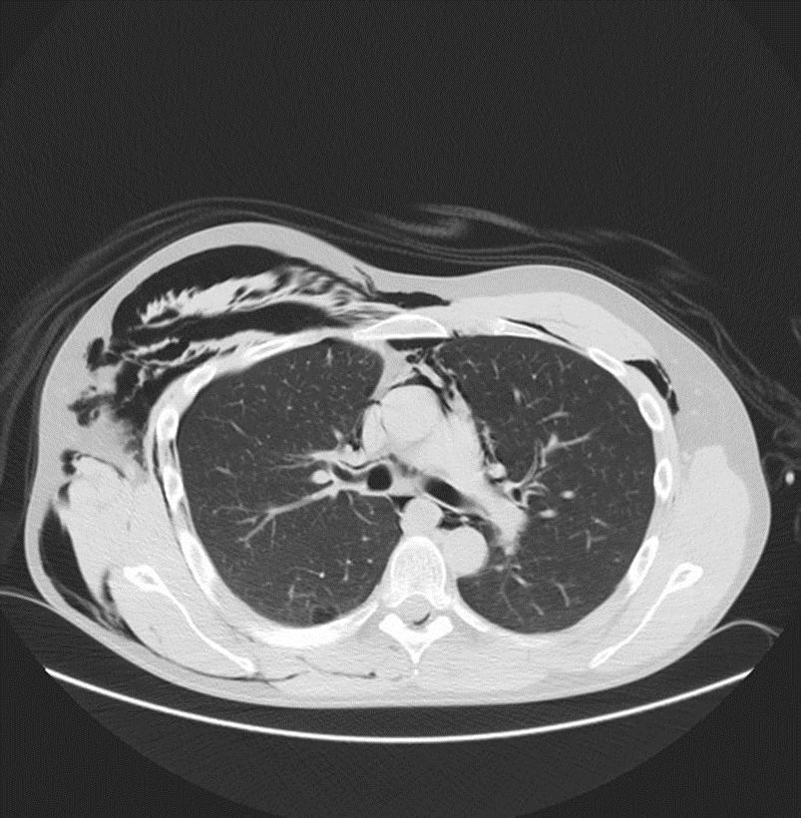

(SAQ 2 contd…)
- Give an interpretation of the image providing
Five positive findings
Two negative findings

- List three potential complications of these changes.

- List three options for the treatment of the changes shown.

17. A 10 year old girl has fallen off a wall and presents with a “sore arm”.

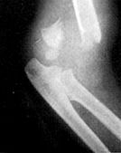
X-ray is shown below.

a. Give 3 features which are required to “clear the neck”. (3 marks)

b. Describe the x-ray. (1 mark)

c. What is the diagnosis? (1 mark)

d. What are 2 potential neurological complications of this injury and how would you test for them? (4 marks)

e. Give an example of one other joint injury that can also give rise to nerve injuries. (1 mark)

19. A 28 year old man has been out kite surfing and was thrown into the water at high speed. He is brought in on a spinal board with C-spine protection. He is intubated and ventilated and put on a propofol infusion.

His observations are: Pulse 65 /min, BP 90/60 mmHg and he is warm and well perfused.

The C-spine film and tomogram are shown below.
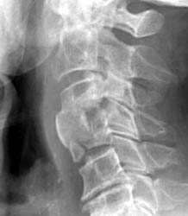

a. Describe 3 abnormalities on the x-ray. (3 marks)

b. Describe 2 aspects of his cardiovascular status. (2 marks).

c. What is the likely diagnosis? (2 marks)

d. What 3 signs would support this? (3 marks)

30. A 65 year old male presents following a fall. He complains of a painful swollen left wrist.

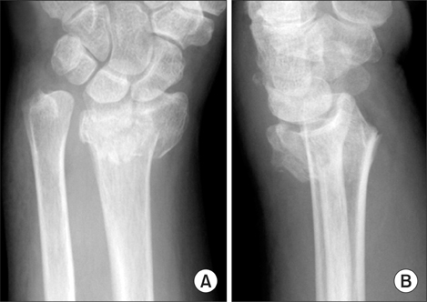
An x-ray of his wrist is shown below.

a. Describe his x-ray. (2 marks)

b. List the contra-indications to performing a Bier's block. (4 marks)

c. List the key steps in performing a Bier's block. (4 marks)

60. This 32 year old male lost control of a high pressure injector and comes in with a wound on his left lower leg.

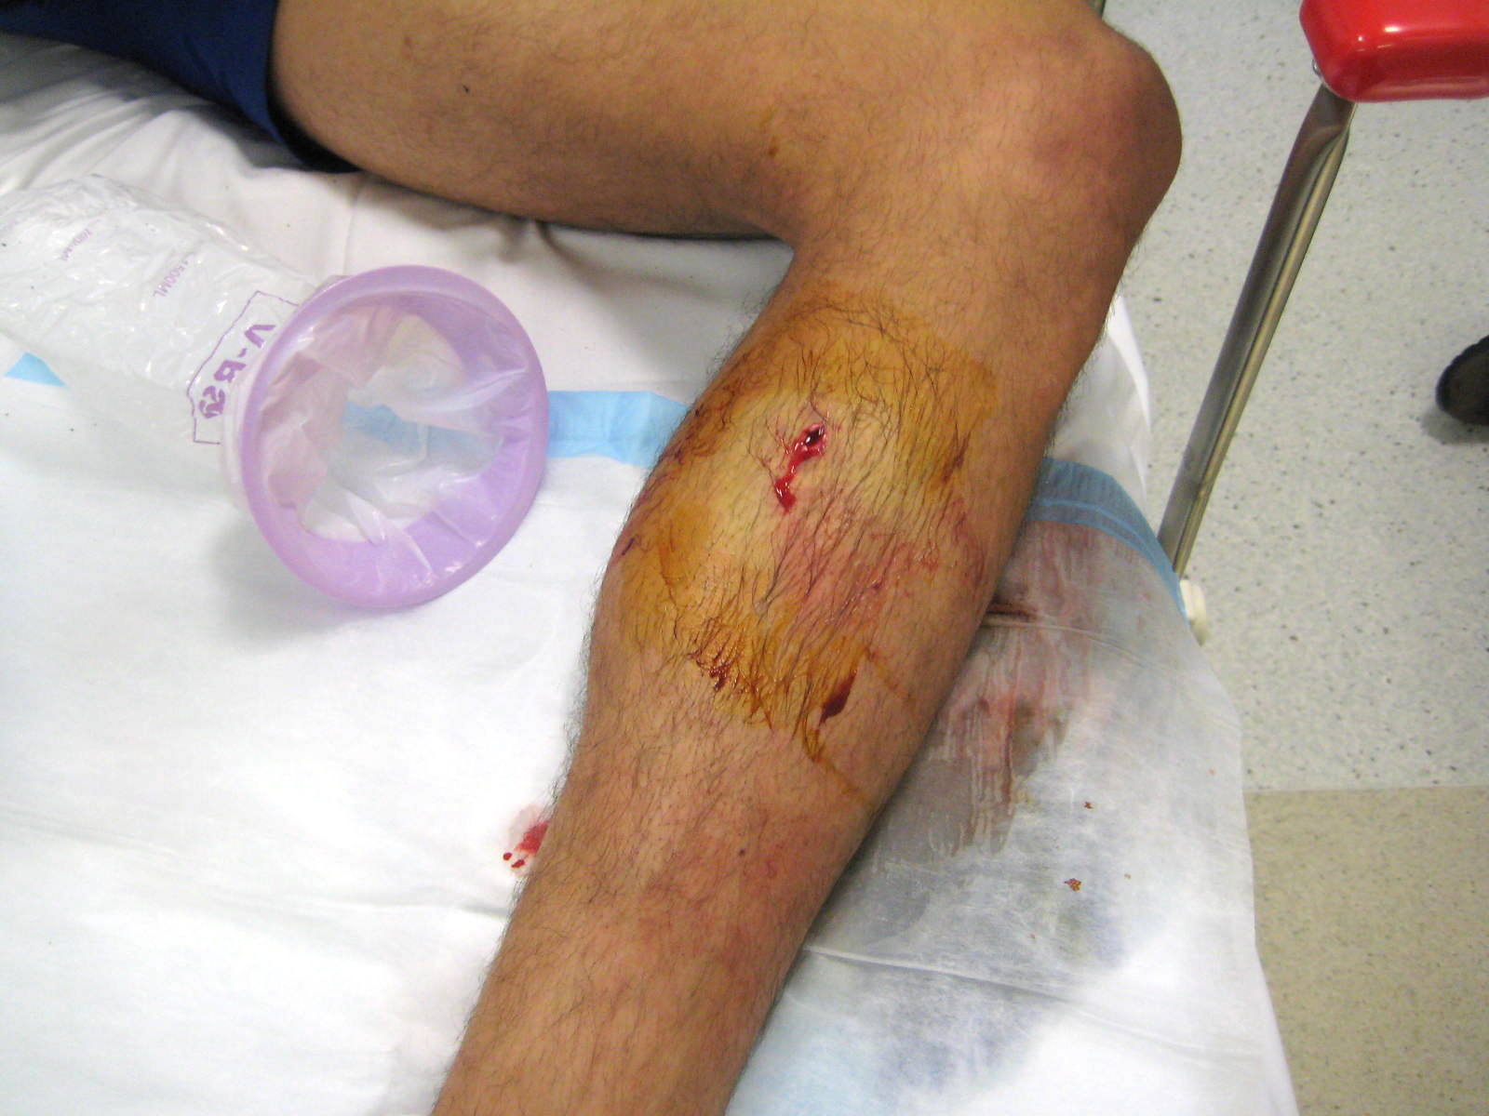

a. List three complications that are likely to occur within the next 48 hours. (3 marks)

b. List the management priorities for this injury. (5 marks)

c. What factors contribute to damage? (3 marks)

68. You are the director of a tertiary ED which is a level one trauma centre. Recently the directors of trauma and haematology have both written to you regarding your department’s haphazard use of blood products in the severely injured. You search your intranet and realise that you do not have a policy.

a. What are 3 triggers for massive transfusion? (3 marks)

b. Name 4 physiological or biochemical parameters that should be measured early and often. (2 marks)

•

c. What is the indication for Cryoprecipitate delivery? (2 marks)

d. What are the targets for Hb, Platelets and INR in massive transfusion? (3 marks)

