Small Group Tutorial – Paediatric Rashes
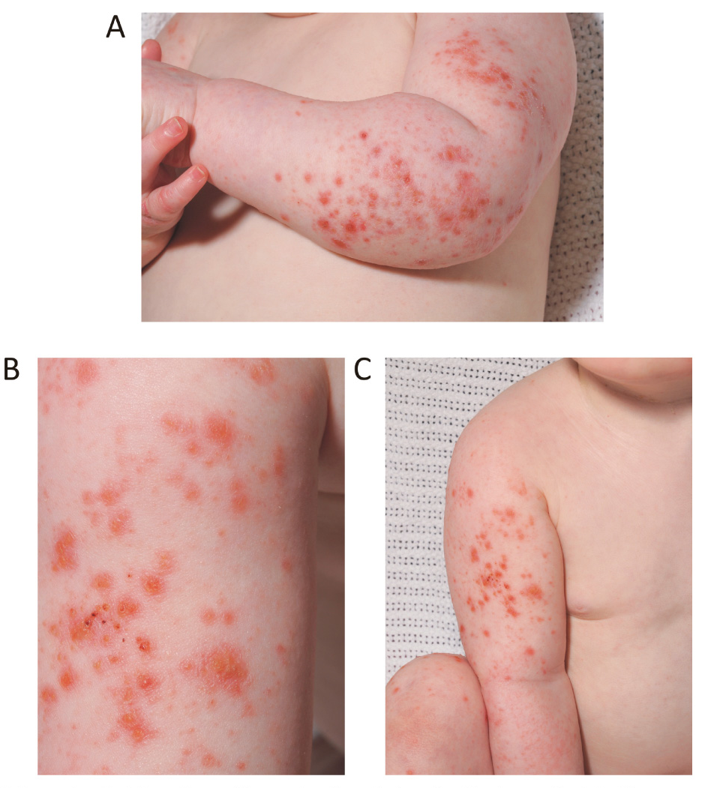

A 3-year-old boy presents to ED with a 2 day history of fever, coryza and the rash pictured above.
He has a history of eczema, which was mild and has required no active management since the age of 12 months

- List your differentials for this presentation
- Describe your management of this patient

A GP rings your urban district emergency department at 6pm on a Friday evening wanting to send in a patient. He has just seen a 14-month-old girl in his rooms who has presented with a prolonged illness over the last 2 weeks. The child has been febrile, intermittently lethargic and has coryza. They have presented tonight with a petechial rash over her trunk and lower limbs.

Her observation taken by the GP are as follows

Temp 39.8
HR 180
RR36
Sats 97%RA

- List your differentials
- What advice will you give the GP?
- Describe your assessment when the patient arrives to your ED

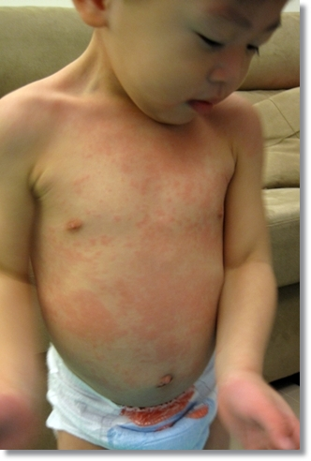

A 2 year old boy presents to your department with a 5 day history of fever. He has become irritable over the last 24 hours, and his mother thinks his knees and ankles are swollen. He is miserable when examined, although looks settled when left alone in bed. He is unimmunised

His observations are as follows
T 37.2
HR120
RR28
Sats 100%RA

- List your differentials
- Describe your assessment

