Monash Practice SAQ 2024.1 Dane Horsfall Cabrini 12 Marks:

A 78 year old man is brought to your emergency department after an unconscious collapse. He is now alert and well. His vital signs are normal. His ECG is shown.
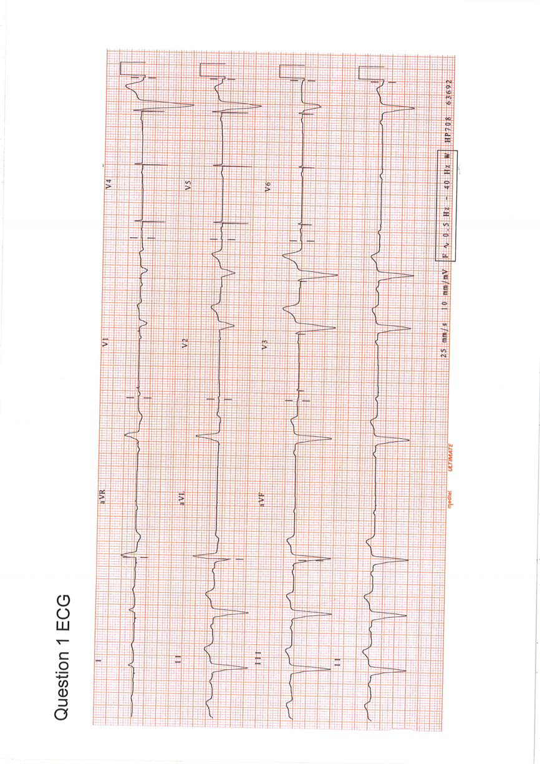

A.Describe 2 key features of the ECG (2 Marks)
- Failure of ventricular capture (4th beat, 6th , 9th, 10th beats)
- Native Atrial activity (P waves)
- Ventricular pacing with LBBB morphology,

0.5 LAD

Not accepted:
- Mobitz Type 2 heart block
- bradycardia
- unsensed beats

B.List four potential causes of this ECG (4 Marks)

- Lead dislodgement or malposition (most common cause)
- Programming errors with suboptimal output
- Battery failure
- Exit block - failure of capture when falls outside of refractory period
- Electrolyte abN esp hyperK and acidosis
- Cardiac fibrosis/inflammation at site of ventricular wire tip
- Ischaemia
- Medications eg flecainide, Sotalol – accept only one
- hypothermia
- twiddler’s syndrome

Half mark
-electrolyte imbalance

Don’t accept
- lead fracture since good pacing spikes.
- failure of device

C. List 5 key steps in performing transcutaneous pacing. (5 Marks)

- deactivate PPM wioth magnet
- If alert and orientated gain consent
- Sedation/analgesia not propofol
- Connect 3 leads
- Connect pads(AP better)
- Turn pacing setting on defib
- Select pacing mode(fixed/demand),
- Set rate 50-70bpm,
- Increase output to 70mAmps (not J ½ mark) to achieve electrical and mechanical capture then increase 5-10 mAmps
- Trouble Shooting if not captured at current of 120-130mA - resite electrodes and repeat above.

0.5
-analgesia/sedation
-attempt to explain to and recognition may not be able to provide informed consent
-Joules or volts rather than mAMPs

Don’t accept:
- consent since probably too unwell to obtain and need to proceed under ‘duty of care’

D. Explain the difference between electrical and mechanical capture (1 mark)
-Electrical capture = ECG showing widened QRS following each pacer spike.

-Mechanical capture = palpable pulse with each pacing spike and QRS and other signs of increased circulation – increased blood pressure, improvements in skin color and warmth, and improved level of consciousness.

References:
https://www.ncbi.nlm.nih.gov/pmc/articles/PMC7192127/#:~:text=The%20most%20common%20cause%20of,electrocardiogram%20is%20usually%20very%20helpful

https://litfl.com/pacemaker-malfunction-ecg-library/

https://criticalcarenow.com/transcutaneous-pacing-for-nurses/#:~:text=Electrical%20capture%20is%20confirmed%20by,and%20improved%20level%20of%20consciousness)

Results:

Pass mark >=9.5/12
Passed 21/34 = 62%
Failed 13/34

