Fellowship course
Week 12 – Paediatrics 2

WRITTEN EXAMINATION
SHORT ANSWER QUESTIONS

EXAMINATION TIME: 60 Minutes

Question 1 (11 marks) 6 minutes

A 3 week old male is brought to emergency with frequent vomiting over a 24 hour period.

Initial blood tests are taken- see prop booklet page 5.

- Provide one (1) calculation to help you to interpret these results. (1 mark)

Derived value 1: _____________________________________________________________
___________________________________________________________________________
- What is the significance of this calculation finding? (1 mark)

___________________________________________________________________________
- What is the most likely diagnosis? (1 mark)

___________________________________________________________________________
- List four (4) investigation findings from these blood tests to support this diagnosis. (4 marks)

- ________________________________________________________________________
- ________________________________________________________________________
- ________________________________________________________________________
- ________________________________________________________________________

Question 1 (continued)

- List two (2) urgent, key investigations that you would order for this patient. State one (1) justification for each choice. (4 marks)

 | Investigation  (2 marks) | Justification  (2 marks)
1
2

Question 1

Arterial blood gas, serum and urine biochemistry

Reference range
FiO₂ 0.21
pH 7.54 7.35- 7.45
pCO2 50 mmHg 35-45
PO2 62 mmHg 80- 95
Bicarbonate 41 mmHg 22-28
Base excess + 10 -3 - +3
O2 saturation 99 % > 95

Na⁺ 131 mmol/l 134-146
K⁺ 2.1 mmol/l 3.4- 5.0
Cl⁻ 66 mmol/l 98- 106
Bicarbonate 45 mmol/l 22- 28
Urea 10.5 mmol/l 2.5- 6.4
Creatinine 0.05 mmol/l 0.05- 0.1
Glucose 3.4 mmol/l 3.5- 5.5

Urine spot
Na 22 mmol/l
K 28 mmol/l
Cl <10 mmol/l

Question 2 (12 marks) 6 minutes

A 12 year old female presents to the emergency department with a rash on her lower limbs.

A photograph of her lower limbs is taken- see props booklet page 1.

- Define petechia, purpura and ecchymosis. (4 marks)

_________________________________________________________________________
__________________________________________________________________________
__________________________________________________________________________
__________________________________________________________________________
- Other than Idiopathic Thrombocytopaenia purpura, list four (4) likely differential diagnoses for this rash for this patient. (4 marks)

- ________________________________________________________________________
- ________________________________________________________________________
- ________________________________________________________________________
- ________________________________________________________________________

Question 2 (continued)

After complete assessment, you suspect a diagnosis of Idiopathic Thrombocytopaenia Purpura.

- What is the prognosis for this patient with no active treatment? (1 mark)
__________________________________________________________________________
You decide to commence active treatment.

- What is your preferred initial treatment for this patient? (1 mark)

__________________________________________________________________________

- List one (1) additional treatment option for this patient at presentation. (1 mark)

___________________________________________________________________________

- Under what circumstances would you consider this treatment at presentation? (1 mark)

___________________________________________________________________________

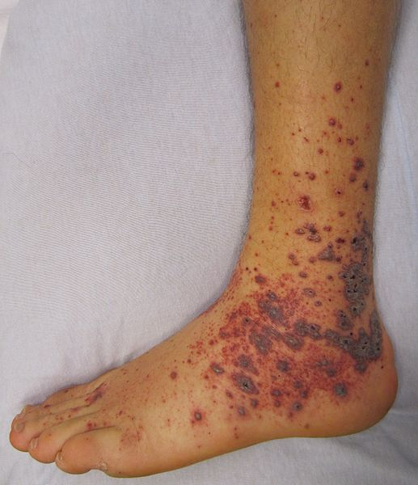

Question 3 (12 marks) 6 minutes

An 18 month boy presents with 24 hours of vomiting and bloody diarrhoea.
- Other than Haemolytic uraemic syndrome, list four (4) likely causes for this presentation. (4 marks)

- _________________________________________________________________________
- _________________________________________________________________________
- _________________________________________________________________________
- _________________________________________________________________________

- List four (4) features on examination that would support the diagnosis of haemolytic uraemic syndrome. (4 marks)

- _________________________________________________________________________
- _________________________________________________________________________
- _________________________________________________________________________
- _________________________________________________________________________

Question 3 (continued)

- List four (4) laboratory findings that are consistent with haemolytic uraemic syndrome. (4 marks)

- _________________________________________________________________________
- _________________________________________________________________________
- _________________________________________________________________________
- _________________________________________________________________________

Question 4 (20 marks) 9 minutes
- Complete the table, listing six (6) causes of neonatal jaundice. List each cause in the characteristic timeframe for appearance of each particular cause of jaundice. (6 marks)
Time to onset of jaundice | Cause of neonatal jaundice  (6 marks)
< 2 days | 1.  2.
2-3 days | 1.
3-7 days | 1.
> 1 week | 1.  2.

Question 4 (continued)

- List two (2) biochemical features seen with pathological jaundice. (2 marks)

- _____________________________________________________________________
- _____________________________________________________________________

- List three (3) options for the management of pathological jaundice. (3 marks)

- _____________________________________________________________________
- _____________________________________________________________________
- _____________________________________________________________________

- Define “Apparent Life Threatening Event”. (1 mark)

___________________________________________________________________________
___________________________________________________________________________

Question 4 (continued)

- List three (3) features of a benign “Apparent Life Threatening Event”. (3 marks)

- _______________________________________________________________________
- _______________________________________________________________________
- _______________________________________________________________________

- List five (5) investigations that are indicated in a patient who does not fit a benign pattern of “Apparent Life Threatening Event”. (5 marks)

- _______________________________________________________________________
- _______________________________________________________________________
- _______________________________________________________________________
- _______________________________________________________________________
- _______________________________________________________________________

Question 5 (25 marks) 9 minutes

A 2 year old presents with suspected Kawasakis disease.

- List the six (6) criteria for the diagnosis of Kawasakis disease. (6 marks)

- _______________________________________________________________________
- _______________________________________________________________________
- _______________________________________________________________________
- _______________________________________________________________________
- _______________________________________________________________________
- _______________________________________________________________________
- List five (5) epidemiological features of Kawasakis disease. (5 marks)

- _______________________________________________________________________
- _______________________________________________________________________
- _______________________________________________________________________
- _______________________________________________________________________
- _______________________________________________________________________

Question 5 (continued)
- List four (4) possible complications of Kawasakis disease. (4 marks)

- _______________________________________________________________________
- _______________________________________________________________________
- _______________________________________________________________________
- _______________________________________________________________________
- List four (4) blood tests that support the diagnosis of Kawasakis syndrome. State the expected abnormality. (8 marks)

 | Blood test  (4 marks) | Expected abnormality  (4 marks)
1.
2.
3.
4.

- List two (2) specific treatments recommended in the treatment of a patient with suspected Kawasakis syndrome. (2 marks)

- _______________________________________________________________________
- _______________________________________________________________________

Question 6 (17 marks) 6 minutes

- List the three (3) criteria for a case definition of measles. (3 marks)

- _______________________________________________________________________
- _______________________________________________________________________
- _______________________________________________________________________

- List five (5) features of the rash seen in association with measles. (5 marks)

- _______________________________________________________________________
- _______________________________________________________________________
- _______________________________________________________________________
- _______________________________________________________________________
- _______________________________________________________________________

Question 6 ( continued)

- List four (4) groups of patients that are non susceptible to measles virus. (4 marks)

- _______________________________________________________________________
- _______________________________________________________________________
- _______________________________________________________________________
- _______________________________________________________________________

You ensure adequate analgesia and hydration for an 8 month old who appears well with a case of measles in your department.

- List five (5) other key management steps for this patient. (5 marks)

- _______________________________________________________________________
- _______________________________________________________________________
- _______________________________________________________________________
- _______________________________________________________________________
- _______________________________________________________________________

Question 7 (13 marks) 6 minutes
A 5 year old male presents to ED after an episode of drowning.
He is intubated on arrival and the Xray below is taken soon after intubation.

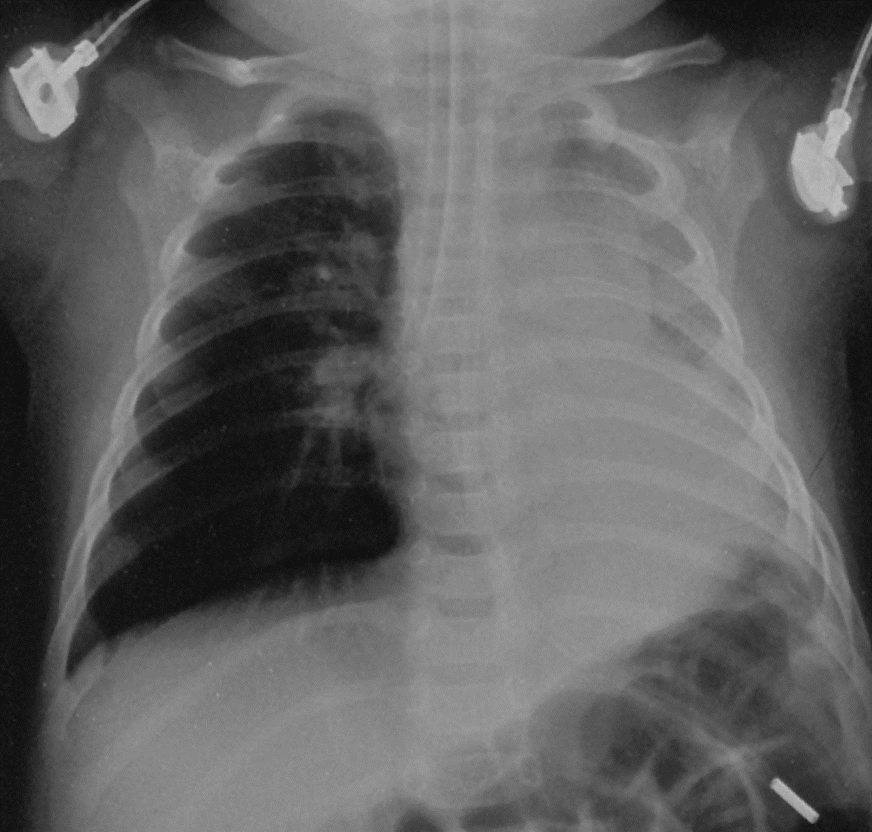
A CXR is taken:

Question 7 (continued)
- State four (4) abnormal findings in this CXR. (4 marks)

- _______________________________________________________________________
- _______________________________________________________________________
- _______________________________________________________________________
- _______________________________________________________________________

His weight is 20 kg.
- List the initial ventilator settings that you would commence. (5 marks)

Mode
(1 mark)

Tidal volume
(1 mark)

Respiratory rate
(1 mark)
I:E
(1 mark)
PEEP
(1 mark)

Question 7 (continued)
45 minutes after instituting these settings, his Peak Inspiratory pressures are 50 cm H₂0.
- State four (4) steps that you would perform to rectify this problem. (4 marks)

- _______________________________________________________________________
- _______________________________________________________________________
- _______________________________________________________________________
- _______________________________________________________________________

Question 8 (14 marks) 6 minutes

A 3 month old female presents with shortness of breath and difficulty breathing.
Her observations are:
BP 85/ 50 mmHg
HR 125 / min
RR 80 / min
Oxygen saturations 98% room air
Temperature (rectal) 36.5 °C

- List four (4) likely differential diagnoses for this patient (each to be from a different pathological category). For each, state the method of confirmation of diagnosis. (8 marks)

 | Differential diagnosis  (4 marks) | Method of confirmation of diagnosis  (4 marks)
1
2
3
4

Question 8 (continued)

- List five (5) historical factors that would suggest a serious illness for this patient. (6 marks)

- _____________________________________________________________________
- _____________________________________________________________________
- _____________________________________________________________________
- _____________________________________________________________________
- _____________________________________________________________________

Question 9 (11 marks) 6 minutes

An 18 month old female presents with respiratory distress and pallor.

An ECG taken on arrival is taken - refer the prop booklet page 6.
- What is the diagnosis based on this ECG? (1 mark)

___________________________________________________________________________
- State four (4) features shown in this ECG that support this diagnosis. (4 marks)

- ________________________________________________________________________
- ________________________________________________________________________
- ________________________________________________________________________
- ________________________________________________________________________

Question 9 (continued)

The child is placed in a resuscitation cubicle with full external monitoring applied.

- State six (6) immediate steps in your management, demonstrating your escalation until this condition is adequately treated. Provide drug doses and routes where appropriate. (6 marks)

- ________________________________________________________________________
- ________________________________________________________________________
- ________________________________________________________________________
- ________________________________________________________________________
- ________________________________________________________________________
- ________________________________________________________________________

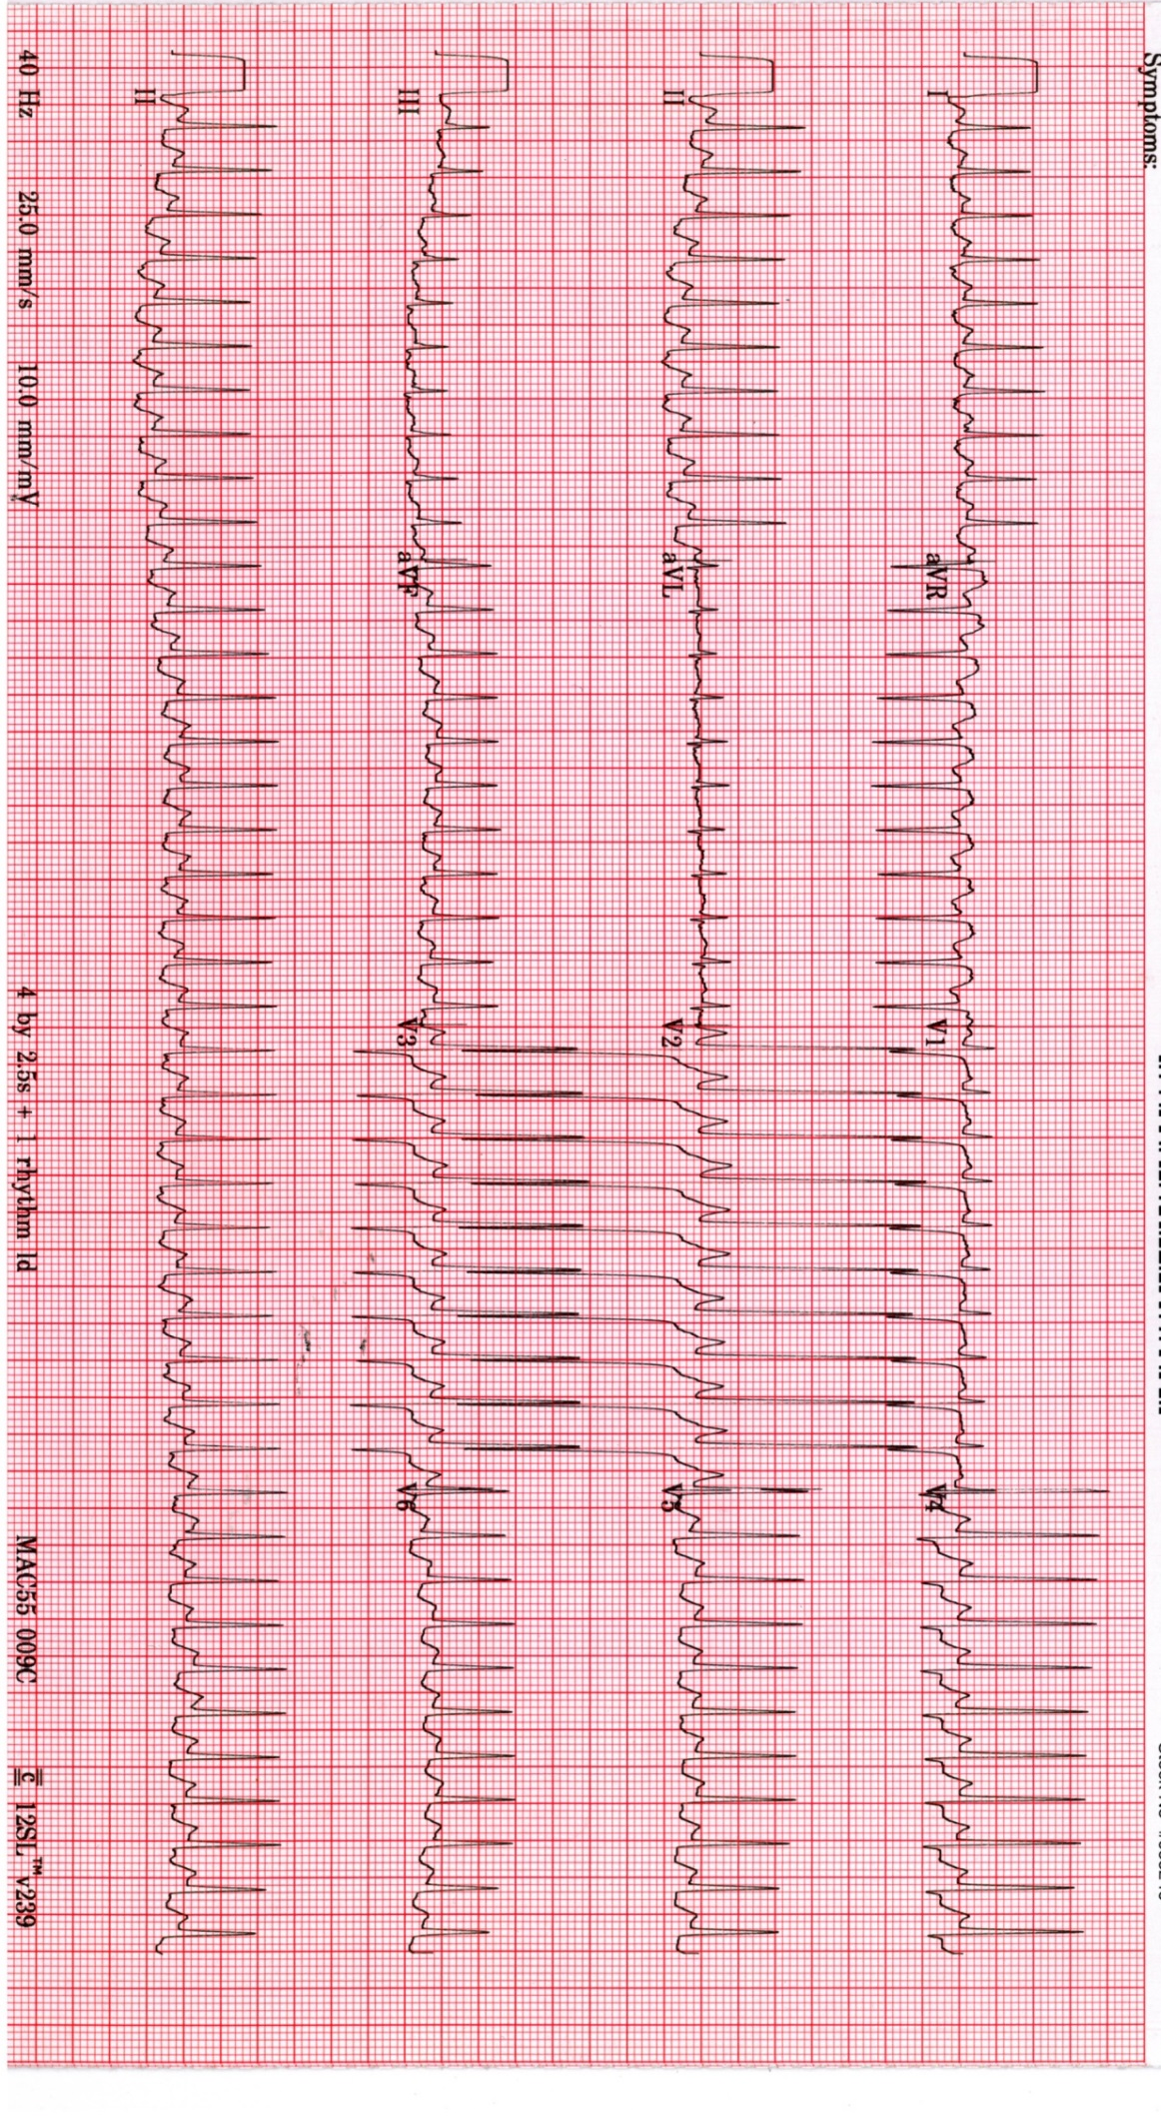

Question 10 (12 marks) 6 minutes
You are working in a mixed ED in an outer suburban hospital with an inpatient Paediatric service.
An 11 month old female developed a rash over a 48 hr period. The rash is present over the entire body, sparing the palms and soles.

A photograph of the child is taken - refer to the prop booklet page 3.

- What is the diagnosis? (1 mark)

___________________________________________________________________________
- List three (3) likely underlying causes for this condition (each cause to be a different aetiology type).(3 marks)

- ________________________________________________________________________
- ________________________________________________________________________
- ________________________________________________________________________

Question 10 (continued)

- What is your preferred disposition for this patient? List two (2) points in your answer. (2 marks)

___________________________________________________________________________
___________________________________________________________________________
- Justify your preferred disposition for this patient. State two (2) points of justification for your choice. (2 marks)

- ________________________________________________________________________
- ________________________________________________________________________

- Other than disposition arrangements, list four (4) key steps in the management of this condition. (4 marks)

- _______________________________________________________________________
- ________________________________________________________________________
- _______________________________________________________________________
- ________________________________________________________________________

