Fellowship Practice Exam
March 2021

WRITTEN EXAMINATION
SHORT ANSWER QUESTIONS

EXAMINATION TIME: 3 HOURS

- ACEM trainees can liaise with their DEMTs to apply to ACEM education team via email (educationalresources@acem.org.au) on their behalf and use the
​ actual ACEM exam platform to attempt the practice written exam.
ACEM exam platform : elearning.acem.org.au/login/index.php

Question 1
A 74 year old man is brought in from home by ambulance with a blood pressure of 75/40 mmHg. He is incoherent and delirious and can provide no further history. You perform a bedside ultrasound to assess the potential causes of shock.

Part a
List six (6) important diagnoses that you would seek on bedside ultrasound and state one (1) specific diagnostic ultrasound feature that would be consistent for each diagnosis and one specific treatment, with rationale, for each diagnosis.

Please note you cannot repeat the same ultrasound feature for two diagnoses.

Model Answer
Diagnosis  (6 marks) | US findings  (6 marks)  Each finding can only be used once | Specific treatment with rationale  (6 marks)

Question 2
A 69 year old female presents to the Emergency Department with 12 hours of chest pain and shortness of breath. An ECG is taken on arrival:
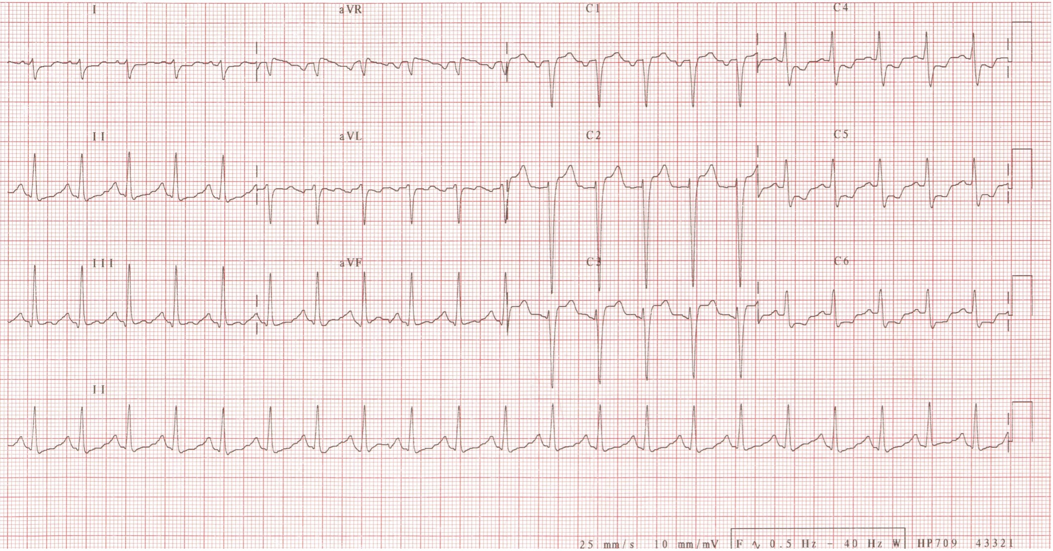

Part a
List three (3) abnormal ECG findings.

Part b
State a unifying diagnosis.

Part c
The patient is given appropriate initial treatment. While still in the Emergency Department she becomes hypotensive with a Blood Pressure of 70/40 mmHg.
Complete the table by listing four (4) SPECIFIC complications of this patients condition that you would look for and for each list one (1) physical exam finding you would expect.

COMPLICATION | EXAM FINDING

Question 3
A 25 year old man presents to your Emergency Department complaining of pleuritic chest pain and shortness of breath. A chest-X-ray is obtained and shown below.
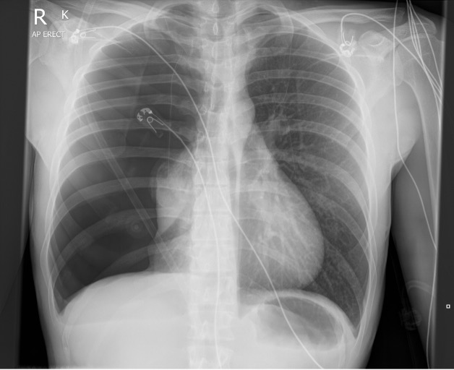

Part a
What is the diagnosis?
(Case courtesy of Andrew Murphy, Radiopaedia.org, rID: 4649)

Part b
List four (4) abnormal findings seen in this CXR.
Part c
List seven (7) factors which may influence your choice of treatment.

Question 4
A 40 year old female patient presents to your Emergency Department with right upper quadrant pain. Despite normal laboratory tests, you still consider acute cholecystitis as the likely diagnosis.
You decide to perform a bedside ultrasound.

Part a
List four (4) positive findings to suggest Cholecystitis.

Part b
Please complete the table with two (2) reasons for false positive and false negative ultrasound findings that are SPECIFIC to cholecystitis.

False +ve | False -ve

Part c
Ultrasound confirms cholecystitis and the patient is admitted to the ward for laparoscopic cholecystectomy.
List four (4) complications, specific to this procedure, that can potentially be a reason for the patient to re-present to the Emergency Department after surgical discharge.

Question 5
A 70 year old woman presents to your Emergency Dept. with knee pain after a fall from standing height. She has a past history of type 2 diabetes and obesity.

Part a
An x-ray of her knee is taken:
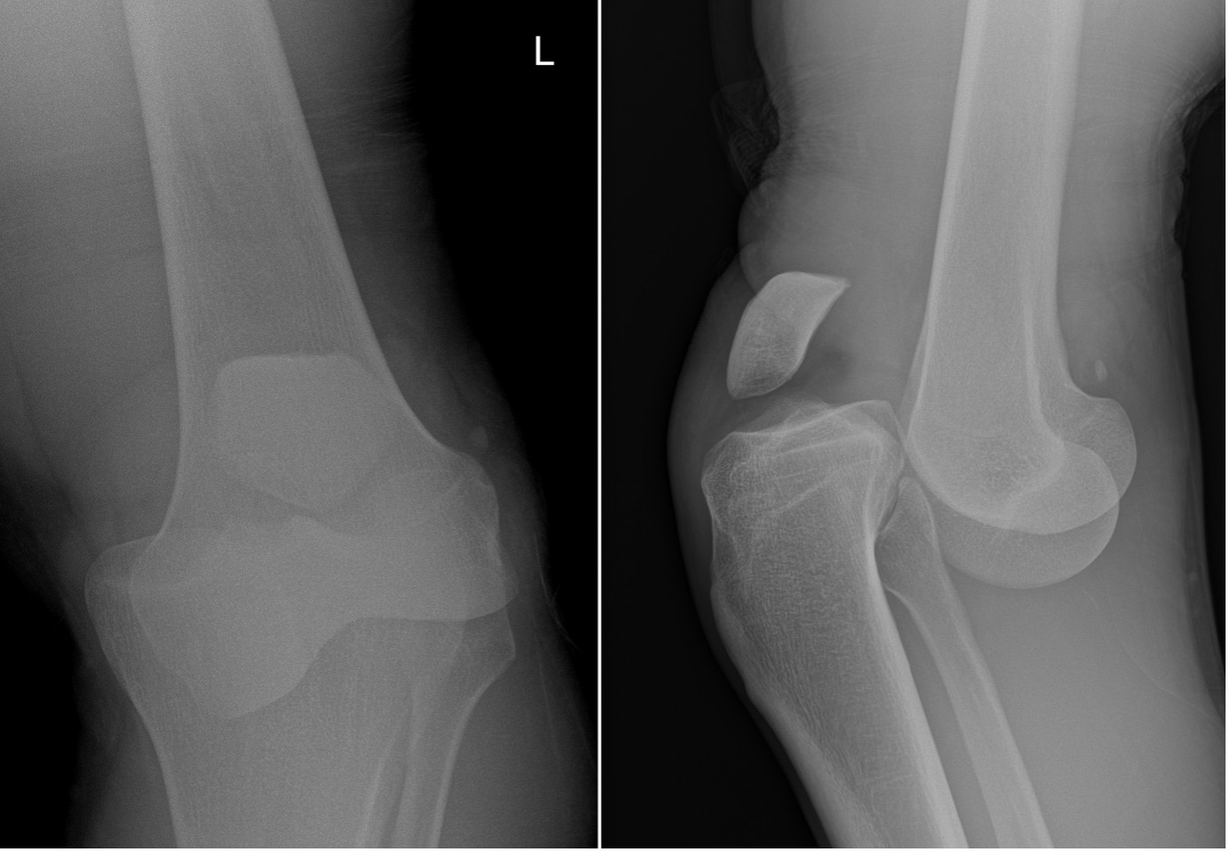
Please state your diagnosis.

Part b
State five (5) steps in your initial treatment of her injury.

Part c
List four (4) complications of this injury.

Part d
Other than a post reduction x-ray, list one (1) key investigation needed for this injury and provide the rationale.
Model Answer
Key Investigation | Rationale

Question 6
A 62 year old male is brought to your Emergency Department by ambulance with a presenting complaint of flaccid paralysis of all four of his limbs without a preceding history of trauma.
Vital signs are:
GCS | 15/15
HR | 84 bpm
BP | 140/80 mmHg
RR | 16/min
SaO2 | 94% on room air
You suspect he has suffered an acute spinal cord compression.

Part a
Complete the table below listing four (4) possible causes and one (1) risk factor for each that you would seek on history.

 | Cause of Acute Cord Compression  (4 marks) | Risk Factor  (4 marks)
1
2
3
4
5
6

Part b
Outline four (4) key steps you would take in managing this patient.

Question 7
A 35 year old lady presents to your tertiary hospital emergency department with per vaginal bleeding. She is currently 32/40 gestation and G1P0. After taking a history and performing an examination, you suspect she has a placental abruption.

Part a
Apart from placental abruption, list four (4) other differential diagnoses that should be considered.

Part b
List four (4) risk factors for placental abruption.

Part c
The patient has increased PV bleeding and becomes hypotensive. Other than IV fluid resuscitation, outline 4 other steps in your immediate management for this patient.

Question 8
A 26 year old male was camping and fell asleep on the ground. On waking, he noted two small puncture marks to his ankle and was concerned about a possible snakebite. He had a pressure immobilisation bandage applied by his partner. On arrival to the ED, he has the following vital signs:
RR | 16 bpm
Sa02 | 99% RA
HR | 80 bpm
BP | 130/70 mmHg
Temp | 37.2

Part a
List four (4) signs on examination that would suggest he has been envenomed.

Part b
The patient has no signs on examination to suggest envenomation. List three (3) investigations you would perform at this stage.

Part c
After the initial investigations, list two other specific timeframes when you would perform further tests for this patient.

Part d
List three (3) criteria that would need to be met for this patient to be discharged.

Question 9
A 40-year-old homeless man is brought to your Emergency Department with altered conscious state and vomiting. His medical history includes insulin-dependent diabetes mellitus.
His vital signs on arrival are:
HR | 120 bpm
BP | 85/55 mmHg
RR | 26 breaths/minute
O₂ Sats | 99 % (room air)
Temp | 38.9 ⁰C
GCS | 10/15 (E2V3M5)
As part of his resuscitation in the Emergency Department, an Arterial Blood Gas and Urea & Electrolytes are performed. The results are as follows:
ARTERIAL BLOOD GAS
(room air)
 |  | Reference Range
pH | 7.31 | 7.35 - 7.45
pO₂ | 70 mmHg | 75 - 100
pCO₂ | 56 mmHg | 35 - 45
O₂ Sats | 90 % | 95 - 100
Bicarb | 16 mmol/L | 22.0 - 30.0
BE | -5 | -3 - +3
BIOCHEMISTRY
 |  | Reference Range
Na⁺ | 148 mmol/L | 135 - 145
K⁺ | 3.0 mmol/L | 3.5 - 4.5
Cl⁻ | 112 mmol/L | 95 - 110
Glucose | 35 mmol/L | 3.6 - 7.7
Urea | 19 mmol/L | 3.0 - 11.0
Creatinine | 150 µmol/L | <90
Lactate | 3.0 mmol/L | 0.2 - 1.8
Ketones | <0.1 mmol/L | <0.1

Part a
Complete the following table with regard to the acid/base abnormalities demonstrated above.

Acid/Base Abnormality | Likely Cause
1. | 1.
 | 2.
 | 3.
2. | 1.
 | 2.
 | 3.

Part b
State two (2) calculations you would apply to these pathology results to assist in your assessment and

Part c
List three (3) other abnormalities demonstrated in these pathology results.

Part d
Outline the principles of your fluid management strategy in this patient. State four (4) points in your answer.

Part e
There is no clear focal source of sepsis in this patient.
List three (3) antibiotic choices in this patient

Question 10
Your junior doctor is caring for an elderly female patient who has sustained a fractured neck of femur following a fall at home.
The patient is 60kg, and currently has the following vital signs:
Temp | 36.7 C
HR | 88 bpm
BP | 155/76 mmHg
Sats | 96% on air
GCS | 15
You have recommended a fascia iliaca compartment block for analgesia.

Part a
State three (3) contraindications to a fascia iliaca compartment block.

Part b
List the nerves blocked by this procedure.

Part c
Give the local anaesthetic and dose you would recommend.

Part d
State three (3) symptoms or signs that portend systemic toxicity from the local anaesthetic.

Part e
State five (5) life threatening complications from systemic local anaesthetic toxicity.

Part f
State your rescue therapy (drug and dose) for life threatening local anaesthetic toxicity resistant to standard resuscitation efforts.

Question 11
A 72 year old man presents following a brief syncopal episode at home. He has a history of hypertension and diabetes. He is placed in a resuscitation cubicle with IV access and all monitoring applied.
His vital signs are:
BP | 80/50 mmHg
RR | 18/min
Temp | 37 deg C
Sats | 98% room air
GCS | 15
An ECG is performed on arrival.
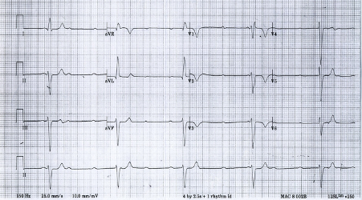

Part a
What are the two (2) MOST LIKELY underlying causes of this ECG abnormality?

Part b
He does not respond to appropriate medications. A venous blood gas demonstrates normal electrolytes.
What is your next line of treatment for this patient?

Part c
State five (5) key steps you would take to initiate this treatment.

Part d
Following initiation of your treatment, this is his rhythm strip. State four (4) actions you would take in response. (4 marks)
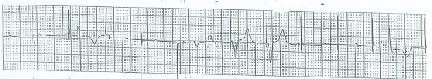

Question 12
A 26 y.o lady has been referred to your Emergency Department by her child and maternal health nurse who is concerned about perinatal depression. She has a one month old baby and has been reluctant to get out of bed. She complains of recurrent abdominal pain. She has a background of having emigrated to Australia three years ago with her husband and his family, after an arranged marriage. She speaks minimal English.

Part a
List five (5) factors on history that you would seek in your risk assessment of this patient.

Part b
List three (3) features in your assessment that would make you concerned for post-partum psychosis.

Part c
After further history taking you are concerned there may be a risk of self-harm or harm to the baby.
Outline four (4) points of management that are specific for this patient.

Question 13
A 26 year old woman has presented with one day history of headache and abdominal pain. She is confused with a GCS of 14.
A non‐contrast CT Brain has been obtained.
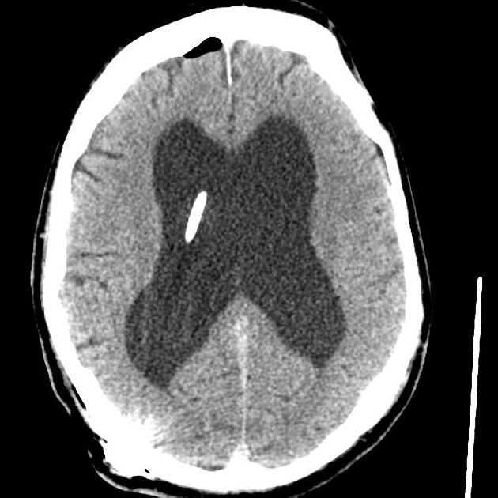

Part a
List four (4) abnormal findings demonstrated on this CT scan.

Part b
List two (2) possible causes SPECIFIC to this patient for her presentation today.

Part c
What other imaging should be ordered for this patient?

Part d
List two (2) abnormalities that you would look for in this subsequent imaging.

Part e
Approximately how much effective radiation exposure has the patient received from her CT brain?

Question 14
An 11 year old girl presents to your rural emergency department after a car accident. An Xray of the left femur is shown.
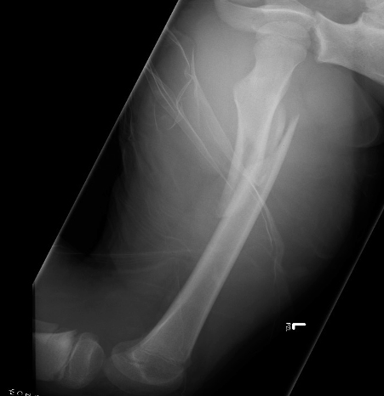

Part a
List one (1) important abnormality on the Xray.

Part b
List two (2) immediate concerns relevant to this injury.

Part c
List two (2) long term complication associated with this injury?

Part d
You are to provide a medical escort for her transfer to your local paediatric trauma centre 45 minutes away.
List three (3) specific modalities to provide analgesia for the transfer?

Part e
Her vital signs are as follows:
HR | 140
BP | 85/50
RR | 25
T | 36
Describe her haemodynamic state.

Part f
Initial resuscitation is carried out and it is decided to prepare for transfer.
List four (4) steps you will take to prepare for an uncomplicated transfer.

Question 15
ACEM’s quality framework has 5 domains which are considered to encompass the priorities of each Emergency Department.

Part a
From the domain “Clinical Profile”, list five (5) audits which should be undertaken by Emergency Departments.

Part b
Complete the following table listing three (3) other Domains of Quality recommended by ACEM and for each domain, give one (1) example of ED work that would fall in that domain.
Part c
State one (1) role of this quality framework.

Question 16

A 50 year old woman is referred to the emergency department by her general practitioner with unintended loss of weight and a serum calcium level of 3.9 mmol/L.

Part a
Aside from spurious and malignancy-related causes, name three (3) other causes of hypercalcaemia.

Part b
Complete the table below listing three body systems (NOT cardiovascular) that may be affected by this patient’s calcium level. For each system list one (1) clinical feature that may be found on history or examination.

Part c
List two (2) ECG changes that may occur in hypercalcaemia.

Part d
List four (4) treatment options for this patient in the emergency department, with a brief description of how each treatment lowers serum calcium.

Question 17
A 25 yo male is brought into ED following a high speed MVA. He was wearing a seat belt and has no apparent head or neck injuries.
Vital signs are:
BP | 130/85
HR | 115 reg
Oxygen Saturation | 95% RA
Temperature | 37.0
GCS | 15
Your junior registrar indicates that there is no intrabdominal pathology based on the FAST scan they have just performed. You review one of their images, see below:
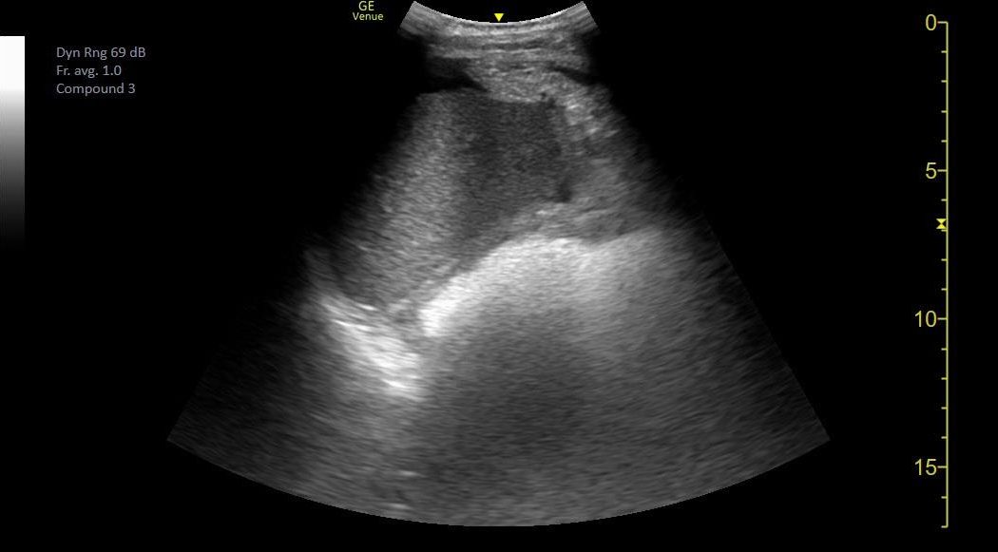

Part a
List two (2) adjustments you would make to optimise the image.

Part b
List three (3) reasons for a false negative RUQ scan in the setting of a patient with abdominal trauma.

Part c
State two (2) issues you would raise with the junior registrar regarding the ultrasound following the resuscitation?

Part d
List three (3) strategies for reducing transmission of infection when using an ultrasound machine

Question 18
A 7 year old boy is brought into your Emergency Department having a generalised tonic clonic seizure that started 15 minutes ago. No medications have been given. He has had no previous seizures and has no significant past medical history. He was well before the seizure started. The patient's weight is 25kg.

Part a
PRESCRIBE, in the order you would give them, three (3) DIFFERENT medications you would use to terminate the seizure

Part b
Despite the above measures he continues to seize. You decide to intubate and ventilate him. List four (4) drugs you would prepare prior to intubation and give a justification for each.

Part c
Five minutes after intubation, the patient’s oxygen saturations drop to 88%. List four (4) adjustments you could make to the VENTILATOR SETTINGS to improve oxygenation?

Question 19
A 37 year old female presents to the ED four hours after ingesting 100 ferro-gradumet (ferrous sulphate 325mg) tablets.

Part a
List two (2) local and two (2) systemic features of iron toxicity.

Part b
List four (4) investigations you would perform on presentation and one justification for each.

Part c
List two (2) contraindications for whole bowel irrigation.

Part d
List two (2) indications for the administration of desferrioxamine.

Part e
State the mechanism of action of desferrioxamine.

Part f
List four (4) criteria that must be met for safe discharge home from ED.

Question 20
A 3 month old boy is brought to the ED with his mother. She gives a history of him rolling off the change table, landing on the side of his chest. He has been crying since the fall.
A CXR is shown below:
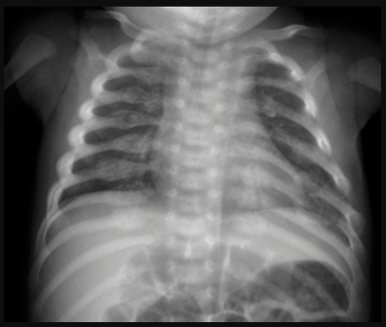

Part a
State one (1) significant finding on this chest x-ray and the most likely diagnosis.

Part b
List five (5) physical examination findings you will specifically assess for and one justification for each.

Question 21
A 76 year old man has been bought to the ED from nursing home with increasing confusion and agitation. He has assaulted another resident.

Part a
List two (2) medications and the dose range you would consider for managing his agitation in ED and list two (2) potential adverse effects for each drug.

Part b
List three (3) elements of the history that may help to distinguish delirium from dementia.

Part c
The patients biochemistry is shown below:
 |  | Reference Range
Na | 112 mmol/L | (135-145)
K | 4.0 mmol/L | (3.5-5.2)
Cl | 79 mmol/L | (95-110)
Bic | 21 mmol/L | (22-32)
Urea | 3.1 mmol/L | (2.8-7.2)
Crea | 61 umol/L | (45-90)
eGRF | 80 ml/min | >90)
BSL | 6.3 mmol/L | (3 – 7.7)
List three (3) investigations that would help determine the cause of the electrolyte imbalance above.

Question 22
A previously healthy, not sexually active 14 year old girl was referred by her GP, with a 2 day history of right iliac fossa pain for evaluation of suspected appendicitis. She has had no vomiting but has had one episode of diarrhea.
Her vital signs on arrival:
Temp | 37.5 °C
HR | 64 bpm
BP | 116/70 mmHg
She is tender in the right lower quadrant of her abdomen with no guarding or rebound.

Part a
List four (4) differential diagnoses apart from acute appendicitis.

Part b
List three (3) Examination findings in any patient that are suggestive of acute appendicitis.

Part c
List four (4) Ultrasound findings supportive of acute appendicitis.

Part d
State two (2) utilities (usefulness) of performing an abdominal/pelvis US in this patient.

Question 23
An 80 year old male from a residential agent care facility (RACF), is referred to your ED by his GP with increasing confusion and fevers of up to 38.5 degrees Celsius for IV antibiotics for a suspected urinary tract infection.
He denies dysuria or frequency; however, he does have suprapubic tenderness and staff report malodorous and cloudy urine.

Part a
State the diagnostic definition of a Urinary Tract infection in older adults.

Part b
What is the most commonly isolated organism in urine cultures from both community-dwelling older persons and Residential Aged Care residents?

Part c
With the exception of diabetes, list three (3) features of a patient’s past medical history that will increase their risk for a UTI.
Part d
With the exception of renal stones, list three (3) features of a patient’s past UROLOGICAL history that will increase their risk for a UTI.

Part e
With the exception of a 'Urinary tract infection' state one (1) possible cause for chronic dysuria in this patient.

Part f
The nursing staff are concerned that the patient is confused. You decide to use a delirium screening tool.
List ONE (1) example of a validated delirium screening tool which can be used in the emergency department.

Part g
The ACEM policy Care in Elderly Patients in ED recommends screening of delirium in the emergency department for all patients older than 75 years. You are tasked to choose to implement this validated tool.
State TWO features this tool should have to be effective and achieve its stated aim.

Question 24

A 14 year old girl is referred to your tertiary ED by her GP with concerns for a new diagnosis of an eating disorder.

Part a
List three (3) important features on history.

Part b
List and justify three (3) essential investigations.

Part c
List three (3) findings that would warrant admission to hospital.

Question 25

A 45 year old man with chronic pancreatitis and chronic liver failure frequently presents to your emergency department requesting analgesia for abdominal pain. The intern has reviewed the patient today, and is concerned 'something is really wrong'. The gastroenterology registrar has refused to see the patient as they discharged him just last week after 'another pointless admission'. The patient is becoming increasingly belligerent.

Part a
State three (3) initial priorities in responding to this situation.

Part b
The gastroenterology registrar does review the patient, and is concerned they may have spontaneous bacterial peritonitis. You agree to assist them in arranging an abdominal paracentesis.
List three (3) factors that would help you determine whether the intern could perform this procedure without direct supervision.

Part c
The patient is admitted under the gastroenterology unit however dies during this admission. Significant delays to care in the ED are identified during a case review.
State four (4) steps you could take to evaluate the cause of these delays to care?

Part d
List two (2) potential benefits of a management plan for complex patients.

Question 26

You are examining a 26 year old male with the forearm wound pictured below:
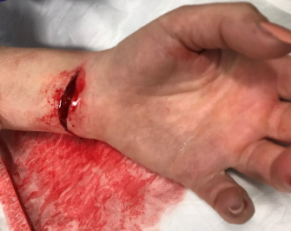

Part a
Complete the table listing how you would examine the motor and sensory components of each of the nerves supplying the hand.
Model Answer
Nerve | Motor | Sensory
Median

Ulnar

Radial

Part b
Describe how you examine for Flexor Digitorum Profundus and Flexor Digitorum Superficialis injuries in the fingers.

Part c
Complete the following table regarding tetanus wound management.

History of tetanus vaccination | Time since last dose | Type of wound | DTPa, DTPa combinations, dT, dTpa, as appropriate | Tetanus immunogolulin
≥3 doses | <5 years | All wounds
≥3 doses | >10 years | All wounds
<3 doses or uncertain | Uncertain | Clean, minor wounds
<3 doses or uncertain | Uncertain | Contaminated or major wound

Question 27
A previously well 35 year old male without any allergies, is brought by ambulance to your rural ED. You are 90 km away from the nearest trauma centre. General Surgery and Anaesthesia services are onsite. He has suffered an isolated head injury.
On arrival the patient is alert and complains of a headache. He is amnestic to the events, repeatedly asking staff what had happened. He has no significant neurological deficits.
His vitals are:
HR | 90 bpm
BP | 130/85 mmHg
SpO2 | 98% RA
Temp | 36.5 °C
GCS | 14 (E4, V4, M6)
After your initial assessment, the patient is taken for CT of his brain and C-spine.
Two single slices of the CT scans are provided below:
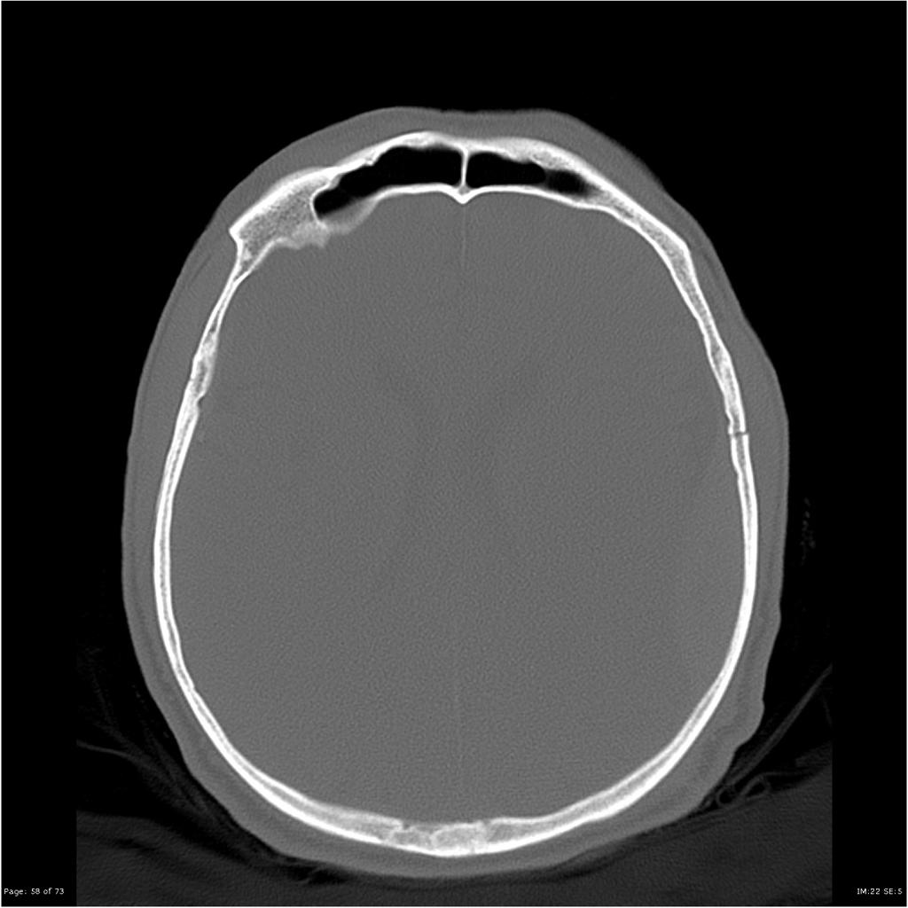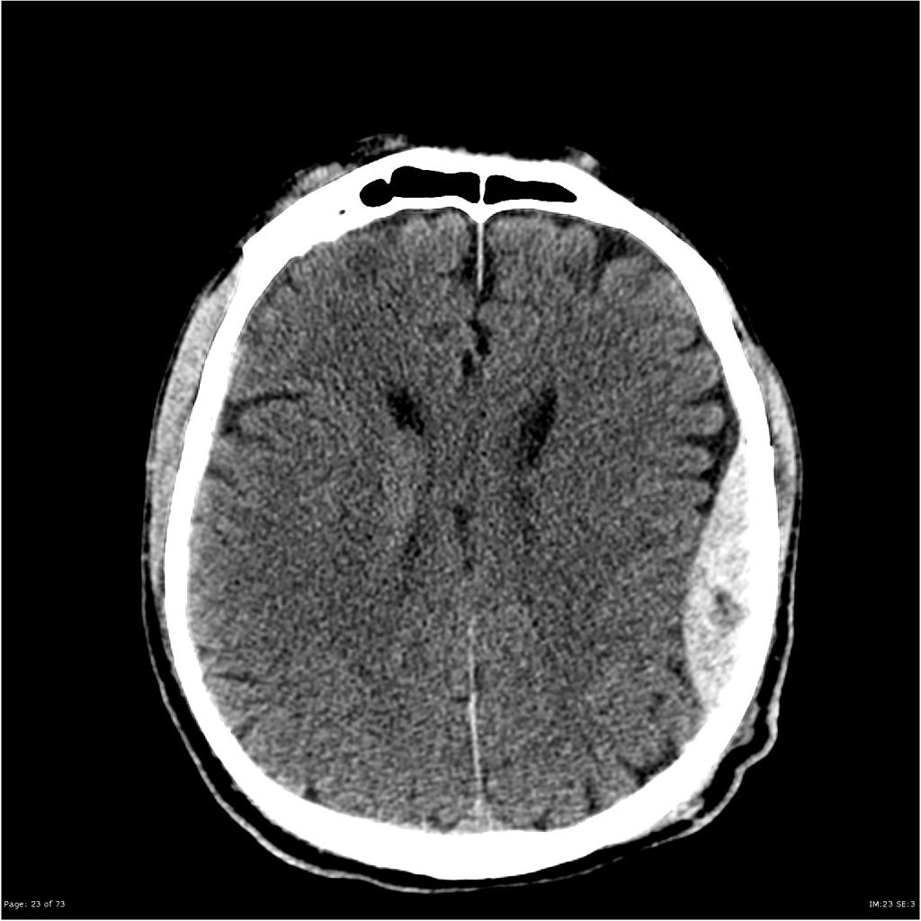

Part a
List three (3) MOST IMPORTANT findings.

Part b
Shortly after the CT scan, the patient deteriorates. His GCS falls to 10 (E2, V3, M5). His pupils remain equal. You decide to intubate him.
State five (5) MOST IMPORTANT peri-intubation considerations SPECIFIC to this patient.

Part c
Under your expert care, the intubation progresses uneventfully.
List three (3) important considerations for the patient’s ongoing management.

Part d
20 minutes later, the patient becomes bradycardic (HR 54) and hypertensive (BP - 200/110). His left pupil becomes dilated.
State four (4) immediate actions for this deterioration in the patient’s condition.

Part e
A junior registrar who has been assisting you manage the patient, bursts out crying and leaves the resuscitation cubicle.
State three (3) actions you would take to manage this situation.

