Fellowship Practice Exam
August 2021

WRITTEN EXAMINATION
SHORT ANSWER QUESTIONS

EXAMINATION TIME: 3 HOURS

- ACEM trainees can liaise with their DEMTs to apply to ACEM education team via email (educationalresources@acem.org.au) on their behalf and use the
​ actual ACEM exam platform to attempt the practice written exam.
ACEM exam platform : elearning.acem.org.au/login/index.php

Question 1

A 34 year old female presents to the ED via ambulance and proceeds to emergently deliver a term baby in a resuscitation cubicle. Immediately after the second stage of labour you notice heavy vaginal bleeding.

Part a
What is the definition of primary postpartum haemorrhage?

Part b
List four (4) risk factors for primary postpartum haemorrhage.

Part c
List six (6) immediate interventions you would undertake in the emergency department in this patient to control her postpartum haemorrhage.

Part d
The patient continues to deteriorate and has a pulseless electrical activity (PEA) cardiac arrest. In addition to uncontrolled postpartum haemorrhage, list four (4) most likely causes of PEA in this patient.

Part e
With regards to management of pulseless electrical activity cardiac arrest in neonates and adults, complete the following table.

Question 2

A 45 year old man presents to your emergency department with chest pain. He is assessed by a junior doctor who identifies ST elevation in the inferior leads on the ECG. The HMO believes the patient has acute pericarditis.

Part a
List four (4) ECG features you would look for that would be more suggestive of a STEMI rather than acute pericarditis.

Part b
You assess the patient and review the ECG. You agree with the junior doctor's provisional diagnosis of acute pericarditis.
List five (5) non-infectious causes of acute pericarditis.

Part c
The patient has a blood pressure of 90/70mmHg with heart rate 115 bpm. You perform a bedside echocardiogram and detect a large pericardial effusion.

Other than the presence of a pericardial effusion, list three (3) echocardiographic features that would be consistent with cardiac tamponade.

Question 3
An 80 year old gentleman presents with acute dyspnoea, onset 2 hours ago. His past history is unclear. On arrival he is placed on non-invasive ventilation.
His vital signs are:
HR | 107
BP | 110/70
SaO2 | 95% on 50% FiO2
Temp | 36.4 oC
RR | 24

Part a
A portable CXR is taken soon after his arrival. List three (3) abnormal findings in this CXR image.
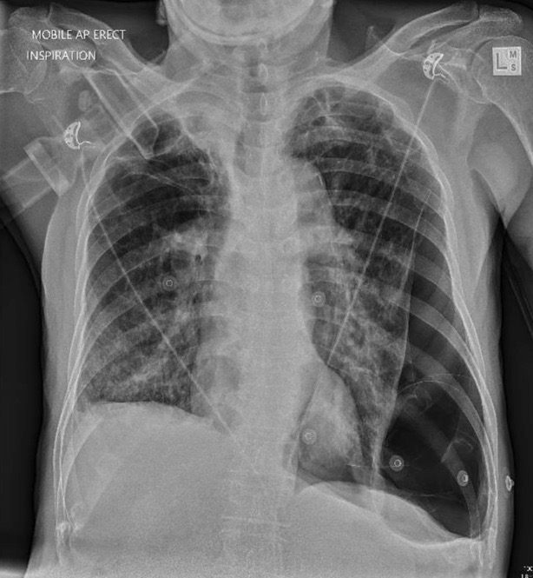

Part b
State the immediate change in your initial management required after these CXR findings.

Part c
In general, List six (6) causes for the most important finding on this CXR.

Part d
Your resident asks about the utilisation of point of care ultrasound in this patient. Complete the table below listing different lung ultrasound findings you would expect in the right and left chest for this patient.

Question 4
A 60 year old woman presents to your Emergency Department with two days of increasing abdominal pain and vomiting. She has no significant medical history, with no prior surgeries. You suspect a small bowel obstruction (SBO).

Part a
List five (5) potential causes of SBO in this patient.

Part b
As part of your assessment, you perform a bedside ultrasound to assess for SBO.
List three (3) ultrasound findings that would support the diagnosis of SBO.

Part c
As part of your management, you elect to insert a nasogastric tube (NGT).
In general, LIST four (4) contraindications to NGT insertion in any patient.

Question 5

A 34 year old man is brought to your Rural Emergency Department, one hour after being struck by a car. He is conscious, complaining of a painful R leg. He has no other injuries.

A photo of his legs is shown below:
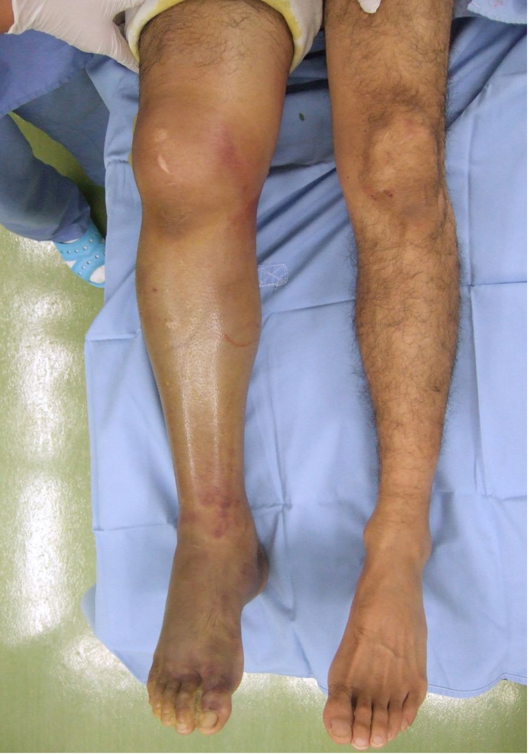

Part a
List two (2) important abnormal features shown in this photograph.

Part b
Xrays of his leg are shown below:
List three (3) abnormal features on these Xrays.
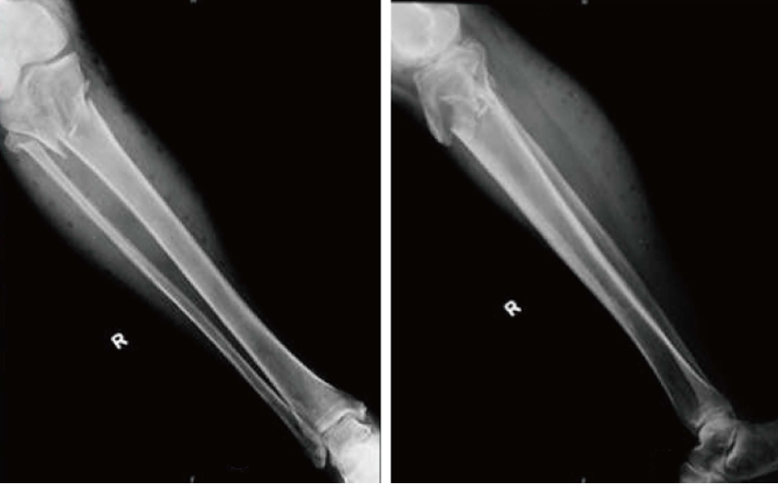

Part c
The patient has received adequate analgesia. List your next three (3) priorities in the management of this injury in the Emergency Department.

Part d
List four (4) potential complications of this injury.

Question 6
A 78 year old man presents to your Emergency Department with sudden vision loss in his right eye. He initially noted a diplopia and subsequently was told by his wife that his right eye was bulging.
On examination he has proptosis. Visual acuity is light perception only.
You suspect orbital compartment syndrome.

Part a
List 4 pathological processes that can lead to orbital compartment syndrome.

Part b
Apart from proptosis and vision loss, list three (3) further clinical examination findings that would help confirm orbital compartment syndrome.

Part c
You confirm orbital compartment syndrome. The patient requires a lateral canthotomy.
List five (5) steps in performing a lateral canthotomy and cantholysis.

Question 7
A 38 year old female presents to the Emergency Department with altered mental state, ataxia and nystagmus. She has a past history of frequent attendances due to intoxication with alcohol.
HR | 110
BP | 100/80
RR | 12
Temp | 38.8 oC
CGS | 10 (E3 M3 V4)

Part a
List five (5) important aspects of her history.

Part b
List four (4) investigations with rationale for each.

Part c
Your junior registrar has reviewed the patient and believes they have Wernicke’s encephalopathy.
List two (2) ocular findings associated with Wernicke’s encephalopathy.

Part b
Prescribe your specific treatment for Wernickes encephalopathy.

Question 8
A 75 year old female presents from her nursing home with a one week history of worsening confusion, lethargy and hypothermia. She is now obtunded. Her TSH is markedly elevated, and you suspect myxoedema coma.

Part a
Apart from those mentioned in the stem, list five (5) physical examination features of myxoedema coma.

Part b
Apart from thyroid hormone levels, list four (4) blood test abnormalities you would expect to find in this patient.

Part c
Give your T3 and T4 dosing for treatment of this patient.

Part d
What other essential treatment (including dose) would you give?

Question 9
An 80 year old man has been transferred to your Emergency Department from his nursing home with an altered conscious state.
An arterial blood gas sample has been taken and the results are:
 |  | Reference Range
FiO2 | .21
pH | 7.09 | 7.35-7.45
paCO2 | 72 mmHg | 35-45 mmHg
HCO3 | 27 mmol/L | 22-26 mmol/L
paO2- | 50 mmHg | 80-100 mmHg

Part a
What is your interpretation of the Arterial Blood Gas? State three (3) points in your answer.
.

Part b
Show four (4) calculations to justify your interpretation.

Part c
Give two (2) likely causes for his acid/base status and for each of those causes give one (1) intervention that is likely to quickly reduce his paCO2. Do not list the same intervention twice.

Part d
What is his O2 saturation approximately?

Part e
If a patient with chronic CO² retention is administered excessive oxygen list two (2) important mechanisms by which the CO² may rise.

Question 10
A 78 year old woman with a past history of COAD, Type 2 diabetes, hypertension, hypothyroidism, presents with SOB in the setting of respiratory sepsis.
On arrival, she looks unwell with increased work of breathing. Her initial examination findings are:
A | patent
B | RR 32, SaO2 94% on room air, creps at right base, expiratory wheeze bilaterally
C | HR 125 /min , BP 105/70. mmHg
D | GCS 15/15
E | Temp 39.3 oC, BSL 18 mmol/L
She has no epidemiological risk factors for COVID‐19 but precautions are taken given she has respiratory symptoms.
Early in her presentation she receives IV antibiotics, slow IV fluids, bronchodilators and corticosteroids.
While in the department her oxygenation deteriorates and she looks more unwell.

Part a
List three (3) methods for improving oxygenation in this patient with one (1) pro and one (1) con for each.

Part b
She continues to deteriorate with worsening hypoxia and hypotension. You feel that she requires intubation.
State five (5) steps you would do in preparation for intubation.

Part c
Post intubation, her BP drops to 85/50.
List two potential causes and state a management step for each.

Question 11
A 55 year old male is brought in by ambulance with palpitations. He is placed into a resus bay and has intravenous access inserted. He has no chest pain and his vital signs are as follows:
HR | 180 bpm
BP | 120/80 mmHg
Sats | 96% RA
Temp | 36.5 oC

This is his ECG.
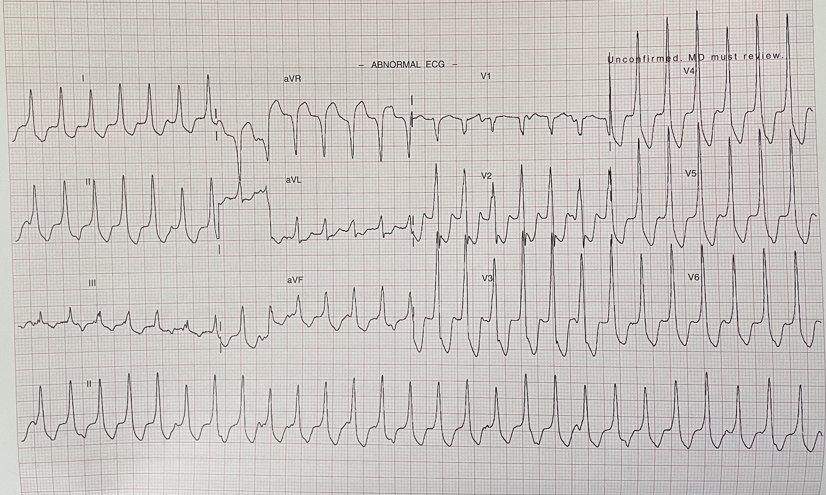

Part a
In the following table list four (4) ECG features that help distinguish VT from SVT and whether they are present on this man’s ECG.

Part b
List, in sequence, four (4) steps you would take to achieve cardioversion.

Question 12
A 28‐year‐old female has been brought to your emergency department by concerned work colleagues. They have noticed a significant change in her behaviour over several months. Large amounts of money are missing from company accounts.
From your assessment she has normal cognition but is poorly engaged and repeatedly states there is nothing wrong.
You suspect this is a first presentation of bipolar disorder.

Part a
In addition to increased spending and/or gambling (risk taking behaviour), list four (4) other typical symptoms that would be highly suggestive of an acute manic episode in this patient.

Part b
List six (6) symptoms that would indicate a major depressive episode.

Part c
State two (2) non‐psychiatric differential diagnoses to be considered when assessing a patient with acute manic episode.

Question 13
A young unidentified patient presents to your tertiary ED after a car accident in which they were unrestrained. An urgent CT is obtained and single axial and coronal portal venous contrast phase slice of this series is shown below.
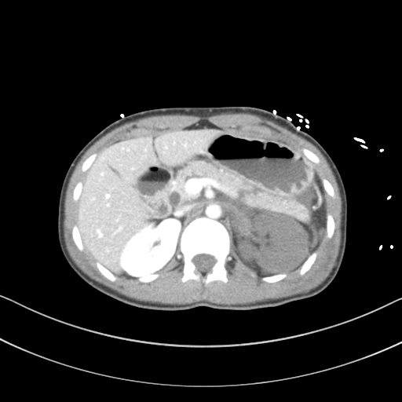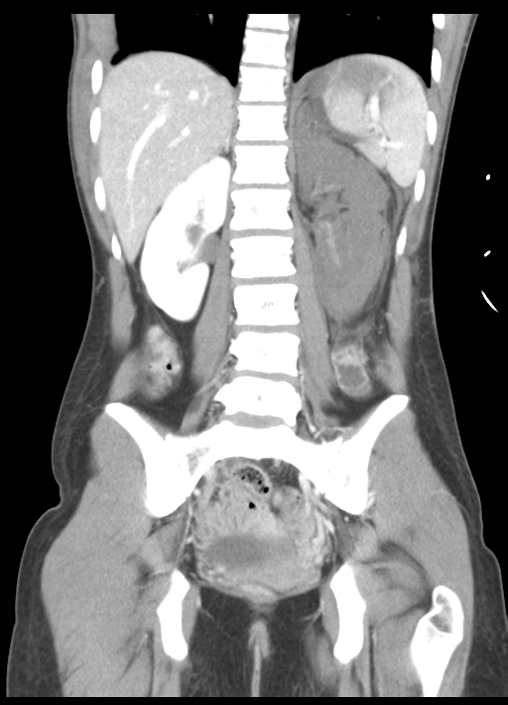

Case courtesy of Assoc. Prof Craig Hacking, Radiopaedia.org, rID: 34984

Part a
List three (3) abnormal findings seen in this CT.

Part b
Regarding the use of CT in blunt abdominal and pelvic trauma, list five (5) pathologies which may frequently be missed on the initial scan.

Part c
Regarding the use of thromboelastogram (TEG) in trauma, please list a treatment response to the following TEG result.

Question 14
A junior doctor from a rural clinic has phoned you to seek advice. A 13 year old female patient has been brought in by her parents with a severe acute behavioural disturbance.
All attempts at verbal de-escalation have failed. No trigger has been identifed and she has no access to any prescription or recreational drugs.
She weighs 50kg, has a past history of Autism, with no regular medications and no known allergies.
She has not received any other treatment so far.

Part a
Complete the table by listing your advice for first line sedation options.

Part b
The patient is kicking and screaming and now refusing oral medication. She is being physically restrained by parents and staff.
Complete the table by listing your advice for second line sedation options.

Question 15
After taking an active interest in the prevention of adverse events for patients, your director has allocated you to the Patient Safety portfolio.

Part a
List two (2) factors shown to increase rates of adverse events for patients.

Part b
You have discovered that your department has an unacceptably high rate of patients who “Did Not Wait” from the ED waiting room.
List four (4) factors associated with patients who “Did Not Wait”.

Part c
Complete the following table with respect to the prevention of patients leaving without being seen and the management of those who failed to wait to be seen. State three (3) strategies for each heading.

Question 16
A 40 year old male presents to your Emergency Department with worsening painful rash and a headache for 2 days.
His past medical history includes HIV and diabetes.

Part a
List 2 abnormalities seen in these photographs of his rash.
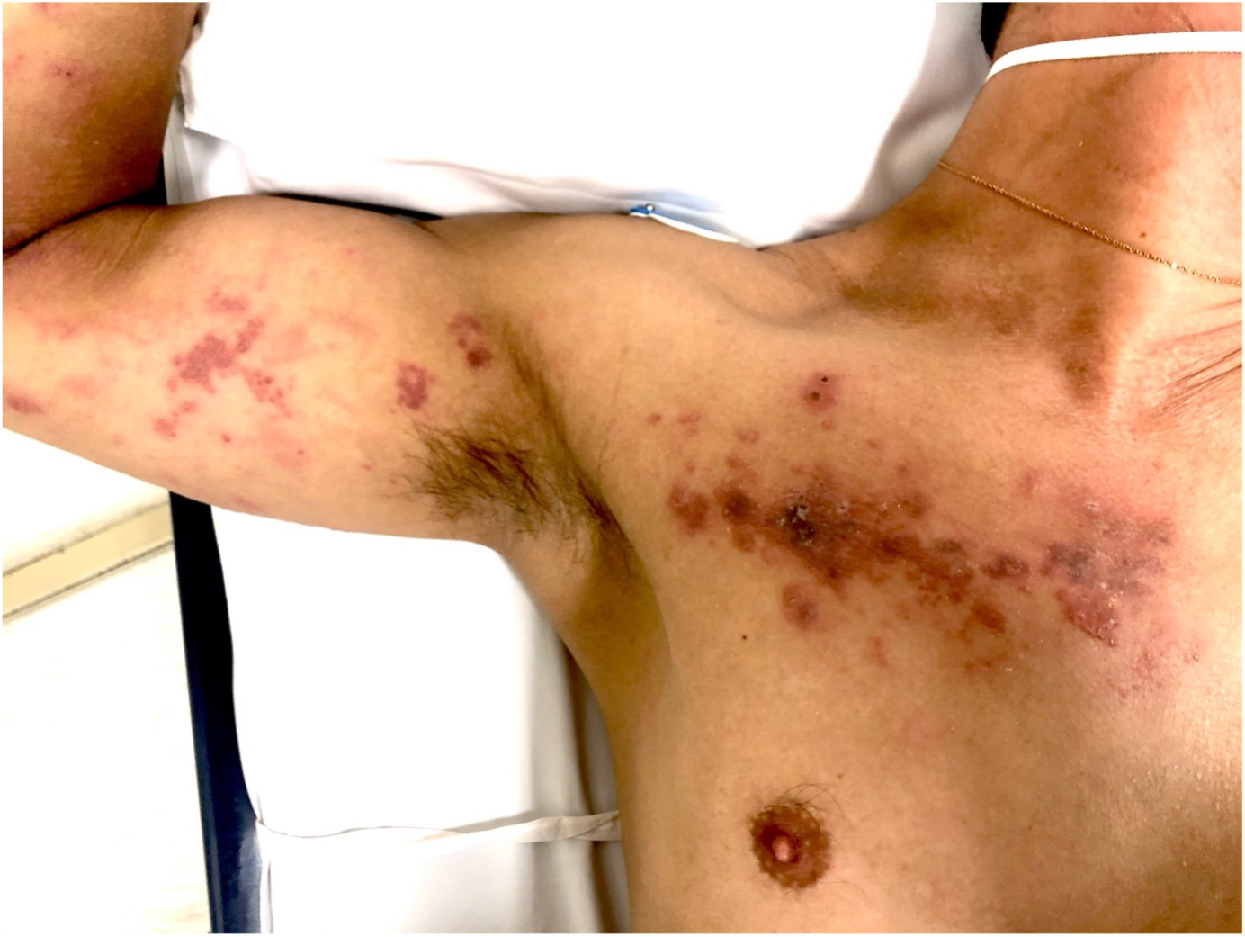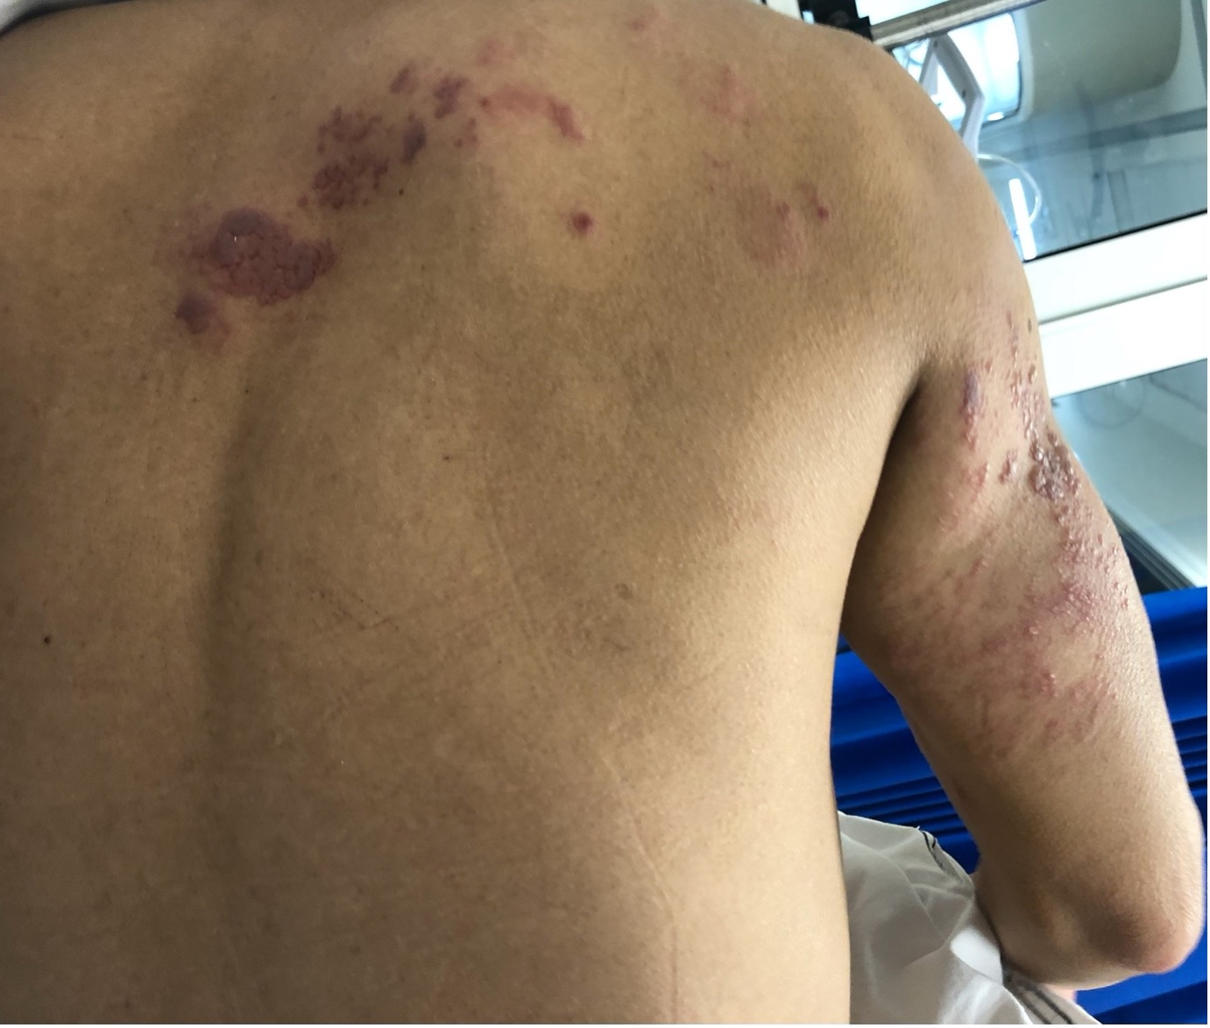

Part b
List two points about the most likely diagnosis & please be as specific as you can.

Part c
Other than blood tests, list and justify three (3) investigations you would perform in the ED.

Part d
Apart from consultation with infectious diseases, list three (3) other steps in your management of this patient.

Part e
The triage nurse approaches you and confides that she is 20 weeks pregnant and concerned about contact with the patient. Apart from consulting with infectious diseases, list two (2) important steps in your management.

Question 17
A 45 yr old male has been brought into your ED after a cardiac arrest in the community. ROSC was achieved after 2 cycles of CPR and 1mg of Adrenaline.
His vitals on arrival are:
Temp | 36.6 ºC
P | 45 bpm
BP | 85/50
RR | 30
SaO2 | 90% on 15 L O₂ via facemask
GCS | 12/15

Part a
As part of his initial assessment a POCUS exam is performed with the following images obtained.
Apical 4 chamber view | Parasternal short axis view
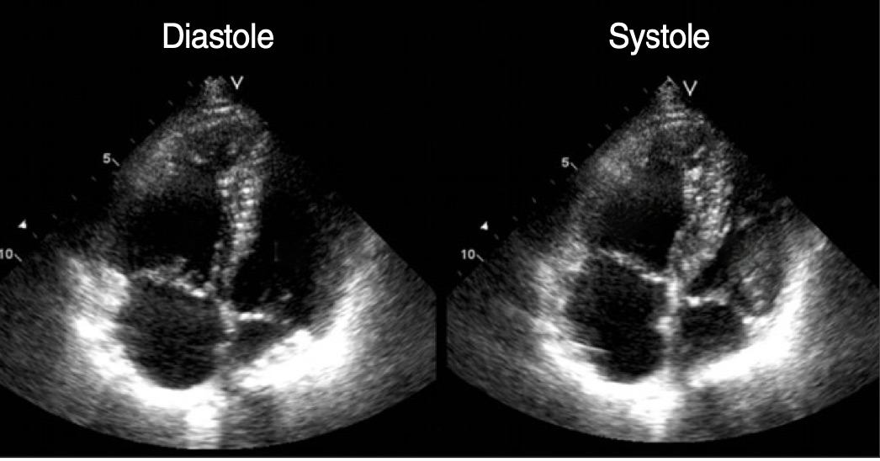 | 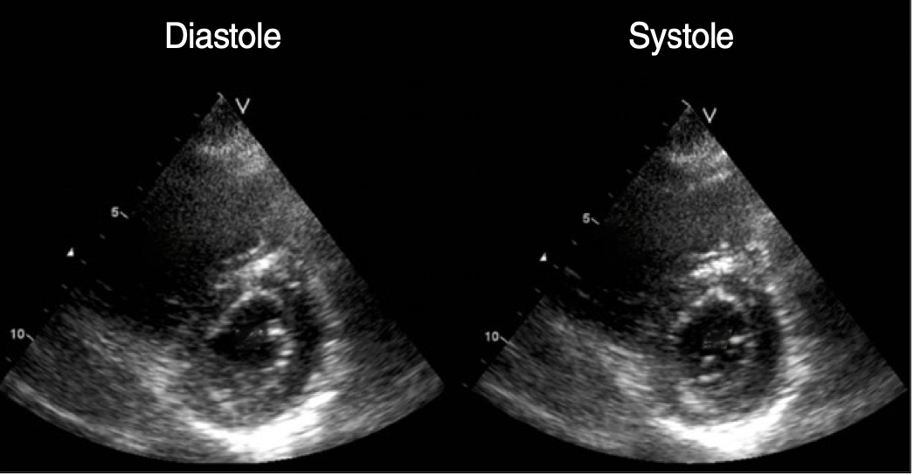

List four (4) important abnormal findings seen.

Part b
What is the most likely diagnosis?

Part c
List three (3) other POCUS findings that would support your diagnosis?

Part d
List two (2) pro's and two (2) con's of a specific treatment you would consider for this patient.

Question 18
A 10 day old baby presents to your emergency department via ambulance with parents reporting episodes of being unresponsive, floppy and short of breath.

Part a
List six (6) likely differential diagnoses you would consider.

Part b
List three (3) clinical signs that would make you suspect a duct dependant cardiac lesion?

Part c
The neonate has the following vital signs:
Temp | 35.3 ºC
HR | 180 bpm
RR | 65 bpm
BP | 65/30 mmHg
O2 sats | 80 % RA
Temp | 37.8 ºC
capill return | 3 seconds
Weight | 4 kg
The neonate is in a resuscitation cubicle and you have managed to site an IV line. BSL 4.2 mol/L
State five (5) initial resuscitation treatment steps including doses where applicable.

Part d
Following your resuscitation the baby has prolonged apnoea’s and you decide to intubate.
Fill in the following table regarding the intubation plan.

Question 19
A 30 year old female is brought to your emergency department after a suspected drug overdose. She was found in an altered conscious state at her residence and was witnessed to have a tonic clonic seizure by Paramedics on their arrival. She has received 3x 5mg IV Midazolam but continues to actively seize on her arrival to the ED over 40 minutes after she was first found.
Her vitals on arrival:
HR | 130 bpm
BP | 160/100 mmHg
Sats | 95 % 15L 0² via NRB mask
Temp | 39.5 ºC

Part a
Please list four (4) specific poisons which may cause benzodiazepine resistant seizures with one specific antidote for each?

Other appropriate answers may be acceptable
Nb some other causes of seizures such as serotonin syndrome and salicylates have specific treatments but the seizures will usually respond to benzodiazepines

Part b
The patient continues to have seizures and requires intubation. List four (4) significant complications of prolonged seizures that may develop in this patient.

Part c
The patient is stabilised and the seizure has been controlled. Complete the table below, list two (2) toxidromes which could potentially explain this presentation and for each state two (2) clinical findings that would make it more likely.

Question 20
An 18 month-old boy is brought to the ED with fever and reduced neck movements. Apart from a temperature of 38.3 ºC he looks well and is playing happily in the ED cubicle.
On examination, he is reluctant to move his head to the left.
A lateral neck x-ray is taken and shown below.
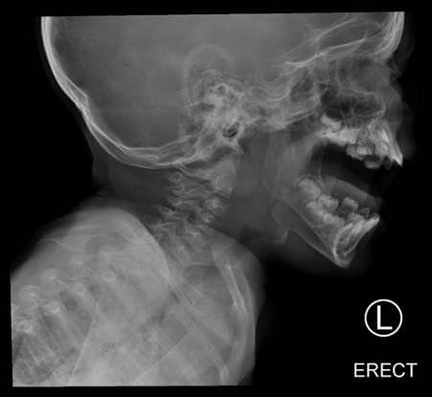

Part a
What is the most likely diagnosis?

Part b
What is the justification for your conclusion (x-ray findings to support this diagnosis)?

Part c
List four (4) appropriate management steps.

Part d
List six (6) signs would indicate worsening airway obstruction in this child?

Question 21
An 18 year old presents with progressive pain, swelling and erythema of his distal phalanx. Ten days earlier he had sustained a deep abrasion to the dorsum of his left ring finger whilst playing hockey on artificial grass.
The picture of his finger is shown below:
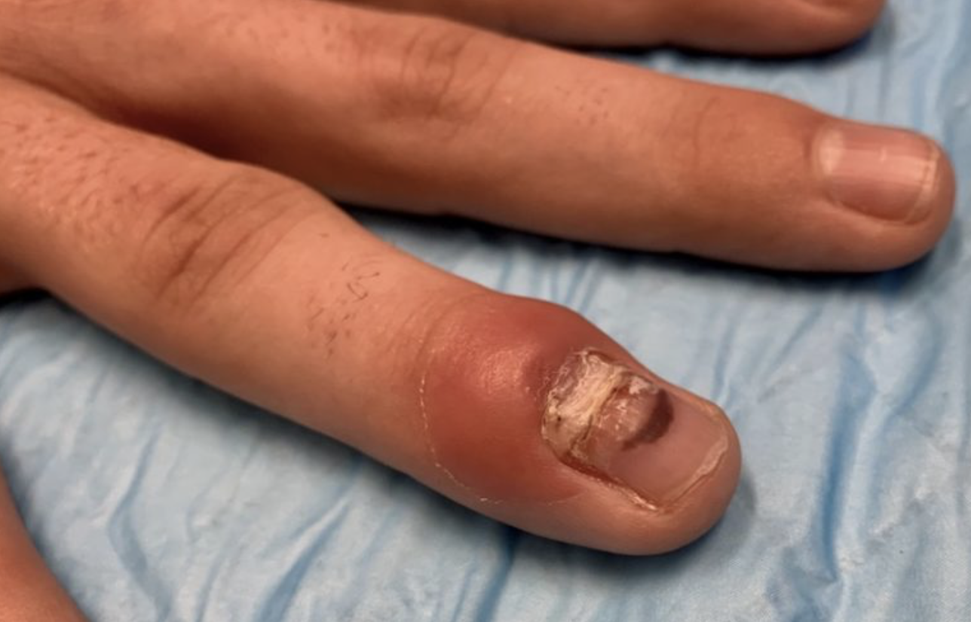

Part a
Please state how would you describe the findings to the plastic registrar.

Part b
List Three (3) abnormal findings on the Point of care ultrasound (POCUS) shown below.
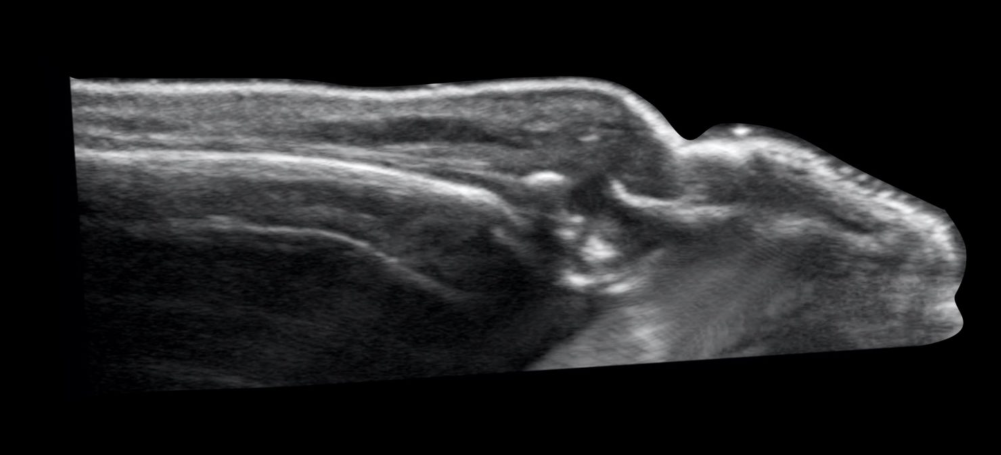

Part c
State one (1) important point you need to emphasis when consulting the plastic team.

Part d
Excluding analgesia, state three (3) important and specific management steps in this patient.

Part e
State one (1) POCUS technique you would utilise for patients with painful digits to increase your image quality and sensitivity.

Question 22
A 7 yr old girl presents with her mother with a straddle injury to her genital region, the injury occurred while she was at her friend’s house.

Part a
List four (4) relevant factors to address in your history.

Part b
List three (3) important factors to evaluate on examination.

Part c
She is really anxious about the examination. List two (2) options to facilitate the examination.

Part d
She is ready for discharge, but parents are very concerned about her discomfort especially with voiding. List two( 2) practical tips to reduce her symptoms.

Question 23
An 80 year old female with the past medical history of hypertension, hyperlipidemia and depression is brought in to the Emergency department from home by her family. She was last seen the previous day when she seemed lethargic.
Her vital signs on arrival:
BP | 70/50 mmHg
HR | 40 bpm
Temp | 31.0 ºC
O2 Sat | 80 % 40 % FiO2
GCS | 10 E3V2M5

Part a
List four (4) differential diagnoses for her presentation.

Part b
State four (4) important steps in her management.

Part c
In general list four (4) important points you need to consider when resuscitating a hypothermic patient.

Question 24
A 12-month-old previously well boy, immunised and without any allergies, is brought to your emergency department with a four-day history of fever, cough and nasal congestion and now he has developed a petechial rash on his lower back.
He is bright and alert with the following vital signs:
Temp | 38.5 ºC
HR | 150 bpm
RR | 38 /min
Sats | 98 % RA
Weight | 10 kg

Part a
List three (3) specific characteristics of a petechial rash.

Part b
List four (4) potential differential diagnoses.

Part c
Using this table, List three (3) investigations with one (1) rationale for each.

Part d
His rash is spreading while in ED and he looks more unwell, so you decide to give him antibiotics. Please prescribe the antibiotics.

Question 25
You are a 1st year Emergency physician at a metropolitan ED.
Your director has asked you to develop an ED guideline/protocol on recognition and diagnosis of suspected thrombosis with thrombocytopenia syndrome (TTS) following Astra-Zeneca ® COVID-19 vaccine.

Part a
State four (4) common presenting features of TTS.

Part b
State two (2) abnormalities on blood tests that would raise concern for TTS.

Part c
List four (4) non-ED stakeholders in your hospital you would consult to develop the guideline.

Question 26
You are assessing a 65 year old male who has presented to the ED complaining of dizziness.

Part a
Complete the table below, stating the clinical features helping in differentiating between Peripheral vs Central causes of Vertigo.

Part b
Complete the following table for a 3 step clinical decision tool that assists with differentiating central vs peripheral vertigo and the expected findings in peripheral and central vertigo.

Part c
Complete the table below listing the Sensitivity and Specificity for the above clinical decision tool.

Question 27
A 34 year old man has been brought to your RURAL ED after falling out of a tractor on his farm. He has sustained an isolated injury to his right lower limb - see clinical photo below.
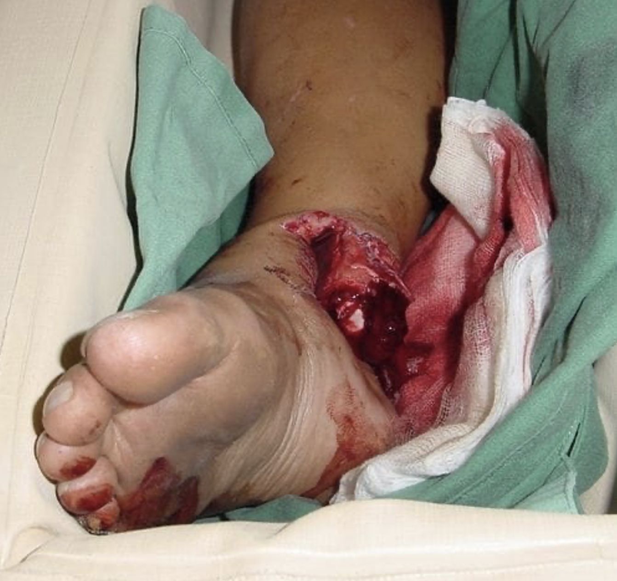

Part a
Complete the following table regarding Gustilo Classification for open fractures.

Part b
State five (5) INITIAL TREATMENT priorities for this patient’s lower limb injuries.
Model Answer
- Haemorrhage control - direct pressure
- Analgesia - give example and dose
- Appropriate antibiotics - cefipime and metronidazole (contaminated - farm)
- Reduction of fracture dislocation under procedural sedation.
- Immobilise & elevate / tetanus toxoid / immunoglobulin
- Ortho referral

Part c
After your initial management, one of the nurses alerts you that the patient’s foot looks more pale than it did before, with a reduced dorsals pedis pulse. Your hospital CT scanner is currently being repaired and unavailable for use. You decide to perform an arterial pressure index utilising a bedside doppler ultrasound device.
Please complete the following equation:
Model Answer
Arterial Pressure Index = Injured SBP / Uninjured brachial SBP

Part d
Please state four (4) steps in order to perform the arterial pressure index of the injured lower limb.

Part e
Your calculated arterial pressure index for the injured lower limb is 0.6.
Please state what an arterial pressure index of 0.6 in this case may signify.

Part f
Please state and justify your disposition for this patient.

