MH SAQ practice Surg and Specialty surg

SAQ 1

A patient presents to the emergency department after sustaining multiple lacerations to the sole of the foot from oyster shells after walking on the beach. You wish to perform a regional block to the plantar aspect of the foot.

1. Name the 3 nerves involved and their cutaneous distribution (3 marks)

2. Where would you insert LA to anaesthetise these regions (3 marks)

4. What other issues must be addressed in the treatment of this injury prior at discharge (4 marks)

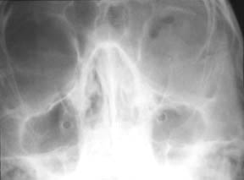
SAQ 2

A 24 year old male had been assaulted. He has swelling around his LEFT eye and a cut on his RIGHT cheek. Your SHO has requested facial views.

a. Give 3 abnormalities on the x-ray. (3 marks)

b. List six aspects of assessment of the orbit and its contents. (4 marks)

c. List 3 further steps in this patient’s management. (3 marks)

SAQ 3

A 25 year old man sustains facial injuries in a high speed motor vehicle crash in which he was the unrestrained driver.
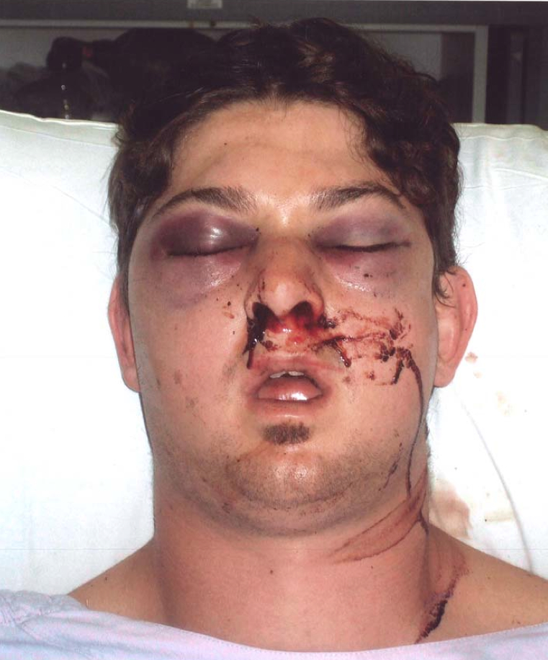

His observations are:
GCS 15
HR 100 /min
BP 130/75 mmHg supine
O₂ sat 97 % room air

a. Describe 3 abnormalities shown in this photograph. (3 marks)

b. What 3 underlying injuries could there be? (3 marks)

c. List 5 factors that provide a risk to his airway? (5 marks)

SAQ 4

A 14 month old girl presents via ambulance to your tertiary ED. She was eating a sausage when she appeared to choke and turn blue. Parental back blows were given.

On arrival the child is drooling, has mild respiratory distress, is upset and has Sats of 96% on 6L 02, a RR of 34 /min and a mild stridor.

A neck x-ray has been done and is shown below.

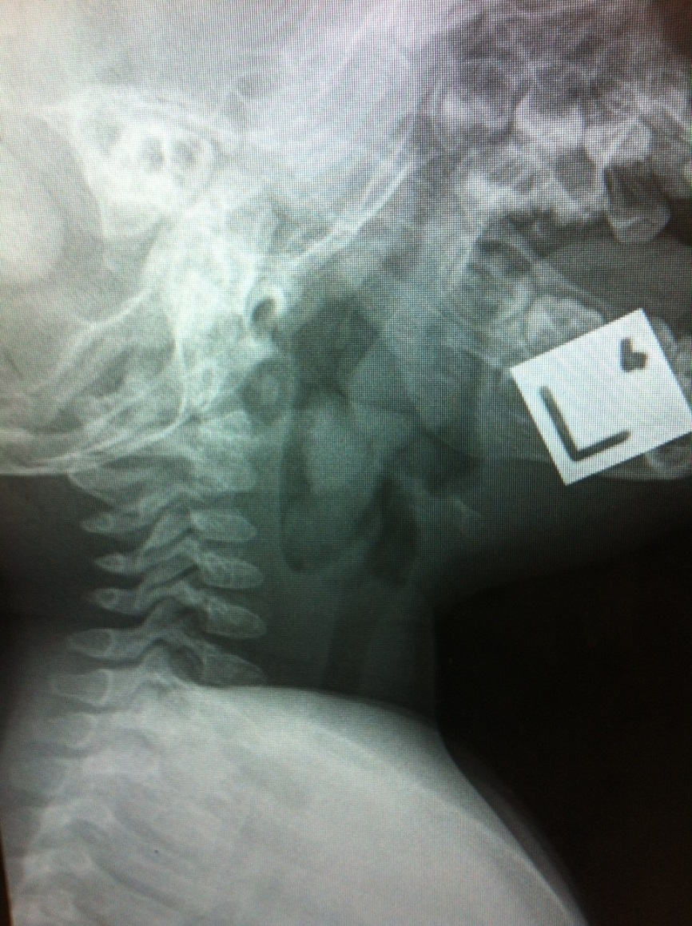

a. What is the major abnormality on the neck x-ray? (2 marks)

b. List and justify 3 options to managing her airway issue. (6 marks)

c. What are 2 ways an unwitnessed bronchial foreign body aspiration may present in children. (2 marks)

SAQ 5

A 74 year old female presents to ED with 2 hrs of left sided epistaxis. HR is 80 /min, all other vitals are within normal limits. She has been pinching the anterior nares tight for 20 minutes.

a. List 4 risk factors for epistaxis in this patient population. (2 marks)

b. You examine the nose and the nostril is full of clotted blood, there is still active bleeding around this and the patient reports blood trickling down the back of their throat. Outline your approach. (6 marks)

c. You are now able to examine the nose and there is still active bleeding but you are unable to see a bleeding point.

The patient’s vitals are HR 115 /min, BP 105/60 mmHg, Sa02 96% RA.

What methods are available to specifically treat this scenario? (2 marks)

SAQ 6

A 75 year old man has been brought to the ED with abdominal pain. He has come from a nursing
home. His background history includes dementia and ischaemic heart disease.
An Xray has been performed:

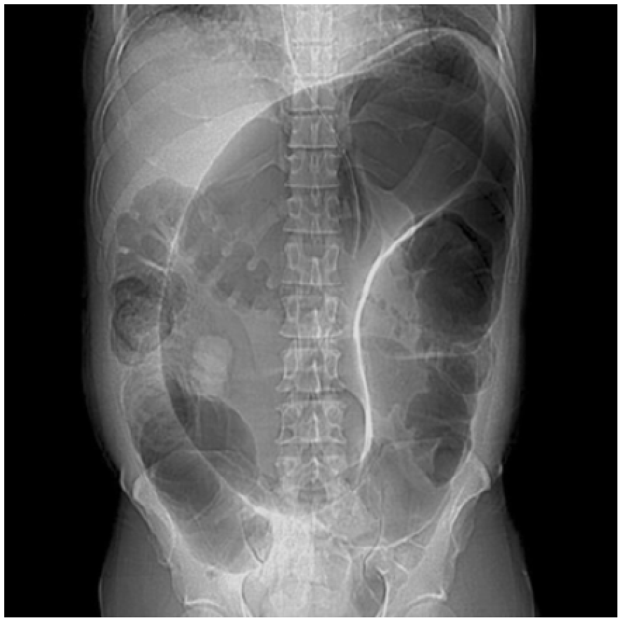

1. Give your diagnosis/diagnoses with supportive Xray findings. (4 marks)

2. List 3 specific treatment options for this patient’s problem. (3 marks)

3. List 2 features of your supportive treatment. Include doses and end-points.
(4 marks)

4. List 3 important considerations in determining your ceiling of care. (3 marks)

SAQ 7

A 2 year old child who has inserted a plastic bead into his right nostril is brought to the emergency department by his mother. The child is not distressed. Part of the bead is visualised high up in the nostril.

a) Describe the 'parental kiss' method for removing the bead, as you would to a parent.

b) List two (2) other methods for removing the bead.
c) You decide you will need sedation to remove the bead. Give three (3) options for sedation, including dosing and an adverse effect.

Drug | Dose | Adverse effects

SAQ 8

A 85 year old woman from a nursing home presents with sudden onset of central abdominal pain radiating through to her back.
Her observations are as follows:
Temp 37.6
PR 110
BP 90/50
GCS 14
Sats 95% on RA

1. List 3 categories of diagnoses and 2 differentials for each
Diagnostic category | Differentials

2. What are your 4 immediate priorities?

3. List 4 investigations and their pros and cons in this setting.
Investigation | Pro | Con

