MH SAQ practice Psych

1. A 60 year old man comes to the ED with his sister. She says he has been withdrawn and quiet lately, and has been saying he wants to die.

a. Give 6 features in assessing his risk of suicide. (6 marks)

b. What are 4 important aspects of the mental health act in the state where you work? (2 marks)

c. How would you ensure this patient could make a decision regarding his treatment? (2 marks)

2. The ambulance service has brought a 23 year old man to your ED. He was found wandering the streets naked. He became aggressive while being transported to hospital.
On arrival to the triage desk, he is swearing loudly and trying to leave.
He is known to have a history of schizophrenia and drug use.

1. Give the 2 legislative principles of care that might allow you to keep this man against his will. For each principle of care, list 2 main conditions that must be met. (6 marks)

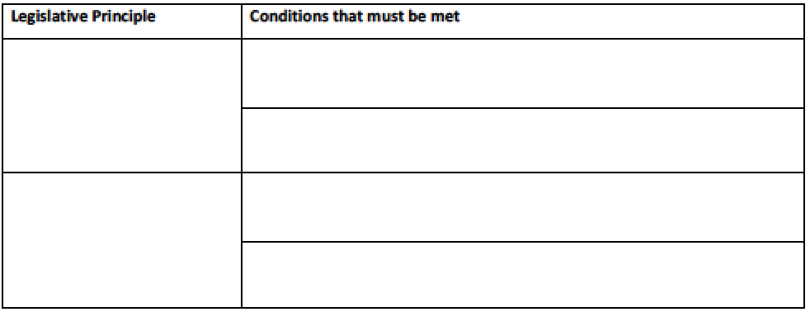

2. List 5 main steps in restraint of this man, in escalating order. Where appropriate, give initial doses of medications. (5 marks)

During the management of this patient, one of your junior doctors has received a needle-stick injury from a hollow-bore needle used on the patient.

3. Complete the table about risk of transmissible disease in this scenario. (3 marks)
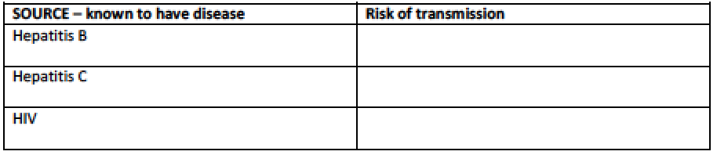

3. A 38 year old man walks up to the triage desk. He is agitated, shouting and uncooperative with simple instructions He is poorly kempt, clammy and tremulous.

- List five differential diagnostic categories you would consider when trying to assess this man?
Give two examples from each category.

Category | Example

- Briefly describe two different strategies for gaining the cooperation of this man?

- List the legal principles that guide your management?

4. A 40 year old man is brought to the Emergency Department after taking an overdose of prescribed medication.

- List seven (7) features on history that indicate a heightened risk for completed suicide.

- Provide a list of investigations which would be completed prior to referral to the psychiatric services including three (3) mandatory tests and four (4) optional tests determined by the details on assessment. Include detail on how the investigations will aid assessment.

Test |  | How test will aid assessment
Mandatory test 1
Mandatory test 2
Mandatory test 3
Optional test 1
Optional test 2
Optional test 3
Optional test 4

- List two (2) absolute and two (2) relative indications for admission.

5. The police bring a 13 year old girl to your emergency department following an argument with her
mother. She is agitated, combative, crying, and has self-inflicted lacerations to both arms. The
mother is en route to the emergency department.

1. What are 5 options for treating her agitation?

2. What 5 features on assessment would indicate a need for inpatient treatment?

3. List 3 ways her age impacts on your management?

6. A 40 year old man presents with suspected acute alcohol withdrawal.

1. What are the 7 features of Delerium Tremens?

2. What 5 important alternative diagnoses should you consider in an alcoholic patient with features of Delerium Tremens?

3. List 5 steps in your treatment of severe acute alcohol withdrawal?

7. A 30 year old known schizophrenic is brought in to the emergency department by police. He is aggressive and has been handcuffed.

1. According to DSM-5 diagnostic criteria, 2 or more of a list of characteristic symptoms must be present for a significant portion of time. List these characteristic symtpoms

2. What 5 factors need to be considered when initially assessing this patient

3. What medication would you use to control this man’s aggression if deemed medically necessary?

- You are about to see a 4 year old child in ED. Name 3 people considered to have parental responsibility (3 marks)

- Name 3 subsets of emergency department patients who might not be able to consent (3 marks)

- You are dealing with a hypotensive 6 year old child who was involved in an accident. Pt has free fluid in the abdomen on FAST scan. You need to urgently transfuse the child but parents are Jehovah witnesses and are opposing transfusion. Name 2 immediate steps you would take in this situation (2 marks)

- What is the legal age of consent in Australia? (1 mark)

- What is the single most important factor that prevents a medical practitioner from legal hassle in an emergency situation? ( 1mark)

