MH SAQ practice paediatrics

SAQ 1

A 3½ year old boy accompanied by mum presents to ED with painful left leg and ongoing limp left leg for last four days. According to mum there is no history of fall or trauma. On examination, he is holding left leg in slight flexion and is unable to weight bear. You decide to do a pelvic X-ray. His observations are:
Pulse 95bpm BP 90/60mmHg RR 22/min Sats 97%air Temp 37.1C

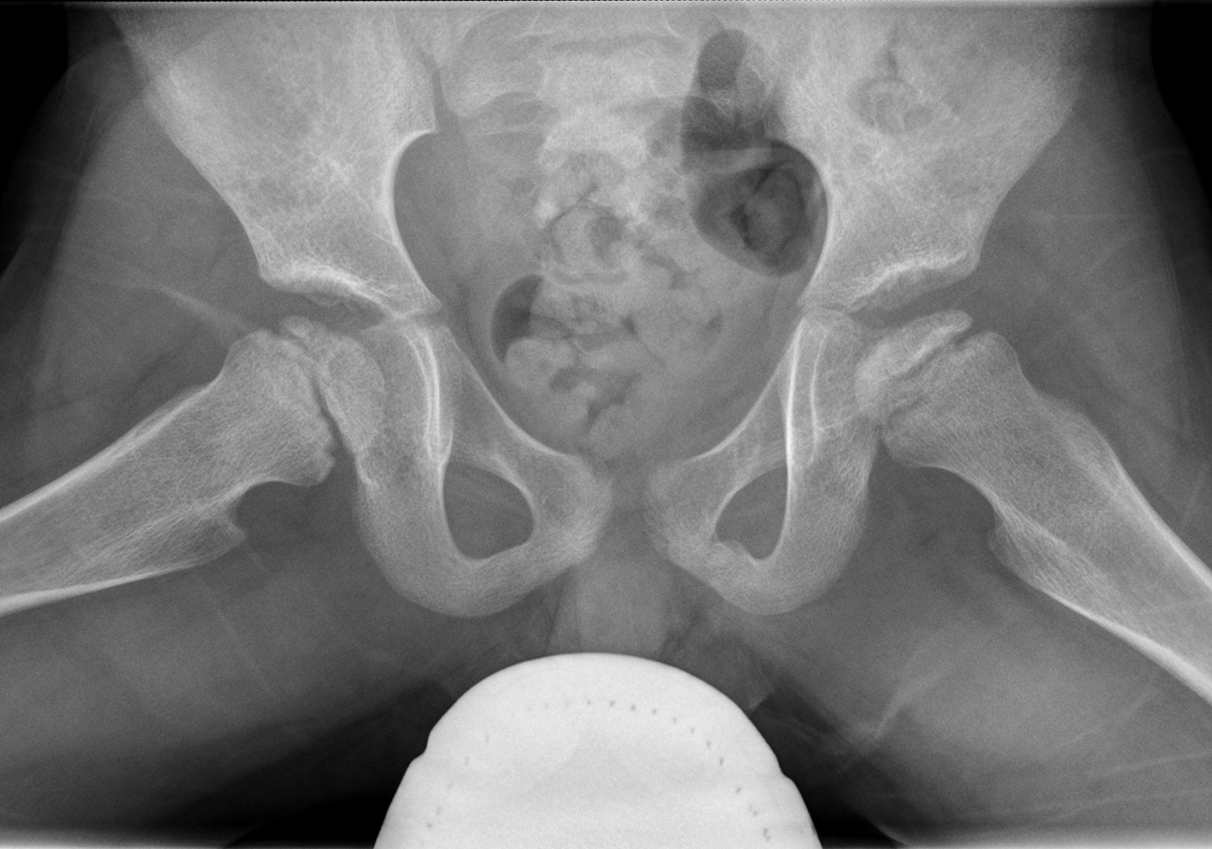

1. Describe the abnormality on the XR (1 mark)

2. What is the most likely diagnosis? (1 mark)

3. List 8 causes of atraumatic limp in a child this age (4 marks)

4. List 4 assessment parameters are the most useful for suspected septic arthritis in a child with a painful hip (4marks)

SAQ 2

The concerned parents of a 2 day old infant present for review at your emergency department. They have noted that there is marked yellowing of the skin. You note that the yellow discolouration extends from the head to the trunk but not to the arms or legs.

1. List 6 differentials you would consider for this neonate. (3 marks)

2. List the most relevant investigations which you would consider in the ED. (5 marks)

3. List the most important steps if the conjugated bilirubin level is greater than 15% of the total (measured level at 15microM/L). What would be the next appropriate investigation and why? (2 marks)

SAQ 3

A 15 month child comes to the ED following a 3 day history of a viral illness with a maculopapular rash. On the day prior to presentation he had bouts of colic but had been eating and drinking and had been otherwise settled.

He comes to the department unwell, with bloody diarrhoea and a capillary refill time of 3 seconds.

This is his abdominal x-ray.

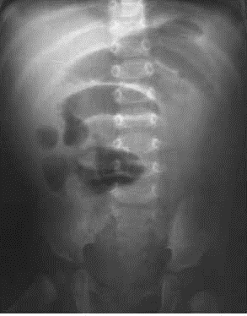

a. What is the likely diagnosis? (2 marks)

b. List 3 predisposing factors. (3 marks)

c. What are the child’s fluid requirements over the next 12 hours? (3 marks)

d. Name 2 treatment options. (2 marks)

SAQ 4

A 3 year old girl attends your department late one night. She has stridor but is alert, and has previously been well.

a. Apart from croup, give 4 differential diagnoses. (2 marks)

b. List 3 drugs, the dose and route of administration used to treat croup. (3 marks)

c. Give 4 aspects of the scoring system to evaluate croup. (4 marks)

d. Give 2 reasons to admit a child with croup. (1 mark)

SAQ 5

A 4 year old boy is brought to your ED having sustained a 4cm eyebrow laceration following a fall at a playground. He is accompanied by his mother.

You plan to suture the wound under procedural sedation using ketamine.

a. List 8 contraindications to ketamine use in this setting. (4 marks)

b. List 4 potential side effects/complications associated with ketamine use in this setting. (2 marks)

c. Complete the following table regarding ketamine usage in paediatric procedural sedation by route of delivery. (4 marks)

 | Intra-muscular (i.m) | Intra-venous (i.v)
Initial dose
Top-up dose
Advantage
Disadvantage

SAQ 6

A 4 year old girl has been brought to your ED with an exacerbation of asthma.

1. List 6 features of your examination that would lead to you concluding that this
exacerbation is life-threatening in severity. (6 marks)

You have assessed the girl to be experiencing a life-threatening exacerbation of asthma.
2. List 5 treatments you would use including doses. (5 marks)

3. List the drugs you would use to facilitate intubation if necessary. Include doses.
(2 marks)

SAQ 7

A 1 year old presents to your ED with a history of a few days of fever and general unwellness.
A picture of his hand is attached.
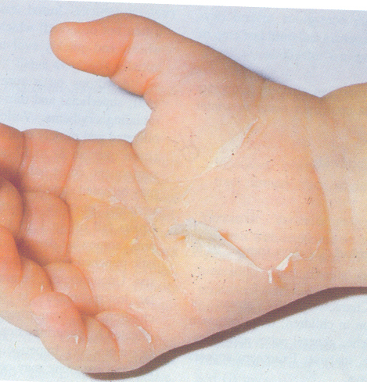

a. List 4 differential diagnoses for this patient. (4 marks)

b. List 4 other features you would look for on examination to support your most likely diagnosis. (4 marks)

c. List possible complications of this condition. (2 marks)
SAQ 8

A 2 year old girl has been brought to your ED with a rash. She has been unwell with fever
for 5 days. She had been seen by her local doctor 2 days ago.
Her rash is shown in the clinical image below.
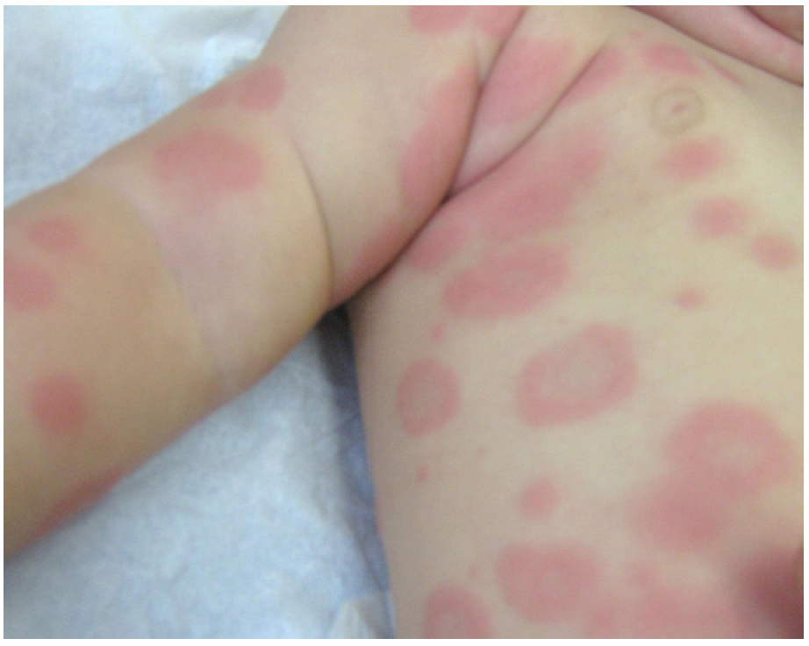
1. In point form, describe the image. (4 marks)

2. Give your diagnosis for the rash. (2 marks)

3. List the 2 most common aetiological groups responsible for this rash, and 4 specific
agents in each group. (6 marks)
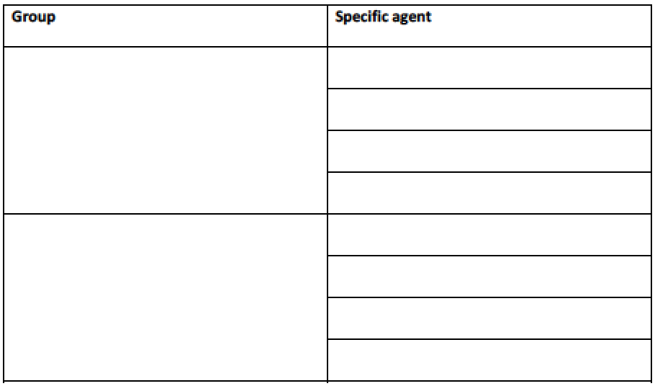

SAQ 9

A young mother has just delivered a baby in your resuscitation cubicle. She was estimated to be 36
weeks gestation. There was no meconium staining of the amniotic fluid.
You are tasked with managing the child.
1. What are the 3 initial assessment features in neonatal resuscitation? (3 marks)

The child is not breathing.
2. What is your initial action? (1 mark)

3. List 4 additional actions you may perform during the resuscitation of this child. For each,
give the indication. (8 marks
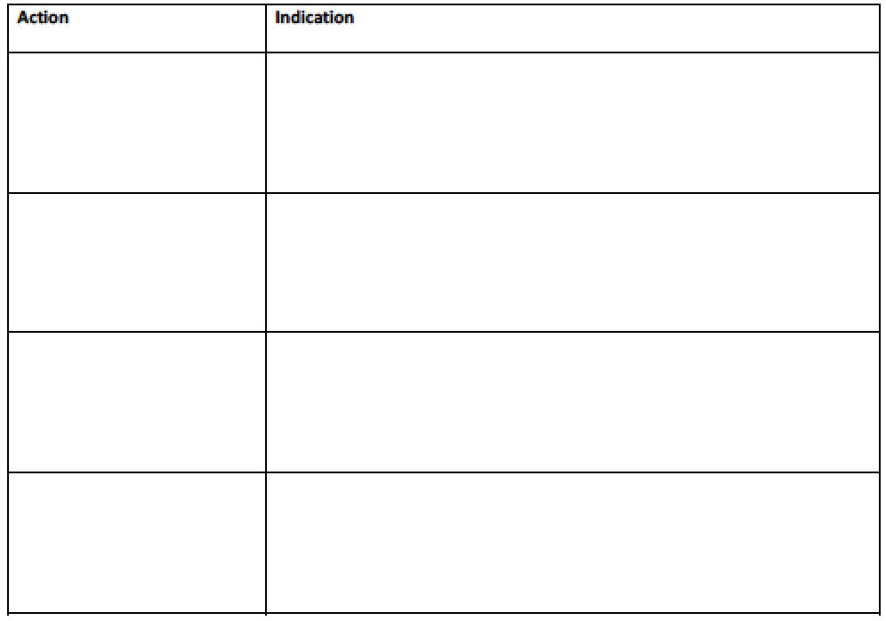

SAQ 10

A three year old child is brought in by her mother in with the presenting complaint of vomiting.
Her initial observations are: Temp 37C, PR 120, normal colour, RR 18, Oxygen saturation 99% R/A, GCS 15, pupils 3mm, briskly reactive.
After 10 minutes in the waiting room the triage notes that she has a staggering gait. You are called to review her in the CIN room.
She is pale and drowsy with generally reduced tone, PR 88, RR 10, pupils 2mm and slightly sluggish.

- Outline 5 essential steps in her resuscitation (20%)

- Apart from ingestions list 4 potential aetiologies for her presentation (20%)

- List 5 potential toxicological aetiologies for this presentation (20%)

- You learn that her mother had given methadone to settle her behaviour. What is your response? (20%)

