MH SAQ practice gen med / specialty med

SAQ 1

A patient attends to the emergency department following an episode of haematemesis. He is tremulous and confused. He has a past history of liver disease and oesophageal varices secondary to chronic alcohol abuse.
He has the following vital signs:

GCS 13 (E4 M6 V3)
HR 125 /min
BP 95/40 mmHg
Temperature 35.5 ºC
O₂ Saturation 99 % on 6L O₂ by Hudson mask

1. Describe 4 steps in your initial resuscitation

2. Describe 2 measures could you use to stabilise the bleeding in the emergency department

3. Name 4 other related medical problems may be present that require treatment in the emergency department?

4. What is your disposition?

SAQ 2

A 60 year old woman presents with a one day history of fever and right arm
discomfort.

Her observations are:
HR 95 /min
BP 120/75 mmHg supine
Temperature 38.5 oC

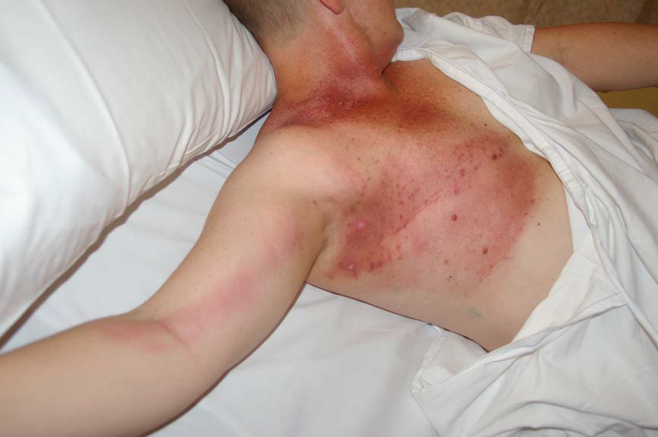

1. What is the most likely diagnosis?

2. What 2 underlying conditions will be contributing?

3. Outline 4 steps in your intial treatment?

4. What is her disposition likely to be?

SAQ 3

A 16 year old woman is brought to the emergency department by her parents who are concerned about her recent loss of weight. She is known to have an eating disorder and currently has a BMI of 15.

1. Name 4 possible disposition destinations?

2. Name 4 features on assessment would mandate an admission to ICU?

3. What criteria would she need to meet to be safely discharged home?

4. Name 5 acute complications of anorexia nervosa?
SAQ 4

A 35 year-old female is brought to the ED by her husband. She has not been feeling well and is becoming irritable, agitated and is constantly sweaty. She is known to have hyperthyroidism and last week underwent surgery. Examination reveals a HR 144 bpm and T 38.4°C.

1. What three clinical features are most relevant to assess for thyroid storm? (3 marks)

2. List 4 specific drugs that would be used to treat this patient and outline their mechanism of action. Provide doses where appropriate. (4 marks)

3. Apart from supportive measures such as ivi fluids, correcting fluid or electrolyte imbalance, external cooling, outline options for refractory thyroid storm (3 marks)

SAQ 5

A 19 year old university student presents to the ED via ambulance. She is confused and has a widespread purpuric rash but no meningism. Her temperature is 38.7°C, HR 140 /min, BP 70/30 mmHg.

a. What is the likely diagnosis? (1 mark)

b. List 4 immediate drug management priorities with doses. (4 marks)

c. What other management needs to be considered? (2 marks)

d. The patient is deteriorating despite aggressive intervention. The parents arrive in the resus room and 5 minutes later the patient has a cardiorespiratory arrest. Outline 3 issues around having the parents present in the resus room. (3 marks)

SAQ 6

A 40 year old male presents with swelling and pain in his right ankle. There is no history of recent trauma.

a. What are 4 major differential diagnoses?

b. What are 4 important features you would enquire about on history?

c. List and justify 4 investigations you would you order.

d. Following full assessment you are confident your patient has an STI. What are your 4 management priorities?

SAQ 7

A 45 year old man presents to the ED with a rash on his palm which is intensely itchy. The SHO thinks it is Scabies. A picture is shown below.
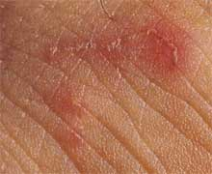

a. Describe 2 features of the rash. (2 marks)

b. Give the Diagnosis and one differential. (2 marks)

c. What causes the itching? (1 mark)

d. What are 2 other features of this condition? (2 marks)

e. What are 2 treatments that could be given to this patient? (2 marks)

f. What further advice would you give to the patient? (1 mark)

SAQ 8

A 34 year old man presents 10 days after a business trip to Papua New Guinea. He has had fevers, malaise, generalised aches and frequent episodes of diarrhoea.

His vital signs are:
HR 130 /min
BP 100/50 mmHg
Temp 38 °C
Sats 98 % on air

a. List 10 potential causes of fever and illness in this man.

b. What blood tests will you request?

Investigation | Justification

c. List 5 major complications of severe Plasmodium falciparum malaria.

d. What are the two main choices for the urgent initial treatment of severe Plasmodium falciparum malaria?

SAQ 9

A 58 year old Chinese Australian woman presents with fatigue. On examination she has a pulse of 95 /min, BP 100/45 mmHg and sats of 98% RA. She is afebrile. She appears deeply jaundiced.

Bloods are done and appear below
FBE. Hb 39
RCC 0.95
MCV 129
Retics 31.58%
WCC 5.4
Neut 4.26
UELFT Na 137
K 3.6
Cl 106
HCO3 17
Urea 4.4
Cr 66
Bili 137
ALT 5
LDH 693
GGT 20
ALP 79

a. Interpret the blood tests and provide a provisional and differential diagnosis. (3 marks)

b. List 3 other pathology tests with a brief justification you would order to help determine the diagnosis. (3 marks)

c. Briefly outline your management. (4 marks)

SAQ 10

A 72 year old man comes in with change in facial appearance and mild headache.

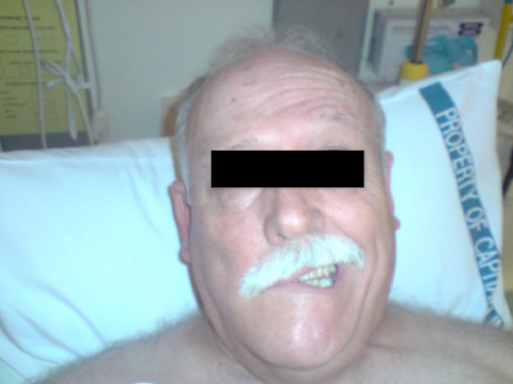

a. What are the key clinical findings from this photo? (2 marks)

b. What is the likely diagnosis with justification? (2 marks)

c. What other findings would you search for on physical exam? (2 marks)

d. Outline your disposition and management plan (4 marks)
SAQ 11

A 50 year old woman presents to ED with a 4 days history of malaise, intermittent fever, and the rash depicted here.

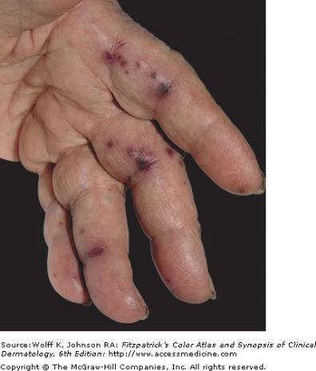

a. Describe this rash. (3 marks)

b. List 4 important examination findings that would be relevant in this case. (4 marks)

c. Name the 4 most relevant investigations that you would perform in the ED. (4 marks)

SAQ 12

A 55 year old woman has been referred to the ED by her GP with a 2 day history of bilateral leg weakness. Her GP suspects Guillain-Barre syndrome.

1. List 6 differential diagnoses for this patient’s weakness. (Do not include GBS) (6 marks)

2. List 3 cardinal features on examination you would expect to find that would be consistent with classical Guillain-Barre syndrome. (3 marks)

3. List 3 investigations that will be useful in supporting the diagnosis of GBS. Include the expected findings. (6 marks)

4. List 2 life-threatening complications of GBS. For each complication, mention how you will detect its presence or severity. (4 marks)

SAQ 13

A 30yo IV drug user is BIBA with acute stridor. En-route he has been given adrenaline 500mcg IM, ventolin and oxygen. He has an IV in place.
He is alert, diaphoretic, and pale, febrile T-38.5C, PR 100SR, BP 120/80, RR 20, Sats 96% R/A. He has impaired mouth opening and abdominal rigidity. He reports feeling unwell and complains of difficulty swallowing and back pain and over the past three days.

- What is your DDx for this presentation? (40%)

- What is the pathophysiology of tetanus (20%)

- What are the priorities in the management of this man with generalized tetanus? (40%)

