MH SAQ practice ECGs – for candidates

SAQ 1

A 35 year old woman presents with palpitations and shortness of breath. On arrival her BP is 70/40 mmHg. An ECG is taken and is shown below.

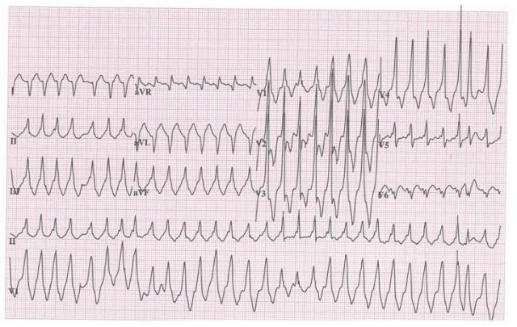
1. What are 5 important features of the ECG?

2. List three possible differential diagnoses.

3. List 5 important steps in your immediate management.

SAQ 2

A 65 year old man is in your ED with a known overdose of Digoxin. An ECG has been performed and is shown below.
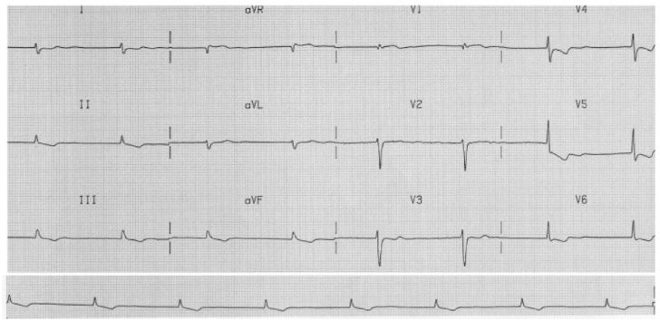

His U+E’s are Na+ 142 mmol/L, K+ 6.7 mmol/L, U50.1, Cr 502.

1. Describe 4 features of the ECG. (4 marks)

2. Give 3 indications for digibind. (3 marks)

3. List 3 other treatments for this patient and give reasons for using them. (3 marks)

SAQ 3

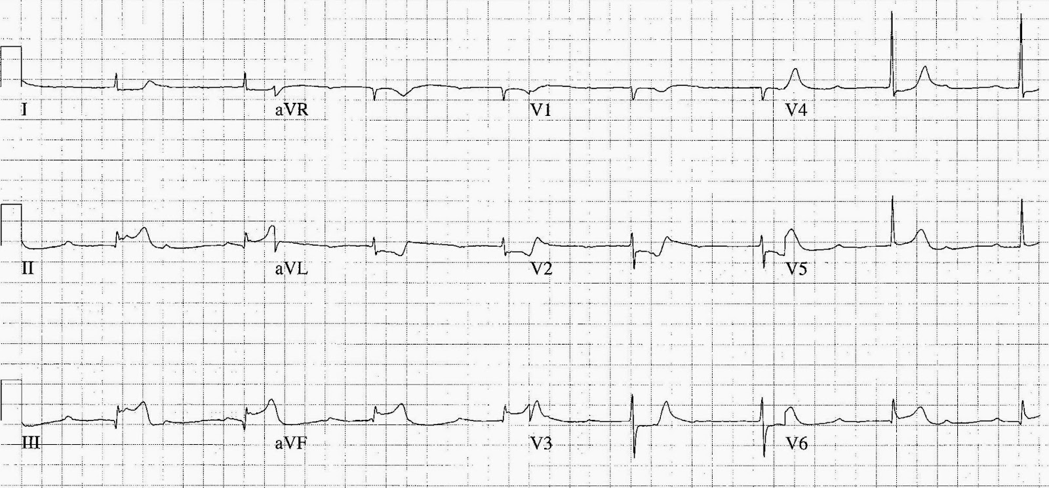
A 60 year old male presents to your ED complaining of chest pain for the last 2 hours. He has no known medication history and does not take any regular medications.

His ECG on arrival is below.

1. What is your interpretation of his ECG? (3 marks)

2. The patient's blood pressure is 80 mmHg. Outline the key steps in managing his hypotension. (4 marks)

3. The cardiology team have advised you to commence the patient on a vasoactive agent to improve his blood pressure. List 3 appropriate inotropes / vasopressors and their dosing in the table below. (3 marks)

 | Agent | Dose
1.
2.
3.

SASQ 4

A 16 year old boy with a congenital heart problem presents to ED with episodes of syncope.

This is his ECG.

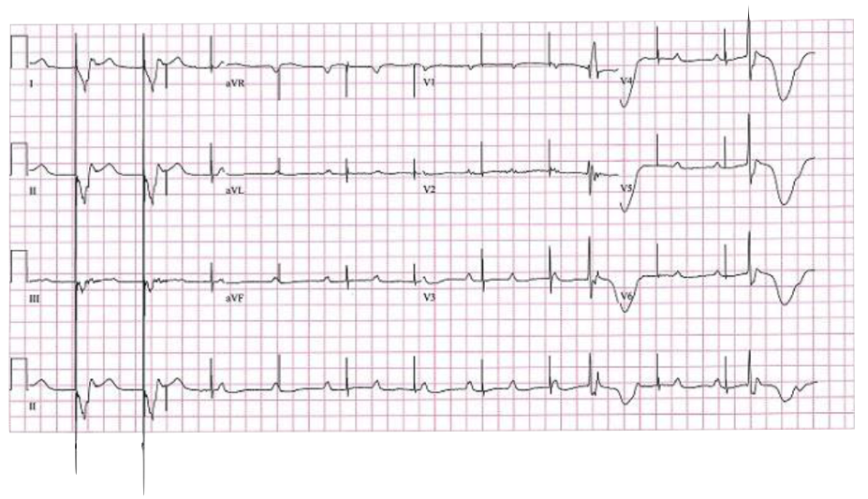

1. Describe the ECG. (5 marks)

2. Name 5 potential causes for this appearance. (5 marks)

SAQ 5

A 3 month old girl is brought in to ED with pallor and lethargy for the past hour. She has had fevers and URTI symptoms for the past 3 days.

Her observations are as follows:
GCS 15/15 but floppy/lethargic
HR 250 /min
BP 75/45 mmHg
CRT 2 seconds
Sat 95 %A
Temp 38.2 °C

This is her ECG.

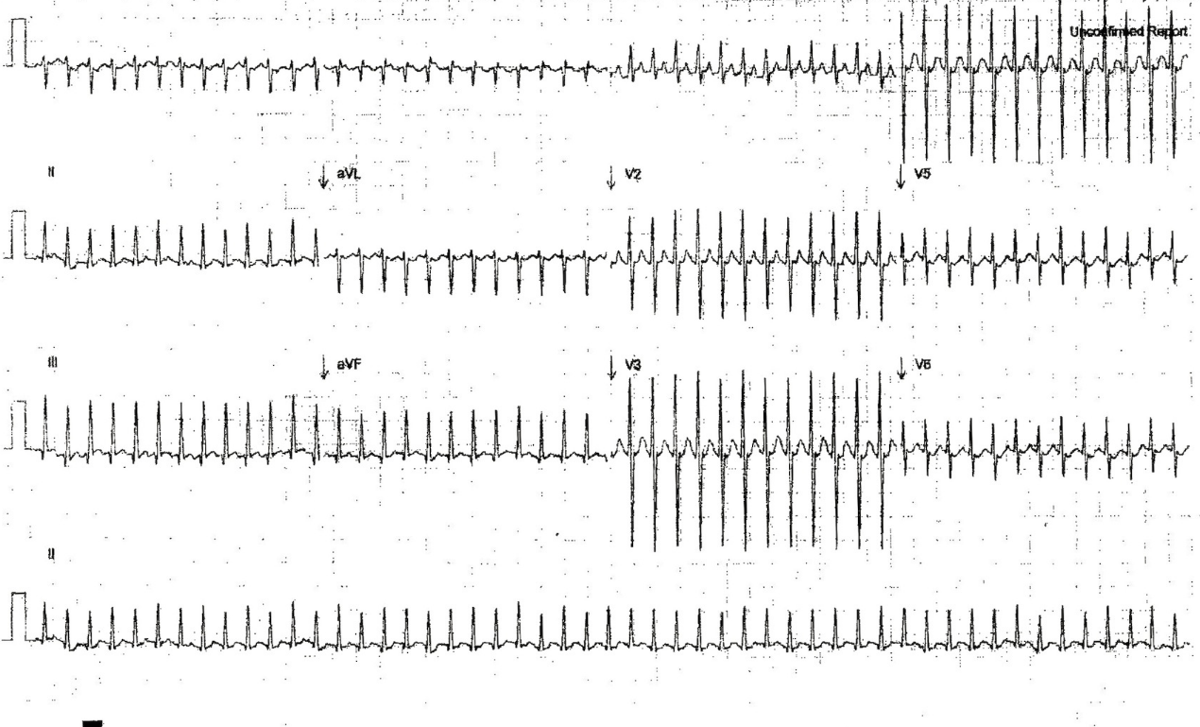

1. What is the most likely diagnosis? (1 mark)

2. What are 2 features of the ECG that support this diagnosis? (2 marks)

3. List 3 treatment options in the order of escalation that you would perform them. (3 marks)

4. List 4 investigations you would perform in the ED and their justification. (4 marks)

SAQ 6

A 48 year old man has been brought to the ED with chest pain and dizziness for the last 1
hour.
His vital signs are:
GCS 14 E4 V4 M6
BP 80/45 mmHg
O2 sats 99% 6L O2 via mask
Temp 36.5 degrees
His ECG is shown below.

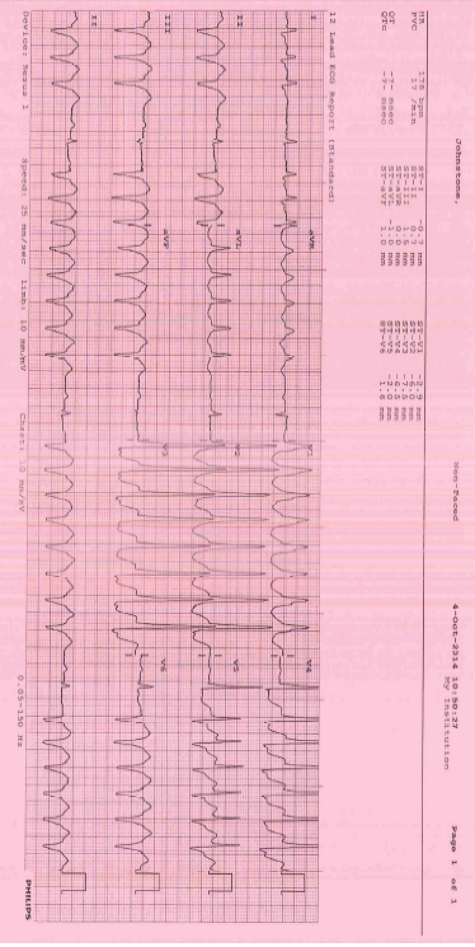
1. What is your diagnosis of the rhythm displayed in the ECG? (1 mark)
_________________________________________________________________________
2. List 3 supportive features from the ECG. (3 marks)
_________________________________________________________________________
_________________________________________________________________________
_________________________________________________________________________
3. List 4 likely causes of this problem. (4 marks)
_________________________________________________________________________
_________________________________________________________________________
_________________________________________________________________________
4. List 3 management steps you will undertake in the ED. Provide doses where
appropriate. (6 marks)
_________________________________________________________________________
_________________________________________________________________________
_________________________________________________________________________
_________________________________________________________________________
_________________________________________________________________________

SAQ 7

A 45 year old man presents with vague symptoms of central dull chest pain and mild shortness of breath on exertion for the past 3 days.

His observations are:

Temperature 37 ºC
BP 120/70 mmHg
RR 18 /min
O₂ saturations 99% on room air

An ECG is taken and is shown on the opposite page

1. Interpret his ECG giving three (3) positive findings.

2. List four (4) differential diagnoses for this appearance on the ECG.

3. List three (3) features on assessment that would determine disposition.

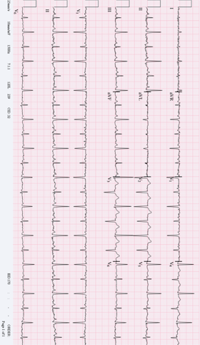

SA 8

A 47 year old lady presented to the emergency department with syncope and altered conscious state. She has a past medical history of hypertension, paroxysmal atrial fibrillation and depression.

Her observations in the emergency department are as follows:
GCS 14 (E3, V5, M6)
BP 60/40 mmHg

An ECG is taken on arrival and shown on the page opposite.

1. Describe her ECG giving three (3) positive and two (2) relevant negative findings

2. Describe four (4) different steps you would take to treat her hypotension.

3. List two (2) pros and two (2) cons of using activated charcoal for this patient.

