Small Group teaching

Dissection and AAA

Case 1
A 75 year old man presents with sharp chest pain that he describes as radiating to his back. He has a BP of 190/100, HR 95, is afebrile and O2 sats 96% RA. He has a history of hypertension but is on no medications. You suspect a diagnosis of aortic dissection
- What features of history would support the diagnosis of acute aortic dissection
- Please describe what features on clinical examination would support the diagnosis of acute aortic dissection
- Please describe what investigations you would perform and justify why you would choose them
- The patient has a CT performed – see below. Please describe the scan.
- Please describe your ongoing management

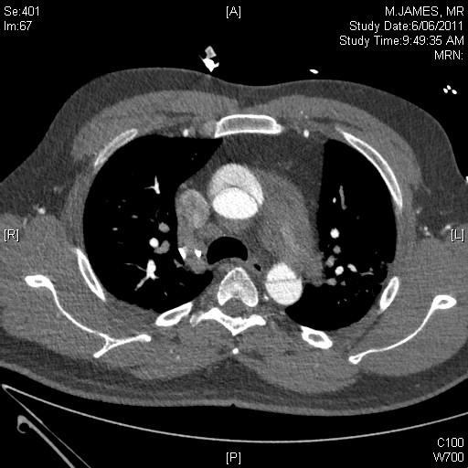

Case 2

A 75 year old female presents to a peripheral hospital with severe abdominal pain through to her back. On assessment she has a BP of 75/40, HR 120 is pale and in obvious distress. She has a tender abdomen but you are unable to appreciate an abdominal mass.
- Please list your differentials
- Please describe your immediate management
- Please describe what investigations you may perform and justify your choice
- Please describe your understanding of hypotensive resuscitation (or low volume resuscitation) and how it potentially applies to this patient
- You manage to perform a CT (see slice below). Please describe the CT
- You are in a peripheral hospital (imagine you are at Casey ED and its 10pm on a Saturday night). Please describe how you would arrange for this patient to get their definitive management. How would this differ if you were at LaTrobe regional hospital?

