Small Group Teaching - Biers Blocks

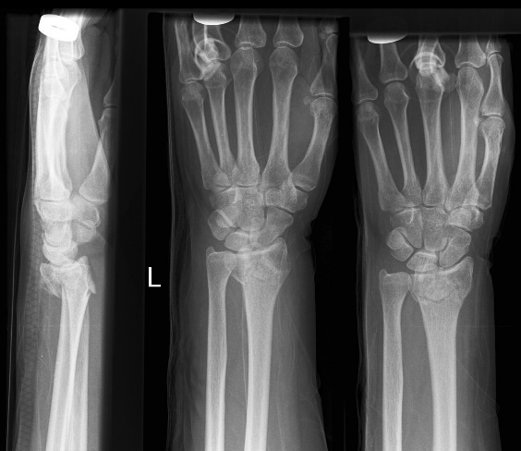
A 76yo woman presents following a simple fall sustaining the following closed, isolated injury. You elect to reduce the fracture under Biers block regional anaesthesia.

- What are the advantages and disadvantages of your choice of procedure?
[Optional SAQ question for exam candidates: “Discuss the options for managing this fracture in the Emergency Department”]

- In what circumstances would a Bier’s block be contraindicated?

- How would you prepare for this procedure?

- As you attempt to manipulate the fracture, but the patient cries out in pain. You have reached the maximal dose of prilocaine recommended for her weight. How would you manage this situation?

- The fracture has been reduced, a below elbow cylindrical plaster has been applied and you are pretty happy with your efforts. You release the tourniquet, she groans and has a generalised convulsion. You look over at the procedure trolley and realise that you have used bupivacaine instead of prilocaine. What is your immediate management, and what issues will you need to address before the end of your shift?

Reading:
http://www.aagbi.org/sites/default/files/la_toxicity_2010_0.pdf
http://edteaching.com/images/stories/videos/biers.mp4
http://www.bestbets.org/bets/bet.php?id=113

