SAQ questions from DEMT Discussion Group: November 2014

Note:
- X-rays, clinical images and ECGs are reproduced in this document without owner’s consent
- There are some questions in the document without model answers
- Items have been briefly reviewed and some typographical errors amended and small changes to increase consistency provided. Detailed quality assurance by the exam sub-committees has not been undertaken.
- If you have any questions about these items please contact mary.lawson@acem.org.au

1. A 19 year old university student presents to the ED via ambulance. She is confused and has a widespread purpuric rash but no meningism. Her temperature is 38.7°C, HR 140 /min, BP 70/30 mmHg.

a. What is the likely diagnosis? (1 mark)

Meningococcal Septicaemia

b. List 4 immediate drug management priorities with doses. (4 marks)

  - Immediate antibiotic administration ceftriaxone 2g IV
  - IV fluids initial bolus 30ml/kg then further 20ml/kg titrated to response
  - Noradrenaline if poor response to fluid bolus 10mg in 100mls at 1-20mls/hr aim MAP >65 (or other reasonable dosing schedule)
  - PPE for staff particularly airway Dr

c. What other management needs to be considered? (2 marks)

  - Prepare for physiologically difficult intubation
  - Public health notification and staff plus contact prophylaxis
  - Treatment of coagulopathy
  - Disposition ICU

d. The patient is deteriorating despite aggressive intervention. The parents arrive in the resus room and 5 minutes later the patient has a cardiorespiratory arrest. Outline 3 issues around having the parents present in the resus room. (3 marks)

Many documented benefits for family: reduced PTSD, helps grief, seeing that everything done, felt supported patient, aids family cohesion/bonding. Negatives are can disrupt the resus and need to be removed, needs a dedicated staff member to look after family.

2. A 23 year old man with known asthma is brought to ED by ambulance with an acute exacerbation.

a. What features on history would concern you that his attack might be severe?

Known brittle, ICU admissions, Frequent steroid courses, significant co-morbidities, known poor compliance

b. What features on examination would suggest he had a severe exacerbation?

Altered LOC, reduced RR, accessory muscle use, quiet chest, signs pneumothorax, signs coinfection, cardiovascular compromise

c. Clinical examination confirms he has had a severe episode. List and justify the investigations you would perform.

CXR, coinfection/pneumothorax, ABG evidence of resp failure or hypercarbia

d. List your immediate treatment priorities.

No model answer provided

3. A 25 year old woman presents to ED after a large wooden plank fell on her left foot. She describes pain in the mid-foot region.

a. What are the three components of the Ottawa foot rules (OFR’s)?

Bone tenderness over navicular or base of 5th MT, Ability to weight bear 4 steps at time of injury and at time of the assessment

b. What are the three exclusion criteria for the application of the OFR’s?

Obvious deformity, suspected hindfoot or forefoot #’s

c. Foot x-rays are taken and reveal an isolated un-displaced fracture of tuberosity of the navicular bone. What are 5 important features of your subsequent management?

Analgesia, Plaster POP (walking). Plaster care/check advice, discharge analgesia, follow up ortho clinic

4. A 40 year old male presents with swelling and pain in his right ankle. There is no history of recent trauma.

a. What are 4 major differential diagnoses?

Septic arthritis, Gout, reactive arthritis (Reiter’s), RA, other sero-negative arthritis, drug induced

b. What are 4 important features you would enquire about on history?

Known rheumatologic disorder, previous Gout, recent STI, diarrhoeal or viral illness. Family history, IBD, Systemic symptoms (fever/chills, sweats, lethargy)

c. List and justify 4 investigations you would you order.

FBC; ? anaemia of chronic disease
ESR and CRP; confirm inflammatory process
HLA B27; ?AS
Rheumatoid factor and ANA rule out other
Joint aspirate can diagnose septic arthritis, gout and pseudo-gout
STI tests
Stool tests confirm recent GI infection
NB; x-rays of little value

d. Following full assessment you are confident your patient has an STI. What are your 4 management priorities?

For arthritis analgesia (typically NSAID’s), Inform patient, medical certificate as required.
For STI’s, AB’s doxycycline 100mg 7 days, azithromycin 1G or similar.
Contact tracing, Advice re unprotected sex, Follow up and retesting.

5. A 17 year old woman presented to ED after taking an overdose. She weighs 50kg and has taken 60 tablets of 300mg aspirin.

Her vital signs are:
HR 110 /min
RR 28 /min
BP 100/60 mmHg
Sats 100 % room air
Temp 36.5 °C

a. What features stratify her as high risk? (2 marks)

Dose > 300mg/kg
Tachypnoea

b. What investigations, apart from an ECG and paracetamol level, would you request? (2 marks)

ABG
Salicylate level
BSL

c. She deteriorates further and requires intubation. What are the specific considerations when intubating patients who have taken an overdose of aspirin? (2 marks)

Avoid acidosis – give Sodium Bicarbonate prior to intubation
Hyperventilate once intubated
Avoid long acting muscle relaxants to monitor for seizure activity

d. What are the indications for haemodialysis? (4 marks)

Unable to maintain urinary alkalinisation
Serum salicylate levels increasing (> 4.4 mmol/L) despite optimal medical treatment
Altered mental status, acidaemia, renal failure
Very high salicylate levels - Acute > 7.2mmol/L, Chronic > 4.4mmol/L

6. A 55 year old woman presents by ambulance. This is her appearance upon arrival in ED:

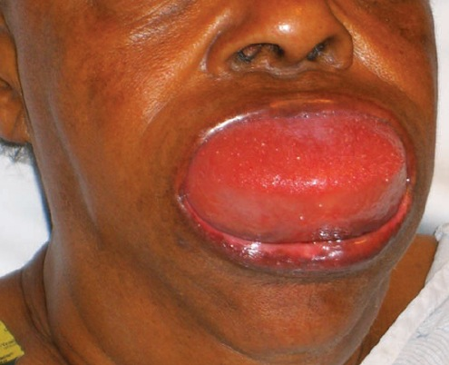

a. List 3 differential diagnoses.

Angioedema, Anaphylaxis, Trauma (haematoma)

b. List 5 features of her medical history that are particularly important to ask about.

Allergy history, medication history, family history of similar events, previous episodes and how managed

c. State your first 5 management steps.

Resus with full monitoring, Adrenaline neb(5mg) and/or IM (.3-.5mg), urgent airway call (anaesthetics/ICU), difficult airway and surgical airway kit at bedside, optimise current airway by positioning, IV access, supplemental O₂ if hypoxia

7. A 35 year old woman presents with palpitations and shortness of breath. On arrival her BP is 70/40 mmHg. An ECG is taken and is shown below.

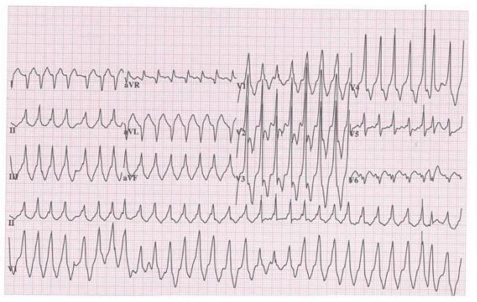
a. What are 5 important features of the ECG?

Rate @ 240, Rhythm irregular (AF),rightward access, Delta waves, / fusion beats in severalleads esp lead 2 and V1

b. List three possible differential diagnoses.

AF RBBB, WPW with aberrancy, VT, Torsades

c. List the important steps in your immediate management.

Resus with full monitoring, supplemetal O2, iV access, fluid bolus, synchronised DC cardioversion 100J with sedation and analgesia

8. The triage nurse rings you regarding a 32 year old with diabetes and bipolar disorder who is a frequent presenter to your ED. She often presents with disruptive behaviour but the nurse is concerned that today she appears disorientated, ataxic and complains of nausea and vomiting for the last two weeks.

Temp 37.4 °C
HR 110 /min
BP 90/60 mmHg
RR 22 /min
Sats 97 % on air

Her lithium level is 3 mmol/L.

a. List 4 potential causes you would consider in this patient that may have resulted in lithium toxicity.

pre-renal impairment: dehydration
pregnancy with hyperemesis
UTI
lithium induced nephrogenic diabetes insipidus
DKA/HHS
drug interaction with impaired renal excretion - NSAIDs
hyponatraemia
acute overdose in the setting of chronic ingestion

b. A urine bHCG confirms pregnancy, and a UTI. List four antibiotics used to treat UTI and discuss why you would or would not use them in pregnancy.

Safe
nitrofurantoin (avoid after 36/40)
amoxycillin (may be resistant, depends on local sens but safe in preg)
trimethoprim (after the first trimester, folic acid antagonist may increase neural tube defects in first trimester)
cephalexin (broad spectrum but safe in pregnancy)

Less optimal
tetracyclines - tooth discolouration
norfloxacin - renal abnormalities
ciprofloxacin - avoid in pregnancy

c. Your 4th year student asks you about the role of charcoal in lithium overdose. You explain that charcoal does not bind lithium. Name 3 classes of drugs seen in overdose that are not bound by charcoal and give two examples of each.

toxic alcohols - methanol, ethylene glycol, isopropyl glycol, ethanol
heavy metals - iron, lead, potassium, mercury, arsenic, cyanide
acids/alkali

d. What alternative enhanced elimination technique may have a role in lithium toxicity?

haemodialysis

e. Name 3 toxicokinetic or toxicodynamic features of a drug that make it amenable or appropriate to this method of enhanced elimination, and 2 other drugs toxicities where the method plays a role.

carbemazepine
toxic alcohols
sodium valproate
theophylline
phenobarbitone
salicyclate
potassium

f. You find on questioning that it is likely she is 16/40 pregnant, homeless and with no regular medical care. List and expand briefly on 4 issues that should be discussed with this woman, including other services that may need to be involved.

pregnancy medical care - obstetric physician input given ongoing need for diabetes control and likely lithium requirement during pregnancy - lithium being teratogenic (tricuspid valve abnormalities)
Tie in with GP
psychiatric care and support during pregnancy - tie in with maternal mental health
maternity care, including scans
social supports - social worker involvement
pregnancy advice - safe behaviours/listeria avoidance/drugs in pregnancy/smoking/alcohol

9. A 35 year old woman who is 30 weeks gestation, is brought to your ED after a witnessed cardiac arrest.

a. What are the leading causes of maternal death in pregnancy? (4 marks)

Pulmonary embolism (thrombus)
Trauma , (homicide, MVA, suicide )
haemorrhage (placental abruption, placenta previa)
maternal cardiac disease ( AMI, peripartum cardiomyopathy, dysrhythmia )

b. List 5 airway and ventilation issues you could anticipate when attempting to intubate this patient. (5 marks)

Increased risk of aspiration – due to decreased lower oesophageal sphincter tone, increased abdominal pressure, decreased gastric emptying.
More oedematous airways – tongue and supraglottic airways oedematous, and more friable (therefore more likely to bleed and swell) (may need to use smaller ETT)
Decreased FRC and increased O2 consumption – develop hypoxia more quickly, less tolerant of apnoeic periods.
Mask ventilation more difficult due to low FRC, elevated diaphragms, and raised intraabdominal pressure.
Obesity relatively common in pregnancy, causing relative neck extension when supine (causing greater anterior placement of larynx). Also shorter neck in obese gravid women
Large breasts, causing difficult larygoscopy
When ventilating, significant respiratory alkalosis should be avoided as this can cause decreased uterine blood flow.

c. What are the indications for a perimortem caesarean section? (1 mark)

Cardiac arrest in mother, gestational age >24 weeks (age of feus in weeks corresponds to the distance in cm from fundus to symphysis pubis from 18-30 weeks ).
Preferably within 5 minutes of arrest, up to 20 minutes – survival of infant directly related to the time elapsed from maternal arrest to delivery. Poorer neurological outcomes for child if performed > 5mins post arrest.
May benefit maternal outcome also – as it removes the aortocaval compression, and decreases abdominal pressure.
CPR should continue during and after the procedure.
Consent not required

d. Outline the steps in performing a perimortem c-section.

  - Make a vertical incision through the abdominal wall from the level of the uterine fundus to the symphysis pubis
  - If available, use retractors to expose the anterior surface of the uterus and retract the bladder inferiorly
  - Use a scalpel to make a small vertical incision through the lower uterine segment
  - Use bandage scissors to extend the incision vertically to the fundus
  - Deliver the infant, suction the nose and mouth, and clamp and cut the cord

10. You are working in the resus room on a patient who is intubated and has capnography attached.

What are four uses/indications of capnography in intubated patients?

Verification of ET tube placement
Titrating ETCO2 levels in patients (eg in patients with increased ICP)
Determining adequacy of ventilation
Continuous monitoring of tube location during transport
Gauging the effectiveness of resuscitation and prognosis during cardiac arrest

11. A 28 year old man presents to the ED complaining of shortness of breath and pleuritic chest pain. His arterial blood gases are as follows:

On Air
pH 7.37
pO2 8.0
pCO2 2.3
BE -2.0

a. Give three investigations, other than D-Dimer, you would perform. (3 marks)

F.B.C., CXr, ECG, CRP

b. At this stage give 4 risk factors as described by the BTS to exclude Pulmonary Embolism. (4 marks)

Surgical- major abdo/pelvic surgery, hip/knee replacement, Post op ICU
Obstetric- puerpurium, late pregnancy, Caesarain Section
Lower limb problems- Fracture, Varicose veins
Malignancy- pelvic or abdominal, disseminated
Reduced mobility- hospitalisation, Institutional care
Others- proven previous VTE

His D-Dimer result returns at 0.2 (normal range <0.14)
c. What 2 management steps would you now make? (2 marks)

Start anticoagulants initially LMH- enoxiparin 1.5 mg/kg OD or 1 mg/kg BD
Arrange definitive investigation- spiral CT chest or CT angio or VQ scan if clear CXr, or pulmonary angio

d. The patient becomes acutely short of breath and hypotensive. What management step would you now take? (1 mark)

Thrombolyse with 50 mg bolus of alteplase

12. A 7 year old child presents to the ED with a 12 hour history of headache and photophobia, but no rash.

Urea and Electrolytes as follows

Na+ 125 mmol/L
K+ 3.7 mmol/L
U 3.2
Cr 51

a. Give 2 possible neurological diagnoses for the symptoms described. (2 marks)

Meningitis, intracranial haemorrhage, Migraine, Encephalitis

b. What is the neurological cause for the Hyponatraemia? (1 mark)

Meningitis

c. What are 2 complications of Hyponatraemia? (2 marks)

Seizure, anorexia, headache, drowsiness, nausea and vomiting, tachycardia and about 10 million others

d. List 5 investigations you would perform in the ED for a patient with Hyponatraemia. (5 marks)

Urinalasis, FBC, U&Es, LFTs, BM/glucose, urine osmolality, ECG, CXr, consider CT head, LP if no signs of raised ICP

13. A 45 year old man presents to the ED with a rash on his palm which is intensely itchy. The SHO thinks it is Scabies. A picture is shown below.
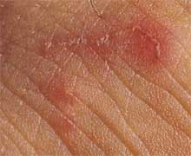

a. Describe 2 features of the rash. (2 marks)

Erythematous linear popular rash suggestive of burrows

b. Give the Diagnosis and one differential. (2 marks)

Diagnosis: Scabies
Differential: Insect bites, dermatitis or psoriasis

c. What causes the itching? (1 mark)

Itch caused by reaction to the faeces, eggs and the mites themselves later during disease

d. What are 2 other features of this condition? (2 marks)

Tends to be worse at night and during winter months, tends to affect multiple household members, if undiagnosed lasts for years (7 year itch), can become superinfected

e. What are 2 treatments that could be given to this patient? (2 marks)

Scabicide – e.g permethrin
Antihistamines- tablets or creams
Steroid cream/ointment- 1% hydrocortisone
Crotamiton- anti pruritic topical

f. What further advice would you give to the patient? (1 mark)

Advise thorough hygiene and treatment of all household members
advise to boil wash all clothing and bedding
See GP if not effective or returns

14. A 65 year old man is in your ED with a known overdose of Digoxin. An ECG has been performed and is shown below.
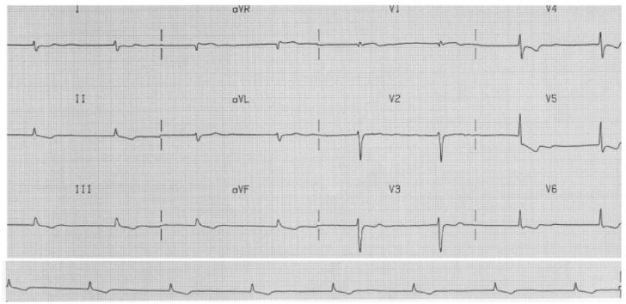

His U+E’s are Na+ 142 mmol/L, K+ 6.7 mmol/L, U50.1, Cr 502.

a. Describe 4 features of the ECG. (4 marks)

Supraventricular bradycardia ? slow AF as no visible p waves, T wave inversion and ST depression inferolaterally, reverse tick sign laterally, prominent u wave laterally,

b. Give 3 indications for digibind. (3 marks)

K+ > 5, digoxin level >15, ingested >10mg, ventricular tachyarrhythmia, haemodynamically unstable bradyarrhythmia, altered mantal status attributable to dig toxicity

c. List 3 other treatments for this patient and give reasons for using them. (3 marks)

Calcium gluconate- 10ml of 10% over 2 min to counteract the hyperkalaemia
Calcium chloride- 5 ml of 10% over 2 min
Salbutamol nebuliser 5ml- increases intracellular K+ reabsorption
Fast acting Insuline 10-15 iu in 500ml of 10% dextrose- increase K+ reabsorbtion
Atropine 0.5 mg up to 3mg to reverse bradycardia
Magnesium in case of torsades de pointes

15. A 30 year old female who works as an accountant and is known to have been depressed for some time is brought to the ED after having been found unresponsive.

An ECG has been taken on arrival and is shown below.
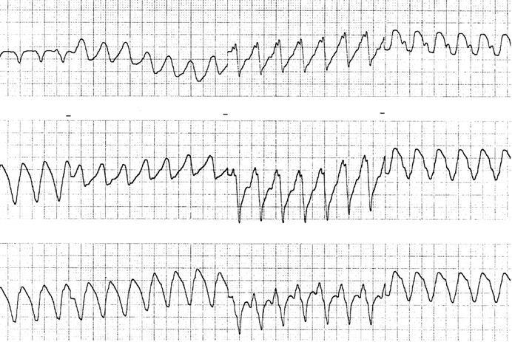

a. Describe the ECG and give the cardiac diagnosis. (2 marks)

Broad complex Tachycardia, regular, most likely Ventricular tachycardia

As you are looking at the ECG the patient has a fit.
b. Given this event, what is the most likely diagnosis for the patient? (1 mark)

Tricyclic overdose

c. What drug would you give and what is it’s mode of action? (2 marks)

Drug: Sodium bicarbonate 1mEQ/kg bolus
Mode of action: Unblocks the sodium channels and might reduce the bioavailability of TCAs by increasing their binding to protein

d. What aspects of the patient’s condition would you monitor after giving this drug? (2 marks)

Monitor pulse, BP, rhythm, mental status, oxygenation

e. Give 4 other actions you would take to manage this patients fitting. (4 marks)

Protect airway- recovery position +/- nasopharyngeal airway, give O2 if not already on, IV lorazepam 0.1 mg/kg, call anaesthetist/ICU, follow the seizure pathway

16. A 65 year old male attends complaining of loss of vision in his left eye.

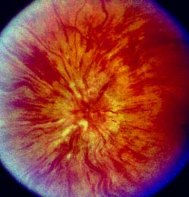

a. Give six features you would enquire about in the history. (3 marks)

Visual acuity
Flashers/floaters/ amaurosis fugax
trauma
headache/temporal pain/ systemic upset
neurological signs or symptoms
eye pain
previous medical history e.g. AF, TIA

b. List 2 abnormalities of the fundus shown in the picture above. (2 marks)

Venous engorgement and widespread haemorrhage. Sunset appearance

c. What is the diagnosis? (2 marks)

Central retinal vein occlusion

d. Give 6 associations of this condition. (3 marks)

Trauma- closed head
Vasculitis
Hypercoaguability states
Hypertension
DM
Alcohol
Glaucoma

17. A 10 year old girl has fallen off a wall and presents with a “sore arm”.

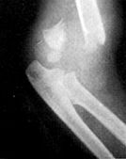
X-ray is shown below.

a. Give 3 features which are required to “clear the neck”. (3 marks)

Pt fully conscious
No evidence of intoxication
No neck pain/ midline tenderness
No neurological deficit
No distracting injury
ROM >45º in all directions
Age < 65

b. Describe the x-ray. (1 mark)

Fracture distal shaft of humerus with posterior displacement

c. What is the diagnosis? (1 mark)

Supracondyla fracture humerus

d. What are 2 potential neurological complications of this injury and how would you test for them? (4 marks)

Median nerve palsy- reduced sensation over the palm, reduced thumb opposition and wrist palmar flexion
Radial nerve – reduced sensation thumb, reduced wrist dorsiflexion

e. Give an example of one other joint injury that can also give rise to nerve injuries. (1 mark)

Shoulder dislocation- axillary nerve
Neck of fibula fracture- peroneal nerve
Knee dislocation- superficial peroaneal nerve
Hip dislocation-
anterior- femoral nerve
Posterior- sciatic nerve
Medial(acetabular)- gluteal nerves
Wrist- median nerve

18. A 38 year old woman 35 weeks pregnant comes to the ED with visual disturbance and headache. Her BP is 165/100 mmHg.

FBC WTU LFT
Hb 8.1 Blood ++ Bil 12
Plt 50 Protein+++ AST 1000
WCC 5.1 Nitrates - GGT 817
poikilocytes seen

a. Describe 2 abnormalities of the FBC and explain them. (2 marks)

Anaemia due to haemolysis
Low platelets due to microangiopathy as part of HELLP syndrome (Haemolysis, elevated liver enzymes and low platelets)

b. What is the likely diagnosis? (2 marks)

Pre eclampsia and HELLP syndrome

c. To control BP what drug, including dose and route, would you use? (3 marks)

Labetalol 10mg IV or 100mg PO
Can use hydralazine 10mg IV

d. Give 3 other steps in the management of this patient. (3 marks)

Call anaesthetist and senior obstetrician.
Magnesium 4-6mg IV
Arrange to deliver baby.
Treat in darkened, quiet room

19. A 28 year old man has been out kite surfing and was thrown into the water at high speed. He is brought in on a spinal board with C-spine protection. He is intubated and ventilated and put on a propofol infusion.

His observations are: Pulse 65 /min, BP 90/60 mmHg and he is warm and well perfused.

The C-spine film and tomogram are shown below.
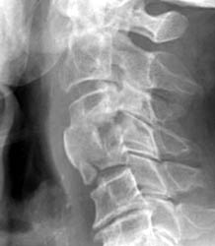

a. Describe 3 abnormalities on the x-ray. (3 marks)

# body C4, loss of space C3-4, probably soft tissue swelling
Burst fracture

b. Describe 2 aspects of his cardiovascular status. (2 marks).

Hypotensive and bradycardic/normocardic

c. What is the likely diagnosis? (2 marks)

Spinal shock

d. What 3 signs would support this? (3 marks)

priapism
Pink, well perfused peripheries,
flaccid paralysis below level C4,
increased tendon jerk reflexes below that level (might be absent initially)
loss of sensation,
very weak respiratory effort,

20. A 42 year old man has been found outside the ED fitting. He is dishevelled and smells strongly of alcohol.

His BM is 2.4

a. What is the definition of status epilepticus? (1 marks)

Status epilepticus is seizure lasting > 30mins or more than one seizure wiith failure to recover between fits.

b. Name 3 steps in managing his fitting. (2 marks)

Treatments: support airway and give high flow oxygen. And check BM
Give 4mg IV lorazepam or 10mg iv diazemuls.
Pabrinex IV replacement and then give 50mls 50% dextrose or 500mls 10% dextrose IV.
May need phenytoin 18mg/kg IV or thiopentone 4-3-5mg/kg.

c. List 3 reasons for organising an urgent CT head on this man.(3 marks)

Reasons for CT. May have intracranial bleed requiring surgery.
May have meningitis.encephalitis and need LP and look for SOL.
Possibility of closed head trauma

d. Give 4 reasons why alcoholics are more prone to fit. (4 marks)

more likely to have head injury with complications. Alcohol withdrawal.
coagulopathy making bleeds worse,
impaired gluconeogenesis causing low BM

21. A 15 month child comes to the ED following a 3 day history of a viral illness with a maculopapular rash. On the day prior to presentation he had bouts of colic but had been eating and drinking and had been otherwise settled.

He comes to the department unwell, with bloody diarrhoea and a capillary refill time of 3 seconds.

This is his abdominal x-ray.

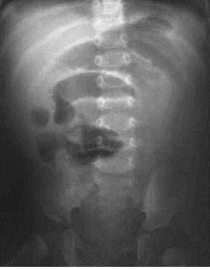

a. What is the likely diagnosis? (2 marks)

Intussusception

b. List 3 predisposing factors. (3 marks)

Vviral illness, cystic fibrosis, benign or malignant bowel tumours- e.g. putz Jeager, Meckel’s, coagulopathies e.g HSP- causing haematomas, sutures and staples, inverted appendiceal stump, Male gender

c. What are the child’s fluid requirements over the next 12 hours? (3 marks)

Fluids- 1yearold= 10kg, 500 ml over 12 hours, keep UO 2ml/h

d. Name 2 treatment options. (2 marks)

Air contrast/hydrostatic enema if large bowel involved,
Surgical

22. A 60 year old man comes to the ED with his sister. She says he has been withdrawn and quiet lately, and has been saying he wants to die.

a. Give 6 features in assessing his risk of suicide. (6 marks)

Sex
Age
Depression- H/O
Previous attempt at suicide
Excessive alcohol/drugs
Rational thinking loss
Separated/divorced/widowed
Organised/serious attempt
No social support
Suicide intent for the future

b. What are 4 important aspects of the mental health act in the state where you work? (2 marks)

No model answer provided

c. How would you ensure this patient could make a decision regarding his treatment? (2 marks)

No model answer provided

23. A man staggers into your department and says that he and many other people have been on a train and were sprayed with a liquid. He then collapses.

a. Other than calling your ED consultant, give 4 actions you would take to manage the situation. (3 marks)

1. Isolate the pt- undress and destroy clothes, thoroughly wash- all done in protective gear
2. inform unit/hospital manager
3. declare major incident standby,
4. contact police to corroborate story
inform ambulance control,

b. Give 4 muscarinic effects of organophosphate poisoning. (4 marks)

Diarrhoea
Urination
Miosis
Bronchospasm
Emesis
Lacrimation
Salivation
Piloerection

c. Give 3 drugs to treat organophosphate poisoning.

Diazepam- 10mg IV, or another benzodiazepine
Atropine- large doses may require 20mg or more infusion
Pralidoxime- specific antidote to organophosphate poisoning

24. A 3 year old girl attends your department late one night. She has stridor but is alert, and has previously been well.

a. Apart from croup, give 4 differential diagnoses. (2 marks)

1. inhaled foreign body
2. epiglotitis
3. angiooedema
4. tracheitis.

b. List 3 drugs, the dose and route of administration used to treat croup. (3 marks)

1. dexamethasone 0.15-0.6mg/kg,
2. prednisolone 1-2mg/kg,
3. budesonide 1-2mg nebulised,
adrenailne 5mls 1:1000 neb.

c. Give 4 aspects of the scoring system to evaluate croup. (4 marks)

1. recession
2. stridor
3. air entry
4. cyanosis

mental state

d. Give 2 reasons to admit a child with croup. (1 mark)

1. croup score > 2
2. no response to treatment
parental anxiety. late at night as croup tends to get worse overnight.

25. A 35 year old male attends your department. His partner is HIV positive and being treated for TB.

Blood gases on 60% oxygen show:
pH 7.44
pCO2 4.0 Kpa (30mmHg)
pO2 16.5 Kpa (124mmHg)
Bicarb 22 mmol/L
Base Excess -1

Chest x-ray is shown below.
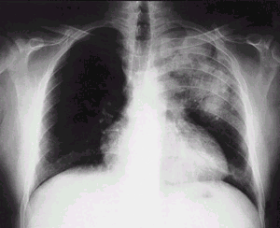

a. Describe the chest x-ray. (2 marks)

PA erect CXr- Patchy consolidation in the L upper zone

b. Excluding TB, give 2 differentials diagnoses. (2 marks)

Left upper lobe pneumonia
Aspergilosis
Pneumocystis
Psitticosis
Pneumonitis- viral

c. List 3 organisms that may infect the pulmonary system in HIV. (3 marks)

Staphylococcus Aureus, a, Pneumocystis Cariniae, Aspergillous, Streptococcus pneumoniae, Legionell, Haemophylus- you name it it’ll do it

d. Give 6 tests in the ED which would help in the management of this patient. (3 marks)

FBC, U&Es, CRP, Glucose, CD4 count, pulse oximetry, ABGs (sigh), BP

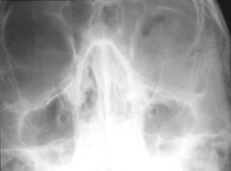
26. A 24 year old male had been assaulted. He has swelling around his LEFT eye and a cut on his RIGHT cheek. Your SHO has requested facial views.

a. Give 3 abnormalities on the x-ray. (3 marks)

left, ? orbital floor fracture. ? fluid level in left antrum.

b. List six aspects of assessment of the orbit and its contents. (4 marks)

Visual acuity. pupil response, anterior chamber/lens and fundus. eye movements, infraorbital nerve function. proptosis and enophthalmos, subcut emphysema.

c. List 3 further steps in this patient’s management. (3 marks)

discus with max fax,
advice re nose blowing.
return immediately if decreased vision or pain on eye movements
Analgesia- eg 800 mg ibuprofen TDS
advice to avoid flying/pressurined areas
commence on ABX

27. A 35 year old man is flown in by air ambulance after being found unconscious in a remote area of bushland in winter. He is in asystole and the ambulance officers are currently performing CPR. His Temp is 28.6°C.

a. What is the current advanced life support algorithm? (3 marks)
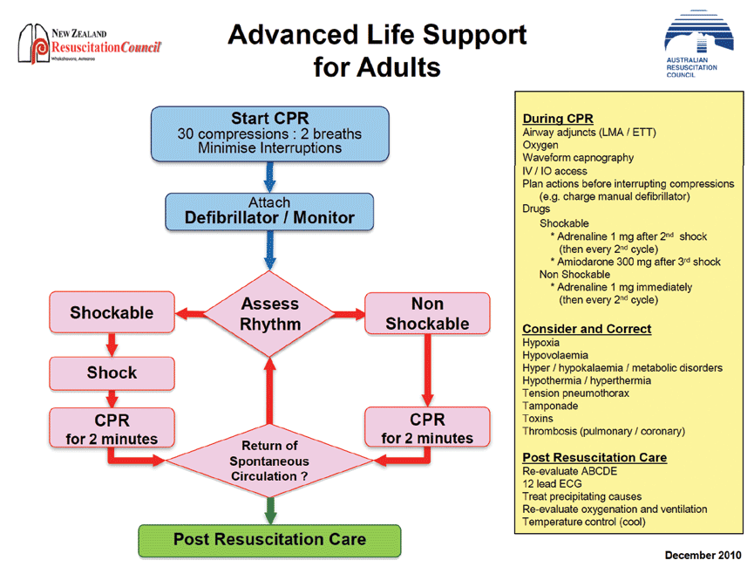

- Detail in yellow box:
  - Need Adrenaline doses
  - Reversible causes

b. What are the major modifications needed to be made to this algorithm in the case of unintentional (environmental) hypothermia? (3 marks)

- Start and continue ALS until patient is rewarmed (Temp ≥ 32°C) unless other obvious lethal injuries present
- Withhold drugs until temp ≥ 30° C then double interval between giving drugs until temp ≥32°C
- Can defibrillate initially 3 x if in VF/VT but then cause (as no effect) until temp ≥30°C
- Main therapy is re-warming

c. Name 2 methods of each:
- Passive external rewarming
- Active external rewarming
4 marks (2 each)

- Passive external rewarming
- Warm environment
- Remove wet clothes and dry patient
- Insulation blankets
- Warm blankets
- Active external rewarming
- Warmed and humidified air/O2
- Warm forced air blanket
- Heat packs to torso/armpits/groin

d. Describe 3 methods of active internal rewarming (3 marks; includes at least 1 method of lavage)

- Warmed IV fluids (43°C) – 1-1.5°C/hr
- Lavage
  - Gastric – NGT warmed fluid
  - Bladder – IDC warmed fluid
  - Peritoneal – warmed fluid in/out peritoneal cavity
  - Pleural – warmed fluid in/out of pleural cavity same side; one ICC upper chest, one lower
- Extracorporeal warming – ECMO 8-12°C/hr

28. A 25 year old man sustains facial injuries in a high speed motor vehicle crash in which he was the unrestrained driver.
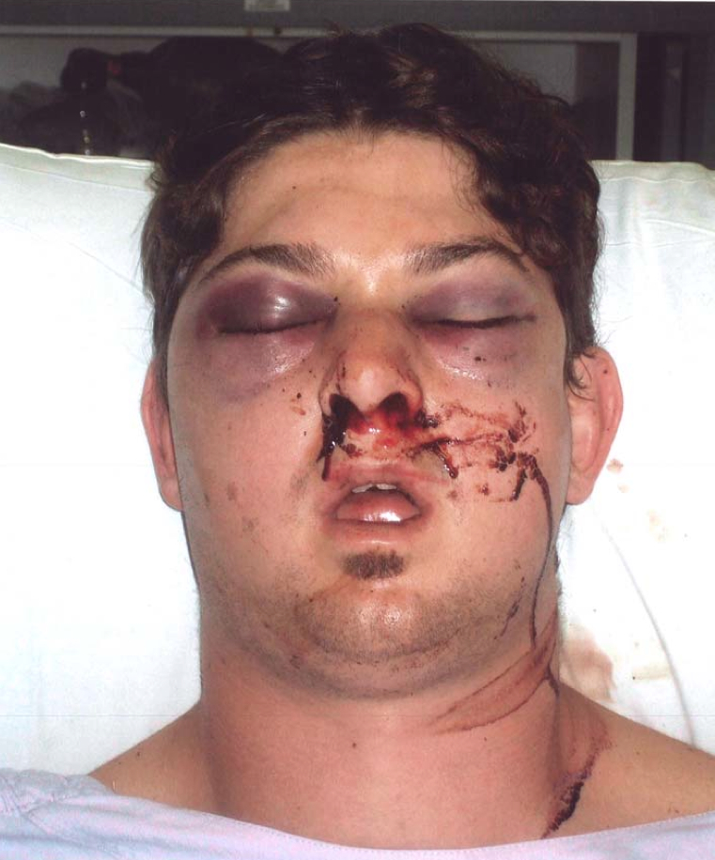

His observations are:
GCS 15
HR 100 /min
BP 130/75 mmHg supine
O₂ sat 97 % room air

a. Describe 3 abnormalities shown in this photograph. (3 marks)
- Periorbital bruising bilaterally
- Facial swelling especially over the right zygoma
- Haemoserous nasal discharge
- Possible swollen tongue
- Chipped right upper incisor

b. What 3 underlying injuries could there be? (3 marks)
- Facial bone fractures
- Mandibular fracture
- Base of skull fractures
- Intracranial haemorrhage

b. List 5 factors that provide a risk to his airway? (5 marks)
- Swollen tongue – haematoma
- Direct trauma to airway
- ICH causing depressed GCS
- Blood loss into airway from facial fractures
- Mandibular fracture
- Small mouth
- Bull neck

29. a. List 4 indications for endotracheal intubation. (4 marks)

To create and airway
To maintain an airway
To protect an airway
To provide for mechanical ventilation

From Cameron, Textbook Adult Emergency Medicine 2009, p 20

b. List 2 indications for non-invasive ventilation. (1 mark)

Acute pulmonary oedema
Respiratory failure (will accept COPD as alternative)

Cameron, p21

c. List 4 contra-indications to NIV. (2 marks)

Coma
Combative patient
Inability to tolerate tight-fitting mask
Lack of trained staff to institute and monitor NIV

d. What is the mechanism of action of NIV? (3 marks)

Controlled FiO2 at set positive pressure –
Recruits alveoli that were closed improving VQ match
Increases pulmonary compliance, decreasing work of breathing

30. A 65 year old male presents following a fall. He complains of a painful swollen left wrist.

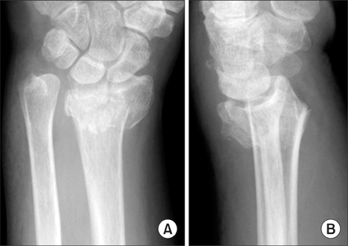
An x-ray of his wrist is shown below.

a. Describe his x-ray. (2 marks)

Intra-articular fracture of the distal radius with dorsal angulation

1 mark for intra-articular fracture distal radius
1 mark for dorsal angulation

No marks given for Colles fracture

b. List the contra-indications to performing a Bier's block. (4 marks)

1/2 mark each to maximum of 4 marks from:
Refusal of procedure
Uncooperative patient
Compromised limb circulation
Compartment syndrome of affected limb
Sickle cell disease
Ipsilateral # humerus
LA Sensitivity / allergy
Staff / area / equipment unavailable

Soft tissue injury at tourniquet site
Age <10 / Paediatric patient
Peripheral vascular disease / Raynauds
Systolic >200mmHg
Severe liver disease
Unstable epilepsy
Unable to gain bilateral iv access

Taken from Dunn Emergency Medicine Manual 5th Edition Volume 1 Chp 9 Page 159 and Cameron Textbook of Adult Emergency Medicine 3rd Edition Chpt 22.2 Pg 701

c. List the key steps in performing a Bier's block. (4 marks)

1/2 mark each for:
1. Consent - ideally written
2. Area / staff / monitoring
3. Bilateral iv access - no marks if only iv access mentioned must specify bilateral
4. Check equipment
5. Inflate cuff - ideally answer should state >100mmHg above systolic
6. Injection of local anaesthetic - prilocaine ideally but accept lignocaine (as per Dunn & Tintinalli)
7.Perform procedure - MUA wrist
8.Deflate cuff / post-procedural monitoring

Taken from Dunn Emergency Medicine Manual 5th Edition Volume 1 Chp 9 Page 159

31. A 4 year old boy is brought to your ED having sustained a 4cm eyebrow laceration following a fall at a playground. He is accompanied by his mother.

You plan to suture the wound under procedural sedation using ketamine.

a. List 8 contraindications to ketamine use in this setting. (4 marks)

1/2 mark each up to 4 marks from the following:
Parental refusal
Procedural required unsuitable for ketamine sedation
Inadequate staffing / area / equipment
Previous adverse reaction to Ketamine
Altered conscious state
Unstable patient: seizures, vomiting, hypotension
Cardiovascular disease - heart failure, uncontrolled hypertension, congenital heart disease
Procedures involving stimulation of posterior pharynx
Known airway instability or tracheal abnormality
Psychosis
Thyroid disorder or medication
Porphyria
Risk of raised intraocular or intracranial pressure
Active pulmonary infection or disease including acute asthma and URTI
Full meal within 3 hours (relative contraindication only, balance risk against urgency of procedure)

b. List 4 potential side effects/complications associated with ketamine use in this setting. (2 marks)

1/2 mark each up to 2 marks from the following:
Airway obstruction
Nystagmus
Muscle rigidity
Random movements (can resemble seizure like activity)
Vomiting (during or after procedure)
Emergence phenomena
Apnoea
Failed procedure (need for a General Anaesthesia)
Hypersalivation

c. Complete the following table regarding ketamine usage in paediatric procedural sedation by route of delivery. (4 marks)

1/2 mark for each correctly completed table cell - only 1 example for advantage / disadvantage by route required for mark - longer list of acceptable answers re: adv/disad examples only in table

 | Intra-muscular (i.m) | Intra-venous (i.v)
Initial dose | 4 mg/kg | 1 - 1.5 mg/kg
Top-up dose | 2 mg/kg | 0.5 mg/kg
Advantage | Nil iv required, as safe as iv  Longer action etc. | More predictable, easier top-up, quicker onset etc.
Disadvantage | Pain / distress on injection, less predictable etc. | iv line required, quicker offset etc.

All answers taken from PMH Emergency Department guideline on Ketamine Sedation

32. a. What patient factors may make rapid sequence intubation difficult or impossible? (3 marks)

Upper airway obstruction
Distorted facial or neck anatomy (congenital or acquired)
Poor cervical mobility (acute or chronic)

b. What alternatives should be considered in these cases? (2 marks)

Awake fibre-optic intubation under local anaesthetic
Awake surgical airway (cricothyroidotomy or tracheostomy)

c. List the steps of preparation for rapid sequence induction. (5 marks)

Staff – assemble skilled team, call for expert help if required (anaesthetics/ENT)

Equipment – appropriate size laryngoscope, ETT, syringe, tape, suction, oxygen, airway adjuncts and rescue plan for can’t intubate/can’t ventilate,

Drugs – induction and paralysis agents, pressor, IV fluids with multiple, secure access.

Patient – assess airway and C-spine, fasting status, allergies, medications; pre-oxygenate, optimise position

Monitoring – continuous ECG monitoring, pulse oximetry, BP monitoring and end-tidal CO2 monitor

33. a. Name 2 indications for electrical defibrillation. (2 marks)

VF
Pulseless VT

b. Name 2 areas to avoid placement of pad. (2 marks)

Areas to avoid- ecg electrodes
Medication patches
Breast tissue
Implanted pacemaker/ICD (at least 12-15 cm away)
(any two)

c. Name 4 complications of defibrillation. (4 marks)

- Skin burns
- Myocardial injury and post defibrillation arrhythmias
- Skeletal muscle injury /thoracic vertebral fracture
- Electrical injury to the health care provider

d. How will you optimise transthoracic impedance while using a defibrillator for an adult patient? (2 marks)

- Use pads 10-13 cm in diameter
- Use conductive pads or electrode gels
- Perform defibrillation when the chest is deflated(during expiration)
- Apply pressure of 5kg for manual defib pads

34.a. Name composition of normal saline and Ringer’s lactate. (2 marks)

Normal Saline – Sodium 154 mmol,CL 154, K+ 0, Ca++ 0
Hartmann’s – Sodium 131mmol, Chloride 111mmol, K+ 5mmol, Ca++ 2 mmol, Lactate 29mmol

b. What are the targets to titrate fluid therapy? (4 marks)

Any 4 from the following –
Physiological – SBP 90, MAP > 65mmHg, HR <100
Perfusion – UOP > 0.5ml/kg/hour, Lactate <2mmol, resolving base deficit, Cap refill < 4s
Invasive measurement – CI >2.5 L/min/m2, PAOP > 15 mmHg.

c. What are the complications of fluid therapy? (4 marks)

Any 4 from the following -
Hypothermia after large volumes of fluid therapy
Coagulopathy due to dilution
Tissue oedema – limb and abdominal compartment syndrome
Pulmonary oedema
Hyperchloraemic acidosis with NS
Anaphylaxis to synthetic colloids /blood transfusion

35. A 60 year old male presents to your ED complaining of chest pain for the last 2 hours. He has no known medication history and does not take any regular medications.

His ECG on arrival is below.
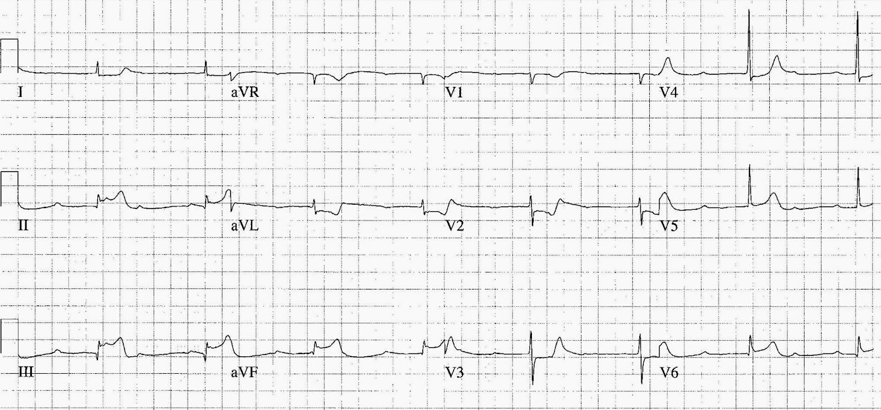
a. What is your interpretation of his ECG? (3 marks)

Inferior STEMI – (1 mark)
Complete heart block – (1 mark)

1 mark for any of:
Possible RV involvement (STE III>II)
Possible posterior involvement (Flat ST depression V2-3)
Bradycardia

b. The patient's blood pressure is 80 mmHg. Outline the key steps in managing his hypotension. (4 marks)

Main priority revascularisation - angioplasty / thrombolysis – (1 mark)
Cautious fluid bolus -must acknowledge risk of pulm odema or use bolus <500ml –(1 mark)

1 mark each for any two of:
Atropine - likely to be ineffective
Avoid / cease GTN
Transcutaneous pacing
Inotropes as listed below only
IABP - only acceptable if preceded by revascularisation

c. The cardiology team have advised you to commence the patient on a vasoactive agent to improve his blood pressure. List 3 appropriate inotropes / vasopressors and their dosing in the table below. (3 marks)

 | Agent | Dose
1. | Dopamine | 3-5 mcg/kg/min to maximum of 20-50 mcg/kg/min
2. | Dobutamine | 2-5 mcg/kg/min to maximum of 20 mcg/kg/min
3. | Noradrenaline | 2 mcg/min up titrate to response

1/2 mark for each correctly completed box.

Taken from Tintinalli's Emergency Medicine 7th Edition Chapter 54 Table 54-5 Pg 388 with Milrinone excluded.

Consistent with management advice in Dunn Emergency Medicine Manual 5th Edition Vol 1 Chpt 28 Pg 440

36. A 40 year old female is brought to your ED following a 2.5g propranolol overdose taken 3 hours ago.

Vital signs:
Pulse 45 /min
BP 82/45 mmHg
RR 16 /min
Temp 36.8 ºC
GCS 13 (E=3, V=4, M=6)
BSL 6.7 mmol/L

a. Outline a step-wise approach to the patient's bradycardia and hypotension? (4 marks)

1 mark each up to 4 marks for each of in a logical order, note HDI may be appropriately commenced very early in the algorithm without penalty

Fluid bolus 10-20 ml/kg
Atropine 100-300mcg iv repeat if response
Isoprenaline infusion
Adrenaline infusion
High Dose Insulin Infusion
Intra-lipid - on toxicology advice only
Pacing - External
Pacing - Transvenous
ECMO

b. Clinical toxicology have been consulted and advised you to commence HDI therapy. How is HDI administered? (4 marks)

1 mark for each of:
Loading dose of glucose 25g (50ml of 50% dextrose) iv bolus
Loading dose of insulin 1IU/kg iv bolus
Infusion of glucose 25g (50ml of 50% dextrose) per hour
Infusion of insulin 0.5IU/kg per hour, may up titrate to effect

c. What are the potential complications associated with HDI therapy? (2 marks)
1 mark for each of:
Hypoglycaemia
Hypokalaemia

Answers taken from Murray et al. Toxicology Handbook 2nd Edition. Section 3.15 Beta-blocker pg 168-170. Section 4.14 Insulin (high-dose) pg398-399.

37. A 72 year old diabetic female is brought to your Emergency Department by ambulance. She complains of feel generally unwell for the last two days with abdominal pain, cough and fevers.

Vitals signs:
Pulse 121 /min
BP 89/58 mmHg
RR 28 /min
Sats 89 % Room Air
Temp 39.8 ºC

a. List 3 key steps in this patient’s management. (3 marks)

Resuscitation - 1/2 mark
Screening / diagnosis e.g. blood cultures / biochemistry etc. - 1/2 mark
Antibiotics - broad spectrum cover required - 1 mark
1/2 mark each for any two of:
Source Control
Monitoring
Disposition
Boundary of Care

b. List your resuscitation goals for the first 6 hours. (4 marks)

1 mark each up to 4 marks from:
CVP 8-12 mmHg
MAP >65 mmHg
Urine output >0.5ml/kg/hr
Central venous sats >70% or mixed venous sats >65%
Lactate clearance

c. The patient requires inotropic haemodynamic support. Which inotrope should be used? (1 mark)
Noradrenaline - 1 mark
d. The patient is intubated for respiratory failure. List the four key components of your ventilation strategy for this patient? (2 marks)
1/2 mark for each of :
Tidal volume 6ml/kg
Plateau pressure <30 cm H₂O
PEEP Titrated to FiO₂ Minimum 5 cm H₂O - Maximum 24 cm H₂0
FiO₂ Titrated to Sats 88-95% or PaO₂ 55-80 mmHg

Answers taken from Surviving Sepsis Campaign International Guideline for Management of Severe Sepsis and Septic Shock 2012 and ARDSnet NIH NHLBI ARDS Clinical Network Mechanical Ventilation Protocol Summary

38. A 16 year old boy with a congenital heart problem presents to ED with episodes of syncope.

This is his ECG.

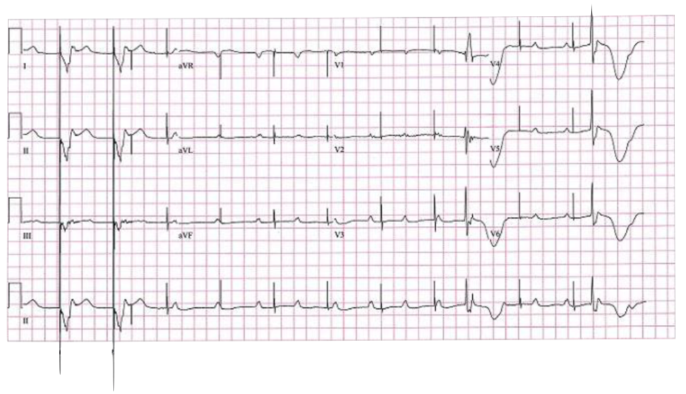

a. Describe the ECG. (5 marks)

Paced rhythm rate 75 bpm
Loss of capture
Period of ventricular standstill
Occasional ventricular ectopic/escape beats
P waves rate 75 – 100 bpm, complete heart block

b. Name 5 potential causes for this appearance. (5 marks)

Lead breakage or displacement causing pacemaker failure
Fibrosis causing pacemaker failure
Electrolyte abnormality
Toxicological causes – Ca channel/B blocker/digoxin toxicity
Failure to capture/needs check of threshold for capture

Source: Fellowship VAQ 2013.1

39. A 46 year old man is brought to your ED by ambulance following an overdose of unknown medications. He had a brief generalised seizure en route.

On arrival his observations are:

GCS 12
BP 85/60 mmHg
Temp 37.0 °C
O₂ Saturation 100 % on 8 L/min O₂

His ECG is shown below.
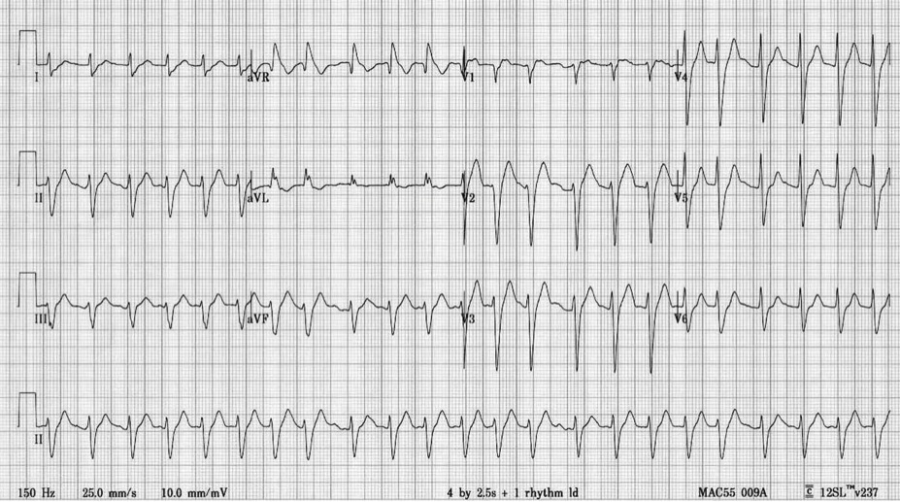

a. Describe the ECG. (5 marks)

    - Rate 150, Axis normal, Rhythm irregular broad complex tachycardia, R Prime AVR ,
    - Interpretation – consistent with Na Channel Blockade
    - QRS upper limit or slightly prolonged,
    - QT almost half the RR along with examples gave extra marks

b. What are the first 5 things you would do to manage the patient?

Mx in resus area, team approach, delegate care of rest of department
treatment with NaHCo3 (50 ml 8.4%, repeat to achieve pH 7.5 and QRS <120ms)
Fluid Mx for hypotension (1litre 0.9% NaCl stat and repeat if necessary to achieve MAP > 65mmHg)
Benzodiazepines for seizures (appropriate dose for agent chosen)
RSI and ventilation to low normal CO2

40. An elderly man collapses and is unresponsive at a shopping centre.

He receives prompt BLS from bystanders, then defibrillation from an AED prior to the arrival of the ambulance 10 minutes post-arrest. He is found to be in VF and does not revert with defibrillation by the ambulance crew. He is transported to the ED, where he is still pulseless and the monitor shows this rhythm.

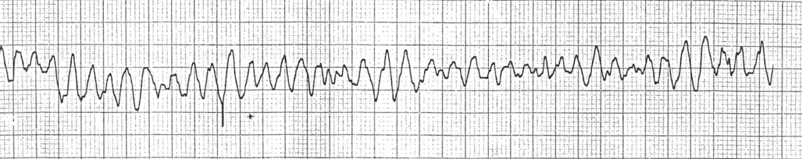

What are your immediate actions? (8 marks)

Assume leadership, delegate roles
Ensure continuous BLS provided throughout
Manual biphasic shock 200J
Continue CPR 2 minutes
During CPR:
Check electrode position
Secure IV access
Adrenaline 1mg and repeat after second shock and every second loop
Correct reversible causes (4Hs,4Ts)
Advanced airway
Amiodarone 300mg after 3rd shock
Post-resuscitation care/12-lead ECG/reperfusion

From ARC Resuscitation guideline, online, accessed 5/8/2014

41. A 24 year old woman has just died in your ED despite active resuscitation after sustaining massive head injuries in a motor vehicle accident. Police are in attendance but her family members are unaware of the situation.

a. Provide 6 principles to follow when communicating the news to the family. (6 marks)

Do not tell them over the phone
Say relative is unwell and they need to attend urgently

On arrival, greet in person
Delegate other roles so you will be uninterrupted
Have another staff member present
Introduce yourself and confirm identity and relationship to deceased of all present
Summarise what has happened and state that the patient has died
Do not use euphemisms
Allow whatever form of grief reaction occurs the time and space needed
Ask for and answer questions
Allow viewing of body
Use touch to comfort if appropriate
Offer food and drink
Give access to telephone
Offer pastoral care referral

b. Provide 4 circumstances when a death must be reported to the coroner. (4 marks)

pass/fail - Where there is any suspicion the death is not from natural causes

Additional material (may vary from state to state)
The term “reportable death” means a Western Australian death –
(a) that appears to have been unexpected, unnatural or violent or to have resulted, directly or indirectly, from injury;
(b) that occurs during an anaesthetic;
(c) that occurs as a result of an anaesthetic and is not due to natural causes;
(d) of a person who immediately before death was a person held in care
(e) that appears to have been caused or contributed to while the person was held in care:
that appears to have been caused or contributed to by any action of a member of the Police Force;
(f) of a person whose identity is unknown;
(g) that occurs in Western Australia where the cause of death has not been certified under section 44 of the Births, Deaths and Marriages Registration Act 1998;
(h) that occurred outside Western Australia where the cause of death is not certified to by a person who, under the law in force in that place, is a legally qualified medical practitioner.

42. You are the duty consultant. A 30 year old patient is being brought in by the paramedics as a Priority 1 patient (ETA 5 mins). He was found hanging by his friend at home. Initial rhythm was PEA. The paramedics have been working on the patient for 55 minutes and the patient has not regained circulation. You have been informed that patient is intubated and there is an IO access in.

a. How will you generally prepare for the patient’s arrival? (4 marks)

Likely to be a futile further resuscitation
Gather the team (medical, nursing, scribe)
Prepare ALS drugs and airway equipment
Delegate the floor activities to the next senior
Triage staff to accompany next of kin to relative’s room
Create a resus bed to receive the patient

b. A decision was made to call off the resuscitation attempt immediately after patient arrival. Describe the next steps you will take, (6 marks)

Leave all the lines and tubes in situ
Death to be reported to the coroner
Instruct staff not to handle the body
Leave all evidence including clothing intact
Thorough and complete documentation
Information for next of kin/patient’s GP

43. You are checking pathology results when you come across a positive chlamydia result. The pathologist has flagged that this is a notifiable disease.

a. What action should you take? (5 marks)

Recall the notes
Ascertain whether the patient is aware
Contact the patient and organise for appropriate treatment, advice on barrier precautions, further screening and treatment of sexual partners (may be via GP)
Notify the Communicable Diseases Department for further action/contact tracing
Document all actions in patient notes

b. Give three other examples of incidents that require mandatory reporting in the ED. (5 marks)

May include: Child sexual or physical abuse, elder abuse, incompetent/negligent/substance-abusing/mentally ill (in some jurisdictions) colleague, death during anaesthetic, death in care, death without clear natural cause.

44. You have been asked by the Head of your ED to give a presentation on Access Block and the National Emergency Access Target (NEAT).

a. What is the definition of Access Block? (2 marks)

This refers to the percentage of patients who were admitted or planned for admission but discharged from the emergency department (ED) without reaching an inpatient bed, transferred to another hospital for admission, or died in the ED whose total ED time exceeded 8 hours, during the 6 month time period. Taken from ACEM Policy on Standard Terminology P02v4 March 2009

1 mark for recognising proportion / percentage of patients who do not reaching in-patient bed
1 mark for accurate time frame of exceeding 8 hours

b. What is the National Emergency Access Target? (2 marks)

The National Emergency Access Target requires that by 2015, 90% of all patients presenting to a public hospital Emergency Departments will be admitted, transferred or discharged within four hours – Applies to all of Australia. Taken from WA Government Emergency Access Reform Web Site.
NOTE – New Zealand Access Time Target is 95% within six hours.

1 mark for correct percentage of patients to be admitted.
1 mark for correct time frame of within 4 hours.

c. Outline potential solutions to improving Access Block & Overcrowding (6 marks)

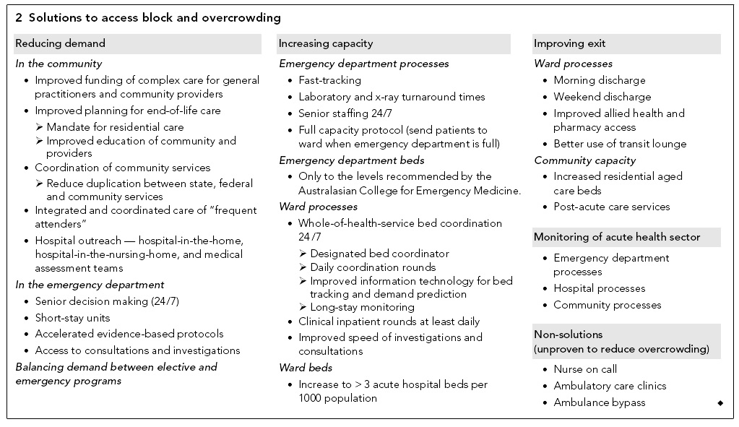
1 mark per entry to maximum of 6 marks- a maximum of 3 marks can be given for Emergency Department specific strategies i.e. for full marks must include minimum of 3 hospital or community based strategies. Table taken from Cameron PA, Joseph AP, McCarthy SM. Access block can be managed. MJA 190;7:364-368. April 2009.

45. a. You are about to see a 4 year old child in ED. Name 3 people considered to have parental responsibility. (3 marks)

A. The child’s parents if married to each other while child being assessed.
- Mum or dad if separated as per court order
- The child’s legally appointed guardian
- DCP

b. Name 3 subsets of ED patients who might not be able to provide consent. (3 marks)

A. Children and adolescents
B. Intellectually impaired
C. Mental health patients
D. Patients under the influence of drug and alcohol
E. Critically unwell patient

c. You are dealing with a hypotensive 6 year old child who was involved in an accident. The patient has free fluid in the abdomen on FAST scan. You need to urgently transfuse the child but the parents are Jehovah Witnesses and are opposing transfusion. Name 2 immediate steps you would take in this situation. (2 marks)

A. Proceed with the transfusion
B. Proper documentation in the notes that blood transfusion is needed to sustain life.

d. What is the legal age of consent in Australia? (1 mark)

18 years and in some circumstances, up to 16 years.

Ref : Textbook of adult emergency medicine by Cameron (3rd edition)

46. a. Name 2 types of consent in the ED. (2 marks)

Implied
Verbal
Written
(any 2)

b. You are going to perform a chest drain on a conscious patient. He is a 60 year old man with a history of COPD who has 50% pneumothorax. His vitals are: Pulse 90 /min, BP 140/80 mmHg, RR 28 /min, Sats 93 % on 2L NP Oxygen. Provide 6 principles you would follow when obtaining consent from your patient. (6 marks)

Ascertain patient is competent
No language barrier
Use simple language/No complicated medical terminology
Treatment options but why insertion of chest drain is needed
Possible complications of chest drain
The consequences of not proceeding with the advised treatment
Opportunity for the patient to ask questions

47. You have been invited to join your Emergency Department’s Quality Improvement Workgroup.

a. List the key steps in the Quality Improvement Cycle. (4 marks)

Plan – the change – 1 mark
Do – implement the change – 1 mark
Check – monitor and review the change – audit – 1 mark
Act – revise / review the plan and repeat the cycle – 1 mark

Exact wording not required statements consistent with concept will be given marks
Taken from Dunn Emergency Medicine Manual 5th Edition Volume 1 Chp 22 Pg 351

b. List 6 clinical indicators used in Emergency Medicine to measure clinical care and outcomes. (6 marks)

1 mark to maximum of 6 for any of:
ATS Compliance
% Access block
STEMI – time to angio / thrombolysis
Admission rates
DNW Rates
Number of deaths in ED
Time to antibiotics
Time to analgesia
NEAT Compliance
Trauma audits
Satisfaction surveys – patients or staff
Staff retention / sick leave
Patient complaints audit
Notes audits
Occupational health and safety audits – staff injuries or needle sticks etc.
Missed results audit

List not exhaustive – taken from Taken from Dunn Emergency Medicine Manual 5th Edition Volume 1 Chp 22 Pg 352 and Cameron Textbook of Adult Emergency Medicine 3rd Edition Section 27.3 Pg 822

48. There have been a number of incidents in your ED Short Stay Unit where patients have unexpectedly deteriorated during their stay.

a. Provide 2 examples of the role of a Short Stay Unit. (2 marks)

To manage Emergency Medicine patients who would benefit from extended treatment and observation but have an expected length of stay of less than 24 hours.
Taken from Cameron Textbook of Adult Emergency Medicine 3rd Edition Section 27.2

1 mark for providing extended care for Emergency Medicine patients
1 mark for acknowledging an expected length of stay of 24 hour or less

b. What steps would you take to develop a solution to this problem of patients unexpectedly deteriorating during their stay? (4 marks)

Gather information – 1 mark
Develop solution plan – 1 mark
Implement plan – 1 mark
Audit / Re-collect data – 1 mark

Note exact wording not essential but plan must include aspects of each of these domains to score maximum marks

c. You have been asked to develop a set of exclusion criteria for your Short Stay Unit. List your exclusion criteria. (4 marks)

½ mark for each exclusion criteria to maximum of 4 marks.
Patients who should be admitted to in-patient wards – complex medical or surgical problems
Multiple problems
Elderly patient
Paediatric patients
Patients without clear management plan / diagnosis
Patients with intensive nursing requirements
Risk to staff patients – psychotic, violent, forensic history

Taken from Cameron Textbook of Adult Emergency Medicine 3rd Edition Section 26.6

49. a. Define triage. (3 marks)

Answer must include: a process for sorting patients based on the urgency of need for medical care (3 marks)

b. What are the underlying principles of triage? (2 marks)

Answer must include equity (or justice/fairness) and efficiency (2 marks)

May also mention ongoing process, doing the greatest good for the greatest number, fairness/appropriateness of treat those in greatest need ahead of those who arrived before them.

c. Populate the following table with the correct values. (5 marks)

ATS Category | Max waiting time | ACEM target % seen in time
ATS 1 | immediate | 100%
ATS 2 | 10 minutes | 80%
ATS 3 | 30 minutes | 75%
ATS 4 | 60 minutes | 70%
ATS 5 | 120 minutes | 70%

50. A 2 week old term baby weighing 4kg is brought to the ED with difficulty breathing and floppiness.

Her vital signs are as follows:
HR 160 /min
BP 65/35 mmHg
Sat 83 % on air
Temp 37.6 °C
CRT 4 seconds

She is lethargic, and will respond to voice.

a. List 4 differentials for her presentation.

Must include – sepsis, congenital heart disease

T trauma/NAI
H heart (CHD), hypovolaemia
E electrolyte imbalance
M metabolic disease – CAH
I IEOM
S Sepsis/infection
F formula related
I intestinal (volvulus/NEC)
T thyroid
S seizures

b. List your treatment priorities in sequential order. (4 marks)

Airway/breathing – airway manouveurs and oxygen – improve saturations, if persistent hypoxia will likely require RSI

Treat shock – IV access, IO if unable and IV fluid – 10-20ml/kg bolus (smaller bolus in case of CHD), reassess and repeat

Seek/treat hypoglycaemia 2ml/kg 10% dextrose

Source control – Assume sepsis and empirically treatment with antibiotics – cefotaxime 100mg/kg and amoxicillin 50mg/kg

If CHD strongly suspected – prostaglandin

c. You decide to intubate this baby. What 2 sizes of ETT will you prepare?

3 + 3.5mm

51. A 4 year old boy presents to the ED with cough, stridor and fever.

a. List 4 causes of stridor in this patient. (4 marks)

Croup
Epiglottitis
Bacterial tracheitis
Retropharyngeal abscess
Angiooedema/anaphylaxis (with concurrent febrile illness)
Inhaled FB (with concurrent febrile illness)

b. List 4 features on history or examination that would make epiglottitis a more likely diagnosis. (4 marks)

Not immunised
Acute onset of illness
Toxic/shocked appearance
Very high fever
Drooling
Cough minimal or absent
Low pitched stridor

c. In a patient with suspect epiglottitis, what are your management priorities? (2 marks)

Keep child as calm as possible, avoid unnecessary interventions
Secure airway – ideally in theatre with gas induction
Source control – 3rd generation cephalosporin (cover HiB + others)

52. A 12 month old child presents to ED with a widespread red rash and difficulty breathing shortly after eating peanut butter for the first time.

Her vital signs are
HR 150 /min
Sat 88 %A with wheeze, no stridor
RR 50 /min
BP 60/30 mmHg
GCS 15/15

a. What is the initial dose and route of administration of adrenaline (1:1000) in millilitres for this patient? Show your working. (3 marks)

Expected weight for a 1 year old = (1 + 4)x2 = 10kg
Dose of adrenaline = 0.01 ml/kg of 1:1000 = 0.1ml IM

b. List 4 other treatments (with doses) that you would consider giving as adjuncts to IM adrenaline. (4 marks)

20ml/kg (200ml) 0.9% NaCl bolus
Salbutamol nebuliser 5mg
Adrenaline nebuliser 5mg
Hydrocortisone 4mg/kg (40mg) IV or prednisolone 2mg/kg = 20mg
Antihistamine – Cetirizine 2.5mg or chlorpheniramine 2mg
Oxygen at 6L per minute/to maintain sats >92%

Not promethazine – contraindicated in <2

c. After a period of observation you decide to discharge the child with a prescription for an EpiPen. List 3 important pieces of discharge advice. (3 marks)

Educate how and when to use EpiPen (action plan)
Warn about biphasic reaction. Watch for return of symptoms – administer epipen and return immediately to ED – call 111
Avoid all foods with peanuts (read labels/ask when eating out) +/- tree nuts
See GP in 24-48h for review

53. A 3 month old girl is brought in to ED with pallor and lethargy for the past hour. She has had fevers and URTI symptoms for the past 3 days.

Her observations are as follows:
GCS 15/15 but floppy/lethargic
HR 250 /min
BP 75/45 mmHg
CRT 2 seconds
Sat 95 %A
Temp 38.2 °C

This is her ECG.

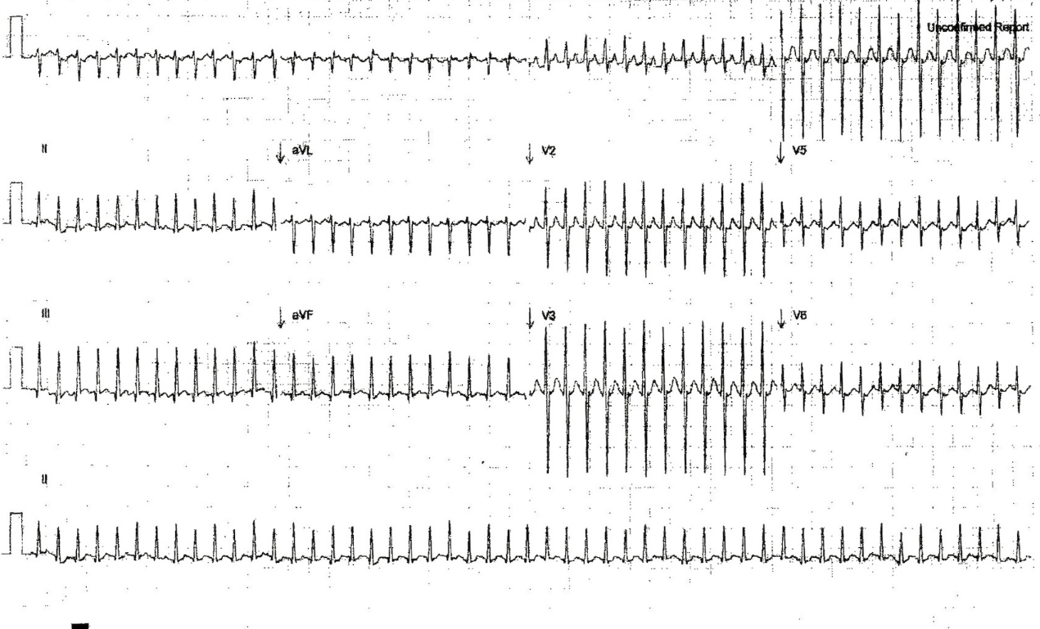

a. What is the most likely diagnosis? (1 mark)

SVT

b. What are 2 features of the ECG that support this diagnosis? (2 marks)

Rate is extremely fast – too fast for sinus tachycardia
Narrow complex
No P waves seen

c. List 3 treatment options in the order of escalation that you would perform them. (3 marks)

Vagal manouveurs – dunk head in ice water or cold face cloth dropped on face
Adenosine IV 100mcg/kg (can double dose Q2min up to 400mcg)
(Amiodarone IV 5mg/kg over 30 min)
DCCV cardioversion – sync 0.25-0.5J/kg (with sedation)

d. List 4 investigations you would perform in the ED and their justification. (4 marks)

BSL/glucose – prolonged tachycardia could cause hypoglycaemia, hypoglycaemia as cause of floppiness
FBC – anaemia leading to circulatory collapse, inc or dec WCC (sepsis)
Electrolytes/renal function – potassium/calcium/magnesium – deficiencies leading to arrhythmia
CXR – look for cardiomegaly/signs of CHD/myocarditis, signs of LVF, focal infection
Septic screen (blood culture, urine, consider LP) – sepsis as cause of SVT
Urine toxicology screen – as cause of arrhythmia

54. A 32 year old woman presents to your tertiary ED from her GP.

She has been referred with a letter stating:

“Thank you for reviewing this 32 year old who has recently returned from a trip to the UK, she has pleuritic chest pain and I am concerned about a possible PE.”

a. Name 3 risk stratification tools that you use to guide your assessment. (3 marks)

Wells
PERC
Modified Geneva

b. You calculate a Wells score of 3. What is the patient’s risk of PE? (1 mark)

20%

c. A D dimer is 1100 and you need to discuss imaging with the patient. List 3 benefits and 3 negatives of CTPA. (3 marks)

- Benefits (any of) – effective gold standard test, sensitive compared to VQ, evaluates clot burden may give alternative diagnosis, available to ED, relatively rapid, minimally invasive (cc angiogram)
- Negatives (any of) – radiation, contrast allergy, contrast nephrotoxicity, difficult IV access difficult, expensive, can miss small sub-segmental (particularly if older gen CT).

d. The CTPA is positive for bilateral proximal PEs. The patient has a BP of 100/70 mmHg, HR 98 /min, SpO2 94% RA. How could you risk stratify her further with regards to possible treatment? (3 marks - need to only list 3 to score 2.5, 4 scores 3 marks)

- Echo – signs of RV strain
- Troponin and/or BNP elevation
- Subjective distress or breathlessness
- ECG changes of RVH

55. A 4 year old boy presents to your ED at 1830h with his mother. He has had a runny nose, cough and wheeze for 2 days. His past history includes asthma and eczema since 18 months of age. He has required several hospital admissions for asthma.

a. List 6 important clinical signs when assessing this child. (3 marks, 0.5 marks each)

Level of consciousness
Respiratory rate (<20 or > 40)
Work of breathing – use of accessory muscles
SPO2
Chest auscultation – presence of wheeze / lack of b/s eg silent chest
PEFR – if able (likely to be too young)
Cyanosis
Ability to speak – words vs short sentences vs long sentences

b. He does not have an oxygen requirement and is assessed as “mild”. List treatment in ED including doses. (1 mark, 0.5 marks each)

Salbutamol 100mcg per puff via MDI and spacer 6 puffs per dose (accept slight variation depending on region)
or Salbutamol via nebuliser 2.5mg – 5mg
Prednisolone 1mg/kg (accept alternative steroid if dose appropriate)

c. The child improves and you wish to educate his mother in spacer and MDI technique and in spacer care. List 6 points that you will cover. (3 marks, 0.5 marks each)

Shake the MDI vigorously
Prime the spacer with 10 puffs of salbutamol (accept 6-12 puffs)
Hold the spacer tightly against the child’s face (may require two operators)
Deliver 1 puff then wait for 6 breaths
Deliver a total of 6 puffs
Wash the spacer in warm soapy water
Do not rinse the spacer
Allow to drip dry

d. List discharge criteria and advice you would give his parents. (3 marks, 0.5 marks each)

Sustained improvement with no requirement for salbutamol for > 2 hours
No O2 requirement
Adequate access to transport and phone
Safe distance from hospital
Competent and willing parents or caregiver
No prior hx of ventilation or ICU admissions
No prior hx of precipitous rapid decline
Adequate community follow-up
Action plan for parents – return if requires > 4 hourly salbutamol (accept range 2-4 hourly)

56. A factory worker presents to your department with 3% body surface area burns to his hands and forearms from a 100% hydrofluoric acid solution.

a. What percentage of body surface area burns would be expected to be associated with systemic toxicity from this acid and how does it cause toxicity?

2.5% BSA
Fluoride ions bind to calcium’s & magnesium resulting in cell dysfunction and death.
Systemic toxicity and ventricular dysrhythmias occur secondary to hypocalcaemia, hypomagnesaemia and acidosis.

b. List 3 investigations that may be useful to help determine further management of this patient and describe the abnormality that may be detected.

ECG : low Ca -> QT prolongation
Serum/ionized Ca – at presentation & Q4 hrly – likely to be low Ca.
Serum Mg – may also be low.
VBG – to detect acidosis
BSL – low/high may be an alternative cause for altered LOC

c. Name the antidote used to treat hydrofluoric acid toxicity.

Calcium.

d. List 3 routes by which it may be administered and the dose typically used for each route.

Topically to the skin as a gluconate gel (2.5%) -this can be applied immediately to the skin after exposure until pain resolves.

Intradermally – difficult in the fingers to give adequate volume.
Usual dose = 0.5ml/cm2 of Ca Gluconate (avoid Ca CO3)

Regional IV infusion -eg. with Biers Block- Dilute 1g of Ca Gluconate in 40mls of N saline, infuse into the arm and leave the cuff inflated for 20 minutes.

Intra-arterial infusion - dilute 1 ampoule of Ca gluconate in 40 ml normal saline & infuse over 4 hrs. Can be repeated as necessary.

57. A 3 year old child is brought into ED with a history of having ingested ‘at least’ 20 of her mother’s iron tablets.

a. List 2 clinical features of significant iron toxicity that are likely to be seen within the first 6 hours after the ingestion.

2 of Vomiting, Diarrhoea + Abdominal pain.

b. List 2 investigations that may be helpful in confirming that a patient has ingested iron tablets and when the abnormality is likely to be detected.

2 of :
Abdo XR – iron tablets are radio opaque so will be visible in the stomach on AXR immediately after ingestion and for many hours (?until passed into SI).

Serum iron level - Levels peak in 4 - 6hrs post ingestion.
Levels > 90 micmol/L are thought to be predictive of systemic toxicity.

ABG - an increased AG metabolic acidosis occurs with systemic toxicity, but this won’t be evident until hours (??>6) after the ingestion.

c. List 2 methods of decontamination that may be useful in the management of iron toxicity and their indications for use.

Whole bowel irrigation –recommended for ingestions of > 60mg/kg confirmed on AXR.
Endoscopic removal - if potentially lethal ingestion where WBI fails or is impossible.

d. Name the antidote used to treat iron toxicity and list 2 indications for its use.

Desferrioxamine

Indications for use are:
Iron levels > 90 micmol/L (500micg/dL) - as this predicts systemic toxicity.

Signs of systemic toxicity including -
Shock
Metabolic Acidosis
Altered mental status

58. A 32 year old female with a history of bipolar disorder is brought in by ambulance after having taken her weeks worth of lithium. She is alert and orientated and complains of no systemic symptoms at this time.

a. List two early signs or symptoms that suggest a significant amount of Lithium has been ingested acutely and the earliest and most frequent sign of neurological toxicity associated with Lithium ingestion.

GI symptoms ie :
Nausea
Vomiting
Diarrhoea
Abdominal pain – occur with significant acute ingestion

Tremor is the earliest sign of neuro toxicity.

b. List 2 tests that may have an influence on further management of a patient presenting after an acute overdose of lithium and explain why they may be relevant.

AXR – may show concretions of tablets in the stomach, indicating need for aggressive GI decontamination.
U + E’s - renal impairment may be an indicator of the need for dialysis. Hypokalaemia can be a complication.
Serum Lithium level - to confirm ingestion, monitor progress & determine safety of medical discharge.
Also:
BSL - excludes hypo/hyper-glycaemia as alternative cause for altered mental status.
Paracetamol level - incase polypharmacy ingestion, since paracetamol OD is initially asymptomatic, but can -> hepatic toxicity, and there is an available antidote if used within the first 8 hrs after ingestion.
Alcohol - since often a co-ingestant & may be an alternative cause for altered mental status.

c. List two treatments that may be considered for a patient suffering from acute Lithium toxicity and one possible indication for each.

Volume resuscitation with Normal saline (10-20ml/kg then reassess) – indicated for patients who are volume deplete after significant GI fluid loss & to maintain adequate urine output of > 1ml/kg/hr to ensure adequate Li elimination.
Haemodialysis - primarily useful in those with significant renal impairment +/or in those who present late with clinical features of lithium neurotoxicity.

59. A 20 year old female presents saying she has taken an overdose of aspirin.

a. List 4 features of acute salicylate intoxication and the dose expected to cause severe toxicity.

> 300mg/kg causes severe toxicity.
Symptoms include (Together known as salicylism):
- Tachypnoea
- Tinnitus
- Vomiting
Progressing to altered LOC / seizures / hyperthermia / metabolic acidosis /
pulmonary oedema (10%) and alveolar haemorroage

b. What method of decontamination may be useful in the management of salicylate toxicity and for up to how long after the ingestion?

Activated charcoal – for up to 8 hours post ingestion (as gastric emptying can be delayed after an OD). A repeat dose after 4 hours may also be useful.

c. Name 2 methods of enhancing the elimination of salicylates and list 1 possible indication for each.

Urinary alkalinisation – indicated in any patient who is symptomatic from toxicity.

Haemodialysis – rarely needed but may be considered when (1 of) :
- -Urinary alkalinization isn’t feasible.
- Serum salicylate levels > 9.4 mmol/L after an acute ingestion.
- -Serum salicylate levels rising to >4.4 mmol(60 mg/dl) despite decontamination & urinary alkalinisation.
- Severe toxicity associated with altered LOC, acidaemia or renal failure
- -V high serum salicylate levels (>7.2 mmol/L or > 100 mg/dL)

60. This 32 year old male lost control of a high pressure injector and comes in with a wound on his left lower leg.

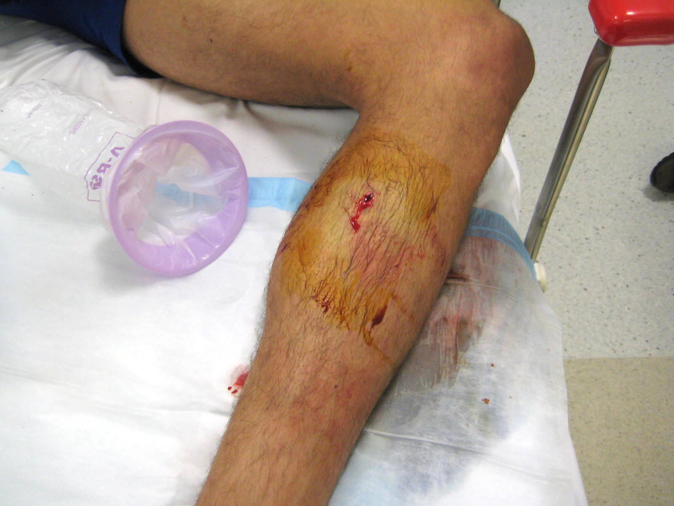

a. List three complications that are likely to occur within the next 48 hours. (3 marks)

  - Compartment syndrome
  - Tissue necrosis from local trauma
  - Wound infection

b. List the management priorities for this injury. (5 marks)

  - Analgesia
  - Elevation
  - Tetanus
  - Plain film to rule out other injury
  - Surgical or orthopaedic admission +/- exploration in OT

c. What factors contribute to damage? (3 marks)

  - Type of liquid injected
  - Location of injury
  - Amount injected
  - Proximity of nozzle

61. A 34 year old man presents 10 days after a business trip to Papua New Guinea. He has had fevers, malaise, generalised aches and frequent episodes of diarrhoea.

His vital signs are:
HR 130 /min
BP 100/50 mmHg
Temp 38 °C
Sats 98 % on air

a. List 10 potential causes of fever and illness in this man.

Malaria
Dengue
Typhoid/paratyphoid
GIT infections – cholera, shigella, salmonella, E coli diarrhoea, giardiasis etc
Viral hepatitis
Typhus/rickettsial diseases
Melioidosis
Japanese or Australian (Murray Valley) encephalitis
Non-exotic/”normal” infections – LRTI, UTI, STI, cellulitis etc etc etc

b. What blood tests will you request?

Investigation | Justification
FBC | Part of fever workup. ?malaria → anaemia
EUC | Unwell, diarrhoea → potential derangement
LFT | Hepatitis possible
Blood culture | Part of workup
Malaria films | Ideally 3 sets over 48 hours (practice varies)
Falciparum +/- vivax antigen | > 95% sensitive for PF

c. List 5 major complications of severe Plasmodium falciparum malaria.

any 5 of:
Haemolysis/anaemia
Splenic enlargement/rupture
Cerebral malaria – delirium, coma, seizures
ARF
Non-cardiogenic pulmonary oedema
Hypoglycaemia
Lactic acidosis

d. What are the two main choices for the urgent initial treatment of severe Plasmodium falciparum malaria?

1. Artesunate (2.4mg/kg IV) then oral
2. Quinine (20mg/kg IVI over 4 hours)

62. A two month old infant has been brought in following a brief seizure. She has had coryzal symptoms and high fevers for two days. She has no relevant past history and no allergies. On examination: HR 110 /min, BP 80/45 mmHg, Temp 39.7°C. There is no rash and no clear focus of infection but the child is ill-appearing and drowsy.

a. What investigations are required?
Investigation | Justification
WCC (FBC)  Other inflammatory markers – CRP etc | At 2 months most would consider too young to assess on purely clinical grounds.  Could comment that WCC/CRP do not confirm/exclude SBI
Electrolytes | Sick child – possible abnormality of fluids in/out
Urine | Part of septic workup – especially as going to give antibiotics
CSF | Part of septic workup. While this could be a “simple febrile convulsion” with another source of sepsis LP is mandatory in this setting
Blood culture | Sepsis workup

A lumbar puncture is performed:
CSF white cell count
Neutrophils 120 (nil)
Lymphocytes 25 (<5)
CSF red cell count 200
CSF Protein 1.2 (< 0.4 g/L)
CSF glucose 0.4 (> 2.5 mmol/L)

b. Interpret these results.

Highly suggestive of bacterial meningitis. Likely a “traumatic tap” but ratio of RBC:WBC still indicates too many WBCs

c. List and justify the medications you would use to treat this child.

Medication | Justification | Dose
Cefotaxime | Could choose ceftriaxone though under 3 months usually cefotaxime (hepatic immaturity) | 50mg/kg 6th hourly  (ceftriaxone 100mg/kg 12th hourly)
Ben Penicillin | To cover listeria | 60mg/kg 4th hourly
Vancomycin | For resistant S pneu – local practice varies – depends on local prevalence. Some wait for CSF gram stain or antigen studies | 30 mg/kg 12th hourly
Dexamethasone | Give before or with antibiotics. Reduce hearing loss in Hib meningitis (JAMA 1997). Decrease poor outcomes (GOS) & death (NEJM 2002) | 0.15 mg/kg
Paracetamol | For fever | 15mg/kg

d. A senior nurse complains to you that one of the junior doctors involved in this case has been caught stealing a box of ciprofloxacin. A formal incident report has been filed and the nurse wants you to “deal with the JMO”. The doctor says he only wanted to take some as prophylaxis against possible meningococcus.
What key principles should you consider in your discussion with the JMO?

- Non-judgemental, non-confrontational, confidential, document discussion.
- “Stealing” drugs is potentially serious – disciplinary/employment ramifications
- Doctor needs counselling - ?apology etc
- Concern about infection not entirely unreasonable though prophylaxis only indictaed if meningococcus confirmed & close exposure (e.g. suctioning, intubation)

63. A 24 year old women who is 10 weeks pregnant presents with suspected pulmonary embolus.

a. List five clinical features that would increase her likelihood of having PE. (5 marks)

utilise Well's criteria - 5 of clinical evidence DVT, alternative dx less likely Cf PE, tachycardia, immobilisation/surgery - recent/within 4/52, haemoptysis, active Ca

b. Describe the utility of the following investigations in this patient. (5 marks)

 | Investigation | Utility
1 | D Dimer | Can effectively exclude PE in low risk patients however more false positives in normal pregnancy (rises with gestation)
2 | CXR | May provide alternative diagnosis - pneumonia, LVF
3 | Lower limb US | If positive can avoid CTPA/VQ and radiation risks; negative scan cannot exclude PE
4 | CTPA | High rates of nondiagnostic studies in pregnancy (35%) Cf. VQ. Increased lifetime risk of breast ca. Comparable radiation. Useful if CXR abnormal/underlying lung disease
5 | VQ | First line imaging investigation. Low rates nondiagnostic VQ in pregnancy (4%). Not useful if CXR abnormal.

c. The patient has been diagnosed with pulmonary embolism. What are the ECG changes below? (1 mark)

INCLUDEPICTURE "http://cdn.lifeinthefastlane.com/wp-content/uploads/2011/12/Massive-PE3.jpg" \* MERGEFORMATINET INCLUDEPICTURE "http://cdn.lifeinthefastlane.com/wp-content/uploads/2011/12/Massive-PE3.jpg" \* MERGEFORMATINET INCLUDEPICTURE "http://cdn.lifeinthefastlane.com/wp-content/uploads/2011/12/Massive-PE3.jpg" \* MERGEFORMATINET INCLUDEPICTURE "http://cdn.lifeinthefastlane.com/wp-content/uploads/2011/12/Massive-PE3.jpg" \* MERGEFORMATINET INCLUDEPICTURE "http://cdn.lifeinthefastlane.com/wp-content/uploads/2011/12/Massive-PE3.jpg" \* MERGEFORMATINET INCLUDEPICTURE "http://cdn.lifeinthefastlane.com/wp-content/uploads/2011/12/Massive-PE3.jpg" \* MERGEFORMATINET INCLUDEPICTURE "http://cdn.lifeinthefastlane.com/wp-content/uploads/2011/12/Massive-PE3.jpg" \* MERGEFORMATINET INCLUDEPICTURE "http://cdn.lifeinthefastlane.com/wp-content/uploads/2011/12/Massive-PE3.jpg" \* MERGEFORMATINET INCLUDEPICTURE "http://cdn.lifeinthefastlane.com/wp-content/uploads/2011/12/Massive-PE3.jpg" \* MERGEFORMATINET INCLUDEPICTURE "http://cdn.lifeinthefastlane.com/wp-content/uploads/2011/12/Massive-PE3.jpg" \* MERGEFORMATINET INCLUDEPICTURE "http://cdn.lifeinthefastlane.com/wp-content/uploads/2011/12/Massive-PE3.jpg" \* MERGEFORMATINET INCLUDEPICTURE "http://cdn.lifeinthefastlane.com/wp-content/uploads/2011/12/Massive-PE3.jpg" \* MERGEFORMATINET INCLUDEPICTURE "http://cdn.lifeinthefastlane.com/wp-content/uploads/2011/12/Massive-PE3.jpg" \* MERGEFORMATINET INCLUDEPICTURE "http://cdn.lifeinthefastlane.com/wp-content/uploads/2011/12/Massive-PE3.jpg" \* MERGEFORMATINET INCLUDEPICTURE "http://cdn.lifeinthefastlane.com/wp-content/uploads/2011/12/Massive-PE3.jpg" \* MERGEFORMATINET INCLUDEPICTURE "http://cdn.lifeinthefastlane.com/wp-content/uploads/2011/12/Massive-PE3.jpg" \* MERGEFORMATINET INCLUDEPICTURE "http://cdn.lifeinthefastlane.com/wp-content/uploads/2011/12/Massive-PE3.jpg" \* MERGEFORMATINET INCLUDEPICTURE "http://cdn.lifeinthefastlane.com/wp-content/uploads/2011/12/Massive-PE3.jpg" \* MERGEFORMATINET INCLUDEPICTURE "http://cdn.lifeinthefastlane.com/wp-content/uploads/2011/12/Massive-PE3.jpg" \* MERGEFORMATINET INCLUDEPICTURE "http://cdn.lifeinthefastlane.com/wp-content/uploads/2011/12/Massive-PE3.jpg" \* MERGEFORMATINET INCLUDEPICTURE "http://cdn.lifeinthefastlane.com/wp-content/uploads/2011/12/Massive-PE3.jpg" \* MERGEFORMATINET 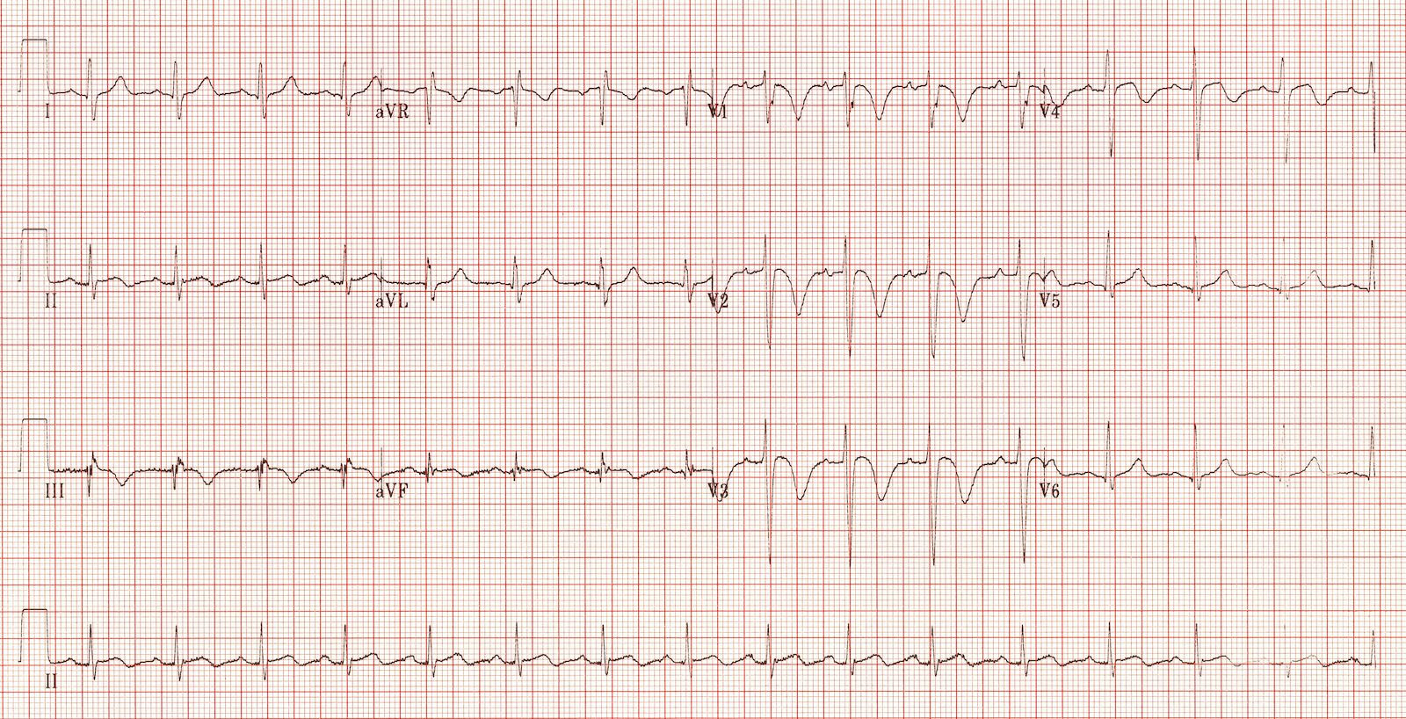

TWI V1-4, III, AVF

d. What do the ECG changes suggest? (1 mark)

acute right ventricular strain/right ventricular dilation likely due to massive PE

e. The patient becomes hypotensive. List 4 treatment options (2 marks)

fluids, inotropes, thrombolysis, embolectomy

64. A 30 year old man presents with a left sided spontaneous pneumothorax.

a. What are 3 features to elicit on evaluation that will help determine your management? (3 marks)

primary/secondary (underlying lung disease), symptomatic, size >2cm or >20% depending on guidelines used

b. Give a clinical circumstances in which each of the following would be appropriate. (3 marks)

Management | Clinical circumstances
Observation | Primary, asymptomatic, small pneumothorax  Primary, minimal symptoms, large also acceptable
Aspiration | Primary, symptomatic, large pneumothorax  Secondary, asymptomatic, small pneumothorax
Intercostal catheter/ pneumocath/ pigtail catheter | Secondary and large, secondary and symptomatic  Failed aspiration

c. List 6 complications of intercostal catheters. (3 marks)

Answer (mandatory) - 6 of bleeding/haemothorax, organ injury (mediastinum/liver/spleen/diaphragm), pain, failure to drain (kinking/blockage), infection, scarring, complications procedural sedation, dislodgement

65. A 5 year old girl is brought to the ED, with worsening asthma for the last 4 hours.

a. What are 4 clinical features of life threatening asthma? (4 marks)

Answer (2 of mandatory) - 4 of confusion, coma, exhaustion, poor respiratory effort, silent chest, cyanosis, hypotension

b. On assessment she is unable to speak, has marked use of accessory muscles, RR 60 /min, Pulse rate 160/min and oxygen saturation of 89% on room air.

List your immediate management, including any drug doses. (4 marks)

Ventolin 6 puffs by MDI or nebuliser Q20min x3 then review, Ipratropium bromide 4 puffs Q20 min, Prednisolone 1mg/kg (methylpred/hydrocort alternatives)

c. Despite appropriate escalation of management the patient's condition deteriorates over several hours and they are intubated in the ED. Give ventilation settings and justify. (6 marks)

Parameter | Setting | Justify
Respiratory Rate | <10/min | Normal RR in 5y 20-30, answer should be less than this to allow time for expiration
Tidal volume | 5-7ml/kg | Decreases barotrauma
Peak inspiratory pressure | 35-50cmH20 | Necessary to overcome high airway pressures
PEEP | 0-5cm H20 | Patient has high intrinsic PEEP - low extrinsic PEEP prevents gas trapping
I:E ratio | 1:4-8 | Allows time for expiration

d. After connecting to the ventilator the patient suddenly deteriorates becoming progressively hypotensive and tachycardic. Give three possible causes. (3 marks)

Answer (mandatory)- dynamic hyperinflation/gas trapping, tension pneumothorax, effect of induction agents, other (hypovolaemia, equipment failure - tube dislodgement/O2 not connected)

e. What is your first step in management? (1 mark)

disconnect the patient from the ventilator/hand ventilate

66. A 42-year-old man is brought to your ED by ambulance with acute confusion. His wife states that he is previously well and on no medications, but his health has been deteriorating for three months, with tiredness and 10kg weight loss despite an enormous appetite. She also states that, on the bright side, he has become completely impervious to the cold and the extra money they’ve spent on groceries has been saved on heating bills.

Observations are:
A intact
B RR 40 /min, sats 100%, chest clear
C HR 140 /min, BP 180/100 mmHg, CR 2 sec
D E4(staring & bulging), V4 (agitated & aggressive), M5 (localising to pain), no focal neurology
E Temp 38.5°C, BSL 10, vomiting, no rash or other signs

a. What is your provisional and differential diagnosis for this man’s clinical picture? (3 marks)

Provisional diagnosis:

Differential diagnosis:

- Most likely thyroid storm
- But also other causes of confusion & high temperature e.g.
  - Infection (meningoencephalitis, sepsis of any source)
  - Too much drug: e.g. salicylates, TCAs, anticholinergics, amphetamine/cocaine,
  - Too little drug: e.g. withdrawal of etoh/benzos, heat stroke, phaeochromocytoma)

b. What conditions may precipitate this clinical picture? (2 marks)

- Nasty precipitants eg acute MI, sepsis, trauma, IV contrast
- UnderDx/Rx TTX esp Graves
- Also XS thyroxine or too little antithyorid Rx

c. How will you treat him in the ED? (5 marks)

- Address ABC/ good supportive care, esp:
  - O2 & IV fluids, because high risk of dehydration & cardiovascular collapse
  - Sedation eg benzodiazepine
- Get help: from endocrinologists, and needs ICU
- Investigations:
  - Endocrine blood tests esp TFT
  - Seek and treat nasty DDx and nasty precipitants e.g. sepsis, ingestion, MI
- Specific ED Rx of thyroid storm:
  - IV B-blocker
  - Hydrocortisone 100mg IV
  - Carbimazole load PO/NGT (exact dose I’d look up) then after 4h add Lugols iodine drops)

67. A 40-year-old female has been brought in following increasing confusion and agitation at home this morning. She has had no other symptoms. She is day 3 after normal vaginal delivery of a healthy baby at another hospital, but her antenatal history is unknown.

Ambulance officers report a generalised tonic-clonic seizure in the ambulance which required 5mg IV midazolam to terminate, followed by ongoing drowsiness and confusion. On arrival in the ED she begins to seize. ED staff and ambulance officers activate the ‘arrest call’ button and transfer her to the Resuscitation Room.

When you arrive she is being nursed on a bed and a provisional trainee is supporting her airway with jaw thrust. Her intravenous cannula has tissued.

On examination:
Airway: snoring / partly obstructed
RR 40 /min
O2 saturations 95%
HR 130 /min
BP 180/100 mmHg
Generalised tonic-clonic seizure
Afebrile

a. List the causes of seizure you would consider in this patient. (4 marks)

  - Eclampsia – timing unusual because post-partum but still likely
  - Cerebral venous sinus thrombosis
  - Meningoencephalitis e.g. post-epidural
  - Hypoxia e.g. due to pulmonary embolus
  - Plus at least one not directly related to pregnancy / delivery: e.g., hypoglycaemia, toxic ingestion, structural intracranial e.g. bleed, epilepsy

b. What is your initial management? (4 marks)
- Form a team and assign roles
- Address ABCs esp airway: simple adjuncts initially eg suction, NPA and lie on side
  - Breathing: high flow O2 and nasal CO2 monitor
  - Circulation: IV/IO access and send bloods / bedside BSL
- Stop the fit: 2nd step of classic status epilepticus regime: Midazolam IV/IO/IM 5mg
- Seek and treat a cause from the list above, esp eclampsia (see drugs in Q3)
- Get help:
  - Obstetrics, renal / neurology, ICU

c. If you suspect eclampsia, what initial drugs/ dose/route/rate would you administer? (2 marks)

- Magnesium sulphate: officially 4G IV over 30 mins is RNS OG policy, but it comes in 10mmol amps. Closest is 20mmol (=5G). Safe enough to give over 20 mins provided you dilute it and watch the BP. Followed by IV infusion.
- Hydralazine: 5mg IV over 10 mins, can repeat.

68. You are the director of a tertiary ED which is a level one trauma centre. Recently the directors of trauma and haematology have both written to you regarding your department’s haphazard use of blood products in the severely injured. You search your intranet and realise that you do not have a policy.

a. What are 3 triggers for massive transfusion? (3 marks)

Massive Haemorrhage with shock or anaemia, ie Immediate need for uncrossmatched blood due to rapid haemorrhage and anaemia
Blood loss exceeding 150 mL/min
Need for at least 4 RBC units in the setting of uncontrolled bleeding
Replacement of 50% of total blood volume within 3 hours (54pprox.. 35mL/kg in an adult)
Coagulopathy in the setting of blood transfusion

b. Name 4 physiological or biochemical parameters that should be measured early and often. (2 marks)

• Temperature;
• Acid–Base Status;
• Ionised Calcium;
• Haemoglobin;
• Platelet Count;
• PT/INR;
• APTT; and
• Fibrinogen Level.

c. What is the indication for Cryoprecipitate delivery? (2 marks)

Cryoprecipitate is used primarily as a source of fibrinogen (but also contains FVIII, VWF and FXIII). This is found in adequate amounts in FFP, and in dilutional coagulopathy FFP alone may be adequate. Coexisting DIC may increase fibrinogen requirements. Empirical use is unnecessary. Use should be guided by fibrinogen determinations.

d. What are the targets for Hb, Platelets and INR in massive transfusion? (3 marks)

Hb>80g/L;
Platelets >50x10⁹/L; and
PT and APTT<1.5 x control.

69. A 14 month old girl presents via ambulance to your tertiary ED. She was eating a sausage when she appeared to choke and turn blue. Parental back blows were given.

On arrival the child is drooling, has mild respiratory distress, is upset and has Sats of 96% on 6L 02, a RR of 34 /min and a mild stridor.

A neck x-ray has been done and is shown below.

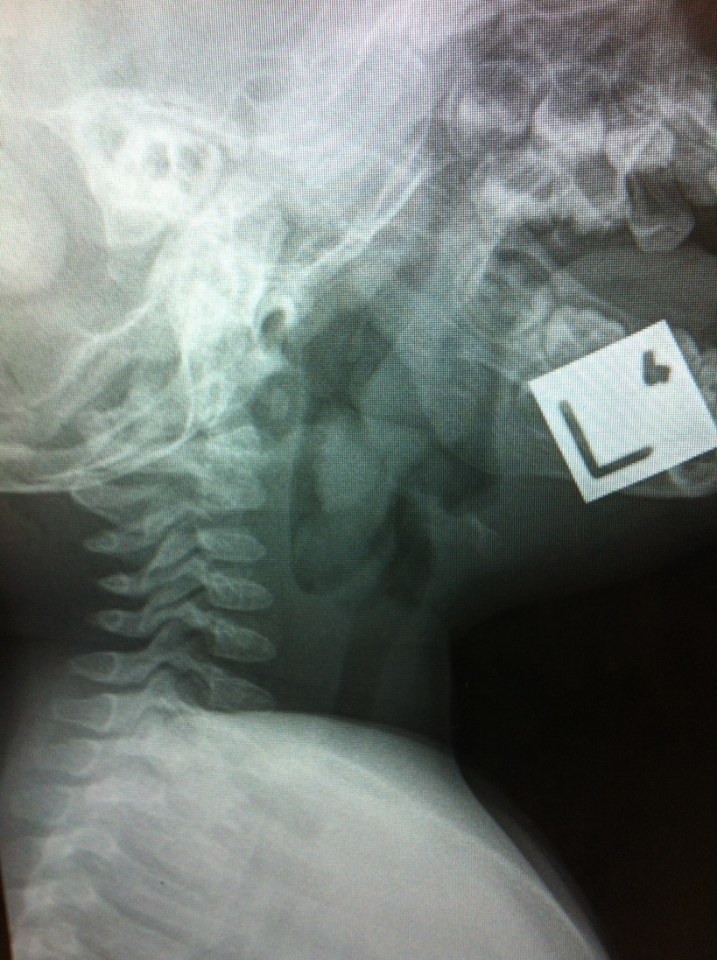

a. What is the major abnormality on the neck x-ray? (2 marks)

Large radio opaque FB (Snag) in allecular and partially occluding upper airway

b. List and justify 3 options to managing her airway issue. (6 marks)

1. Straight to OT with ENT/paeds anaes: has airway now, prob safest, could go bad on way up to OT, may not be possible if in small place
2. ED RSI : if loses airway needs first aid (back blows) then direct laryngoscopy with magills for FB removal; should be achievable in all EDs (backup Cric)
3. Delayed RSI/sedation in ED after getting help down to ED (eg anes/ENT etc). Good approach if remains stable, issues with OT etc etc

c. What are 2 ways an unwitnessed bronchial foreign body aspiration may present in children. (2 marks)

present with persistent or recurrent cough, wheezing, persistent or recurrent pneumonia, lung abscess, focal bronchiectasis, or hemoptysis
70. A 27 year old woman is brought in by housemates to your tertiary ED. She had been not seen for 2 days and was found beside her bed slumped on the floor.

Her observations are:
GCS 13
P 128 /min
BP 95/50 mmHg
T 34.7 °C

a. What are the 3 most important abnormalities on the UELFT? (3 marks)

Renal failure, rhabdomyloysis , hepatitis (?ischaemic)

Sodium 136 mmol/L 137-145
Potassium 4.0 mmol/L 3.2-5.0
Chloride 92 mmol/L 98-111
Bicarbonate 23 mmol/L 22-31
Urea 23.2 mmol/L 2.5-7.5
Creatinine 424 μmol/L 60-110
Est. of GFR 15 mls/min >90
Glucose 3.6 mmol/L 3.5-5.5
Osmol-calc 292 mmol/L 280-300

Bili Tot. 10 umol/L 2-20
ALT 720 U/L <55
AST 15 U/L 5-50
ALKP 89 U/L 20-110
GGT 23 U/L 15-73

CK >103000 U/L 20-200
CRP 1.2 <10

b. List the principles of your fluid management. (4 marks)

ivf crystalloid eg NS, bolus to make restore BP systolic >100 then aim euvolaemic clinically. And then use iDC to guide UO , Aim at least 100ml/hr urine ; consider frusemide/alkalisation to achieve this for rhabdo. Watch for signs volume overload

c. List 6 differential diagnoses. (3 marks)

drug overdose; head injury; hypoglycaemia, seizure, attempted suicide (eg asphyxiation), exac established underlying renal disease; sepsis; SAH ; ethanol abuse

71. A 58 year old man with a PPM presents to your rural ED with palpitations intermittently for 8 hours.

His observations are:
P 60 /min
BP 123/54 mmHg
Sats 96 % RA
GCS 15

An ECG is done and is shown below.
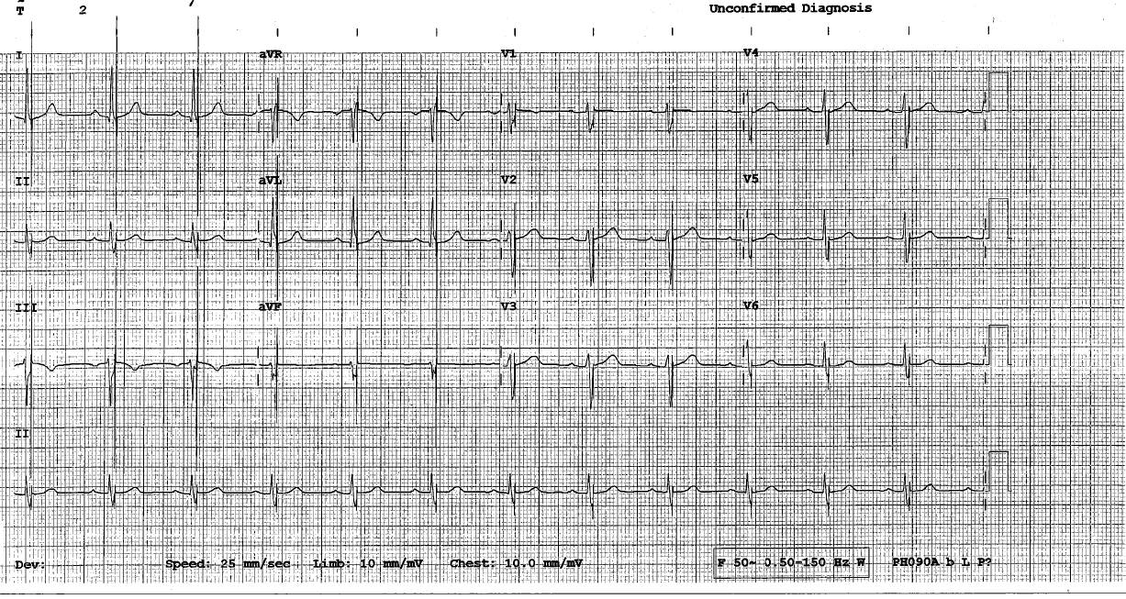

a. What is the ECG diagnosis? (2 marks)

Failure to sense (spikes occurring after native QRS during absolute refractory period)

b. List 4 possible causes. (4 marks)

battery weak, lead damage, electrolyte imbalance, myocardial ischaemia; fibrosis at lead tip; dislodgment of lead ; sensitivity needs adjusting

c. Outline the major consideration of arranging his disposition. (4 marks)

Rural hosp ; no immed risk unless begins trying to pace on T wave , then risk VF. Thus
Obtain receiving hosp cardiology advice first
needs TF to centre with PPM facilities
urgency depends on cause (thus initial screen in rural ED )
needs to be escorted by paramedics able to respond if arrhythmia and remain monitored
Depending on location and timing road vs air

72. A 58 year old Chinese Australian woman presents with fatigue. On examination she has a pulse of 95 /min, BP 100/45 mmHg and sats of 98% RA. She is afebrile. She appears deeply jaundiced.

Bloods are done and appear below
FBE. Hb 39
RCC 0.95
MCV 129
Retics 31.58%
WCC 5.4
Neut 4.26
UELFT Na 137
K 3.6
Cl 106
HCO3 17
Urea 4.4
Cr 66
Bili 137
ALT 5
LDH 693
GGT 20
ALP 79

a. Interpret the blood tests and provide a provisional and differential diagnosis. (3 marks)

Autoimmune haemolytic anaemia; any other haemolytic anaemia (RBC disorders; lead poisoning; G6PD etc);,occult GI bleed in cirrhotic;

b. List 3 other pathology tests with a brief justification you would order to help determine the diagnosis. (3 marks)

Blood film (abnormal RBC morphology); retics (raised in HA); Coombs test (+ = immune mediated); haptoglobin (decreased in HA); coags (bleeding diathesis)

c. Briefly outline your management. (4 marks)

Grossly anaemic but HD stable will require transfusion in conjunction with therapy directed at cause
Thus obtain blood for XM
Correct coagulopathy if present
Transfuse PRBC x3 initially . Aim for Hb >70 initially
Wait for full XM, avoid crystalloid, Oneg unless active bleeding
Does not need ‘resuscitation’ unless evidence active bleeding
Rx process eg prednsiolone for AIHA (haematology advice)
Aggressively Mx/Ix if evidence GI bleed: (PPI, octreotide, scopes, CTAs)

73. A 55 year old man comes into ED with a history of gastroenteritis for 4 days.

His ECG is shown below.

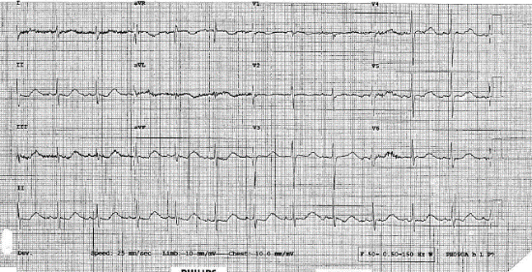

a. What is the most important abnormality? (1 mark)

Long QT

b. List 3 important features to obtain from the history of presenting complaint. (2 marks)

Medication history esp macrolides; antipsychotics; antihistamines, antiarrhythmics, antidepressants; diuretics
History of known QTc congen
Comorbid disease contributing eg thyroid dysfunction; IHD, myocarditis renal dis
Extent of GI losses: dehydration etc
Severity of illness: abdo pain, fevr; blood in stool

c. List the most likely cause in this context and then 2 alternate differentials. (2 marks)

Likely hypo K (Mg or Ca); DDx drug use with impaired excretion eg ARF ; medication interaction; overdose; congenital cause; alcoholism (hypoMg);

d. List and justify your immediate management priorities. (5 marks)

At risk for arrhythmia
Monitored bed
IV access urgent VBG
Avoid any meds that prolong QT
Replace volume; monitor progress with UO, thirst, obs
Replace electrolytes via IV infusion eg K+ 10mmol/hr
Symptomatic Rx: antiemesis, analgesia
Have Mg ready

74. A 25 year old man is brought into your regional ED after a bicycle accident. He is not moving his legs and has limited upper limb movement. He has a soft stridor.

His vitals are:
GCS 14
P 62 /min
BP 80/40 mmHg
Sats 95 % 10L O2

A CT neck is done as part of his assessment.
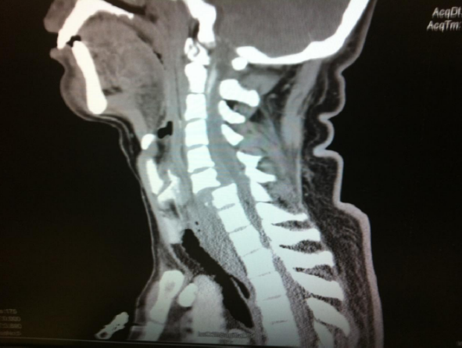

a. Describe the major abnormalities. (3 marks)

Bilateral facet dislocation atC6/7 with posterior displacement by one vertebral width and spinal cord impingement. Large haematoma anterior to C5-T3 causing tracheal and airway compression at subglottic and glottis level

b. Outline your management of his airway and breathing. (7 marks)

Needs airway soon but not NOW.
Potentially difficult ++
MILI and gentle technique mandatory
Careful planning
preO2 as much as possible
Support BP: fluids then pressors as likely neurogenic shock (must have pressor available if not given pre induction). Induction drug must be HD Ok (eg ketamine fentanyl, not big dose props)
Mandatory backup surgical option considered
Options depend on access in institution ; thus OT with fibreoptic/gas; definitie trache primarily with ENT; glidescope in ED with bougie etc. Consider other injuries in decision making

75. You are the director of an urban district ED. Your short stay unit has been suffering with prolonged length of stays and high admission rates.

a. List 5 contributing factors to these issues. (5 marks)

Inappropriate pt selection: ; Lack of senior oversight; lack of clear guidelines for use; use as holding ward for admitted pts; lack of allied health/multidisc input; community support options eg respite NH places etc; ambulance delays ; social factors in ED population; staff training inadequate; nursing support /staffing levels; inpatient team access to admitting power; lack of SOPS for common conditions

b. Outline the key steps in improving the short stay unit’s length of stay and admission rates. (5 marks)

Start with overview of current process; review existing literature; review hospital/obs unit policies as stand; consult major stakeholders then
Clear guidelines for admission; staffed by ED; regular senior review required; senior decision for admit; care plans for common conditions; multidisciplinary input; must keep to accepted standards eg LOS <24 hrs; admission rate less than 10-20% ; audit of performance

76. A 35 year old woman arrives after being brought in by friends due to her altered level of consciousness. Last seen 4 hours ago. They state she has been upset recently and has been commenced on 2 new medicines by her GP. Her GCS is 10, P 130 /min, BP 102/44 mmHg. She is Afebrile.

a. List 4 key ECG features you would look for on initial assessment and justify those. (4 marks)

Wide QRS (Na channel blocking drugs); long QTc (K+ blockers; antidepressants, antipsychotics); R wave positive in avR or deep S in 1 (na channel blockers);; ST-T changes (SAH, ICH); P waves vs AF vs SVT (tachycardic P130); Congenital abnormalities eg Brugada; HCM

b. List 3 key examination findings and relate these to differential diagnoses for her presentation. (3 marks)

Pupil size and reaction: pinpoint; opioids, cholinergics; dilated, amphetamines, anticholinergics; asymmetric (raised ICP)
Chest crackles: unilateral (aspiration); bilateral (aspiration, APO post opioid)
Clonus (serotoninergic drugs
Signs of head trauma/BOS #
Focal neuro abnormality (SAH, ICH, hypoxic BI etc)
Self harms signs (cutting, strangulation) ? suicidal
Ketotic breath, Kussmaul resps (met acidosis , DKA)

c. List 5 key historical features you would ask her friends and justify. (3 marks)

Names of medicines doses , empty packets; Comorbidities particularly diabetes, depression, SCZ, bipolar; prior self harm suicidailty recently; any recent illnesses partic headache, fever; illicit drug use; social supports/family;

77. A 55 year old woman is brought in with a GCS of 7.There is no sign of trauma. There is a history of ethanol abuse. P 105 /min, BP 100/40 mmHg, afebrile, Sats 98 2L NP, RR 34 /min.

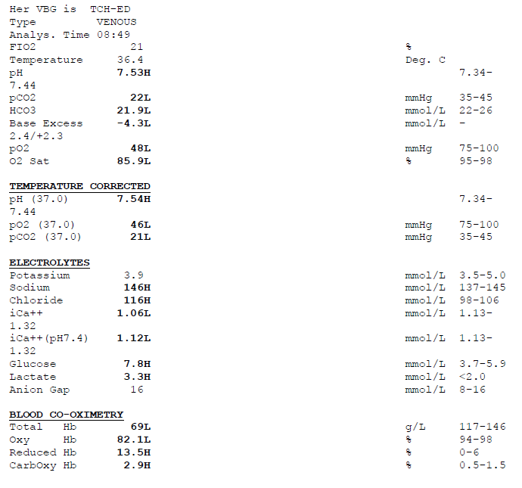

a. What is the acid-base abnormality? (1 mark)

Resp alk incomplete metabolic compensation suggesting acute

b. What are the 3 other significant findings? (1 mark)

Hyperchloraemia, anaemia; raised lactate; borderline na and k, mild carboxyHb; negative BE

c. What is the likely diagnosis (with justification) and what are 2 differentials? (3 marks)

GI bleed leading to hepatic encephalopathy: known etoh, resp alk common, low Hb Gi blood common trigger for enceph; DDx: OD eg aspirin; Head injury, stroke; psychogenic

d. Outline your major goals of management. (5 marks)

Requires intubation and ventilation; followed by urgent CTbrain to exclude head injury/CVA; followed by blood transfusion/coagulopathy correction and urgent endoscopy; needs lactulose, avoid large volumes sodium; Start PPI, consider octreotide if known varices.; ceftriaxone Also needs family discussion as very unwell . disposition ICU under gastro

78. A 72 year old man comes in with change in facial appearance and mild headache.

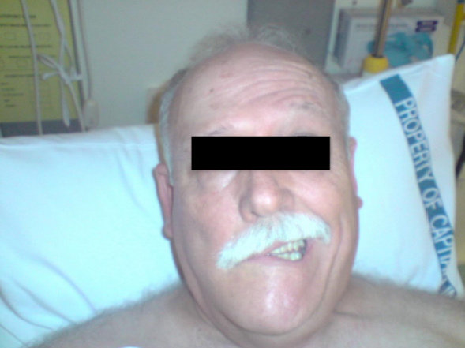

a. What are the key clinical findings from this photo? (2 marks)

R facial droop, Forehead sparing on left

b. What is the likely diagnosis with justification? (2 marks)

Bells palsy as sparing suggests LMN lesion

c. What other findings would you search for on physical exam? (2 marks)

Herpetic lesions (ears, nose, eyes), other focal neuro abnormality particularly multiple other CNs; ticks in ear/folds;

d. Outline your disposition and management plan (4 marks)

Usually home if confirmed bells; give Prednisolone consider valaciclovir if <72hr; needs attention to eye care and advice re taping, lubrication; prognosis advice re likely full recovery but risk of partial or non recovery; GP FU with neurology if persisting or DDX not excluded

79. A 22 year old man presents having taken an overdose 2 hours ago. His family state he may have taken aspirin.

a. What clinical features might the patient have? (4 marks) (any of)
- GIT
    - nausea and vomiting.
    - There can be significant dehydration, from this as well as increased insensible respiratory losses.
- Eighth cranial nerve involvement:
    - Tinnitus
    - Deafness
    - Vertigo
- Respiratory:
    - An ARDS (non-cardiogenic pulmonary edema) type syndrome may occur.
- Hyperthermia.
- CNS:
    - Confusion/ altered conscious state.
    - Seizures
    - Cerebral oedema with coma and death.

b. State 2 biochemical abnormalities that might be evident. (2 marks)
- Hypergylcaemia
- Hypoglycaemia
- Respiratory alkalosis
- Mixed respiratory alkalosis and metabolic acidosis
- Hypokalaemia

c. What are the indications for urinary alkalinisation? (2 marks)
- Symptomatic poisoning
- Acid-base abnormalities
- Serum salicylate levels > 2.2 mmol/L

d. What patients can be discharged? (2 marks)
- Asymptomatic.
- Two falling salicylate levels within the therapeutic range, 3 - 4 hours apart.
- Normal biochemical results, including ABGs.
- Low risk psychiatric assessment

80. A 60 year old woman presents to ED with the primary complaint of being a ‘funny colour’.

Blood results reveal:
Bilirubin 60 (1-20)
AST 400 (4-45)
ALT 200 (0-45)
GGT 125 (0-60)
Amylase 100 (25-136)

a. What is the predominate pattern of these blood results? (1 mark)

hepatocellular damage/transaminitis

b. What are your 4 most likely differential diagnoses? (4 marks)

infectious – viral hepatitis (A,B,C)
toxins/drugs – paracetamol/alcohol/prescribed medications
tumour – benign, malignant, metastatic
immune – autoimmune, related to systemic illness
?consider haemolysis if unconjugated hyperbilirubinaemia, but transaminitis doesn’t fit this picture, would have to be 2 processes

c. List 5 further investigations you would order in the ED to assist your diagnosis. Briefly justify each one. (5 marks)

FBC – look for haemolysis, bone marrow suppression (alcohol, tumour) (?retics, haemolytic screen) (would want conjugated vs unconjugated bili)
Serology – hepatitis A,B,C
Alcohol/paracetamol level or other drug levels – toxin induced transaminitis
?Albumin/coags – will identify degree of liver failure, chronic picture, won’t point to specific diagnosis
CXR – looking for primary malignancy
Hepatic USS – tumours, cirrhosis, (duct obstruction although not obstructive picture)

81. An 18 year old factory worker is rushed to ED having sustained a chemical burn to his eye. He thinks the chemical had ammonia in it. It is now 20 minutes since the accident.

His eye is pictured here.
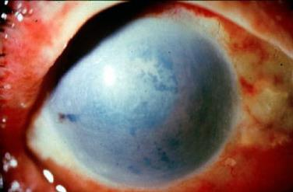

a. Describe the picture. (3 marks)

There is marked clouding/opacification of the entire cornea, limbal ischaemia (must note), conjunctival haemorrhage, swelling, inflammation, inflammation of the eyelid tissues. These features are consistent with a significant/severe alkali corneal chemical burn.

(3 marks) – Must include limbal ischaemia or whitening around cornea, conclude a severe or significant alkali burn.

b. What is your immediate management? (4 marks)

1. Copious Irrigation – water, normal saline, continuous, high volume, aim for pH <8 (may say 7.5) on litmus paper.
2. Analgesia – topical amethocaine or equiv, systemic titrated to pain score
(3. Treat associated burns (skin, other eye))
4. Refer Opthalmology given severity of burn

c. Name 3 things you would do to assess this injury, including prognostic indicators. (3 marks)

1.Hx – collateral history, confirm chemical involved – industrial alkali?
2. Exam – slit lamp -assess for limbal ischaemia (prognostic indicator), depth of burn
(pH if not mentioned above, litmus paper)
3. Visual acuity

82. A 74 year old lady presents to ED with a history of being found on the floor at home confused.

Her arterial blood gas is shown below
FI O2 = 6 litres O2

pH 7.29 (7.35 – 7.45)
pO2 80 mmHg (35 – 45)
pCO2 64 mmHg (90 – 100)
Bic 30 mmol/l
Base excess +3

a. What do these blood results indicate? (Interpret these results) (3 marks)

Pt is acidaemic. Acute on chronic respiratory acidosis with partial/incomplete metabolic compensation (for full chronic expect HCO3:pCO2 ratio up 4:10, so PCO2 up by 20, bic should be up by 8 = 32.)
Type 2 respiratory failure as evidenced by raised pCO2 and relative hypoxia on 6 l O2.
(Some people worked out the Aa gradient - ?accuracy on 6l, what is FiO2?.)
(This is an old question, not enough info for SID, etc.)

b. Name 4 conditions you should consider in the differential diagnosis for the woman’s presentation. (4 marks)

1. Acute/infective exacerbation of COPD
2. Central cause - ?1o ICH, TBI due to fall
3. Toxins – opioid or sedative overdose with respiratory depression
4. (?PE – on background COPD) or one of the below
There is a wide differential, eg hypoglycaemia, PE, pneumonia with sepsis, trauma to chest wall – difficult to mark!

c. List your immediate management priorities. (3 marks)

1. Remove high flow O2
Ensure patent/protected airway
2. Manage breathing and respiratory failure - ?bronchodilators, (steroids), n/p O2, BiPAP, aim for O2 sats 90% and aim to reduce hypercarbia, improved respiratory function
C – treat associated or induced hypotension, dehydration, arrhythmias…
3. Treat associated injuries/conditions, eg. spinal immobilisation if appropriate.
(Plenty of management things but focus on the immediate). One suggestion was to consider ceiling of care, goals of care – would mention this before mentioning intubation)

83. A 25 year old previously fit and well man presents to the ED with chest pain following a tackle at rugby.

An ECG is attached.
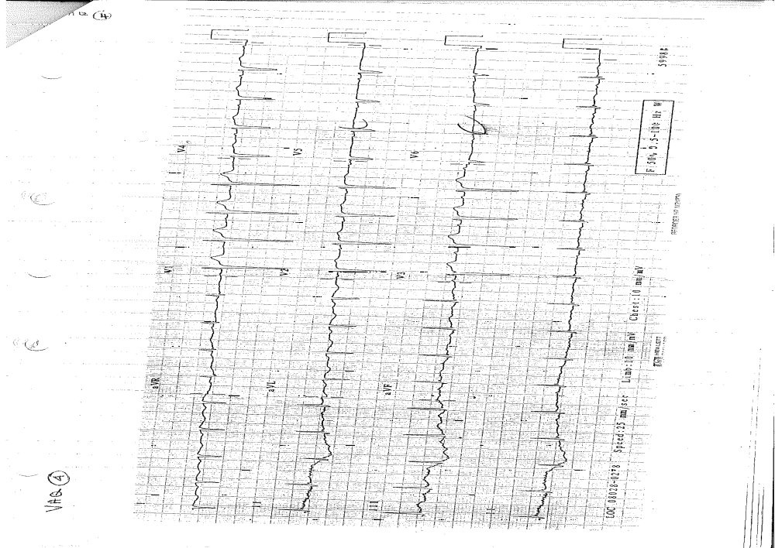
a. Describe the ECG. (3 marks)

Sinus rhythm, rate 100 bpm, regular
Axis - RAD
pr interval normal
qrs complexes narrow
Large r wave in V1, low voltage and negative complexes V5-6
Not pathognomonic for any particular pathology

b. What are 3 possible causes of the ECG appearance? (3 marks)

Given stem = trauma
1. Pneumothorax
2. Myocardial contusion (not high velocity trauma so less risk)
3. Lead misplacement – unusual axis, V1 and lateral lead appearance, or idiopathic

c. How would you further assess this patient? (4 marks)

Hx – severity of injury and mechanism , previous cardiac hx, prev pneumothorax, previous ECG
Exam – ABC stability (look for tension pneumothorax), tracheal deviation, chest sounds, hypotension, assess for C spine injury, secondary survey
Ix – Trauma series - CXR, C spine xray, (?pelvis), bedside USS for pneumothorax, pericardia effusion
(4 marks) way too much for 4 marks! Must include something from each Hx/exam/Ix, some assessment of severity and Ix for pneumothora

84. A 1 year old presents to your ED with a history of a few days of fever and general unwellness.

A picture of his hand is attached.

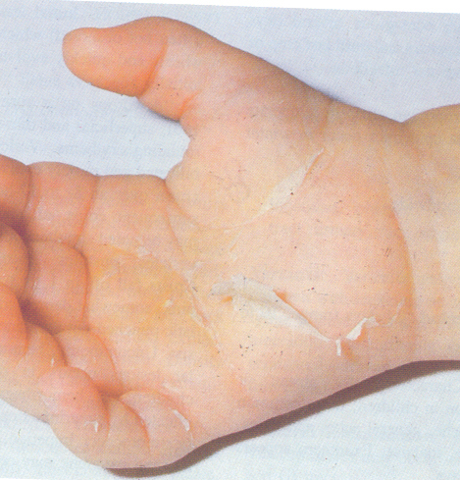

a. List 4 differential diagnoses for this patient. (4 marks)

1. Kawasakis disease
2. Staph scalded skin syndrome or toxic shock, can be strep
3. Drug induced – Stevens-Johnsons or similar
4. Consider traumatic burn, neglect, (?NAI), although stem not suggestive

b. List 4 other features you would look for on examination to support your most likely diagnosis. (4 marks)

1.(Elevated temperature?)
2. Lymphadenopathy
3. Conjunctivitis
4. Mucous membrane involvement - Strawberry tongue. lip peeling
5. Polymorphic rash
(4 marks) – any of these acceptable, note the peeling is generally in convalescent so the rash and acute changes may not be present

c. List possible complications of this condition. (2 marks)

vasculitis
coronary artery aneurysms
(2 marks) Tricky is alternative dx given – complications could be seeding infection

85. A 50 year old man presents to ED unable to weight bear on his right leg after falling 4 metres off a ladder.

His x-ray is shown below.
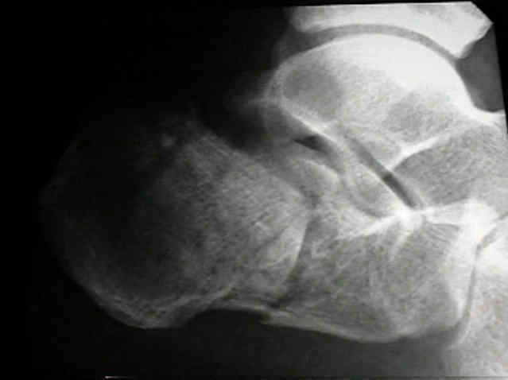

a. Describe the x-ray finding. (2 marks)

Lateral xray of posterior foot, single view. Displaced fracture through the body of the calcaneus with possible further comminution more posteriorly. Bohlers angle is reduced in keeping with the displacement of the posterior portion.

b. List 4 commonly associated injuries or complications of this injury. (4 marks)

1.Axial fractures - # hip, lumbar spine
2. # other calcaneus
3. Compartment syndrome
4. Non-union, malunion and long term disability

c. List your immediate management priorities in this patient. (4 marks)

1. Analgesia
2. elevation and non-weight-bearing, will need backslab
3. Treat other associated injuries, including spinal immobilisation if indicated (may be no. 1?)
4. Consideration of operative management requiring admission under Orthopod
(4 marks) Disposition may not be immediate Mx!

86. A 50 year old woman presents to ED with a 4 days history of malaise, intermittent fever, and the rash depicted here.

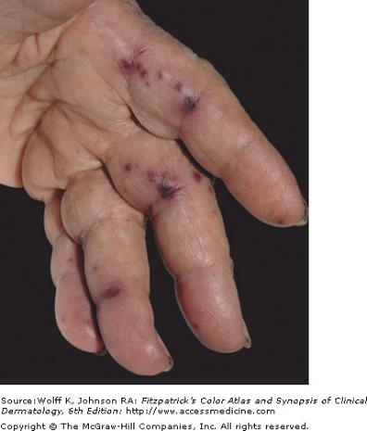

a. Describe this rash. (3 marks)

Picture of left hand palmar aspect
Multiple haemorrhagic lesions along the palmar aspects of fingers – appearance of petechiae or purpura, suggestive of septic emboli.
The diagnosis is Janeways lesions, indicative of sub-acute bacterial endocarditis.

b. List 4 important examination findings that would be relevant in this case. (4 marks)

1. Elevated temperature – may be intermittent
2. Cardiac murmur
3. Other septic emboli – Roths spots, Oslers nodes, petechiae
4. Signs cardiac failure – S3, lat apex, pulmonary oedema…

c. Name the 4 most relevant investigations that you would perform in the ED. (4 marks)

Blood cultures
FBC
ESR/CRP, inflammatory markers
?coagulation screen
?Echocardiogram – debate as to whether this is a ED Ix – would preface by saying if signs acute valvular dysfunction or cardiac comprimise

87. A 41 year old man is brought in by ambulance with a one hour history of palpitations associated with chest discomfort. His GCS is 15 and BP 90/60 mmHg.

His ECG is attached.

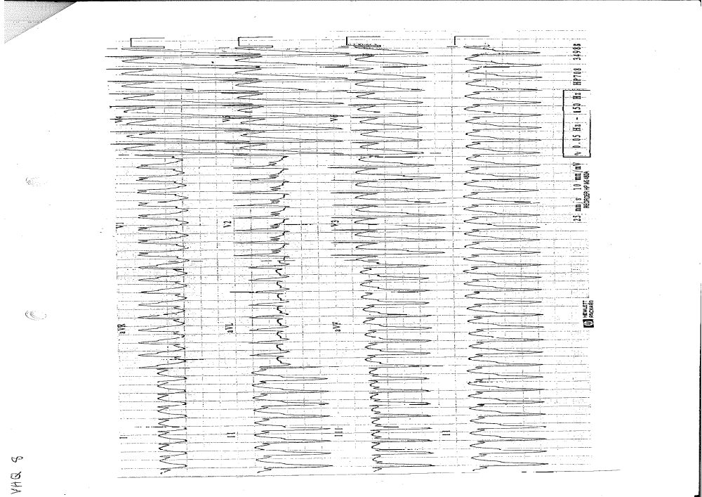

a. What is the most likely diagnosis? (1 mark)

VT

b. What features on history and ECG are supportive of your diagnosis? (3 marks)

Hx – age over 35
ECG – regular broad complex tachycardia, assume VT as safest approach, see ARC guideline note below
Very high rate 200 bpm
‘Northwest axis’ +ve aVR, neg I, aVF
Brugada’s sign – onset QRS to nadir S >100ms seen in II
Josephson’s sign notching near nadir S wave
Not a RBBB or LBBB pattern

c. Name one algorithm or diagnostic criteria that you use clinically when interpreting an ECG such as this one. (1 mark)

A number of algorithms – Brugadas, ultra-simple Brugadas,….see LITFL VT page, great reference

d. Briefly outline your immediate management priorities. (5 marks)

VT with pulse, unstable patient by AHA criteria (hypotensive, chest pain), treat as per ARC or ILCOR guidelines
1. In resus, attention to airway, breathing, high flow pre-oxygenation
2. IV access for sedation – midazolam, judicious propofol, and volume CSL
3. Reversion strategy – DC shock sync 150 J biphasic, 200J mono (300 acceptable)
Consider chemical reversion while preparing if patient stabilises – amiodarone 300mg IV over 20min, then infusion 900mg over 24hr, or second line if DC CV fails or arrhythmia recurs(not sotalol as hypotensive)
4. Treat cause – ischaemia, toxins (drugs), electrolyte abnormalities, myocarditis, HOCM, treat any complications
5. Supportive cares – volume replacement, optimise electrolytes (K, Mg)
6. (Disposition Coronary care)
(5 marks) Lots to write
Notes -
Keep structure of Resus/Specific Care/Supportive Care/Treat cause/treat complications/disposition in the back of you mind.
Want to keep statements broad so all areas covered eg. say reversion as stem then electrical vs chemical – more opportunity to show breadth of knowledge as expertise encompassing holistic care

NB. For assessment questions always think something from each group – hx/exam/Ix.
Note - Summary Recommendations ARC 2009
Class A
• Wide-QRS tachycardia should be presumed to be VT if the diagnosis is unclear.
(Level of Evidence: C)
• Direct current cardioversion with appropriate sedation is recommended at any point in the treatment cascade in patients with suspected sustained monomorphic VT with hemodynamic compromise. (Level of Evidence: IV)
Class B
• Intravenous amiodarone is reasonable in patients with sustained monomorphic VT
that is haemodynamically unstable, refractory to conversion with countershock, or recurrent despite other agents. (Level of Evidence: IV)

88. A 35 year old woman presents to your ED with an acute asthmatic attack. She is on continuous salbutamol nebs, is highly distressed and only speaking single words.

a. Name 4 features on history that increase the risk of severe life threatening asthma. (2 marks)

- previous life-threatening attack,
- previous intensive care admission with ventilation,
- requiring three or more classes of asthma medication,
- heavy use of β-agonists,
- repeated emergency department attendances in the last year and having required a course of oral corticosteroids within the previous 6 months.
- Behavioural and psychosocial factors have also been implicated in life-threatening asthma including non-compliance with treatment or follow up, obesity and psychiatric illness.
Cameron 4th ed Ch 6.2

a. List at least 6 therapeutic drug classes that may be used in the treatment of a severe attack. (2 marks)

- Oxygen
- B2 agonist inh/neb/IV
- Corticosteroids
- Ipratropium
- Adrenaline
- Magnesium
- Aminophylline
- Heliox
- Ketamine (preferred induction agent.)

b. Outline what your initial ventilator settings would be. (4 marks)

- Needs a safe approach.
- Need to mention permissive hypercapnia to be tolerated if necessary.
- Lung protective Strategy
- Pressure or Volume control with attention to ensuring adequate minute ventilation.
- Tidal volume - maximum of 8ml/kg (6-8)
- RR – may need to be very low – start at 10 bpm, but be prepared to titrate down.
- I:E ratio – at least 1:3, may need to be 1:5. May need to adjust inspiratory time to achieve.
- Fi02 100%
- PEEP – controversial 0 or 5 mmHg (may have autopeep)
- Limits – Peak insp 35-40, plateau -35

c. What physiological targets are you aiming for? (2 marks)

- Pt heavily sedated
- Sats > 92%
- PaCO2 – tolerate PaCo2 up to 80 or higher if required.
- pH > 7.15
- normothermia

Alternative question parts.
- Describe the advantages and disadvantages of a class of medication. (ie. Magnesisum, or Salbutamol)
- What are the advantages and disadvantages of Non Invasive Ventilation.
- Describe how you would intubate this patient.
- The patient become hypotensive 5 minutes after intubation. What immediate actions do you take?
89. A 7 year old boy presents with acute respiratory distress. He is intubated in your department by a senior registrar as he has oxygen saturations of 84% on 15L oxygen via NRB mask and is tiring. You are called to the resuscitation room after intubation as his HR falls from 142 /min to 70 /min and oxygen saturations drop from 90% to 75% on 100% oxygen. He is attached to the Oxylog 3000 ventilator. The registrar reports a first pass intubation taking 40 seconds to complete.

a. List your top 6 differential diagnosis for this deterioration (6 marks)

Intubation issues: Anaphylaxis to induction agent, Tube misplacement (oesophageal/bronchial), Tube blocked
Ventilation issues: Ventilator settings inadequate/failure technical with e.g. gas trapping, pneumothorax
Worsening of underlying pathology

b. Outline your approach to the airway in the order that you would perform. (4 marks)

Disconnect from ventilator and bag mask for feel with 100% oxygen
Check ETT placement (ETCO2, auscultation)
Suction ETT
Reintubate if suspected failed intubation

90. A 70 year old man with type 2 diabetes presents to your ED with 24 hours of malaise. His initial observations are: HR 120 /min and BP 70/40 mmHg. His bedside BSL is 11.2 mmol/L and his central capillary refill is 5 seconds. He is confused and review of past notes indicates that this is new and he has a history of alcoholism.

a. What are the 3 most likely causes of this presentation? (3 marks)

Sepsis, Haemorrhage, Cardiogenic

b. What key initial investigations will you perform? (4 marks)

Any of: VBG with stat profile, RUSH USS exam, ECG, urine
analysis, CXR, Clotting screen

c. You perform a PR that shows heavy melena, the patient then has a large fresh haematemesis. List 4 initial management. (2 marks half a point for each)

Blood and products avoiding with permissive hypotension
Terlipressin 2g IV(or vasopressin/octreotide)
Cefotaxime 1g IV
Vitamin K 10mg IV,

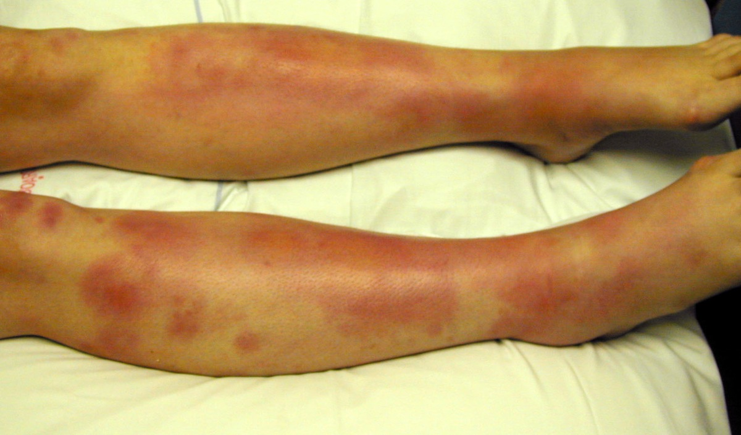
91. This 24 year old female presented to the emergency department complaining of painful lumps and redness confined to her lower legs which had developed over the last two weeks.

a. List your main differential diagnosis with the most likely listed first. (5 marks)

Erythema nodosum
Cellulitis
Contact dermatitis
Insect bites
Burns
Erythema multiforme
HSP
Trauma
Erythema induratum
Well’s syndrome
Panniculitis

b. List the most likely aetiologies for the most likely diagnosis. (5 marks)

minimum of 3 from bold list
Streptococcal pharyngitis
Sulphonamides other drugs and vaccines e.g. OCP
IBD
Pregnancy
Salmonella
Yersinia
Idiopathic
Sarcoidosis
Rickettsial infections
Eponymous – Bechet’s
Hansen’s disease
Neoplasia (lymphoma)
Tuberculosis
EBV
Hep B
Chlamydia

92. A 17 year old male is brought to ED by ambulance, complaining of abdominal pain and vomiting. He appears confused and is unable to prvide a good history. On examination his vitals are: Temp 37.9 ºC, BP 100/50 mmHg, HR 110 /min.

Blood tests taken on arrival show:

Na 140 mmol/l (135-145)
K 5.0 mmol/l (3.5-5.5)
Chloride 100 mmol/l (95-110)
Creatinine 0.1 mmol/l (0.03-0.08)
Urea 16 mmol/l (3.0-8.3)
Glucose 40 mmol/l (3.3-8.3)

Hb 167 g/l (135-175)
PCV 50 % (41-53)
Plt 224 (140-400)
WCC 21.8 (4-11)
Neutrophils 19.2 (4-11)

pH 7.133 (7.35-7.45)
pC0₂ 24.8 (35-45)
p0₂ 112 (90-100)
HCO3 8.3 (24-32)
BE -19.6
Sa02 96.8 %

a. List the major abnormalities. (4 marks ½ for each)

Marked hyperglycaemia
Severe metabolic acidosis
Elevated anion gap of 27 (includes K)
Mild respiratory acidosis as expected C02 20.45 +/- 2
High osmolality 336
Elevated WCC: sirs/sepsis
Corrected Na 149 elevated
Potassium normal but secondary to shift with dehydration and acidosis so whole body stores likely low

b. What is the diagnosis? (1 mark)

DKA

c. What is your initial management? (5 marks)

Initial fluid resus correct shock then 500ml/hr for 4 hrs (titrate to response) Crystalloid of choice
Insulin 0.1 units/kg/hr initial rate
K+ replacement 10mmol/hr and monitor
Prophylactic LMW heparin
Teat precipitant
Disposition ICU/HDU

93. A 30 year old man presents after 24 hours of vomiting. He looks sweaty and unwell.

Initial observations: Temp 37.2°C, HR 120 /min, BP 80/50 mmHg, RR 22 /min, Sa02 99% on room air.

Initial lab results:
Hb 154 g/L (110-165)
WCC 13.3 x10⁹/L (3.5-11)
Plt 239 x10⁹/L (140-400)
Na 130 mmol/L (135-145)
K 5.2 mmol/L (3.5-4.5)
Cl 101 mmol/L (100-110)
HC03 21 mmol/L (22-33)
Urea 10.7 mmol/L (3-8)
Creat 94 umol/L (50-100)
Ca (total) .39 mmol/L (2.15-2.6)
Alb 48 g/L (33-47)
Gluc 4.1 mmol/L (3-7.8)

a. What are the abnormalities? (2 marks)

(must grade levels of abnormality for full marks)
Mild hyponatraemia
Mild hyperkalaemia
Mild metabolic acidosis with normal anion gap of 13

b. List your differential diagnosis with most likely listed first. (7 marks)

Hypoaldosteronism
Hyperemesis from cannabis
Gastritis
Hypoadrenalism (although normal glucose against)
Drugs (ACE inhib, K sparing diurectics, CAH inhibitors)
Renal Tubular acidosis
Ketosis
Sepsis
Panreatitis
Any other reasonable cause

c. What test is used to confirm the most likely endocrine diagnosis? (1 mark)

Short Synacthen test

94. A 55 year old man is referred to your ED by his GP with a complaint of being “generally unwell”. He has a history of hypertension.

The patients chemistry and venous blood gas are shown below:

Na 144 mmol/L (135-145)
K 1.7 mmol/L (3.3-4.9)
Cl 85 mmol/L (98-106)
HC03 40 mmo/L (3.0-8.0)
Creat 0.08 umol/L (0.05-1.12)

pH 7.56 (7.35-7.45)
pC0₂ 44 mmHg (35-45)
p0₂ 68 mmHg (90-100)

a. Describe and summarise the results. (4 marks)

Life threatening hypokalaemia (mandatory to pass)
Hypochloraemia
Metabolic alkalosis with elevated bicarbonate
Anion Gap 20
Normal renal function
Expected C02 43 – appropriate resp compensation
Borderline hypoxia (likely secondary to hypoventilation)
Hypochloraemic hypokalaemic metabolic acidosis

b. What is your differential diagnosis? (6 marks)

Loss of Hydrogen
Renal: Hyperaldosteronism, primary (Conn’s) or secondary, Cushing’s, Bartter’s syndrome)
Upper GI: Vomiting
Drugs: corticosteroids, diuretics

Gain of bicarbonate
Sodium bicarb tablets
Secondary hyperparathyroidism

95. A 65 year old man with insulin dependent diabetes mellitus presents to the ED with a marked sudden decrease in vision.

a. What are your top 6 differential diagnoses? (3 marks)

Central retinal artery occlusion - mandatory
Central retinal vein occlusion - mandatory
Retinal detachment - mandatory
Vitreous haemorrhage - mandatory
Optic neuritis
Loss of contact lens
Cranial nerve palsy causing diplopia
Giant Cell arteritis
Toxic metabolic neuropathy/any post chiasmal cause e.g. CVA, acute glaucoma/local trauma etc

b. What are the key historical features you would ask for to help differentiate between these? (7 marks)

Monocular vs binocular
- Moncular – ophthalmologic cause
- Binocular- central cause – need stroke workup
Painful vs painless visual loss
- Painful favors acute glaucoma, optic neuritis and iritis
Sudden onset profound loss in CRAO
- often preceded by episodes of amaurosis fugax
- occurs over seconds
Spectrum of loss in CRVO
- variable extent: blurring to complete monocular vision loss
- more gradual onset than CRAO
Photopsiae/floaters
- with retinal detachment and vitreous haemorrhage
- associated with underlying diabetic retinopathy
- decreased central/peripheral deficit e.g. dark curtain in visual field
Diplopia
- with diabetic cranial nerve palsy
- vascular compromise of cranial nerves to EOM
- direction of gaze producing symptom gives clue to nerve affected

96. A 60 year old female presents to ED with a painful red eye. There is no history of trauma.

a. What features on history and examination would you expect in acute closed angle glaucoma? (3 marks)

History
- Severe unilateral pain
- Nausea +/- Vomiting
- Reduced vision and halo’s
- Known Glaucoma
- Absence of trauma
- Presence of risk factors; e.g anticholinergic drugs, mydriatics, age, family history, known shallow anterior chamber

b. You diagnose acute closed angle glaucoma. Outline your management. (7 marks)

Antiemetic e.g ondansetron 4mg IV - mandatory
Analgesia likely opiate - mandatory
Acetazolamide 500mg IV then 250mg PO tds – mandatory
Pilocarpine 2% every 5 min for 1hr
Timoptol 0.5% every 30-60mins
Consider mannitol
Urgent Opthalmology consultation – mandatory

97. A 58 year old woman presents to the ED complaining of a five day history of sore throat and progressive difficulty swallowing. Examination reveals she is febrile with stridor at rest. Oropharyngeal examination does not reveal an overt diagnosis.

a. What is your differential diagnosis? (2 marks)

Retropharyngeal abscess – most likely
Prevertebral abscess – rare
Epiglottitis – rare
Peritonsillar abscess – expect local signs
Submandibular cellulitis – expect local signs

b. What are the key features in your immediate management? (8 marks)

ABC approach in Resus and keep sitting in comfortable position
Have difficult airway kit ready if needed
Keep NBM
Analgesia e.g. morphine/fentanyl
IV fluids if clinically dehydrated
Nebulised Adrenaline 5mg - mandatory
Dexamethasone 5mg IV - mandatory
IV Ceftriaxone 2g and Flucloxacillin 1g and metronidazole 500mg (or other appropriate as per local guidelines) - mandatory
Urgent ENT review – mandatory
Anaesthesia and ICU
Disposition HDU/ICU

97. A 74 year old female presents to ED with 2 hrs of left sided epistaxis. HR is 80 /min, all other vitals are within normal limits. She has been pinching the anterior nares tight for 20 minutes.

a. List 4 risk factors for epistaxis in this patient population. (2 marks)

Hypertension
Anticoagulants/antiplatelet
Atherosclerosis
Tumours
General: trauma, infection, nose picking, allergies, travel, low humidity

b. You examine the nose and the nostril is full of clotted blood, there is still active bleeding around this and the patient reports blood trickling down the back of their throat. Outline your approach. (6 marks)

Sit up in room with ENT equipment and good lighting
Ensure BP monitoring
IV access and check Hb and G+H
Personal PPE - mandatory
Nasal speculum to allow visualisation
Suction clots
Local anaesthesia spray with constrictor e.g. lignocaine and phenylephrine spray, or co-phenelcaine
Can try adrenaline soaked pledget with pressure if bleeding spot seen
Cautery (ring if active bleeding spot)
Disposition is discharge if treated ENT if packing or unable to obtain haemostasis

c. You are now able to examine the nose and there is still active bleeding but you are unable to see a bleeding point.

The patient’s vitals are HR 115 /min, BP 105/60 mmHg, Sa02 96% RA.

What methods are available to specifically treat this scenario? (2 marks)

Posterior packing: e.g rapid rhino or other device
Foley catheter if above unavailable/not working
Arterial ligation/embolisation if still bleeding and unstable

98. You have just intubated a 75 year old 60kg woman with deteriorating respiratory function after a fall causing isolated closed chest injuries. She has a history of COPD. She has become increasingly hypoxic and hypotensive since intubation. Your hospital does not have an intensive care unit.

a. List 8 causes for her deterioration (4 Marks)

Anaphylaxis
Ventilator failure / O2 disconnect
ETT misplacement / blockage
Pneumothorax (iatrogenic or traumatic
Breath stacking / hyperinflation
Lack of synchronisation / need for paralysis
Haemothorax
Worsening pulmonary contusions

b. Her hypotension resolves although she has an ongoing high oxygen requirement and high ventilator peak pressures. You have a simple VOLUME cycled ventilator.
List basic ventilator settings for this woman and outline your ventilation strategy. (4 Marks)

Lung protective ventilation. (1)
Avoid volutrauma (1)
Avoid barotrauma (0.5)
Accept permissive hypercapnoea. (0.5)
Use lowest FiO2 possible to avoid hypoxia.(0.25)
Rate 6-10 min (0.25)
TV 240-350mL (4-6mL/kg) (0.25)
PEEP 10cm H20 (or higher) (0.25)

c. This woman needs to be transferred to a tertiary hospital for ongoing management. A retrieval team will arrive in 2 hours to transfer her by fixed wing. You do not need to supply staff for the retrieval. Outline how you would prepare for this transfer. (2 marks)

Communicate with receiving team – where is she going who will be responsible?(0.5)
Prepare the patient – lines, medications, avoid pressure areas, ETT, catheter_(0.5
Prepare notes / xrays_(0.5)
Ongoing monitoring and care of patient while awaiting retrieval team (0.5)

99. A 68 year old woman presents with central chest heaviness and nausea. An ECG is performed and is shown below.

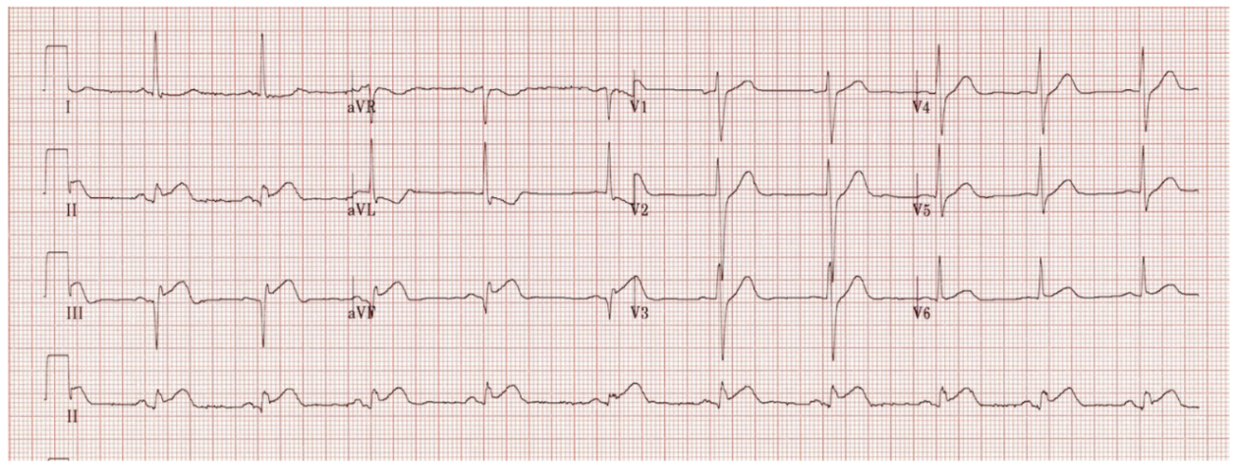

Her vitals are:
BP 120/70 mmHg
PR 60 /min
RR 18 /min
SaO₂ 99 % RA
GCS 15

a. List the 4 most important features on this ECG. (2 marks)

No model answer provided

b. List 3 arrhythmias associated with these ECG findings. (3 marks)

No model answer provided

c. You are 3 hours away from the nearest cardiac catheter facility. Describe how this might change your management approach. (3 marks)

No model answer provided

d. List 2 important management differences between an inferior ST-elevation myocardial infarction and an anterior ST-elevation myocardial infarction. (2 marks)

No model answer provided

100. The mother of a child makes a complaint.

She states that three days previously, her 5 year old son had presented to the ED with elbow pain after a fall onto his outstretched hand.

Following x-rays, the treating doctor had “pulled on the elbow several times causing him to cry”. The doctor stated that he had suffered a “sprained elbow” and to return if the pain did not settle. The mother is distressed that her son had received no analgesia for the sprain and that he continued to not move the elbow because of pain. She also complained that the doctor spoke in a rude and insulting manner, and was very rough in his examination.

During your investigation, you find that the official report of the x-ray revealed a supracondylar fracture.

a. Describe 3 steps in dealing with this child’s second presentation.

No model answer provided

b. List the 4 most important steps in dealing with the mother’s complaint.

No model answer provided

c. Describe 3 strategies to mitigate the risk of this happening again.

No model answer provided

d. List 3 key features which define a pulled elbow.

No model answer provided

101. Your director wants you to write a set of guidelines for the use of physical restraints on a patient in the ED.

a. List 3 indications and three contraindications for patients under these guidelines.

No model answer provided

b. Outline 4 mandatory observations that should occur during restraint.

No model answer provided

c. Describe 3 circumstances under which you would remove the physical restraints.

No model answer provided

d. List 3 legal frameworks under which physical restraint could occur.

No model answer provided

102. A number of staff have been assaulted over the last 6 months in your ED.

a. List 5 key stakeholders to involve in discussions around this issue.

No model answer provided

b. Outline 3 measures at triage to potentially decrease these assaults.

No model answer provided

c. Outline 4 hospital-wide measures (i.e. non-emergency department specific) to potentially decrease these assaults.

No model answer provided

d. List 4 factors which may have led to the increase in assaults.

No model answer provided

103. You have been called to assist a junior doctor dealing with an upset family. The family is unhappy with the proposal of a “Do Not Resuscitate” (DNR) order for their elderly mother.

a. List 4 factors which would support the proposal of a DNR order.

No model answer provided

b. Describe 3 specific methods for dealing with the upset family.

No model answer provided

c. List 3 key pieces of advice you would give your junior doctor in dealing with this in future.

No model answer provided

d. Assuming a DNR order was written up and a decision was made to palliate this patient, list 4 medications you would chart on the patient’s drug chart to assist this goal.

No model answer provided

104. A 48 year old man presents with dizziness and palpitations. An ECG is performed and is shown below.

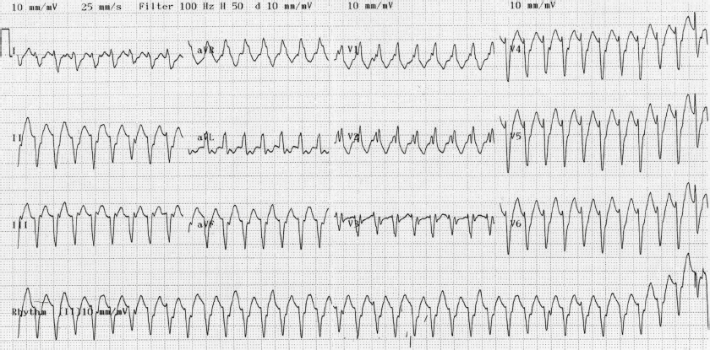

The patient’s vitals are:
BP 100/60 mmHg
RR 18 /min
GCS 15

a. What is the diagnosis? (1 mark)

No model answer provided

b. List 3 features on this ECG which supports your diagnosis. (3 marks)

No model answer provided

c. The patient’s BP drops to 70/40 mmHg and he becomes confused. Describe your 2 most important management priorities at this time. (4 marks)

No model answer provided

d. Is implantable defibrillator an option in this patient? Justify your answer. (2 marks)

No model answer provided

105. This 77 year old man presents with chest pain and dizziness on the background of Type II diabetes mellitus and a permanent pacemaker (PPM) for a sick sinus syndrome 3 years earlier. A recent PPM check was normal.

An ECG is performed and is shown below.
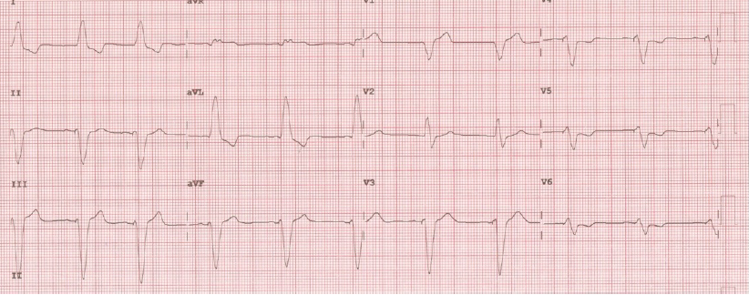

a. List 2 important abnormalities on this ECG. (2 marks)

No model answer provided

b. What is the likely pacing mode shown in this ECG? (1 mark)

No model answer provided

c. List 3 common pacing modes in use in Australia and the common clinical circumstances they are used in. (3 marks)

No model answer provided

d. Describe your immediate management priorities in this patient. (4 marks)

No model answer provided

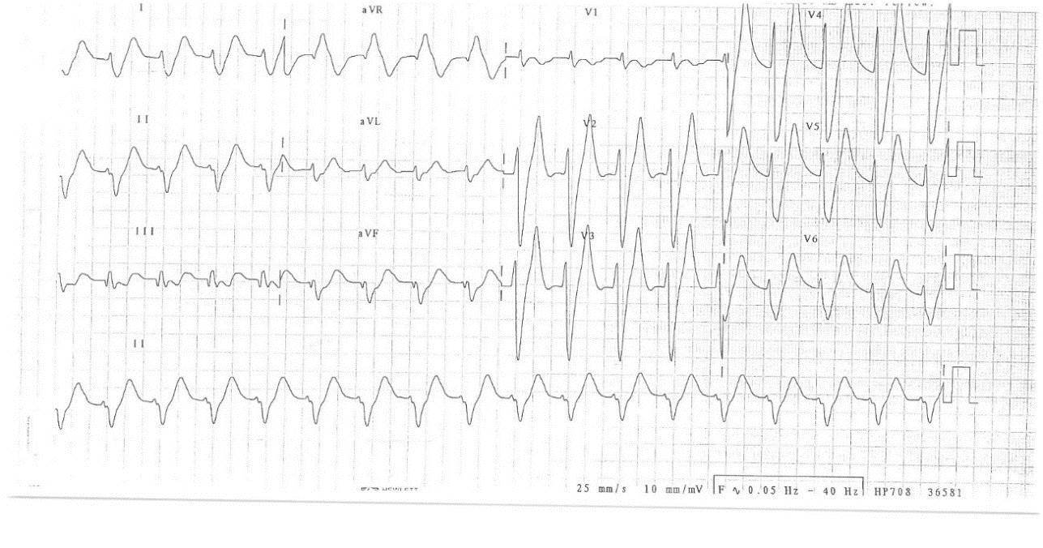
106. A 48 year old haemodialysis patient presents to ED complaining of muscle weakness and nausea.

Vital signs are:
Temp 37.2 °C
BP 100/50 mmHg
RR 20 /min
Sa02 94 % on air
GCS 15
Weight 76 kg

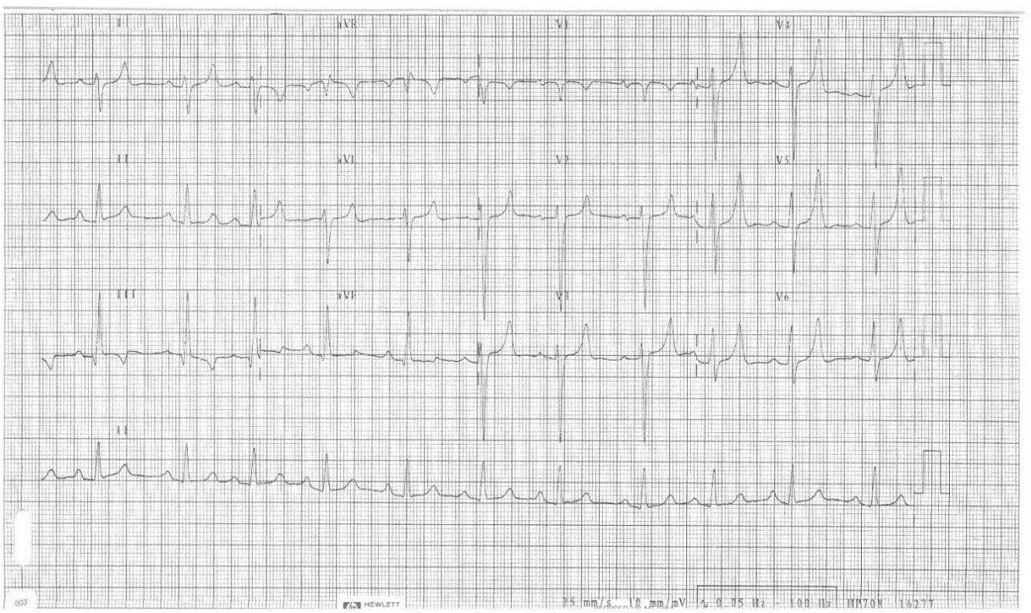
The following ECG is performed:

a. What is the key diagnostic feature of this ECG?

No model answer provided

b. List 5 potential causes of this condition in this patient.

No model answer provided

c. List 6 treatments for this condition in this patient.

No model answer provided

107. An 18 year old male presents the ED having a severe asthma attack. He is on high flow oxygen and receiving nebulised salbutamol.

His vitals are as follows:
HR 140 /min
BP 110/60 mmHg
RR 32 /min
GCS 13/15

An ABG is taken.
pH 7.10 (7.35-7.45)
pO2 54 mmHg (90-10)
PCO2 120 mHg (35-45)
HCO3 18 (24-32)
BXS -5
Lactate 4

a. List 4 abnormalities on this ABG. (2 marks)

No model answer provided

b. Give the names, routes and doses of 6 medications you would treat this man with. (3 marks)

No model answer provided

c. List 4 complications of RSI/ intubating this man. (2 marks)

No model answer provided

d. Describe your ventilator settings in a patient with acute asthma. (3 marks)

No model answer provided

108. A 55 year old man is brought to the ED after being found collapsed at home. He has a medication alert bracelet indicating he has type 1 diabetes.

His observations are:
GCS 12
BP 90/60 mmHg
HR 130 /min
RR 30 /min
Temp 38 °C

A photograph of the patient’s left thigh is taken and is shown below.
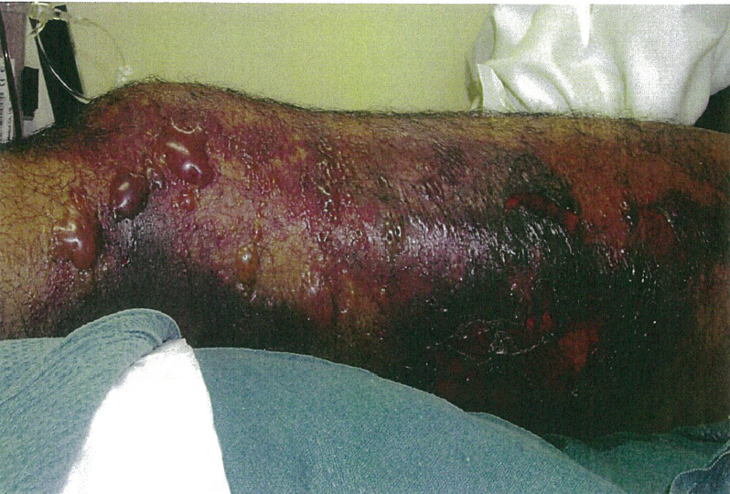

a. Give 3 differential diagnoses. (3 marks)

No model answer provided

b. Name the antibiotics, routes and doses you would use. (2 marks)

No model answer provided

c. Give a detailed description of management priorities for this patient. (5 marks)

No model answer provided

109. A 46 year old man is brought to your ED by ambulance following an overdose of unknown medications. He has had a brief generalized seizure en route.

On arrival his observations are:
GCS 12
BP 85/60 mmHg
Temp 37.0 °C
O₂ Sat 100 % on 8 L/min O₂

His ECG is shown below:

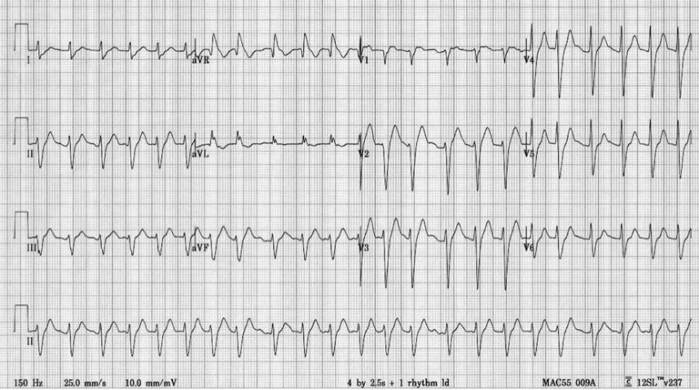

a. Describe the ECG. (5 marks)

No model answer provided

b. What are the first 5 things you would do to manage the patient? (5 marks)

No model answer provided

110. An elderly man collapses and is unresponsive at a shopping centre.

a. What are the 4 elements in the chain of survival that improve the probability of survival? (2 marks)

No model answer provided

He receives prompt BLS from bystanders, then defibrillation from an AED prior to the arrival of the ambulance 10 minutes post-arrest. He is found to be in VF and does not revert with defibrillation by the ambulance crew. He is transported to ED, where he is still pulseless and the monitor shows this rhythm.

b. What are your immediate actions? (8 marks)

No model answer provided

111. Old Format SAQs
a. Discuss the investigations for a suspected pulmonary embolus in a 24 year old woman who is 10 weeks pregnant.
(100%) (2010.1)

No model answer provided

b. A 24 year old woman presents with a left sided spontaneous pneumothorax.
Discuss the treatment options for her pneumothorax (100%) (2011.2)

No model answer provided

112. A 48 year old man is brought by ambulance to your tertiary ED following a collapse at home. GCS on arrival is 3. He is immediately intubated and ventilated before CT scanning of his head and neck. CT reveals a massive intraparenchymal haemorrhage with obstructive hydrocephalus. The neck CT scan is normal. He was previously well on no medication. His partner is present and requests information about his treatment and prognosis.

His observations are:
HR 60 /min
BP 180/110 mmHg
O2 sats 100 %
Temp 36.3 °C

Old Format Question
Describe your management (100%)

No model answer provided

New Format questions
a. What are your management priorities?

No model answer provided

b. List and justify 4 other investigations you would perform.

No model answer provided

c. Describe 5 urgent interventions you would perform.

No model answer provided

d. What are the principles for gaining consent for organ donation?

No model answer provided

113. You work in a rural
edwith only basic specialties represented. An 80 year old man is delivered to your ED with an acute anterior ST elevation MI. He developed central chest pain 2 hours ago, which is ongoing. He is anxious, pale and diaphoretic. Widespread crepitation can be heard throughout his lung fields. Your local helicopter is out on another job and you have no alternative retrieval options for at least 4 hours.

His observations are:
GCS 15
HR 100 /min
BP 190/105 mmHg
RR 24 /min
O2 sats 91 %
Temp 36.8 °C

Old Format Questions
A. Outline your treatment. (70%)

No model answer provided

b. List absolute and relative contraindications to fibrinolytic treatment in patients with acute MI.

No model answer provided

New Format Questions
a. What are your treatment priorities?

No model answer provided

b. List absolute and relative contraindications to lysis. (as above)

No model answer provided

c. Despite your treatment, the patient drops their GCS to 7. List 5 reasons that may explain this deterioration.

No model answer provided

d. You elect to intubate this patient. Outline your drug options for induction.

No model answer provided

114. A baby is born in your resuscitation room after a precipitous birth from a 32 week pregnant woman. The baby is not breathing and there is thick meconium stained liquor on the bed. The delivery is otherwise uneventful and the mother requires no acute medical treatment. There is no on-site neonatal or obstetric service.

Old Format question
a. Describe your management. (100%)

No model answer provided

New Format Question
a. List seven essential equipment items that should be available for resuscitation of a neonate.

No model answer provided

b. List the immediate complications of this preterm labour.

No model answer provided

c. Describe the main differences between the adult and neonatal airway.

No model answer provided

d. List the management priorities for this child for the first 5 minutes.

No model answer provided

e. What preparations do you need to make prior to transfer to definitive care?

No model answer provided

EMQ 1

a) Adrenaline | e) Milronone
b) Dobutamine | f) Noradrenaline
c) Dopamine | g) Vasopressin
d) Levosimendan

For each pharmacological effect below chose the corresponding drug from the list above.

- It is a phosphodiesterase III inhibitor

e. Milronone

- It is a non adrenergic peripheral vasoconstrictor

g. Vasopressin

- It has a potent alpha agonist with significant action at beta 1 receptors and a relative absence of beta 2 effects

f. Noradrenaline

- It is indicated in the treatment of anaphylaxis

a. Adrenaline

EMQ 2

a) 0.1-0.2 mmol/kg | f) 5 mg/kg
b) 1 mmol/kg | g)5 mcg/kg
c) 1 mg/kg | h)10 mcg/kg
d) 2 J/kg | i) 20 mcg/kg
e) 4 J/Kg

Regarding paediatric cardiac arrest match the correct dosing schedule.

- Adrenaline

h. 10 mcg/kg

- Magnesium

a. 0.1-0.2 mmol/kg

- Amiodarone

f. 5 mg/kg

- Defibrillation

e. 4 J/Kg

- Atropine

i. 20 mcg/kg

- Bicarbonate

b. 1 mmol/kg

EMQ 3

a) Adrenaline | g) Crystalloids
b) Atropine | h) Lignocaine
c) Amiodarone | i) Magnesium
d) Bicarbonate | j) Potassium
e) Bretylium | k) Lignocaine
f) Calcium

In each of the situations below choose the drug which is most appropriate in that setting.

- A 23 year old man with a history of depression presents via ambulance with a GCS of 10, has a generalised tonic clonic seizure followed by brief VF arrest. They have return of circulation after one DC shock. This was the initial ECG.

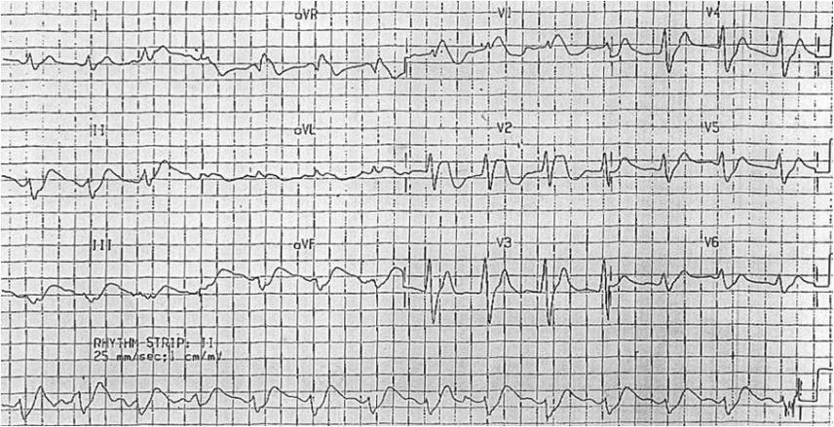

d. Bicarbonate

- A 72 year old woman presents to resus via ambulance having arrested during offload. She has known ischaemic heart disease but is otherwise well. The ambulance was called for a complaint of chest pain. CPR has been commenced and a single shock has been given.

a. Adrenaline

- A 1 week old baby presents to resus in extremis with poor perfusion, tachypnoea with recessions. The baby has a prolonged apnoea and you decide to intubate. Post successful intubation the heart rate drops to 50, there is still a palpable pulse

b. Atropine

- A 64 year old is in VF arrest, they have had 2 shocks and one dose of adrenaline. You are preparing to give the 3rd shock.

c. Amiodarone

EMQ 4

a) 0.05-0.15 mg/kg | f) 5 mg/kg
b) 0.3 mg/kg | g) 0.5 mcg/kg
c) 1 mg/kg | h) 1.5 mcg/kg
d) 2 mg/kg | i) 5 mcg/kg
e) 3-4 mg/kg | j) 10 mg/kg

Match the best dose (or range) with each scenario

- Propofol initial dose for procedural sedation for young adult requiring relocation of an elbow
- Intranasal fentanyl initial dose for analgesia in a child
- Ketamine IM dose for procedural sedation in a child
- Midazolam IV dose for anxiolysis and amnesia during a minimally painful procedure

EMQ 5

a) Bladder lavage | e) Peritoneal lavage
b) Cardiac bypass | f) Thoracic lavage
c) Forced hot air blanket | g) Warm blanket and removal of wet clothing
d) Gastric lavage | h) Warmed IV fluids

Which single rewarming technique from the list is the most appropriate for the given scenario? All patients have been retrieved to your tertiary ED.

1. A 20 year old university student has consumed 6 beers and has decided to paddle to a nearby island on a lilo. He missed the island and was picked up by a rescue helicopter. Immersion time 60 minutes. Temperature on arrival 35C shivering vigorously.

2. A 34 year old woman was ice skating on a frozen lake in the South Island. She fell through the ice. She was recovered after 30 minutes of submersion. CPR commenced immediately. Temperature 19C. She is asystollic

3. A 58 year old man has overdosed on quetiapine in the bush. He has been in the open for 12 hours. Haemodynamics normal. Drowsy but following commands. Temperature 33C. Not shivering.

EMQ 6

a) PO Chloral hydrate | f) Inhaled Nitrous oxide
b) Intranasal Fentanyl | g) IV Propofol with IV Fentanyl
c) IV Ketamine | h) IV Propofol
d) IV Midazolam | i) IV Thiopentone
e) Intranasal Midazolam | j) IV Propofol with nitrous oxide

You are a staff specialist working in a well-staffed tertiary Australasian ED. Choose the best option from the list for each of the following scenarios.

a. Sedation of a 3 year old child with a displaced distal radius greenstick fracture requiring reduction.

2. Sedation of an otherwise well haemodynamically stable 45 year old man requiring DC cardioversion for atrial fibrillation.

3. Sedation for a cooperative 15 year old boy during a lumbar puncture.

EMQ 7

a) Bendrofluazide | f) Labetalol
b) Cilazapril | g) Metoprolol
c) Doxazosin | h) Midazolam
d) Frusemide | i) MgSO4
e) GTN | j) Nifedipine

- A 48 year old man presents with confusion and is found to be hypertensive 260/130 mmHg. What is the most appropriate agent?

- A 76 year old woman presents with severe breathlessness and bilateral crepitations at 0500h. Her blood pressure is 210/110 mmHg. What is the most appropriate agent?

- An agitated 21 year old man with needle tracts on his forearms presents with a blood pressure of 200/100 mmHg. What is the most appropriate agent?

- A 29 year old woman who is 39/40 pregnant presents with headache, abdominal pain, swollen ankles and altered vision. Her blood pressure is 210/120mmHg. What is the best agent?

- A 20 year old woman is 29/40 pregnant and presents in labour. Her blood pressure is 130/90. What is the best agent?

EMQ 8

a) Anterior AMI | f) Posterior AMI
b) Inferior AMI | g) Lateral ischaemia
c) High lateral AMI | h) Pericarditis
d) Left main coronary stenosis
e) LBBB AMI

Consider 4 previously well middle aged men presenting with severe central chest pain. Each has an ECG taken. Select the most likely diagnosis for each of the following ECGs.

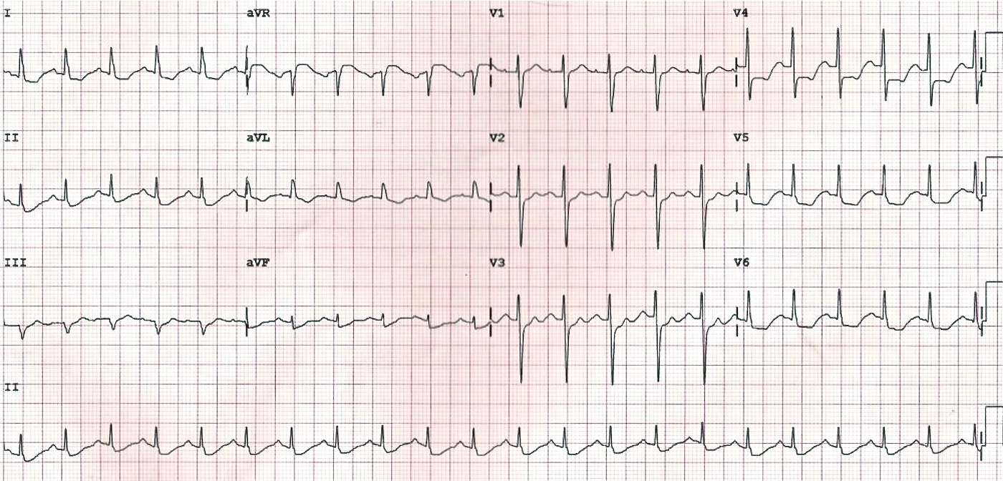
- This ECG is most consistent with

d. Left main coronary stenosis

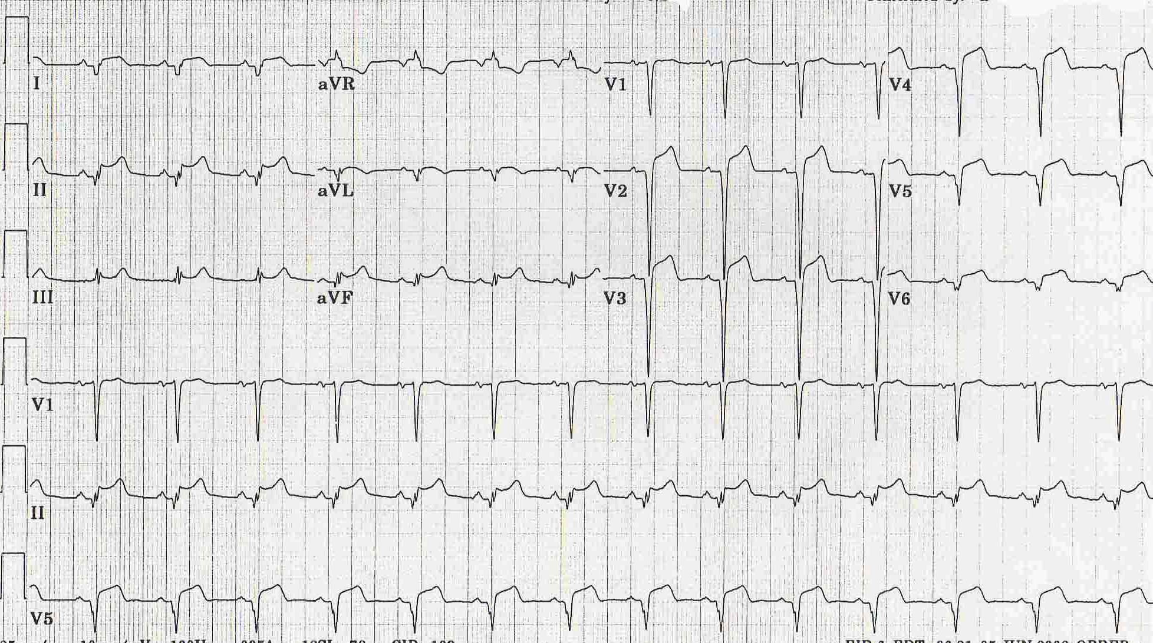
- This ECG is most consistent with

h. Pericarditis

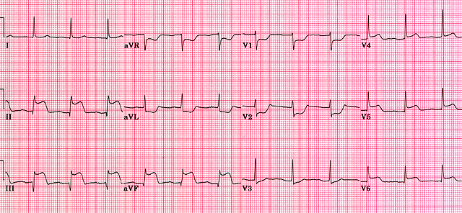
- This ECG is most consistent with

f. Posterior AMI

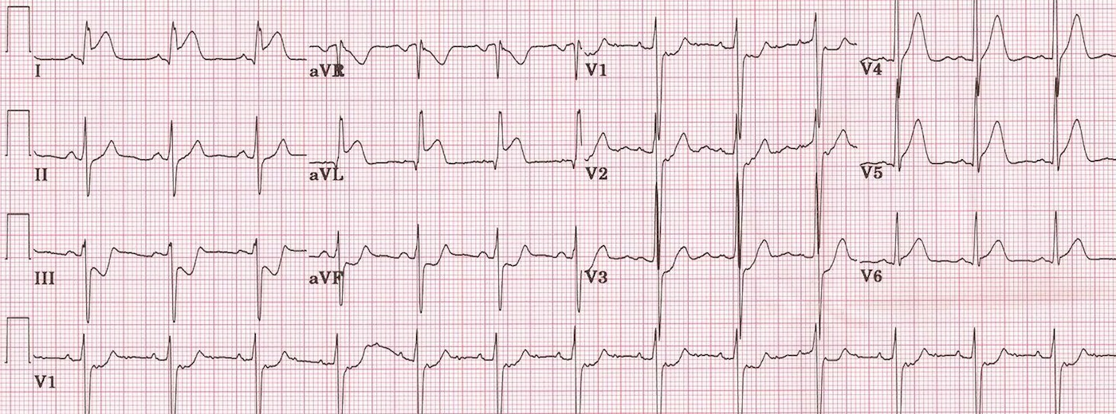
- This ECG is most consistent with

c. High lateral AMI

