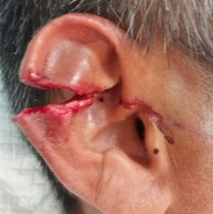

A 68 yo man presents on a weekend to your rural ED following a farm injury. The man sustained an injury to his ear after a mechanical fall over a farm dog onto a sharp piece of corrugated iron. The man is fit and well with no past medical history. He has no other injuries.

1. Describe the injury 4 marks

Full thickness Laceration through helix
Antihelix
Cartilage on view
1cm separation of edges

2. State your approach to anesthetising the wound for closure 3 marks

- drug no adrenaline
- field block description 2 marks

3. List your steps for wound management 5 marks

- irrigate
- sterile tech
- closure in layers - absorbable 5-6.0 cartilage
- 5-6.0 skin
- close followup
- adt
- analgesia antibiotics

