SAQ 4
An otherwise well 8 year old boy presents to your ED with a rash as shown. You make the diagnosis of Henoch Schonlein Purpura (HSP).

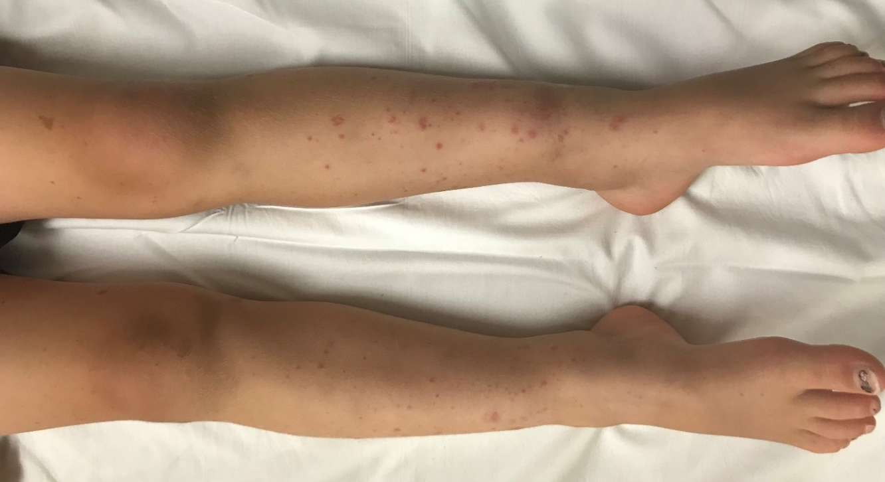
- Complete the table below by listing one (1) clinical feature and one (1) complication of HSP that affects each of the body systems listed.
(Marked out of 8.0)
Body system | Clinical Features | Complication
Renal | Proteinuria/haematuria, HT | Nephrotic/Nephritic syndrome, renal failure  NOT Acute tubular necrosis
Skin | Usually symmetrical palpable purpura, petechial and ecchymosis  Gravity/pressure-dependent areas (buttocks, lower limbs)  Painful subcutaneous oedema, periorbital/dependent areas (hands, feet, scrotum) | Secondary infection
Joints | Arthritis/arthralgias usually large joints of lower limbs, occasionally upper limbs  Usually no significant effusion or warmth | In ability to mobilise due to pain
Abdominal | Abdominal pain | Intussusception, bowel obstruction, GI haemorrhage, bowel ischemia/necrosis/perforation, protein losing enteropathy, pancreatitis

OA is not complication of HSP arthritis
Skin – ‘superinfection’
Pain is a clinical feature not a complication
Renal failure from vasculitis not ATN
Usually no scarring
‘confused for alternative diagnosis’ – not complication

- List four (4) aspects of your management of this child.
(Marked out of 4.0)
-Analgesia bed rest, paracetamol, NSAID
-Ensure well hydrated – usually oral
-Steroids – reduces duration of abdominal and joint pain
-Seek/treat complications – with details
-Disposition – admission if complications, d/c home if no complications
-Follow-up – GP, Paediatrician to identify subsequent renal involvement which rarely requires a renal biopsy +/- immunosuppression – weekly for first month, fortnightly from 5-12 weeks, single reviews at 6 and 12 months, Return to weekly if there is a clinical disease flare
FBE, BP, urinanalysis are all Ix not Mx – if listing Ix need to link with Mx
No low platelets, checking platelets is Ix not Mx
'Appropriate follow-up' is not adequate

Good example Mx:
-Simple analgesia-> paracetamol 15mg/kg and ibuprofen 10mg/kg (if no renal impairment)
-Bed rest for analgesia
-Seek renal dysfunction-> urinalysis (protein/haematuria) and blood pressure (HTN)-> refer to paediatric team if abnormal for admission
-Prednsiolone 1mg/kg if severe pain limiting mobilisation

https://www.rch.org.au/clinicalguide/guideline_index/HenochSchonlein_Purpura/

Results:
Pass mark > 8/12
Passed 19 out of 39 = 49%
Range 2 to 11

