Question 1 (18 marks) 9 minutes

A 52 year old male presents to your Emergency Department with ischaemic sounding chest pain. He has not been seen in any hospital in the last 12 months and has never had Echocardiography.

- State seven (7) factors that, in combination, would allow safe discharge within 3 hours from presentation. (7 marks)
- No ongoing or repetitive pain after initial ED Rx
- No syncope
- No evidence of haemodynamic compromise
- No episodes of sustained VT
- No ischaemic ECG changes
- Normal HS troponin at 0 and 2 hours or single -ve > 3/24 post symptom onset
- (Ejection fraction known to be > 40%)- given in stem
- (No AMI/ PCI/CABG < 6 months)- given in stem
- TIMI score ≤ 1
  - (ie only one of:
    - (Pt is ≤ 65 yrs of age)
    - Aspirin use in the last 7 days (patient experiences chest pain despite ASA use in past 7 days)
    - At least 2 angina episodes within the last 24hrs
    - (ST changes of at least 0.5mm in contiguous leads)- covered above
    - (Elevated serum cardiac biomarkers)- covered above
    - Known Coronary Artery Disease (CAD) (coronary stenosis ≥ 50%)
    - At least 3 risk factors for CAD, such as:
      - Hypertension -> 140/90 or on anti-hypertensives
      - Current cigarette smoker
      - Low HDL cholesterol (< 40 mg/dL)
      - Diabetes mellitus
      - Family history of premature CAD
        - Male first-degree relative or father younger than 55
        - Female first-degree relative or mother younger than 65
- Other serious causes excluded
- If the patient underwent an ECG that demonstrated a left bundle branch block, state three (3) ECG findings that may be useful for identifying myocardial infarction. (3 marks)
- New LBBB/ recent ECG demonstrating the absence of LBBB
- Serial ECGs showing dynamic ST segment change
- Modified Sgarbossa criteria:
  - ≥ 1 lead with ≥1 mm of concordant ST elevation
  - ≥ 1 lead of V1-V3 with ≥ 1 mm of concordant ST depression
  - ≥ 1 lead anywhere with ≥ 1 mm STE and proportionally excessive discordant STE, as defined by ≥ 25% of the depth of the preceding S-wave
An ECG is taken on arrival- refer to the props booklet- page
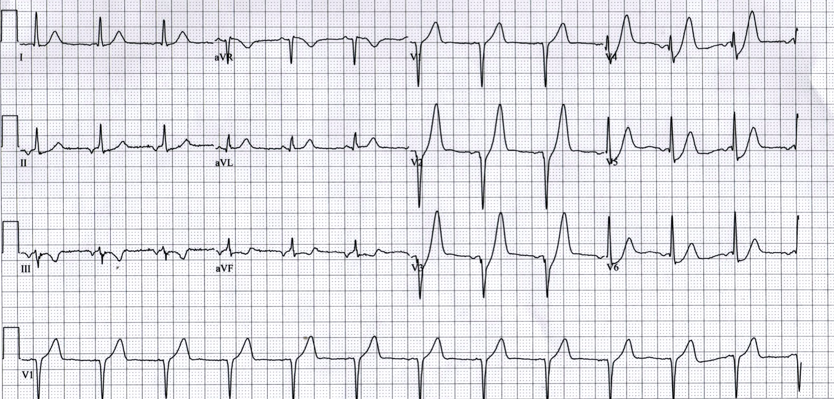

- State three (3) significant abnormal findings in this ECG. (3 marks)
- Upsloping ST depression in V2-V6 (> 1mm at J-point) REQUIRED
- De Winters T waves: Peaked anterior T waves (V2-6), with the ascending limb of the T wave commencing below the isoelectric baseline REQUIRED
- Any 1 of:
  - STE in aVR > 0.5mm
  - STD in III & aVF
  - Subtle ST elevation in aVr
  - P wave inversion II, III, aVF (suggestive of atrial ectopy/ junctional rhythm)
- State the significance of these abnormal findings. State two (2) points in your answer. (2 marks)
- Highly predictive of acute LAD occlusion/ STEMI equivalent
- Emergent reperfusion therapy is indicated (PCI/thrombolysis)

Aspirin, GTN and morphine are provided for this patient.
The patient has ongoing ischaemic sounding chest pain.
His observations are:
BP 130/60 mmHg
HR 90 bpm
RR 14 bpm
Sats 94% RA

- List three (3) further medications that are indicated for this patient. (3 marks)
- Enoxaparin
- Clopidogrel
- Ticagrelor
- Tenecteplase
NB: oxygen not indicated if Sats > 93%

