Question 19. Paediatric resuscitation
(Author: Michael Coman)

An intubated 2yo child in respiratory failure from severe pneumonitis is waiting transfer to the paediatric ICU. He is ventilated in a pressure control mode.

After a period of relative stability the child becomes acutely hypoxic with elevated airway pressures.

a) List 5 potential causes for this deterioration: (5 marks)

- ETT occlusion – secretions, kinking, cuff herniation
- ETT migration – endobronchial
- Barotrauma (pneumothorax)
- Acute complication of underlying disease – bronchospasm, mucous plugging
- Systemic pathology – anaphylaxis
- stacked breaths/dynamic hyperinflation/
- gastric distension leading to splinting of diaphragm
- ventilator tubing kinking/rain out

½ marks:
- Ventilator failure (½ mark). Possible but unlikely and dangerous to consider this high on the list
- Fighting the ventilator – not a great answer, usually doesn’t happen suddenly. I classify this as a general statement to fill a line in the answer book when you run out of more specific and likely causes

Not paid:
- Oesophageal migration of tube, elevated airway pressures don’t really fit acutely
- Insufficient paralysis/sedation – usually not sudden

b) State your three (3) most immediate management priorities: (3 marks)

- Disconnect from ventilator and attempt bag ventilation with 100% oxygen

Mandatory answer- disconnect and ventilate with 100% O2 in my opinion are and should be one action, so 2 marks not given for 1) disconnect and 2) provide 100% O2

Airway management (one mark – airway management is most immediate):
- Confirm position of ETT with capnography +/- direct vision and clinical examination
- Confirm patency of ETT and upper airway – ie suction down tube

Full marks for answers assessing airway patency and confirming position of ETT in the airway. Of course there are many other correct management priorities which will follow, and correct answers which address breathing and circulation concerns before airway concerns will score ½ marks. Mark allocation reflects the importance of prioritization of interventions and rewards a logical ABCDE approach to a critical event)

1/2 mark answers include:

- Decompress PTX
- Treat anaphylaxis
- Call for help. Not incorrect so ½ mark, but I think it would be reasonable to respond to the acute crisis first. That’s what the question is testing.

Careful with your terminology: almost all candidates said disconnect from the ventilator and provide ‘BMV’ vent. How can you mask ventilate an intubated patient. Would you really remove the ETT? Best to say disconnect from ventilator and manually ventilate with 100% O2 if that is what you truly mean

No marks:
- Check vent circuit – not an immediate priority
- Increase sedation and paralysis – dangerous without addressing the cause of the problem
- CXR to check for PTX. Not in the first three immediate priorities

c) The child has a PEA arrest and you commence cardiopulmonary resuscitation. Fill in the missing information (boxes A-H) on the Infant and Children ALS flowchart below: (8 marks)

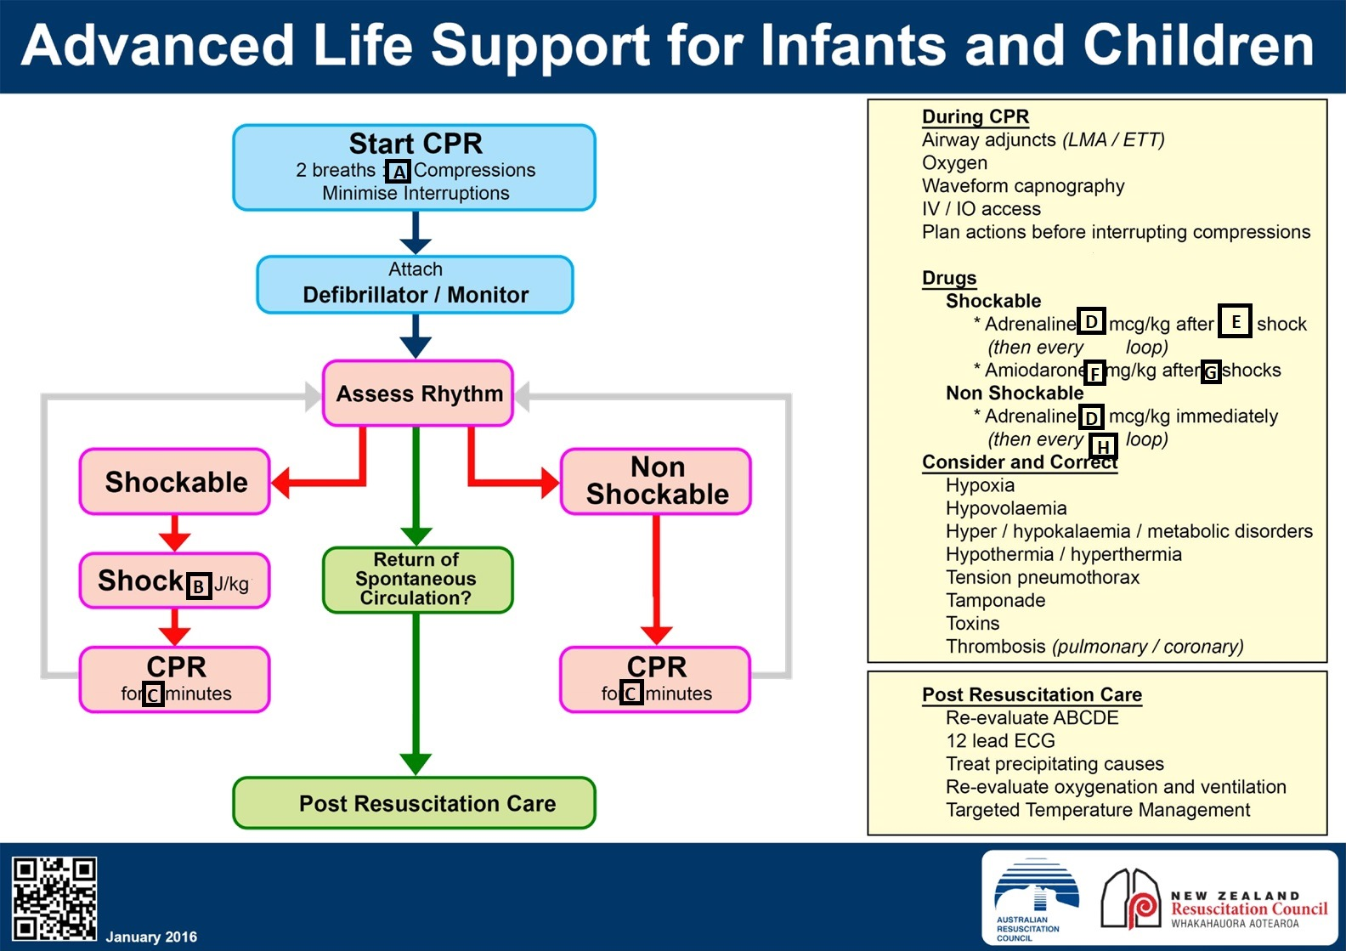

A) 15
B) 4
C) 2
D) 10
E) 2nd
F) 5
G) 3
H) 2nd

This section was answered well, however only 11/31 candidates received full marks! The two sections that received the most incorrect answers were the compression ratio, a number of candidates nominated 30 compressions to two breaths, and the amiodarone dose. Everyone should have got full marks for this – the ALS algorithm is the core of core knowledge.

Overall, this question was well done, and in retrospect was not a great discriminator. The pass mark was unapologetically high – this is bread and butter emergency medicine. I hope that you don’t have too many objections to the marking – I can assure you that I applied the same rules consistently across every paper. Any questions or queries, please feel free to contact me:

michael.coman@monashhealth.org

