Fellowship course
Week 18 – Miscellaneous

WRITTEN EXAMINATION
SHORT ANSWER QUESTIONS

EXAMINATION TIME: 48 Minutes

Question 1 (13 marks) 6 minutes
A 70 year old man presents to the emergency department complaining of painful feet.

A photo of his lower limbs is taken .

- List four (4) abnormal findings shown in this image. For each finding, list one (1) likely underlying cause. Underlying causes should not be repeated for different findings. (8 marks)

Abnormal finding  (4 marks) | Likely underlying cause  (4 marks)
1.
2.
3.
4.

Question 1 (continued)

Further history and examination is not useful in the diagnostic process.

- List five (5) investigations that would of key importance in confirming a diagnosis/ses (5 marks)

- _______________________________________________________________________
- _______________________________________________________________________
- _______________________________________________________________________
- _______________________________________________________________________
- _______________________________________________________________________

Question 1

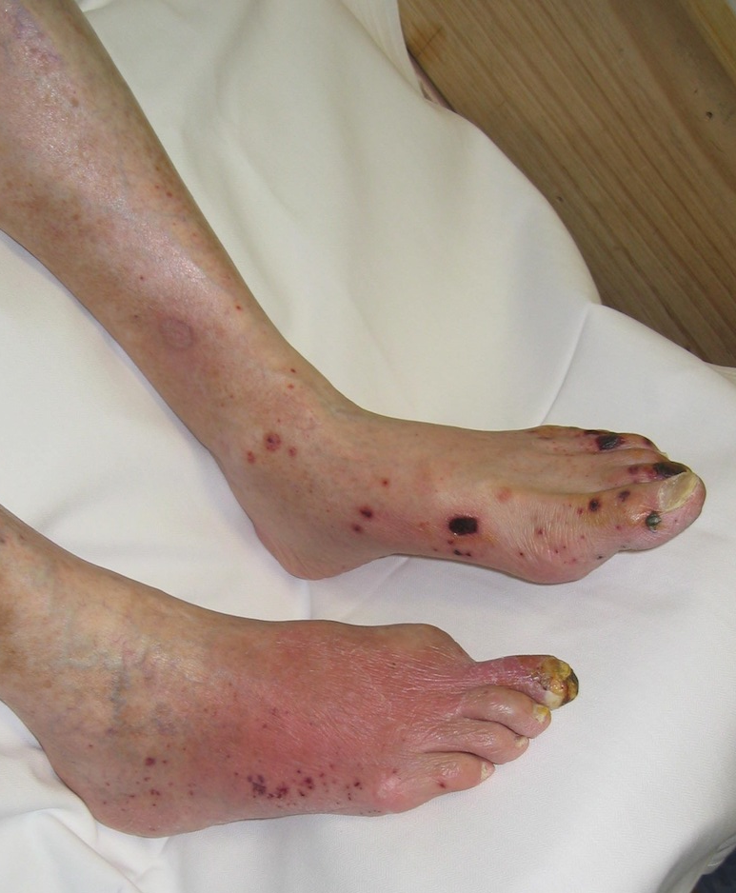

Question 2 (14 marks) 6 minutes
- At what height does acute mountain sickness appear in a person who is not acclimatised to altitude? (1 mark)

________________________________________________________________________

- List three (3) examination features of a patient with high altitude cerebral oedema. (3 marks)

- ________________________________________________________________________
- ________________________________________________________________________
- ________________________________________________________________________
- List four (4) management steps for a patient with high altitude cerebral oedema. (4 marks)

- ________________________________________________________________________
- ________________________________________________________________________
- ________________________________________________________________________
- ________________________________________________________________________

Question 2 (Continued)
- List three (3) examination features of a patient with high altitude pulmonary oedema. (3 marks)

- ________________________________________________________________________
- ________________________________________________________________________
- ________________________________________________________________________
- List four (4) management steps for a patient with high altitude cerebral oedema. (4 marks)

- ________________________________________________________________________
- ________________________________________________________________________
- ________________________________________________________________________
- ________________________________________________________________________

Question 3 (12 marks) 6 minutes

- What is Perichondritis of the ear? (1 mark)

_________________________________________________________________________

- List three (3) causes of perichondritis of the ear. (3 marks)

- _______________________________________________________________________
- _______________________________________________________________________
- _______________________________________________________________________

- Other than analgesia, list three (3) key components to the management of perichondritis of the ear. (3 marks)

- _______________________________________________________________________
- _______________________________________________________________________
- _______________________________________________________________________

Question 3 (continued)

- What is Chondritis of the ear? (1 mark)

___________________________________________________________________________
- What clinical feature differentiates perichondritis of the ear from chondritis of the ear? (1 mark)

___________________________________________________________________________
- State three (3) differences in the management of Chondritis of the ear, as compared to Perichondritis of the ear. (3 marks)

- _______________________________________________________________________
- _______________________________________________________________________
- ________________________________________________________________________

Question 4 (11 marks) 6 minutes
A 64 year old female presents to the Emergency Department, two days after minor trauma to her right foot.

A photo of her foot is taken:

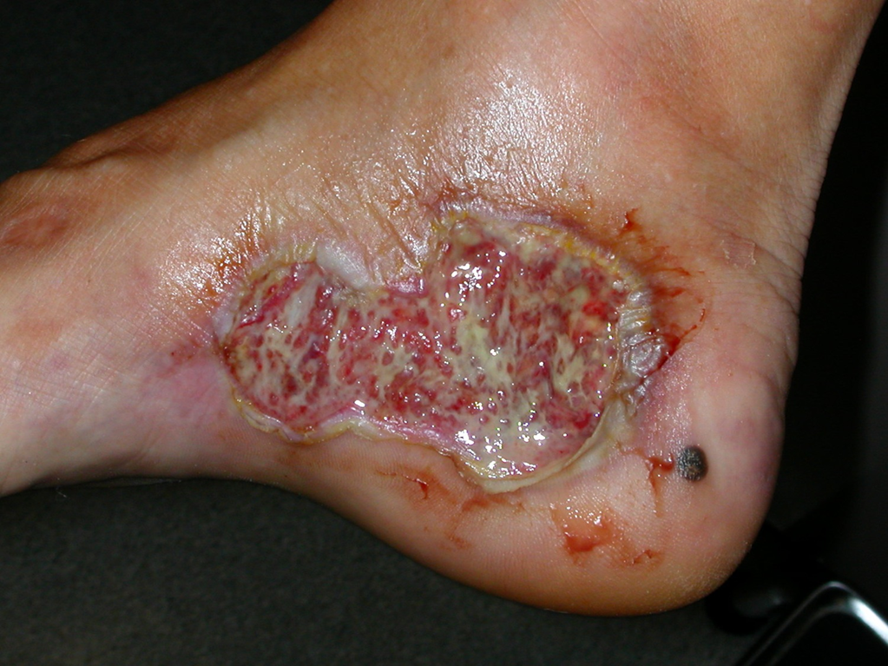

Question 4 (continued)

- What diagnosis is suggested by this presentation and clinical photograph? (1 mark)

__________________________________________________________________________

- List five (5) underlying diseases that may be associated with this condition. (5 marks)

- _______________________________________________________________________
- _______________________________________________________________________
- _______________________________________________________________________
- _______________________________________________________________________
- _______________________________________________________________________

Question 4 (continued)

- List five (5) steps in the management of this condition. (5 marks)

- _______________________________________________________________________
- _______________________________________________________________________
- _______________________________________________________________________
- _______________________________________________________________________
- _______________________________________________________________________

Question 5 (22 marks) 9 minutes
A 65 year old male presents with symptoms suggestive of right renal colic.

- State six (6) aims in the use of radiological investigation for this patient. (6 marks)

- ___________________________________________________________________
- ___________________________________________________________________
- ___________________________________________________________________
- ___________________________________________________________________
- ___________________________________________________________________
- ___________________________________________________________________

- Complete the table below that relates calculi size and spontaneous passage rate. (4 marks)

Calculi diameter (mm) | Spontaneous calculi passage rate (%)  (4 marks)
4

5

5-8

> 8

Question 5 (continued)

- List three (3) types of ureteric calculi that have different chemical composition. List two (2) clinical or epidemiological features for each type of calculi. (9 marks)

Calculi type  (3 marks) | Feature  (6 marks)
1. | 1.
 | 2.
2. | 1.
 | 2.
3. | 1.
 | 2.

Question 5 (continued)

The patient is confirmed to have a single renal calculi on CTKUB. This is his first episode of renal calculi.

- State three (3) points for the role of medical expulsive therapy in the management of renal calculi. (3 marks)

- _____________________________________________________________________
- _____________________________________________________________________
- _____________________________________________________________________

Question 6 (12 marks) 6 minutes

- Regarding Rheumatic fever, list the five (5) major manifestations that are included in the modified Jones criteria. (5 marks)

- ________________________________________________________________________
- ________________________________________________________________________
- ________________________________________________________________________
- ________________________________________________________________________
- ________________________________________________________________________
- Regarding Rheumatic fever, list the four (4) minor manifestations that are included in the modified Jones criteria. (4 marks)

- ________________________________________________________________________
- ________________________________________________________________________
- ________________________________________________________________________
- ________________________________________________________________________

Question 6 (continued)

- Regarding Rheumatic fever, list two (2) investigations that may assist with definitive diagnosis. (2 marks)

- ________________________________________________________________________
- ________________________________________________________________________
- Regarding Rheumatic fever, list one (1) patient group in Australasia that is most likely to experience the disease. (1 mark)

________________________________________________________________________

Question 7 (16 marks) - 9 minutes

A previously well 65 year old lady presents to your emergency department after a brief period of collapse. She is now alert and her vital signs are: BP 80/60 mmHg T 36.8 RR 28 O2 sats 85% RA

Her ECG shows :

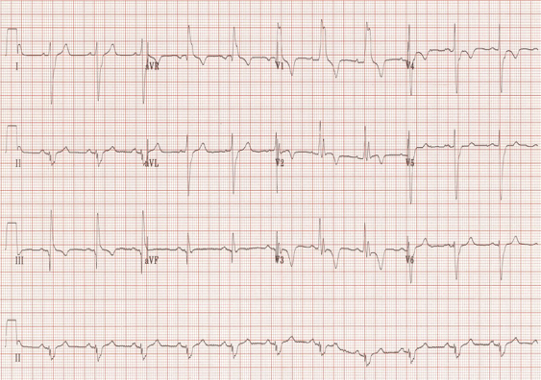

Question 7 (continued)

a) State four (4) abnormalities in her ECG. (4 marks)

- ________________________________________________________________________
- ________________________________________________________________________
- ________________________________________________________________________
- ________________________________________________________________________

b) List four (4) immediate investigations that you would perform with one justification for each
(8 marks).

 | Investigation | Justification
1
2
3
4

Question 7 (continued)

You decide to thrombolyse the patient .
c) State two (2) medications you can use with dosage (2 marks).

- ________________________________________________________________________
- ________________________________________________________________________

d) List two (2) other options to manage the cause of her shock if thrombolysis is contraindicated.
(2 marks)
- ________________________________________________________________________
________________________________________________________________________

