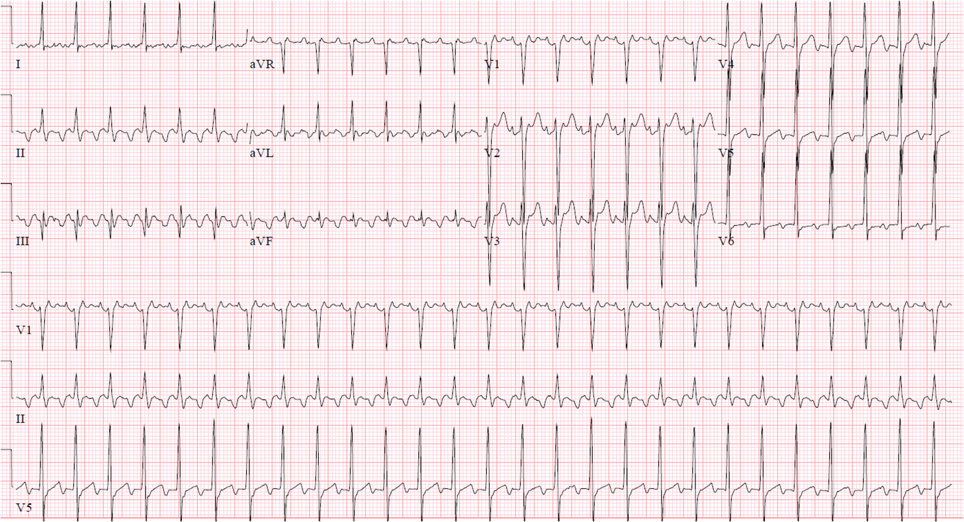

Mr Edward Chan UR 8888

14/8/2019 10:06