Question 26

A 48 year old woman presents with 2 days of vomiting. She is confused and unable to give a clear history. Her current examination shows:

BP 100/82 mmHg

HR 144 bpm

Temp 36.5 C

RR 24 bpm

O2 Sat 98% RA

GCS 13 (E4 M5 V4)

                  pH        7.38         (7.35- 7.45) low normal (N, corrected, balanced)

                  pCO2      36          (35-45) low normal

                  HCO3     21          (22-26) low (just)

                  BE          -3          (-1- 1) matches low Bic

                  Lactate   3.3         (0-2) mildly elevated

                  Glucose    22       (3-6.5) elevated ++

                  Na        129          (135-145) low (uncorrected)

                  Cl-        79            (3.5-5-0) low ++

********************************************

**“The blood gas question” = OMG or yeah!! = Your choice!**

1. Read the stem – all of it. Every word for a reason.
   1. What is there (left ~~foot~~ in) relevant +ve and -ve
   2. What isn’t there (left ~~foot~~ out) what should be / expect
   3. Put it all together (shake it all about)
      1. Matches
      2. Doesn’t match

Who am I, where am I, when am I? 🡪 If time/place mentioned, why?

Why is this question in a fellowship exam? 🡪 common, commonly deadly if missed, both

What would I do if this were a real patient in front of me? 🡪 remember the patient

Expecting:

* Vomiting – hypochloraemic metabolic alkalosis
* Shocked – metabolic acidosis

Missing:

* K, Osmolarity, urea
* Physical findings
* Medications

Not matching:

* Confused – normal pH, temp, SBP 100, 98% sats
* pH normal – fully corrected, two conditions, two effects

[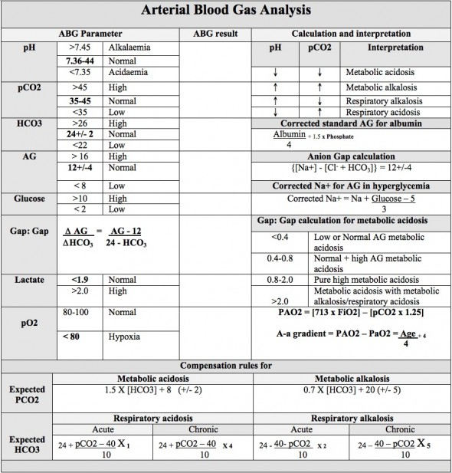](http://cdn.lifeinthefastlane.com/wp-content/uploads/2010/04/ArterialBloodGas_Interpretation_ABG.jpg)

**Arterial Blood Gas (ABG) Interpretation Chart - LITFL**

**Potassium**

* Serum K is *inversely* related to serum pH
* Serum K decreases by 0.3mEq/L for every 0.1U increase in pH above normal
* Alkalosis:
  + Correction of an alkalotic pH will produce a rise in serum K
  + Alkalosis (increase pH) shifts K intracellularly, lowering serum K
* Acidosis
  + Shifts K to intravascular space so increasing the serum K
  + Correction of acidosis will produce a decrease in serum K (may drop precipitously eg correction of DKA)

**Osmolarity** = (1.86 x [Na+]) + [glucose] + [urea] + 9  (using values measured in mmol/l)

* or use (2 x Na) + glucose + urea 🡪 normal osmolar gap (measured - calc) is < 10
* noting measured = Osmolality mOsm/kg solvent, calculated = Osmolarity mOsm/L solution

a) Provide two (2) calculations to assist with your interpretation of these investigations.

(2 marks)

b) State your interpretation of these results. Give three (3) points in your answer. (3

marks)

c) State your three (3) initial treatments, including aims where appropriate. (3 marks)

**Pass = 2 + 2 + 2 = 6/8 (Basic, vital knowledge for a junior FACEM)**

**Calculations**

* AG, corrected Na, expected CO2, expected Bic, Delta ratio

**Interpretation**

* HAGMA, delta > 2 = metabolic acidosis + metabolic alkalosis
* Hypochloraemia from vomiting
* Corrected Na normal
* Hyperglycaemia – not typical of DKA or HHS or stress response
* Clinical (confusion) disproportionate to gases
* Possible single cause – aspirin

**Initial treatments INCLUDING aims** (1/2 marks if treatment without aim)

* Fluids: improvement in haemodynamics (target SBP/MAP +/-pulse), perfusion parameters (skin perfusion, mental state, JVP, urine output, lactate, ketones)
* Insulin: rate, target sugar
* Anti-emetics
* K – with rationale, rate, target (correct K not paid)
* Antibiotics - no

**Issues / Themes to avoid**

* Blank or partially blank answers
* Gases are common and potentially deadly if wrong so like to have relatively high cut point. DO NOT SKIP THE GAS QUESTION. Zero is very bad!!
* Calculations wrong
* Trying to make findings fit e.g. DKA as sole Dx (despite normal pH and Bic)
* Ignoring / forgetting the clinical stem (there for a reason – shock is easy to give treatments for!)
* Investigations or History instead of Treatments
* Aims of treatment already met e.g. SBP 90 or 100
* Treatment generic without dose, rate, endpoints e.g. ‘fluids’ or ‘correct K’
* Multiple answers when 2 or 3 asked for (after the required doesn’t count)
* Interpretation in the calculation section (usually repeated)
  + Read the stem carefully
  + Skim the whole question before answering
    - might give you clues and allow for shorter responses e.g. in this one just give the calculations then interpret over the page