MH SAQ practice Respiratory CXRs

SAQ 1

A 23 year old man with known asthma is brought to ED by ambulance with an acute exacerbation.

a. What 5 features on history would concern you that his attack might be severe?

b. What 5 features on examination would suggest he had a severe exacerbation?

c. Clinical examination confirms he has had a severe episode. List and justify 3 investigations you would perform.

d. List your 4 immediate treatment priorities.

SAQ 2

A 28 year old man presents to the ED complaining of shortness of breath and pleuritic chest pain. His arterial blood gases are as follows:

On Air
pH 7.37
pO2 8.0
pCO2 2.3
BE -2.0

a. Give three investigations, other than D-Dimer, you would perform. (3 marks)

b. At this stage give 4 risk factors as described by the BTS to exclude Pulmonary Embolism. (4 marks)

His D-Dimer result returns at 0.2 (normal range <0.14)
c. What 2 management steps would you now make? (2 marks)

d. The patient becomes acutely short of breath and hypotensive. What management step would you now take? (1 mark)

SAQ 3

A 35 year old male attends your department. His partner is HIV positive and being treated for TB.

Blood gases on 60% oxygen show:
pH 7.44
pCO2 4.0 Kpa (30mmHg)
pO2 16.5 Kpa (124mmHg)
Bicarb 22 mmol/L
Base Excess -1

Chest x-ray is shown below.
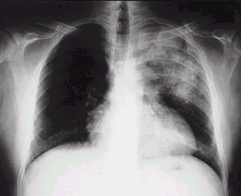

a. Describe the chest x-ray. (2 marks)

b. Excluding TB, give 2 differentials diagnoses. (2 marks)

c. List 3 organisms that may infect the pulmonary system in HIV. (3 marks)

d. Give 6 tests in the ED which would help in the management of this patient. (3 marks)

SAQ 4

A 24 year old women who is 10 weeks pregnant presents with suspected pulmonary embolus.

a. List five clinical features that would increase her likelihood of having PE. (5 marks)

b. Describe the utility of the following investigations in this patient. (5 marks)

 | Investigation | Utility
1 | D Dimer
2 | CXR
3 | Lower limb US
4 | CTPA
5 | VQ

c. The patient has been diagnosed with pulmonary embolism. What are the ECG changes below? (1 mark)

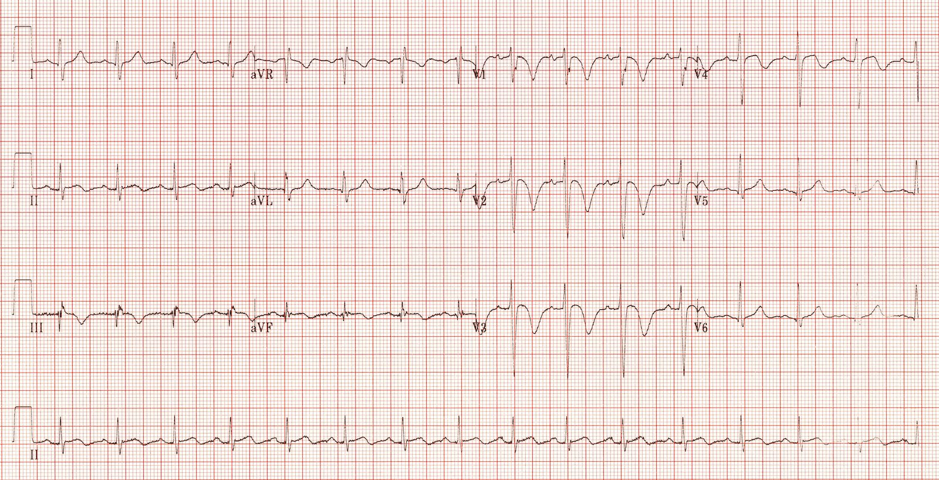

d. What do the ECG changes suggest? (1 mark)

e. The patient becomes hypotensive. List 4 treatment options (2 marks)

SAQ 5

A 30 year old man presents with a left sided spontaneous pneumothorax.

a. What are 3 features to elicit on evaluation that will help determine your management? (3 marks)

b. Give a clinical circumstances in which each of the following would be appropriate. (3 marks)

Management | Clinical circumstances
Observation
Aspiration
Intercostal catheter/ pneumocath/ pigtail catheter

c. List 6 complications of intercostal catheters. (3 marks)

SAQ 6

A 35 year old woman presents to your ED with an acute asthmatic attack. She is on continuous salbutamol nebs, is highly distressed and only speaking single words.

a. Name 4 features on history that increase the risk of severe life threatening asthma. (2 marks)

a. List at least 6 therapeutic drug classes that may be used in the treatment of a severe attack. (2 marks)

b. Outline what your initial ventilator settings would be. (4 marks)

c. What physiological targets are you aiming for? (2 marks)

SAQ 7

A 45 year old man has been brought to your ED by ambulance after being stabbed once in the right
side of the chest.
On arrival, his vital signs are:
GCS 15 E4 V4 M6
Pulse 120 /min
BP 85/40 mmHg
O2 sats 94% 15L O2 via non-rebreather mask

A chest Xray has been performed.

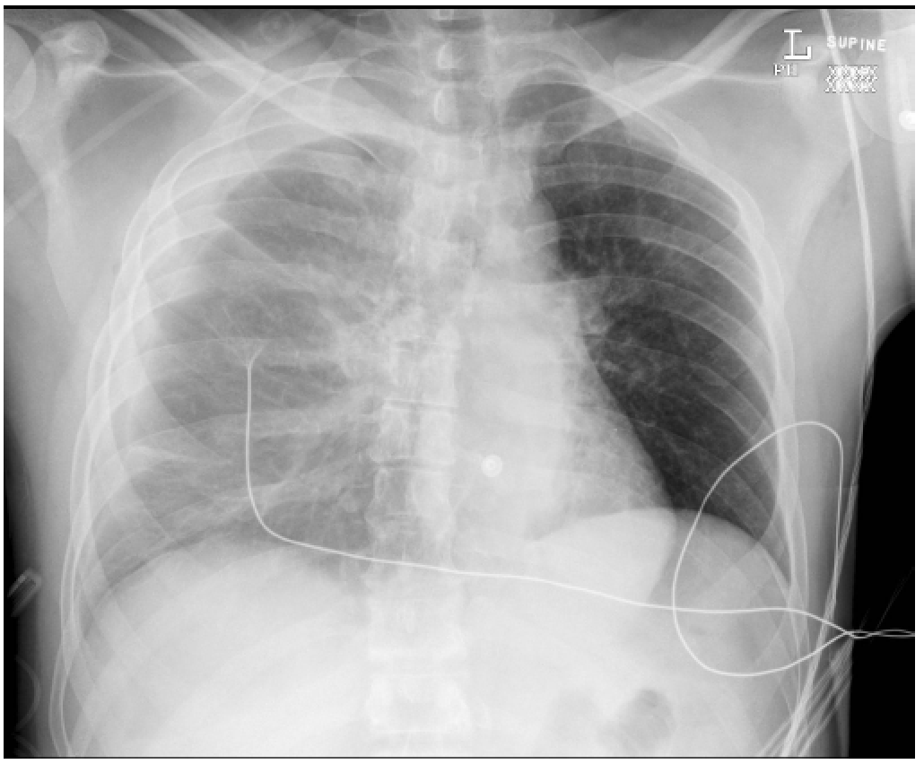

1. Give the main abnormality on the chest Xray, with supporting evidence. (3 marks)

2. List the steps involved in inserting an intercostal catheter in this patient. (9 marks)

SAQ 8

A 45 year old man has presented to the ED with cough of 2 weeks duration.
His chest Xray is given below.

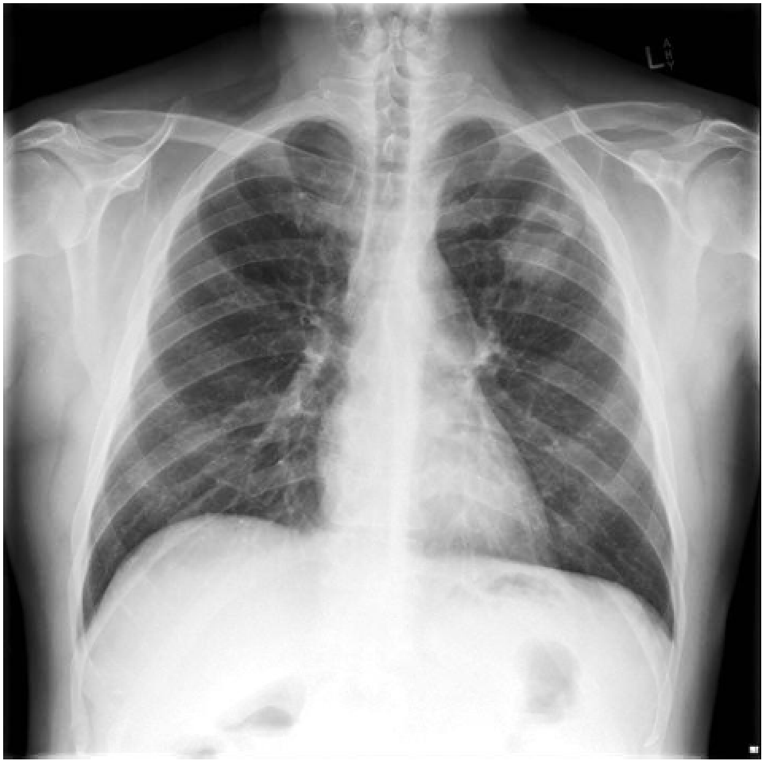

1. Describe the main abnormality on the chest Xray. (2 marks)

2. List 3 relevant negatives on review of the chest Xray. (3 marks)

3. List 3 groups of pathological causes for this abnormality. For each, give 2 aetiological agents.
(6 marks)

