MH SAQ practice questions Pathology

SAQ 1

Your registrar asks you for advice. A 50 year old female has presented following a collapse and is now increasingly confused . Her only injury is a minor abrasion to her forehead.

You have the following blood/urine results thus far:

Patient weight 65kg

Glucose 16.4
Na 111
K 4.2
Urea 7.2
Creatinine 102
Hb 13.1
WCC 12.2
Plt 175
Urine Osmolality 125
Urine Na 42

1. What is her calculated Na? (1 mark)

2. What is her calculated osmolality (1 mark)

3. What are 12 criteria for SIADH on history, examination and investigations? (6 marks)

4. She remains confused and then has a seizure. What is your specific treatment and endpoints. (2 marks)

SAQ 2

A two month old infant has been brought in following a brief seizure. She has had coryzal symptoms and high fevers for two days. She has no relevant past history and no allergies. On examination: HR 110 /min, BP 80/45 mmHg, Temp 39.7°C. There is no rash and no clear focus of infection but the child is ill-appearing and drowsy.

a. List 5 investigations and give a justification for each?

Investigation | Justification

A lumbar puncture is performed:
CSF white cell count
Neutrophils 120 (nil)
Lymphocytes 25 (<5)
CSF red cell count 200
CSF Protein 1.2 (< 0.4 g/L)
CSF glucose 0.4 (> 2.5 mmol/L)

b. What is the most like diagnosis and why?

c. List and justify three medications you would use to treat this child.

Medication | Justification | Dose

d. A senior nurse complains to you that one of the junior doctors involved in this case has been caught stealing a box of ciprofloxacin. A formal incident report has been filed and the nurse wants you to “deal with the JMO”. The doctor says he only wanted to take some as prophylaxis against possible meningococcus.
List 5 key principles should you consider in your discussion with the JMO?

SAQ 3

A 27 year old woman is brought in by housemates to your tertiary ED. She had been not seen for 2 days and was found beside her bed slumped on the floor.

Her observations are:
GCS 13
P 128 /min
BP 95/50 mmHg
T 34.7 °C

Sodium 136 mmol/L 137-145
Potassium 4.0 mmol/L 3.2-5.0
Chloride 92 mmol/L 98-111
Bicarbonate 23 mmol/L 22-31
Urea 23.2 mmol/L 2.5-7.5
Creatinine 424 μmol/L 60-110
Est. of GFR 15 mls/min >90
Glucose 3.6 mmol/L 3.5-5.5
Osmol-calc 292 mmol/L 280-300

Bili Tot. 10 umol/L 2-20
ALT 720 U/L <55
AST 15 U/L 5-50
ALKP 89 U/L 20-110
GGT 23 U/L 15-73

CK >103000 U/L 20-200
CRP 1.2 <10

a. What are the 3 most important abnormalities on the UELFT? (3 marks)

b. List the principles of your fluid management. (4 marks)

c. List 6 differential diagnoses. (3 marks)

SAQ 4

A 55 year old woman is brought in with a GCS of 7.There is no sign of trauma. There is a history of ethanol abuse. P 105 /min, BP 100/40 mmHg, afebrile, Sats 98 2L NP, RR 34 /min.

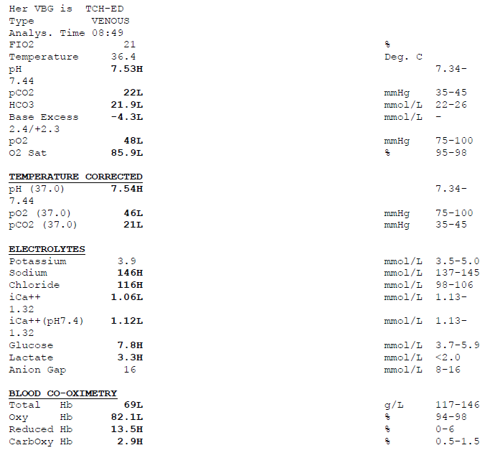

a. What is the acid-base abnormality? (1 mark)

b. What are the 3 other significant findings? (1 mark)

c. What is the likely diagnosis (with justification) and what are 2 differentials? (3 marks)

d. Outline five major goals of management. (5 marks)

A 60 year old woman presents to ED with the primary complaint of being a ‘funny colour’.

Blood results reveal:
Bilirubin 60 (1-20)
AST 400 (4-45)
ALT 200 (0-45)
GGT 125 (0-60)
Amylase 100 (25-136)

a. What is the predominate pattern of these blood results? (1 mark)

b. What are your 4 most likely differential diagnoses? (4 marks)

c. List 5 further investigations you would order in the ED to assist your diagnosis. Briefly justify each one. (5 marks)

SAQ 5

A 74 year old lady presents to ED with a history of being found on the floor at home confused.

Her arterial blood gas is shown below
FI O2 = 6 litres O2

pH 7.29 (7.35 – 7.45)
pO2 80 mmHg (35 – 45)
pCO2 64 mmHg (90 – 100)
Bic 30 mmol/l
Base excess +3

a. List 3 abnormalities on this blood gas.

b. What is the acid/base disturbance?

b. Name 4 conditions you should consider in the differential diagnosis for the woman’s presentation.

c. List five immediate management priorities.
SAQ 6

A 17 year old male is brought to ED by ambulance, complaining of abdominal pain and vomiting. He appears confused and is unable to prvide a good history. On examination his vitals are: Temp 37.9 ºC, BP 100/50 mmHg, HR 110 /min.

Blood tests taken on arrival show:

Na 140 mmol/l (135-145)
K 5.0 mmol/l (3.5-5.5)
Chloride 100 mmol/l (95-110)
Creatinine 0.1 mmol/l (0.03-0.08)
Urea 16 mmol/l (3.0-8.3)
Glucose 40 mmol/l (3.3-8.3)

Hb 167 g/l (135-175)
PCV 50 % (41-53)
Plt 224 (140-400)
WCC 21.8 (4-11)
Neutrophils 19.2 (4-11)

pH 7.133 (7.35-7.45)
pC0₂ 24.8 (35-45)
p0₂ 112 (90-100)
HCO3 8.3 (24-32)
BE -19.6
Sa02 96.8 %

a. List the major abnormalities. (4 marks ½ for each)

b. What is the diagnosis? (1 mark)

c. What is your initial management? (5 marks)

SAQ 7.

A 5 year old boy has been brought to your ED with a 2 day history of fever, cough and lethargy.
He has the following vital signs:

Temp 38.8 degrees
Pulse 145 /min
BP 90/40 mmHg
RR 40 /min
O2 sats 91% room air

Examination of his chest reveals decreased breath sounds and crackles in the right lung base.
He has had a venous blood gas taken:

pH 7.18 (7.35 – 7.45)
pCO2 21 mmHg (35 – 45)
pO2 25 mmHg (80 – 100)
HCO3- 8 mmol/L (22 - 32)
BE -18.5 mmol/L (-3 - +3)
Na 140 mmol/L (135 – 145)
K 5.7 mmol/L (3.5 – 5.0)
Cl 98 mmol/L (100 – 110)
Glucose 38 mmol/L (3.0 – 7.8)

1. In point form, provide explanation for all the abnormalities shown on the VBG.
(8 marks)

2. What is your diagnosis, based on all the clinical information? (2 marks)

3. List your 5 main treatment steps, with drugs and doses where appropriate. (5 marks)

SAQ 8

A 69 year old man has been brought to the ED after an overdose of an unknown quantity of
quetiapine and diazepam. He was found on the floor of his apartment by his landlord. Due to a
reduced level of consciousness, he has been intubated.

His blood results are shown:

Na 136 mmol/L (135 – 145)
K 8.3 mmol/L (3.5 – 5.1)
Cl 101 mmol/L (100 – 110)
HCO3 16 mmol/L (22 – 32)
Urea 15 mmol/L (2.9 – 8.2)
Creatinine 285 umol/L (64 – 108)
Glucose 7.3 mmol/L (3.0 – 7.8)

1. List the abnormalities on the blood results, giving likely possible causes of each abnormality.
(6 marks)

2. What is the most likely clinical scenario responsible for the above blood picture?
(2 marks)

3. List your management steps for his hyperkalaemia. Give doses. (4 marks)

SAQ 9

A 25 year old lady presents with severe epigastric pain and vomiting.

Her biochemistry results are shown below.

Biochemistry

Reference range

Na 132 mmol/L 135 - 145
K 3.9 mmol/L 3.5 - 5.0
Cl 101 mmol/L 101 - 111
HCO3 24 mmol/L 22 - 32
Urea 4.6 mmol/L 2.5 – 7.8
Creat 60 umol/L 40 - 80
ALP 248 U/L 30 - 120
GGT 309 U/L 7 - 64
AST 27 U/L 10 - 50
ALT 55 U/L 7 - 56
Bilirubin 43 umol/L 0 – 20
Lipase 448 U/L 0 - 60

1. What is your diagnosis?

2. What are the two (2) most likely underlying causes and why?

3. List four (4) complications of this condition.

4. List five (5) features that will help determine prognosis on admission?

