MH SAQ practice neurosurgery/eyes

1. A 25 year old male was assaulted with a baseball bat. He had a witnessed LOC for 5 minutes and GCS was 10 when paramedics attended. On arrival to the ED, he had a generalised seizure following which he became agitated and combative with a GCS of 8. His left pupil is dilated and he has already vomited at scene and the ED.

 R L

1. Describe the 4 abnormalities on this CT (2 marks)

|  |
| --- |
|  |
|  |
|  |
|  |

2. List 9 important initial steps in this patient’s initial primary survey, including end points where appropriate (6 marks)

|  |
| --- |
|  |
|  |
|  |
|  |
|  |
|  |
|  |
|  |
|  |

*NB score 2 marks for each 3 steps named*

3. Describe the methods of reducing intracranial pressure in this patient and the rationale of each method (2 marks)

|  |
| --- |
|  |
|  |
|  |
|  |

2. A 45 year-old female has long standing low back pain was discharged the preceding day by a JMO in your ED with a diagnosis of malingering. She now presents to the ED with a sudden and severe lower back pain radiating down the legs. In the department she was unable to control herself and was incontinent of urine.

1. What 6 features would suggest cauda equina syndrome? (3 marks)

|  |
| --- |
|  |
|  |
|  |
|  |
|  |
|  |

2. List the essential test to aid the assessment of a patient with suspected cauda equina syndrome (1 mark)

|  |
| --- |
|  |

3. You investigate and find that the JMO did not examine the patient, wrote no notes and was heard by the ED RN to tell the patient that there is nothing wrong with them and they should not have come to the ED, again. You are the JMO’s supervisor. Outline your approach to this situation (4 marks)

|  |
| --- |
|  |
|  |
|  |
|  |

4. Outline the immediate steps in the management of this patient (2 marks)

|  |
| --- |
|  |
|  |
|  |
|  |

3. A 57 years old male presented to ED with a sudden onset red painful right eye. You suspect a diagnosis of acute glaucoma

1. What are the features of acute Glaucoma on examination? (4 marks)

|  |
| --- |
|  |
|  |
|  |
|  |

2. How does glaucoma cause blindness? (1 mark)

|  |
| --- |
|  |

3. List the 5 most relevant topical medications used in primary open angle glaucoma and explain why they are used: (5 marks)

|  |
| --- |
|  |
|  |
|  |
|  |
|  |

4. A 22 year old male with known cerebral palsy presented to ED with a seizure. He complains of worsening headache and is known to have VP shunt. His observations are stable and GCS15.

1. List the 2 most likely causes of worsening headache in this man? (2 marks)

|  |
| --- |
|  |
|  |

2. How do you interpret shunt function after locating and pressing the chamber? (2 marks)

|  |
| --- |
|  |
|  |

3. What 2 radiological investigations will you arrange for a suspected blocked VP shunt. Explain your rational for each (2 marks)

|  |
| --- |
|  |
|  |

3. The neurosurgical registrar asks you to perform a shunt tap. Outline the steps (2 marks)

|  |
| --- |
|  |
|  |
|  |
|  |

4. What are the possible outcomes of the shunt tap and what is their significance? (2 marks)

|  |
| --- |
|  |
|  |

5. A 65 year old male attends complaining of loss of vision in his left eye.

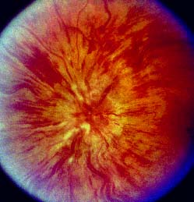

a. Give six features you would enquire about in the history. (3 marks)

|  |
| --- |
|  |
|  |
|  |
|  |
|  |
|  |

b. List 2 abnormalities of the fundus shown in the picture above. (2 marks)

|  |
| --- |
|  |
|  |

c. What is the diagnosis? (2 marks)

|  |
| --- |
|  |

d. Give 6 associations of this condition. (3 marks)

|  |
| --- |
|  |
|  |
|  |
|  |
|  |
|  |

6. A 28 year old man has been out kite surfing and was thrown into the water at high speed. He is brought in on a spinal board with C-spine protection. He is intubated and ventilated and put on a propofol infusion.

His observations are: Pulse 65 /min, BP 90/60 mmHg and he is warm and well perfused.

The C-spine film and tomogram are shown below.

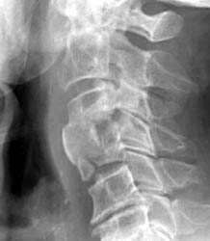

a. Describe 3 abnormalities on the x-ray. (3 marks)

|  |
| --- |
|  |
|  |
|  |

b. Describe 2 aspects of his cardiovascular status. (2 marks).

|  |
| --- |
|  |
|  |

c. What is the likely diagnosis? (2 marks)

|  |
| --- |
|  |
|  |

d. What 3 signs would support this? (3 marks)

|  |
| --- |
|  |
|  |
|  |

7. A 25 year old man is brought into your regional ED after a bicycle accident. He is not moving his legs and has limited upper limb movement. He has a soft stridor.

His vitals are:

GCS 14

P 62 /min

BP 80/40 mmHg

Sats 95 % 10L O2

A CT neck is done as part of his assessment.

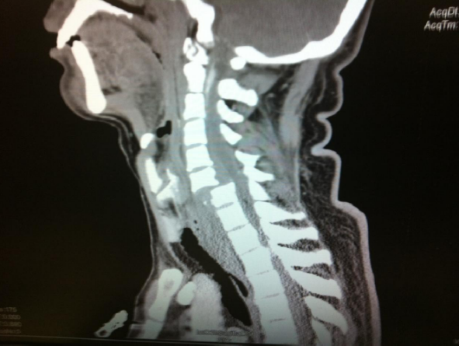

a. Describe the major abnormalities. (3 marks)

|  |
| --- |
|  |
|  |
|  |

b. Outline your management of his airway and breathing. (7 marks)

|  |
| --- |
|  |
|  |
|  |
|  |
|  |
|  |

8. An 18 year old factory worker is rushed to ED having sustained a chemical burn to his eye. He thinks the chemical had ammonia in it. It is now 20 minutes since the accident.

His eye is pictured here.

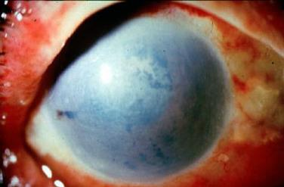

a. Describe the picture. (3 marks)

|  |
| --- |
|  |
|  |
|  |

b. What is your immediate management? (4 marks)

|  |
| --- |
|  |
|  |
|  |
|  |

c. Name 3 things you would do to assess this injury, including prognostic indicators. (3 marks)

|  |
| --- |
|  |
|  |
|  |

9. A 65 year old man with insulin dependent diabetes mellitus presents to the ED with a marked sudden decrease in vision.

a. What are your top 6 differential diagnoses? (3 marks)

|  |
| --- |
|  |
|  |
|  |
|  |
|  |
|  |

b. What are the key historical features you would ask for to help differentiate between these? (7 marks)

|  |
| --- |
|  |
|  |
|  |
|  |
|  |
|  |
|  |

10. A 29 year old man has been brought to your hospital after being hit to the head by a baseball bat.

He has no prior medical history.

His vital signs on arrival to the ED are:

GCS 11 E2 V2 M5

Pulse 110 /min

BP 110/65 mmHg

O2 sats 99% 6L O2 via mask

A CT scan of his head has been performed.

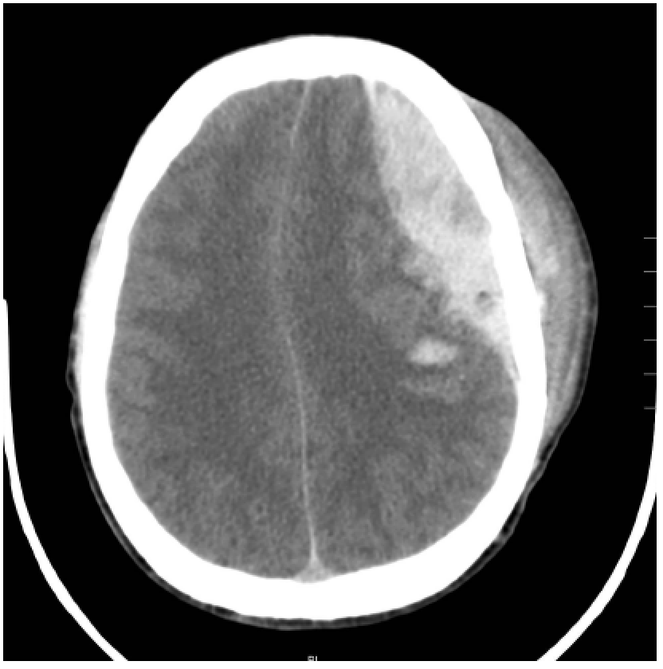

1. List 5 abnormalities on the CT slice. (5 marks)

|  |
| --- |
|  |
|  |
|  |
|  |
|  |

2. List your treatment priorities in the ED. Where appropriate, give end-points. (9 marks)

|  |
| --- |
|  |
|  |
|  |
|  |
|  |
|  |
|  |
|  |
|  |

11. A 70yo female attends with acute, non-traumatic painless right unioccular blindness.

1. List 5 potential aetiologies for this presentation (50%)

|  |
| --- |
|  |
|  |
|  |
|  |
|  |

1. What are the clinical features that would suggest Giant Cell Arteritis? (30%)

|  |
| --- |
|  |
|  |
|  |

1. What is the treatment for Giant Cell Arteritis? (10%)

|  |
| --- |
|  |

1. What are the complications of delayed treatment of Giant Cell Arteritis?

|  |
| --- |
|  |
|  |

12. A 22yo female attends with a sudden onset severe unilateral headache.

1. What features on history and examination support the diagnosis of Acute Sub-arachnoid Haemorrhage? (20%)

|  |
| --- |
|  |
|  |
|  |
|  |

1. What features support the diagnosis of hemicrania? (20%)

|  |
| --- |
|  |
|  |
|  |
|  |

1. What is the optimal timing for an LP to exclude the diagnosis of SAH? (10%)

|  |
| --- |
|  |

1. Describe your procedure/technique for lumbar puncture. (30%)

|  |
| --- |
|  |
|  |
|  |
|  |
|  |
|  |

The LP result (after a negative CT for SAH) follow:

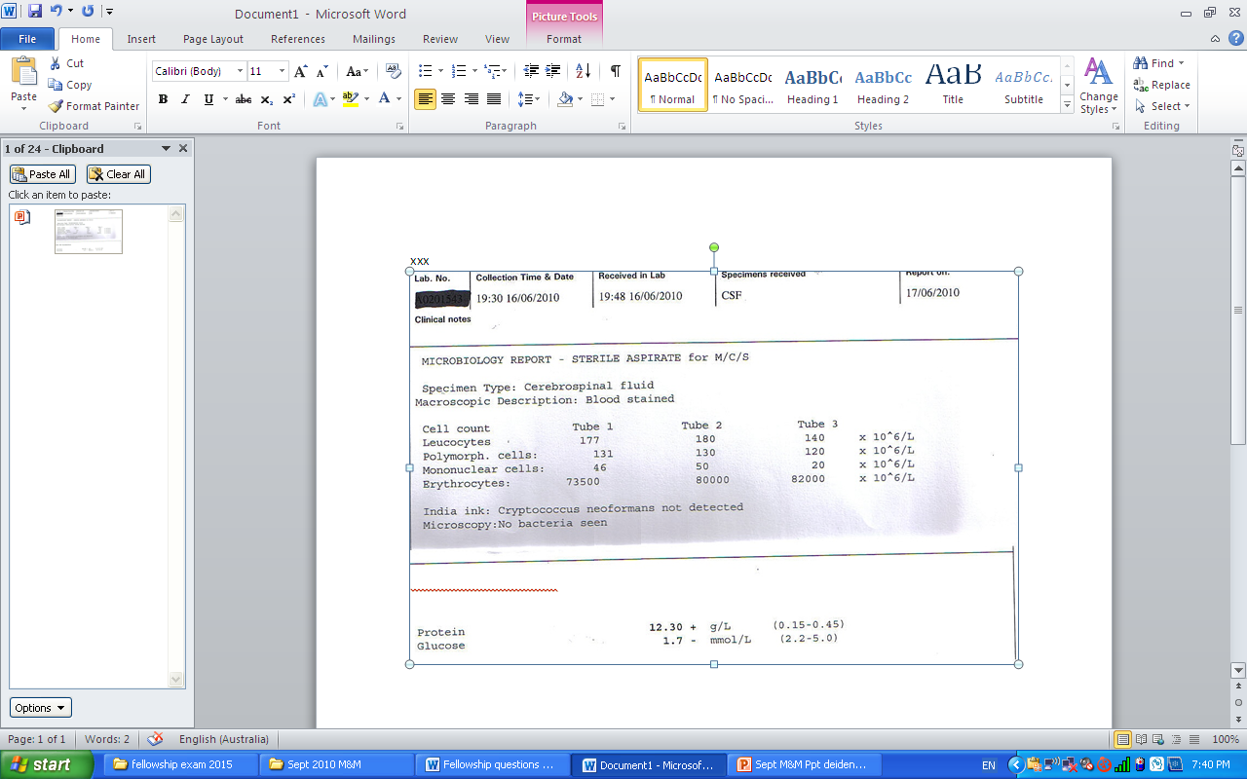

1. What is the next step in the diagnostic work up given this result? (20%)

|  |
| --- |
|  |
|  |

13. You have intubated a patient with a severe head injury from an assault.

His CT is attached.

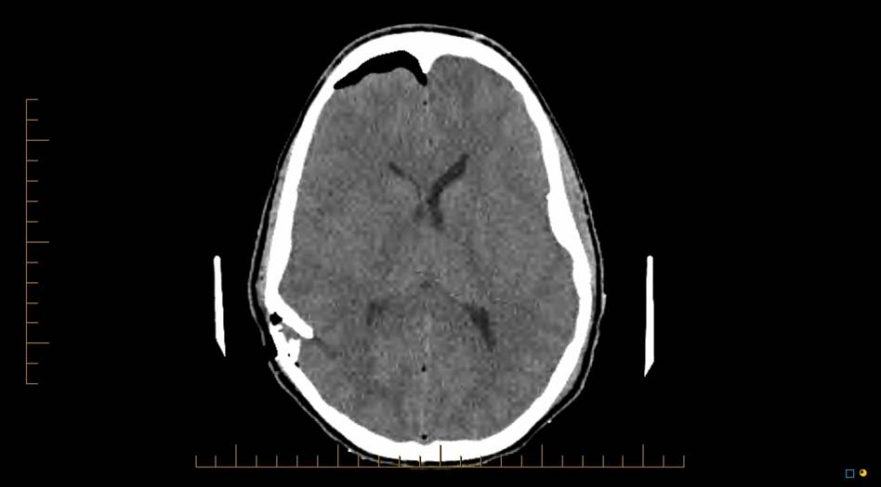

1. List the abnormalities on this CT (50%)

|  |
| --- |
|  |
|  |
|  |
|  |
|  |

1. Would you provide seizure prophylaxis? (20%)

|  |
| --- |
|  |
|  |

1. Outline your management and define your physiological targets in the initial resuscitation for this presentation. (30%)

|  |
| --- |
|  |
|  |
|  |
|  |
|  |
|  |