SAQ 1



1. What is this device ? (1 mark)

|  |
| --- |
|  |
|  |

2. Describe 2 clinical situations when you might consider using this device in ED? (2 marks)

|  |
| --- |
|  |
|  |

3. How can you confirm the placement of this device? (3 marks)

|  |
| --- |
|  |
|  |
|  |

4. Describe clinical situations when this device would be inappropriate/ contraindicated. (5 marks)

|  |
| --- |
|  |
|  |
|  |
|  |
|  |

SAQ 2

A 35 year old man is flown in by air ambulance after being found unconscious in a remote area of bushland in winter. He is in asystole and the ambulance officers are currently performing CPR. His Temp is 28.6°C.

a. What is the current advanced life support algorithm? (3 marks)

|  |
| --- |
|  |
|  |
|  |

b. What are the major modifications needed to be made to this algorithm in the case of unintentional (environmental) hypothermia? (3 marks)

|  |
| --- |
|  |
|  |
|  |

c. Name 2 methods of each:

1. Passive external rewarming

|  |
| --- |
|  |
|  |

1. Active external rewarming

|  |
| --- |
|  |
|  |

4 marks (2 each)

d. Describe 3 methods of active internal rewarming (3 marks; includes at least 1 method of lavage)

|  |
| --- |
|  |
|  |
|  |

SAQ 3

a. List 4 indications for endotracheal intubation. (4 marks)

|  |
| --- |
|  |
|  |
|  |
|  |

b. List 2 indications for non-invasive ventilation. (1 mark)

|  |
| --- |
|  |
|  |

c. List 4 contra-indications to NIV. (2 marks)

|  |
| --- |
|  |
|  |

d. What is the mechanism of action of NIV? (3 marks)

|  |
| --- |
|  |
|  |
|  |

SAQ 4

A 4 year old boy is brought to your ED having sustained a 4cm eyebrow laceration following a fall at a playground. He is accompanied by his mother.

You plan to suture the wound under procedural sedation using ketamine.

a. List 8 contraindications to ketamine use in this setting. (4 marks)

|  |
| --- |
|  |
|  |
|  |
|  |
|  |
|  |
|  |
|  |

b. List 4 potential side effects/complications associated with ketamine use in this setting. (2 marks)

|  |
| --- |
|  |
|  |
|  |
|  |

c. Complete the following table regarding ketamine usage in paediatric procedural sedation by route of delivery. (4 marks)

|  |  |  |
| --- | --- | --- |
|  | **Intra-muscular (i.m)** | **Intra-venous (i.v)** |
| **Initial dose** |  |  |
| **Top-up dose** |  |  |
| **Advantage** |  |  |
| **Disadvantage** |  | *.* |

SAQ 5

a. What patient factors may make rapid sequence intubation difficult or impossible? (3 marks)

|  |
| --- |
|  |
|  |
|  |

b. What alternatives should be considered in these cases? (2 marks)

|  |
| --- |
|  |
|  |

c. List the steps of preparation for rapid sequence induction. (5 marks)

|  |
| --- |
|  |
|  |
|  |
|  |
|  |

SAQ 6

a. Name composition of normal saline and Ringer’s lactate. (2 marks)

|  |
| --- |
|  |
|  |

b. What are the targets to titrate fluid therapy? (4 marks)

|  |
| --- |
|  |
|  |
|  |
|  |

c. What are the complications of fluid therapy? (4 marks)

|  |
| --- |
|  |
|  |
|  |
|  |

SAQ 7

A 72 year old diabetic female is brought to your Emergency Department by ambulance. She complains of feel generally unwell for the last two days with abdominal pain, cough and fevers.

Vitals signs:

Pulse 121 /min

BP 89/58 mmHg

RR 28 /min

Sats 89 % Room Air

Temp 39.8 oC

a. List 3 key steps in this patient’s management. (3 marks)

|  |
| --- |
|  |
|  |
|  |

b. List your resuscitation goals for the first 6 hours. (4 marks)

|  |
| --- |
|  |
|  |
|  |
|  |

c. The patient requires inotropic haemodynamic support. Which inotrope should be used? (1 mark)

|  |
| --- |
|  |
|  |

SAQ 8

A 7 year old boy presents with acute respiratory distress. He is intubated in your department by a senior registrar as he has oxygen saturations of 84% on 15L oxygen via NRB mask and is tiring. You are called to the resuscitation room after intubation as his HR falls from 142 /min to 70 /min and oxygen saturations drop from 90% to 75% on 100% oxygen. He is attached to the Oxylog 3000 ventilator. The registrar reports a first pass intubation taking 40 seconds to complete.

a. List your top 6 differential diagnosis for this deterioration (6 marks)

|  |
| --- |
|  |
|  |
|  |
|  |
|  |
|  |

b. Outline your approach to the airway in the order that you would perform. (4 marks)

|  |
| --- |
|  |
|  |
|  |
|  |

SAQ 9

You have just intubated a 75 year old 60kg woman with deteriorating respiratory function after a fall causing isolated closed chest injuries. She has a history of COPD. She has become increasingly hypoxic and hypotensive since intubation. Your hospital does not have an intensive care unit.

a. List 8 causes for her deterioration (4 Marks)

|  |
| --- |
|  |
|  |
|  |
|  |
|  |
|  |
|  |
|  |

b. Her hypotension resolves although she has an ongoing high oxygen requirement and high ventilator peak pressures. You have a simple VOLUME cycled ventilator.

List basic ventilator settings for this woman and outline your ventilation strategy. (4 Marks)

|  |
| --- |
|  |
|  |
|  |
|  |

c. This woman needs to be transferred to a tertiary hospital for ongoing management. A retrieval team will arrive in 2 hours to transfer her by fixed wing. You do not need to supply staff for the retrieval. Outline how you would prepare for this transfer. (2 marks)

|  |
| --- |
|  |
|  |
|  |
|  |

SAQ 10

A 33 year old woman is being managed in your ED with severe community acquired

pneumonia. She is morbidly obese, with an estimated weight of 180kg and height of 160cm.

Her vital signs are:

GCS 15

Pulse 140 /min

BP 90/45 mmHg

RR 40 /min

O2 sats 90% 15L/min O2 via non-rebreather mask

Temp 38.5 degrees

The patient is becoming tired and you have assessed her as requiring intubation to maintain

adequate oxygenation.

1. In the section below, list 4 difficulties that you may encounter during the periintubation

period. For each difficulty, briefly describe how you will aim to minimise

the problem. (8 marks)

Difficulty: _______________________________________________________

Solution: _______________________________________________________

___________________________________________________________________

___________________________________________________________________

___________________________________________________________________

Difficulty: _______________________________________________________

Solution: _______________________________________________________

___________________________________________________________________

___________________________________________________________________

Difficulty: _______________________________________________________

Solution: _______________________________________________________

___________________________________________________________________

___________________________________________________________________

___________________________________________________________________

Difficulty: _______________________________________________________

Solution: _______________________________________________________

___________________________________________________________________

___________________________________________________________________

Give the ventilator settings you would initially institute by completing the table.

(5 marks)

YOUR SETTING

FiO2

Respiratory rate

Tidal volume

Positive end-expiratory pressure

Peak pressure

SAQ 11

A 75 year old man is brought to your ED with severe shortness of breath. You have assessed

him to have an infective exacerbation of COPD. You are considering non-invasive ventilation

(NIV) as part of his management.

1. List 4 contra-indications to NIV for COPD in the ED. (2 marks)

__________________________________________________________________________

__________________________________________________________________________

__________________________________________________________________________

__________________________________________________________________________

After one hour of bi-level NIV, an arterial blood gas is performed:

FiO2 0.5

pH 7.26 mmHg (7.35 – 7.45)

pCO2 86 mmHg (35 – 45)

pO2 52 mmHg (60 – 100)

HCO3 38 mmol/L (24 – 34)

BE 7.1 mmol/L (-3 – 3)

You note that this result is very similar to the arterial blood gas performed on arrival.

2. List the pathological processes evident on the arterial blood gas, giving supportive

evidence. (4 marks)

__________________________________________________________________________

__________________________________________________________________________

__________________________________________________________________________

__________________________________________________________________________

__________________________________________________________________________

__________________________________________________________________________

3. List the changes you would make to his NIV parameters as a result of the above

findings. (2 marks)

__________________________________________________________________________

__________________________________________________________________________

__________________________________________________________________________

SAQ 12

A 62 year old lady presents with difficulty breathing after eating dinner. She has a history of

ischaemic heart disease.

On arrival, her vital signs are:

GCS 15

Pulse 130 /min

BP 85/45 mmHg

O2 sats 98% room air

Her photo is reproduced:

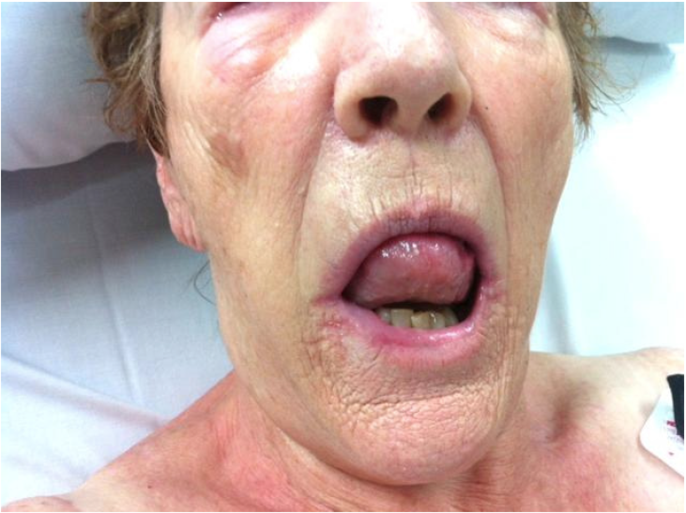

1. Briefly describe 2 abnormalities in the photo. (2 marks)

|  |
| --- |
|  |
|  |

2. What is your clinical interpretation of the information given? (2 marks)

|  |
| --- |
|  |
|  |

3. List 3 signs of impending airway obstruction in this patient. (3 marks)

|  |
| --- |
|  |
|  |
|  |

You have assessed the patient as not requiring immediate airway management.

4. List your 2 main treatment steps. Give doses and endpoints. (4 marks)

|  |
| --- |
|  |
|  |
|  |
|  |

SAQ 13

A 50 year old man presents to your ED with palpitations.On examination, you have found him to be in atrial fibrillation with a

rapid ventricular rate.

1.List your criteria for consideration of this man for cardioversion in the ED. (4 marks)

|  |
| --- |
|  |
|  |
|  |
|  |

2.List 2 drugs you could use for chemical cardioversion. For each drug, give the dose and 2 contra-indications. (8 marks)

|  |
| --- |
|  |
|  |
|  |
|  |
|  |
|  |
|  |
|  |

3. List 3 drugs you could use intravenously for rate control. For each drug, give the dose.

(6 marks)

|  |
| --- |
|  |
|  |
|  |
|  |
|  |
|  |

4. How would you assess this man’s risk of thrombo-embolism? (1 mark)

|  |
| --- |
|  |
|  |

SAQ 14

A 12 year old boy has been brought to your ED after falling off a swing and injuring his wrist. The child weighs 40kg. Your

assessment has revealed a dorsally angulated fracture of the distal radius. The fracture needs manipulation and placement in

a plaster cast. You have decided to perform this procedure in the ED.

1.Give three different methods of procedural sedation for this patient. For each method, give two advantages and two

disadvantages. Give doses where appropriate. (15 marks)

Method 1 _____________________________________________________________________

Advantages _____________________________________________________________________

Disadvantages _____________________________________________________________________

Advantages _____________________________________________________________________

Disadvantages _____________________________________________________________________

Method 3 _____________________________________________________________________

Advantages ____________________________________________________________________