Fellowship Practice Exam

December 2014

WRITTEN EXAMINATION
SHORT ANSWER QUESTIONS

EXAMINATION TIME – 180 MINUTES

Directions to Candidates

1. All questions must be attempted.
2. All SAQs are of equal value, there is no specific mark allocation to individual points within each SAQ.
3. Answer each question in the spaces provided in this booklet.
4. Write your candidate number on every page – the booklet will be separated for marking purposes.
5. DO NOT write your name on the examination booklet.

SAQ 1

A 40 year old man was injured in a campsite accident. He was burned when his shirt was set alight by an open fire. He has full thickness thermal burns to his entire right upper limb and entire anterior chest wall. There are no other injuries. Soon after arrival in your regional ED, he is intubated and ventilated. Ventilatory parameters are satisfactory. He weighs 100kg.

1. Estimate the percentage of total body surface area (TBSA) burned in this patient, showing your method of calculation.

The patient has received initial fluid resuscitation and is cardiovascularly stable.

2. What is Parkland’s formula?

3. Use Parkland’s formula to calculate the volume and rate of fluid you will use over the next 24 hours. State which type of fluid you will use.

4. List five (5) parameters used for intravenous fluid rate adjustment in this patient.

Answer SAQ 1 (Don Liew)
A 40 year-old man was injured in a campsite accident. He was burned when his shirt was set alight by an open fire. He has full thickness thermal burns of his entire right upper limb and entire anterior chest wall. There are no other injuries. Soon after arrival in your regional ED, he is intubated and ventilated. Ventilatory parameters are satisfactory. He weighs 100kg. Reference: Cameron 3rd ed, p 149

General comments
- This question tests knowledge. To do well in it, candidates need to know basic facts.
- Read the stem / questions carefully, and answer questions precisely.
- Marks cannot be allocated to correct answers that are placed incorrectly. For example, a correct response to Q.2 that is written in the space under Q.3 adds little or no marks to either question.
- A formula is a mathematical or scientific expression, like a sentence. As with a sentence, it needs a verb. In this case, the verb is “=”. Answers to Q.2 comprising “Wt x TBSA x 4” without anything else are incomplete, and cannot score full marks.
- Space is limited. Write legibly and neatly. Be precise in your answers: succinct, specific, accurate.
Standards
Maximum score is 20. Borderline score is 14.

1. Estimate the percentage of total body surface area (TBSA) burned in this patient, showing your method of calculation. 4 marks
Rule of 9s: 9% for upper limb plus 9% for anterior chest wall equals 18%.
Lund and Browder: 8.5% for upper limb plus 6.5% for anterior chest wall equals 15%.
Variations between 15% and 20% accepted, provided method of calculation is shown.

The patient has received initial fluid resuscitation and is cardiovascularly stable.
2. What is Parkland’s formula? 5 marks
Perfect mathematical results are not required, provided correct formulae are shown.
Parkland’s formula estimates fluid in ml, to be given over 24 hours.
Intravenous fluid (in ml) to be given in the first 24hrs = % TBSA x 4 x body weight (in kg)

3. Use Parkland’s formula to calculate the volume and rate of fluid you will use over the next 24 hours. State which type of fluid you would use. 6 marks
Total fluid in first 24 hr = (18 x 100 x 4) ml, or 7200 ml
A. Half should be given over first 8 hours
- Ie, (18 x 100 x 4)/2 ml, or 3600 ml
- Initial rate = (18 x 100 x 4) / (2 x 8) ml/hr, or 450 ml/hr
B. Half should be given over subsequent 16 hours
- Rate after 8 hours = (18 x 100 x 4) / (2 x 16) ml/hr, or 225 ml/hr
Fluid choice = crystalloids, such as N Saline or Hartmann’s
NB: Parkland’s serves only as a guide to initial fluid rate, of course. Hence the relevance of Q.4 below!

4. List five (5) parameters used for intravenous fluid rate adjustment in this patient. 5 marks.
Rate adjustment is dependent of fluid parameters:
- UO
- HR
- BP
- Lactate clearance, renal function
- CVP or pulmonary arterial pressures
- Other: Presence of complications such as pulmonary oedema, electrolyte disturbance, cerebral oedema

ECG SAQ 2
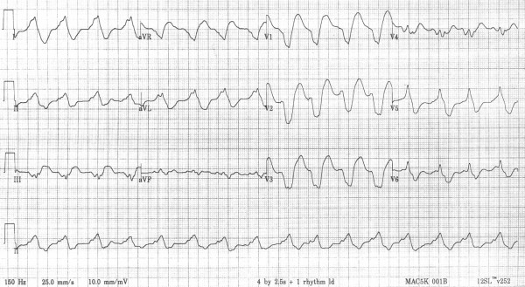
SAQ 2

A 47 year old lady presented to the emergency department with syncope and altered conscious state. She has a past medical history of hypertension, paroxysmal atrial fibrillation and depression.

Her observations in the emergency department are as follows:
GCS 14 (E3, V5, M6)
BP 60/40 mmHg

An ECG is taken on arrival and shown on the page opposite.

1. Describe her ECG giving three (3) positive and two (2) relevant negative findings

2. Describe four (4) different steps you would take to treat her hypotension.

3. List two (2) pros and two (2) cons of using activated charcoal for this patient.

SAQ 2 feedback – Jo Kerr
The differential diagnosis for a sinusoidal, wide complex rhythm between 80-120bpm with QRST fusion includes
- Sodium channel blocker toxicity
- Hyperkalemia
- AIVR
- Tachycardia with aberrant conduction (BBB)
- Massive ST elevation

1. Positive findings
  - Broad QRS complex ( > 200msec)
  - Prominent R wave aVR
  - R/S ratio aVR > 0.7
  - Borderline tachycardia ( rate 96)
  - QTc 506 msec
- Relevant negatives
  - Expect sinus tachycardia with TCA (>120)
  - QT 400msec
  - No AV block ( p waves before all complexes aVF)

- TCA OD
  - cause fatal arrhythmia attributable to blockade of cardiac sodium channels,
  - causing prolongation of the cardiac action potential, refractory period, and atrioventricular conduction.
- Cardiovascular features
  - sinus tachycardia, which is caused by anticholinergic activity and inhibition of norepinephrine uptake
  - hypotension, which is caused by reduced myocardial contractility and peripheral vascular α-adrenergic blockade.
- ECG
  - prolongation of the PR, QRS, and QT intervals;
  - nonspecific ST-segment and T-wave changes;
  - atrioventricular block;
  - right-axis deviation of the terminal 40-ms vector of the QRS complex in the frontal plane;
  - R wave aVR > 3mm or R:S ratio > 0.7
  - right bundle-branch block; and the Brugada pattern.
- Prolongation of the QRS duration >100 ms predicts a higher risk of arrhythmia

2. 1.IV Fluid
Eg N/saline with estimated amount or end point
Please Remember that PAEDIATRIC pts have mls/kg
2.Sodium Bicarbonate 50-100mmol IV stat then every 3-5 min until perfusing rhythm then continue (q 15-30min) aim QRS < 100msec
3.Inotrope With example eg Adrenaline / Noradrenaline
4.Other ETT/hyperventilate/pH 7.5
Balloon pump/ECMO/Bypass
Intralipid
Insulin Euglycemia Rx
Rx for hyperK

Sage Advice
guidance or recommendations offered with regard to prudent action.
- Make sure you indicate clearly which part you are answering
- Please don’t write
  - Repeat as necessary
  - Repeat as required
You need to provide that information
- If the question says 4 DIFFERENT steps
  - Don’t write 3 different inotropes
- DCR is not recommended for wide QRS from Na channel blockade or hyperkalaemia

3. DO NOT USE
- Cheap
- Accessible
- Easy to use
- Messy
- Interferes with resuscitation
- Time consuming
- Corneal abrasions

Single dose activated charcoal
Pro
- Useful if ingestion of potentially toxic amount of poison that is absorbed by charcoal.
- Highly effective if < 1/24 from ingestion but if delayed gastric emptying extend out to 2-3 hrs.
Con:
- Vomiting
- compromised airway or GCS unless intubated
- absent BS
- charcoal resistant poison ( eg lithium)

Enhanced elimination
Multidose activated charcoal
Pro:
- increased effectiveness if large amount ingested or delay to drug dissolution ( SR, enteric coated, slow GI motility, formation of concretions) carbemazepine dapsone phenobarb quinine theophylline
- Effective for drugs with enterohepatic circulation, High binding capacity, small Vd, low protein binding, drug not ionized at physiological pH
Con:
- ileus/ perforation/ obstruction
- Decreased mental state or unprotected airway
- More complications than single dose charcoal
- Increased risk aspiration / obstruction/ perforation

SAQ 3

A 68 year old man presents to the ED with ongoing epistaxis, of spontaneous onset. The patient’s medications include warfarin.

1. List six (6) features in the History that are important for your assessment of this patient.

2. The patient is bleeding only from Kiesselbach’s plexus (Little’s area). He is haemodynamically stable. Outline six (6) steps you would take to control his epistaxis.

3. List three (3) pieces of advice you would give him on discharge.

Answer SAQ 3 (Don Liew)
A 68 year-old man presents to the ED with ongoing epistaxis, of spontaneous onset. The patient’s medications include warfarin. Reference: Cameron 3rd ed, p 582

General comments
This question tests knowledge, but it’s accepted that:
- Minor variations in practice exist.
- The material below is not the exclusive gold standard. Other material not included may also score marks.
Therefore, the following serves only as a guide. Precisely matched wording is not essential, provided concepts are appropriately conveyed. Spelling of medical terms need not be 100% correct, but should be mostly so!
Standards
Maximum score is 15. Borderline score is 11.

1. List six (6) features in the History that are important for your assessment of this patient. 6 marks.
Thoughts (not to be included in your answer, but critical to its content nonetheless)
- Elderly man with iatrogenic bleeding diathesis
- Non-traumatic, so don’t waste time with questions re trauma
- Indication for warfarin is important, as prosthetic valve largely precludes warfarin reversal, whereas AF poses less risk of reversal
- Hx also aims to assess:
- Cause other than warfarin, such as hypertension
- Severity – viz blood loss volume
- Complications – shock
- Implications for Mx – local tamponade, warfarin reversal, prophylactic Abx, patient’s competence
Answer
- Estimate amount of blood loss*: duration of bleed, number of soaked tissues, swallowed blood
- Effects of blood loss*: dizziness, sweating, pallor, dyspnoea, chest pain
- Reason for warfarin*: prosthetic valve indicates incomplete warfarin reversal
- Co-morbidities*, esp uncontrolled hypertension
- Social circumstances: degree of competence, resources to manage at home, expectations
- Medication Hx: concurrent antiplatelet therapy, antibiotics (increase INR), allergies (eg to Abx)

* Issues highlighted by asterisks are requisite for perfect marks for this question.

2. The patient is bleeding only from Kiesselbach’s plexus (Little’s area). He is haemodynamically stable. Outline six (6) steps you would take to control his epistaxis. 6 marks.
Thoughts (not to be included in your answer, but critical to its content nonetheless)
- Complete and persistent haemostasis is the target; recurrent bleeding risk is high
- Strategies: Local effects, optimising coagulation profile and prevention
Answer
- General: reassure, sit patient up, firm external pressure* to nares while equipment prepared
- Suction blood and clots from nostril
- Topical constrictor* agent: cotton pledgelets soaked with lignocaine/adrenaline or Cophenylcaine Forte to Little’s area
- Chemical cautery with Ag nitrate sticks
- If persistent bleeding despite the above, anterior packing with 0.5 inch gauze soaked with constrictor
- Optimise INR*: reverse warfarin with vitamin K if appropriate: <2 if warfarin for AF, and close to 2 for prosthetic valve

* Issues highlighted by asterisks are requisite for perfect marks for this question. Cautery AND/OR tamponade (one alone suffices) also requisite.

3. List three (3) pieces of advice you would give him on discharge. 3 marks.
Answer
A. General*: Do not pick or blow nose for at least 4 days; moisturize nostrils with Vaseline or chloromycetin eye ointment.
B. If warfarin withheld, seek rv* for repeat INR and recommencement of warfarin.
C. Indications for ED return*: recurrent bleed and / or if anterior pack in situ that needs removal.

* Issues highlighted by asterisks are requisite for perfect marks for this question.

SAQ 4

A 6 year old boy is brought in by ambulance with a penetrating chest wound after an incident with a knitting needle and loom bands (small rubber bands) while playing with his little brother.

A clinical photograph is supplied

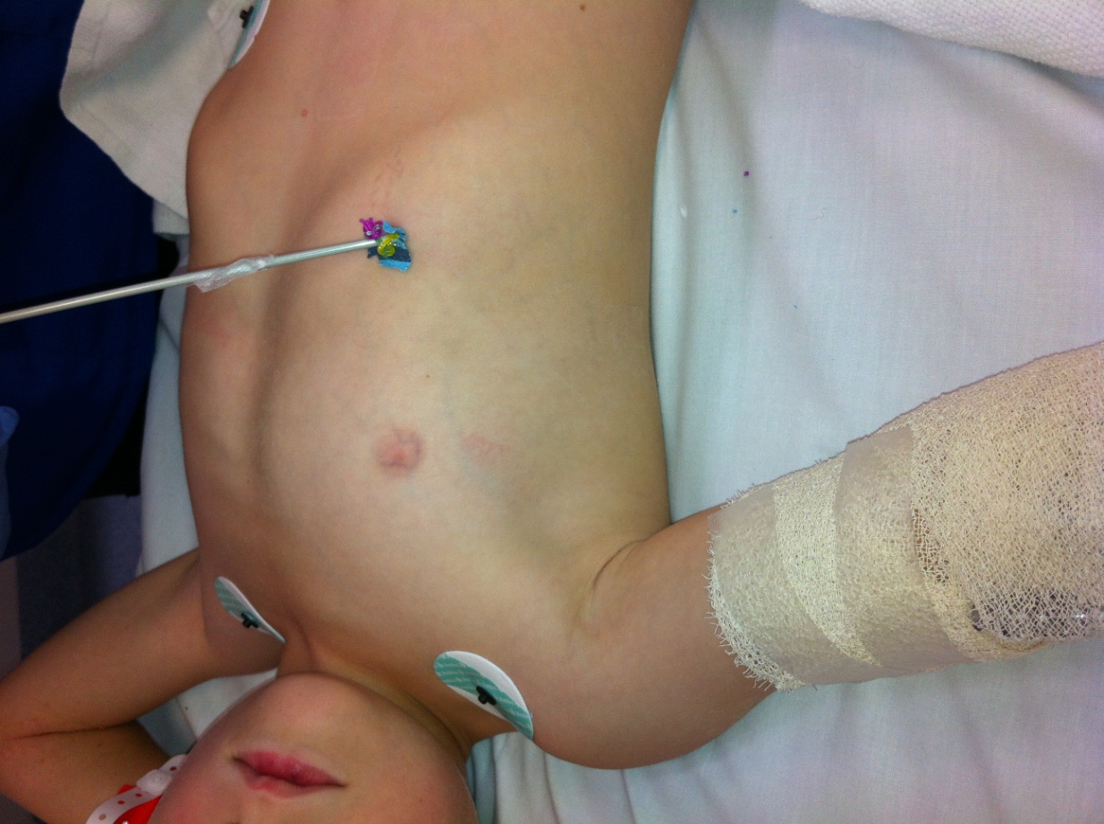

SAQ 4 continued

1. Write three (3) statements that describe the injury in this photo.

2. List six (6) possible complications that may be associated with this presentation

The patient’s chest pain worsens. Vital signs are:

RR 40 /min
PR 160 bpm
BP 60 systolic mmHg
SaO2 98% on room air

3. Describe your three (3) most important management priorities

SAQ 4 – Jeremy Stevens

SAQ 4.

- Write three (3) statements that describe the injury in this photo.
________________________________________________________________________________
Penetrating injury with ?knitting needle to right lower anterior chest (?9th-11th interspace), line of nipple – knitting needle in situ, appears to be at right angle to chest wall, with foreign material at entry point
Unable to assess depth
Child appears comfortable, not distressed, co-operative and well perfused
Chest appears equally expanded right vs left
(IV access in right cubital fossa)
________________________________________________________________________________
- List six (6) possible complications that may be associated with this presentation
________________________________________________________________________________
Tension pneumothorax
Simple pneumothorax
Haemothorax
Hepatic injury
Diaphragm injury
Vascular injury – less likely given location – intercostal
Intra-abdominal visceral injury – gastric, bowel
Infection – empyema
Cardiac injury +/- tamponade - unlikely

The patient’s chest pain worsens. Vital signs are:
RR 40 /min
PR 160 /min
BP 60 systolic mmHg
SaO2 98% on room air

- Describe you three (3) most important management priorities
______________________________________________________________________________
Decompress right chest – presumed tension pneumothorax
Resuscitation – fluid bolus, supplemental oxygen
Analgesia
Leave needle in situ
Urgent surgical review – removal of needle in OT
In general:
- Core topic
- Simple presentation
- Question 2 – term ‘complications’ potentially misleading
- Question 3 – vital signs unclear as to whether tension pneumothorax or haemorrhagic shock

Marking
- 1 mark per correct statement (highlighted = essential) + 1 mark for perspective
- Total exam marks available = 15
- Marks given out of 10 (marks/15 x 10)
- Required

Complications candidates listed that were less important/likely/relevant scored ½ a mark each up to a cumulative total of 1 mark.

My list above is more than the requested number of statements for each question. Highlighted = mandatory

Common problems
- Failure to notice knitting needle
- Failure to consider tension pneumothorax
- Failure for management priorities to address shocked state
- Choice of fluids
  - Patient is hypotensive – give saline bolus as first line, can follow with blood

SAQ 5

An office building collapse results in a large number of injured casualties in a major regional town served by only one hospital with an emergency department. The police have deemed the site safe for emergency responders.

1. List four (4) designated areas that will be required to be set up at the scene to coordinate the medical response to this incident.

2. Outline four (4) differences between Disaster triage and Emergency Department triage.

Disaster Triage | Emergency Department Triage

3. List four (4) actions that will be required to prepare the Emergency Department for the arrival of casualties from this disaster.

SAQ 5 (Trevor Jackson)
Answer standard setting
Pass requires minimum of 9 / 15 options, question ranked overall as a 6

1. List four designated areas that will be required to be set up at the scene to coordinate the medical response to this incident

Forward command post
Casualty collection area
Patient treatment post
Ambulance loading point

Pass level 3 / 4 options required, must include bold

2. Outline four differences between Disaster triage and standard Emergency Department triage

Disaster triage | Emergency Department triage
Goal is to deliver the greatest good to the greatest number with brief focussed assessment | Individualised more detailed approach in order of arrival
Dynamic process, repeated at multiple stages | Single point of time, in order of arrival
Performed by disaster-trained senior medical or Ambulance personnel | Performed by senior nursing staff
Patients sorted into groups requiring immediate, delayed, minimal care or unsalvageable | ATS categories based on urgency

Pass level 2 / 4 options required, must include bold

3. List at least four actions that will be required before the arrival of casualties from this disaster

Activate the Hospital External Disaster code
Decant existing patients (admitted patients to wards, dischargeable patients home, and waiting room/unseen patients notified and removed as possible)
Prepare designated areas for receiving patients per code plan
Allocation of roles to staff per plan
Recall additional staff
Notify key hospital areas of disaster (blood bank/pathology, critical care, theatres and security)
Prepare resources (additional medical supplies, disaster patient ID labels...)

Pass level 4 / 7 options, must include bold

SAQ 6

An 82 year old woman from a nursing home is sent in by ambulance with increasing confusion and agitation. She is combative and agitated.

1. List five (5) differential diagnostic categories. Give 2 examples of each.
Diagnostic category | Example

2. You decide that her agitation needs management. List two (2) drugs and doses for managing her agitation. List two (2) potential adverse effects for each drug.
Drug | Dose | Adverse effects

3. List three (3) features distinguishing delirium from dementia
2015.1 Trial SAQ Exam - SAQ 6 (Barry Gunn)

General points:
- Maintain perspective. Answer this question for this patient. The question is about increasing confusion in an 82 year old lady from a nursing home. It is NOT a generic question about the confused patient. Think about the patient as though you were looking after her in your ED.
- Answer the question that is asked. If the question states, “Give 2 examples”, then give 2 examples only. If you write 3 examples, the third one will not count towards your marks. Also, if you write 2 examples on the one line, then only one of them may be counted or alternatively the one on the next line will not count.
Question 1:
The 5 categories should be relevant to this patient. Examples should not be repeated between categories.
Categories that I think should be considered:
- Infective e.g. UTI, pneumonia, meningitis
- Metabolic / Endocrine e.g. hyponatraemia, hypoglycaemia,
- CNS – e.g. neoplasm or complication of it, stroke (infarct), subdural
- Drug related
  - anticholinergic medications e.g. tricyclics, phenothiazine antipsychotics,
  - serotonin syndrome
  - medication changes e.g. missed or reduced doses of sedative medications
- Gastrointestinal e.g. ischaemic gut, bowel obstruction
- Cardiovascular e.g. silent MI, arrhythmia (e.g. AF), pulmonary embolus
Psychiatric causes such as dementia, Parkinson’s disease, depression are not causes that I would consider on my differential list to explain why this lady has become agitated and confused. Similarly environmental causes such as hyperthermia are very unlikely. Hyperthermic patients are unlikely to be combative and agitated. Some candidates listed opiate toxicity. Again. I do not think this is a likely cause as opiate toxic patients are unlikely to be combative and agitated. Opiate withdrawal may be an appropriate
Question 2:
It is important that doses are appropriate for an 82 year old lady. For example, some candidates wrote 5 – 10 mg of intravenous midazolam. Would you give this dose to an elderly woman in a single bolus? I very much doubt it. I would think that you would give 1-2 mg IV titrated to effect. Also some candidates wrote drugs as a mg /kg dose. As an examiner, I want to know what dose you are going to give this patient.
With regard to adverse effects, some candidates wrote sedation. Isn’t this the aim? However, I think it would be reasonable to write excessive sedation.
Question 3:
This question requires you to write the feature and how if differs in both delirium and dementia. Some candidates wrote how the feature is affected by delirium but not dementia.
The features that could have been listed:
- Clouding of consciousness in delirium; normal conscious level in dementia.
- Delirium fluctuates in severity; dementia does not
- Delirium is usually reversible; dementia usually is not
- Delirium has a short onset; dementia has a much longer onset.
Delirium may be associated with acutely abnormal vital signs in particular fever; dementia is associated with normal vital signs
SAQ 7

A 22 year old male is brought in by ambulance having been involved in a high speed motor vehicle accident.
On arrival his observations are as follows:

GCS 13 (E3, M6, V4)
PR 140 bpm
BP 80/50 mmHg
SaO2 96% on room air

He has no significant past history and is on no medication

A portable pelvic xray is performed as part of his workup.

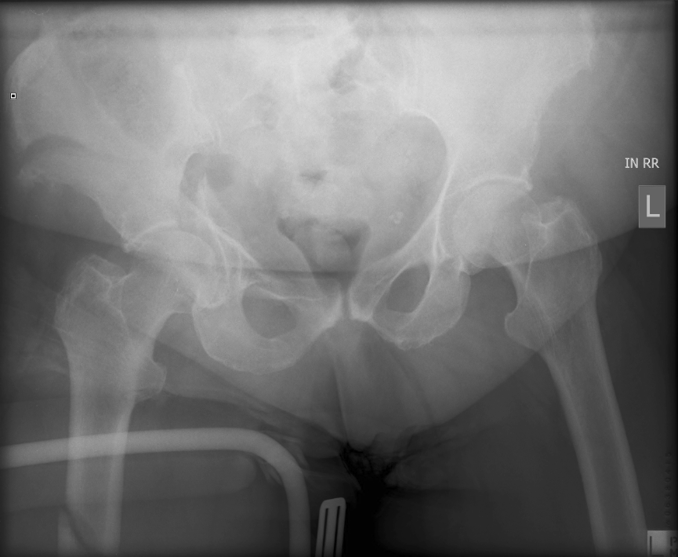

SAQ 7 continued

1. Describe the three (3) most important positive findings.

2. List five (5) treatment priorities relevant to this patient

3. Describe four (4) essential elements of a massive transfusion protocol

SAQ 7
Monash Practice Fellowship Exam, Dec 2014

Feedback to candidates from Dr. Michaela Mee (Emergency Physician, Monash Medical Centre, VIC)

Pass rate: 63% (37/59)
Pass grade: 14/24
Highest mark: 21.75/24
To pass SAQ7 needed to pass 2/3 parts minimum
All parts required a certain element to pass that part (eg recognizing pelvic fracture in part one), and if this was not there, the points achieved for that part were capped (see below)

This SAQ had questions open to interpretation, however the best answers were those that showed perspective, organized thoughts, and a set of headings/fields that lend themselves to a more comprehensive answer.

My recommendation to people is to try to stand back at the start of each question, and think of good subheadings for each element of the answer, allowing further detail under each subheading. This is the best way to show your knowledge and lessen the likelihood of missing important elements. It also means if you are rushed you can get points for general concepts and fill in details later if time.

I also recommend that you think in the examiners shoes to decide what is likely required to pass the question. For example, in part 2 of this question, for a patient with haemorrhagic shock and unstable pelvic fracture, is it enough to mention temporizing measures only such as fluid resus? Would the examiner expect you to mention laparotomy / angiographic embolisation as ways to stop bleeding? Would you be expected to commence RBC/Oneg for fluid resus?

Below I have tried to give examples of a good way to answer each question….

The first part of SAQ7 asks: ‘describe the 3 most important positive findings’ after presenting clinical vital signs, a history, and an XR pelvis. While you can still comfortably pass by assuming this wants you to just describe 3 XRAY findings, you will probably get more points if you include findings of the scenario as a whole. An example of good answer is:
- High risk mechanism, haemodynamic instability: likely haemorrhagic shock
- Unstable pelvic fracture: R acetabulum, R iliac crest…
- R Femur fracture: oblique, with likely Donway splint
My approach to marking this question might be controversial to some (see below). Perhaps the question could have been more clearly worded, nevertheless almost all candidates passed this part.

The second question of SAQ 7 asks for your treatment priorities. In this case, to pass this part you will probably need to think beyond treatment of the fracture per se. This is the guts of SAQ7. I would consider volume resus with RBC, and laparotomy vs pelvic angio embolisation, as required parts of this answer. This is a treatment question, not a management question. By putting ‘urgent IV’ or ‘ABC’ as subanswers, you are just losing potential points. Referrals also have less weight here. It is not enough to call for help from other specialists!.

There are many ways to organize your answer. You will be able to use your system for similar trauma questions so take the time to create an ideal answer. An example of a good answer is as follows:
- Volume resuscitation: urgent Oneg blood, NSaline minimise, massive blood transfusion protocol, permissive hypotension
- Immobilisation: Pelvic binding, C spine, external fixation
- Stop bleeding: laparotomy if peritoneal blood on EFAST, pelvic angio embolisation if neg
- Seek and treat other sources of bleeding/hypotension eg ICC
- Analgesia: IV fentanyl/ketamine
There are other possible great subheadings that people came up with

The third question of SAQ 7 was commonly misinterpreted as asking what the essential elements of massive transfusion were. Remember to read the question, which clearly asks you to describe elements of a massive transfusion protocol. To pass this part you would need to mention blood product ratios in massive transfusion (or show understanding of use of FFP/pl to prevent coagulopathy) somewhere in SAQ7. It is difficult to cover all aspects with 4 points, but if you pick 4 good ones and organize your answer well, you will pass well. An example of a good answer is:
- Early communication/referral: blood bank, haem team, with clear triggers
- Blood product ratios: eg RBC:FFP:Pooled platelets 1-2:1:1
- Monitoring and treatment of complications: eg Coagulopathy, hypocalcaemia, hypothermia, acidosis
- quality assurance: review of safety of rapid blood product admin, audit

Marking System Used for SAQ7:

ELEMENT POINTS max subtot

Part One:

R Acetabulum Fx 1.25
R Alar/Iliac Crest Fx 1.25
R superior pub rami fx 1.25
Extra correct detail of above fx (eg oblique/displ/comm) 0.5 per fx
Possible undispl NOF/sacral fx/Blush sign/SI disrupt
or other fx that is reasonable 0.5-1
‘Unstable’ pelvic fracture/disrupted ring 2
Likely plausible mechanism 0.5
4

R Shaft Femur Fx 1.25
+Donway likely in situ 0.5

Haemodynamic instability/haemorrhagic shock 2
Likely HI/C spine injury (ddx GCS 13 due to shock) 2

Total max possible points for Part 1: __ / 6

Need 3.5/6 to pass this part. Needs to mention one of pelvic fractures to get >/= 3.5/6, otherwise gets 3.25/6

Part 2:

IV Volume/fluid Resuscitation (any) 1
Or Vol resus with Oneg blood/RBC/massive tf 3
+/- Permissive hypotension 0.5

C spine immob 1
Pelvic binding 1
Donway 0.5

OT/laparotomy if FAST positive/peritoneal bleed 2
Pelvic angiography/embolisation if FAST neg 1
+/-Damage control surgery 1

Seek and treat other bleeding/EFAST/ICC/survey 2

Analgesia - any 1
Or ketamine/titrated fentanyl/caution with morphine 2

Other:
Maximise O2 delivery: O2 1
Referrals to trauma/surg/ortho/interventional radiol 1
Tranexamic acid 1
Transfer prep 1

Total possible points for part 2: ___ / 10

NB: Candidate needs to mention use laparotomy / angio embolisation, and fluid/vol resus with RBC, to be able to get >/=6/10 (otherwise max 5.75/10)

Part 3

Initiation/Consultation/Communication systems 2
-blood bank, Haem reg
Indications/Triggers: 2
Haemorrhagic shock actual/impending
Definition of massive tf vary
Treatment related:
-monitoring of complications: hypocalc, 2
acidosis, hypothermia, coagulopathy
-Ratio RBC:FFP:Platelets: 1-2:1:1 2
institution/evidence based
-end points 1
-alternative/adjunct meical treatments 1
eg tranexamic acid

Quality assurance related
-Safety of blood product admin (labeling, checks) 2
-Audit/monitoring/data collection/review 1

Precautions/limitations (eg is not definitive Mx, eg allergy) 2

Other:
-other reasonable 1
eg controverisies, special considerations
eg documentation/staffing

Total possible points for part 3: __ / 8

Candidate needs to mention use of blood products ffp/pl to get >/=4.5/8. Otherwise gets 4.25

TOTAL ___ / 24

PASS MARK for whole question: 14/24
Must pass 2 out of 3 parts to pass whole question. If not, max 13.75/24

SAQ 8

A 6 year old girl is brought to the emergency department by her concerned parents. She is unwell and complaining of a painful right eye. Her temperature is 38ºC. Her left eye region is normal. This is her photograph.

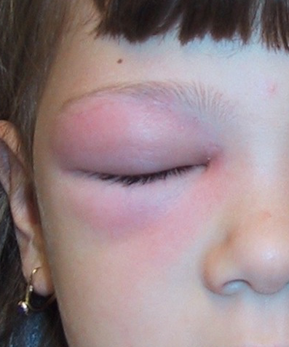

SAQ 8 continued

1. List four (4) examination findings you will look for, which would suggest a major complication.

Examination finding | Complication

2. List three (3) investigations and their justification in this child.

Investigation | Justification

3. List five (5) management priorities, including brief details.

SAQ 8 (Jenny Brookes)
List four (4) examination findings you will look for, which would suggest a major complication.
Need TWO of BOLDED to PASS (Orbit + Eye Cx)
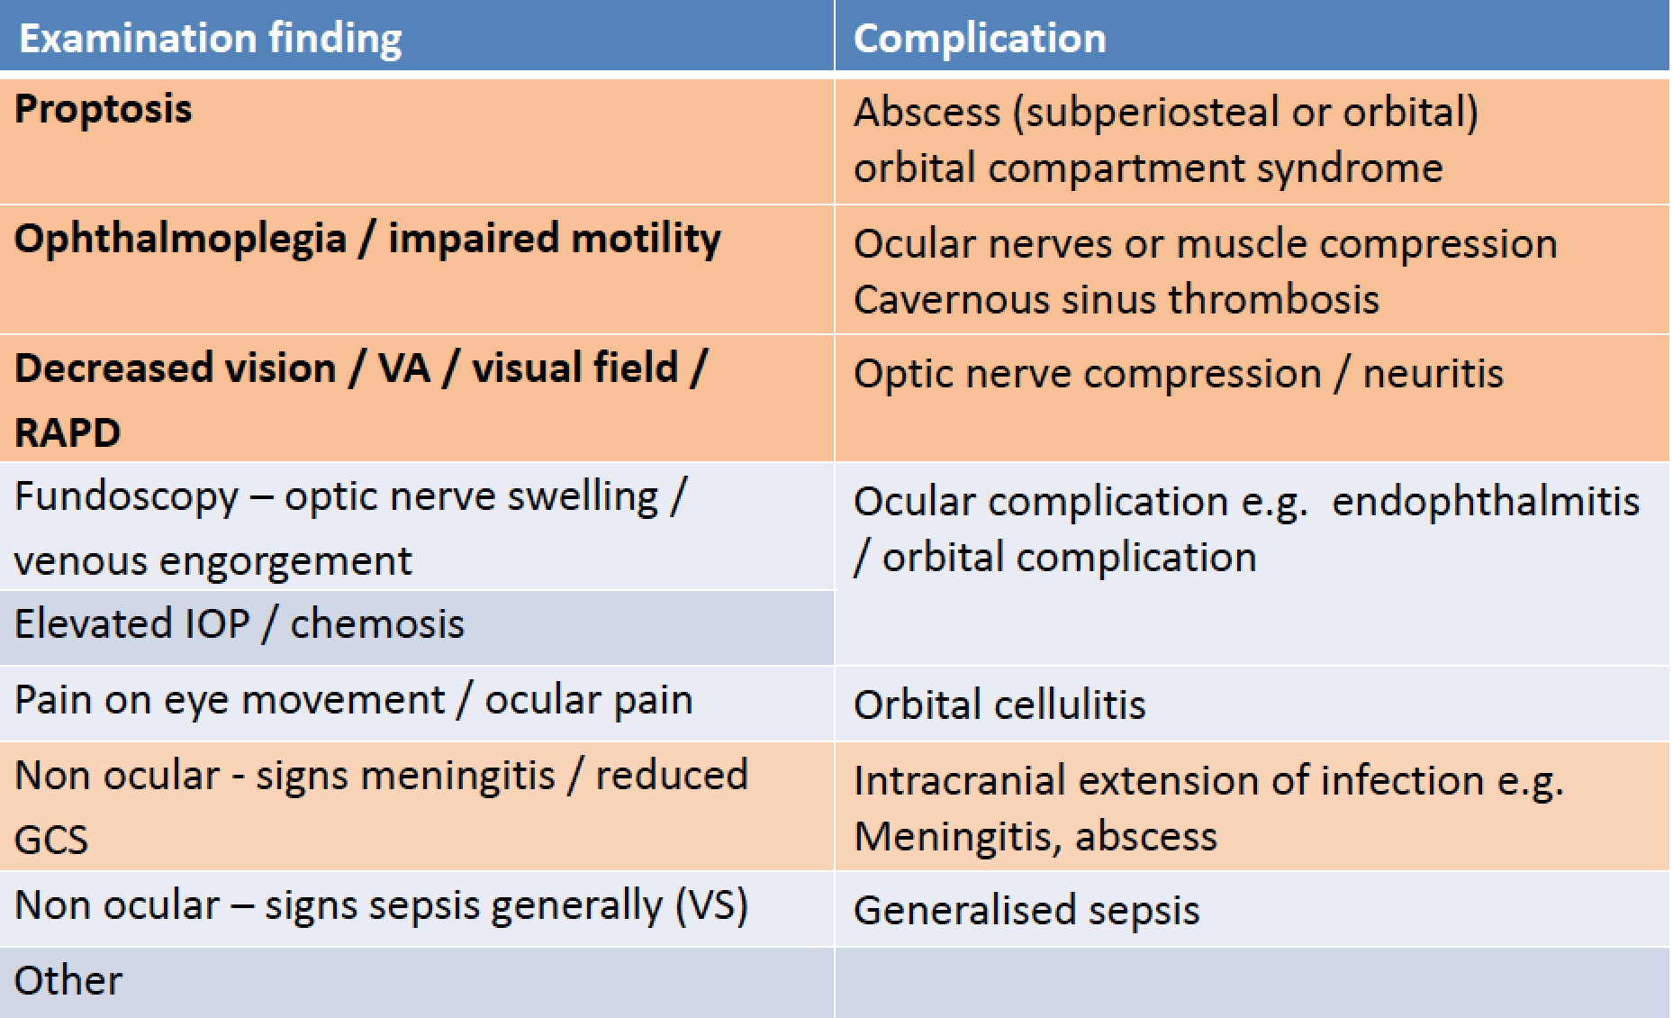

List three (3) investigations and their justification in this child.
2/3 BOLDED, including CT ORBIT, mandatory to pass
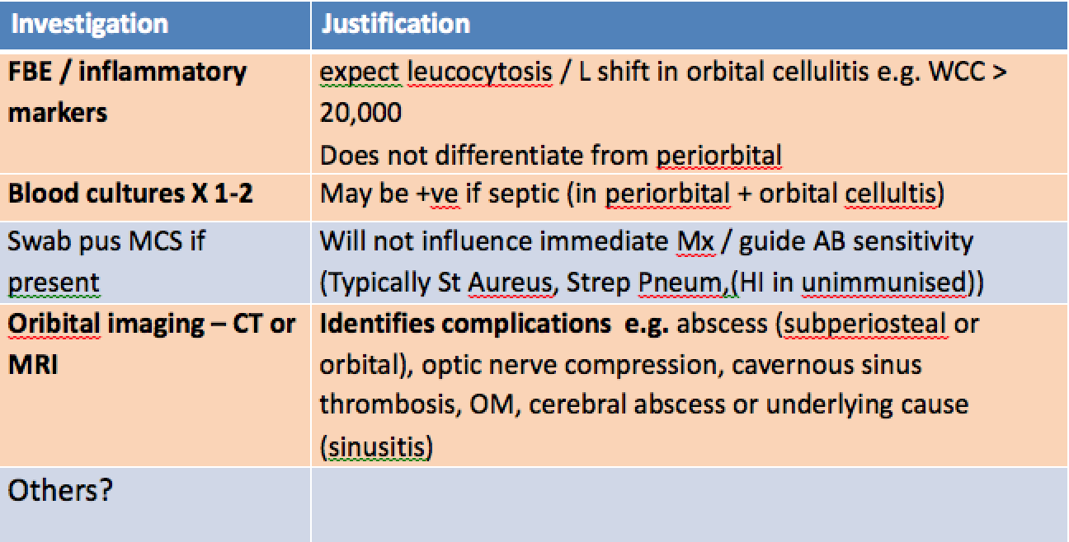

ACEM Glossary of terms

Management

those aspects of care of the patient encompassing treatment, supportive care and disposition.

“Priorities” - Not defined - Implies ranking or order / importance

Management is NOT Assessment history taking, physical examination, investigation
RED mandatory to pass.
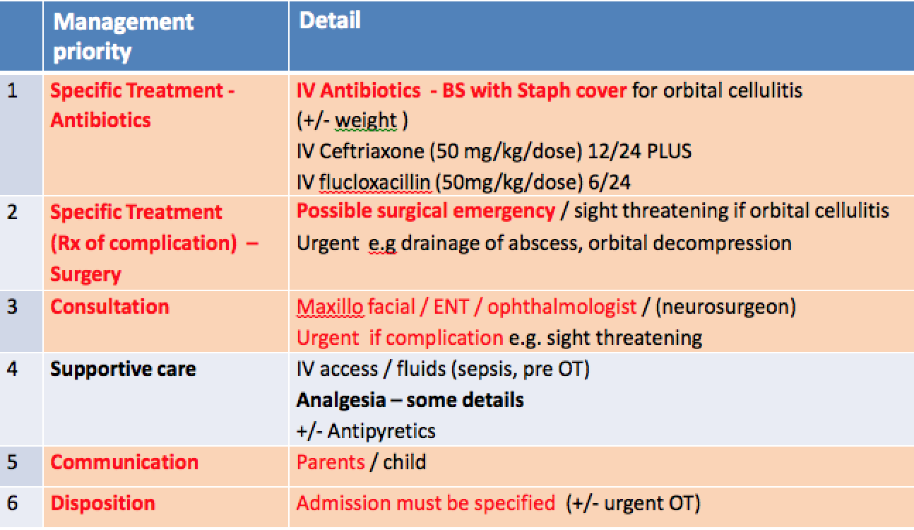
MANAGEMENT PRIORITIES
SAQ 8 A 6 year old girl is brought to the emergency department by her
concerned parents. She is unwell and complaining of a painful right eye. Her
temperature is 38oC. Her left eye region is normal.

Specific Rx

IV ABs / BS with Staph cover (detail)
Consultation Ophthalmology, Fac Max – urgent if complication - surgical emergency

Supportive Care
Analgesia (brief detail)

IV fluids
Communication / explanation parents
Disposition – admission for IV ABs +/- OT

SAQ 9

A 50 year old woman presents to the emergency department complaining of dizziness.

1. List your 4 most likely differential diagnoses.

2. The patient describes true vertigo. List six (6) key features on assessment that differentiate between a peripheral and central cause for her symptoms.
Include three (3) historical and three (3) on physical examination.

3. List three (3) investigations that may be appropriate and justify when you would perform them.

Investigation | When performed

SAQ 9 (Jon Dowling)

List your 4 most likely differential diagnoses

a. Vertigo
- - Peripheral Vertigo – BPPV, labrinthitis, Menierres, vestibular neuronitis, ear pathology

- - Central Vertigo – vertebrobasilar ischaemia/haemorrhage, SOL, Demyelination

b. Cardiovascular – hypotension, dehydration, arrhythmia, “pre-syncope”

c. Other – hypoglycaemia, hypoxia, sepsis, toxin (eg ethanol),

- Marks – one each for each point, minimum one example from a,b and c, plus one other in a reasonable order. One mark removed if in unreasonable order
- One CVS cause mandatory

2. The patient describes true vertigo. List six (6) key features on assessment that differentiate between a peripheral and central cause for her symptoms. Include three (3) historical and three (3) on physical examination

- Historical:
- Sudden onset, severe, worse on head movement, associated nausea fatigue of symptoms– suggest peripheral
- Other neurological symptoms – central
- Tinnitus/hearing loss – peripheral
- Paroxysmal – suggest peripheral
- Recent viral illness – suggest peripheral
- Cardiovascular risk factors suggest central
Exam:
- Any abnormal neurological exam – central
- Nystagmus – up or down beat rotatory nystagmus suggest peripheral, vertical or multiple direction nystagmus suggest central, fatigue of nystagmus suggests peripheral
- HINTS test – negative head impulse test, nystagmus that changes direction and positive test of skew suggest central
- Abnormal ear exam – suggest peripheral
- Positive Hallpike, may be treated with Epley – suggest peripheral

- Marking – 0.5 mark each any three from each list with appropriate interpretation (cannot just list the hx or exam without understanding what it implies). Must include abnormal exam and nystagmus.
- Half marks rounded down.

3. List three (3) investigations that may be appropriate and justify when you would perform them.
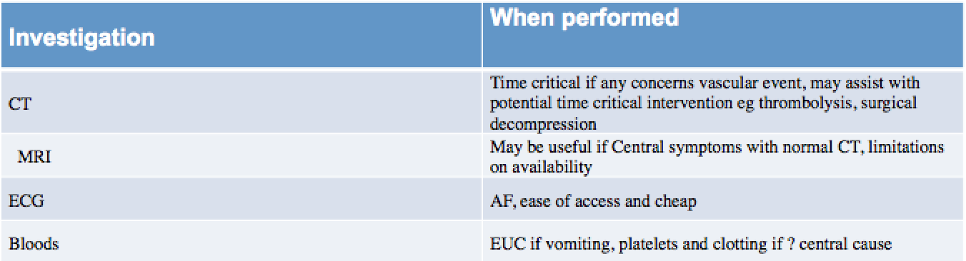

Errors
Q1
- Not reading the Question
- The patient presented with dizziness. If your 4 answers were vertigo, vertigo, vertigo and vertigo then you don’t deserve to pass
- Not including at least one CVS cause
- Writing more than 4 answers

Q2
- Saying the same symptom twice
- Frequent use of headache as a differentiator without qualification
- Writing a list without reference to whether it relates to peripheral or central cause
- Inappropriate use of the HINTS exam

Q3
- Writing examination (eg HINTS or Hallpike)
- Unreasonable Ix in the setting of presentation (eg LP to look for meningitis)
- Audiometry
- Non specific justification eg “ECG – routine on arrival”, “FBC to look for infective cause”

SAQ 10 – CSF result

Reference range
Appearance clear, colourless

Glucose 3.0 mmol/L 2.8 - 4.0
Protein 750 mg/L 150 - 500

WBC
Polymorphs 20 x10⁶/L <5
Lymphocytes 111 x10⁶/L <5
Red cells 8 x10⁶/L <5
Organisms no organisms seen

Serum Glucose 5.0

SAQ 10

A 30 year old woman presents to the ED complaining of fever, headache, arthralgia and photophobia. She has been unwell for 5 days. Her symptoms initially started like an upper respiratory tract infection, and have not improved despite oral antibiotics.

1. List five (5) contraindications for lumbar puncture.

A lumbar puncture is performed and the results are shown on the opposite page.

2. What are the two (2) most likely diagnoses?

3. List 3 features of the CSF that support your diagnoses

4. List two (2) pros and two (2) cons for the administration of intravenous antibiotics in this patient

Pros | Cons

Overall – Anna Davis
Handwriting still makes a difference
When there are multiple points (eg list 5 order makes a diff and adds emphasis to important points
Gave a lot of 10s/14 which was my bare minimum to pass
Breakdown - part 1 out of 5, part 2 out of 2, part 3 out of 3, part 4 out of 4.Total 14.
1. List 5 contraindications to a lumbar puncture
1. Expected candidates to know 5 contraindications to LP
Many candidates said the same indication but broke it up into several parts which I thought was not as good as grouping them
eg Better candidates said suspected coagulopathy eg low platelets, raised inr (very few mentioned a MP rash which I would think would be important) compared with those who listed different sorts of coagulopathy separately
Another example - infection around LP site is 1 point though some listed cellulitis and abscess around lumbar area as separate
Better answers were put in order of most important eg suspected raised intracranial pressure prior to spinal surgery seemed a better perspective
Mine in order
Suspected raised intracranial pressure - altered concious state, unilateral dilated pupil, papilloedema, hypertension bradycardia
focal neurological signs
coagulopathy as one - not broken up into 5 different sorts to cover answer
seizures
abnormality at LP site eg infection or spinal anatomy that would preclude lp eg spina bifida, spinal fusion
Others
Patient refusal
Previous complications of LP
Other infection eg pneumonia to explain Sx
Patient agitation???
Not correct
Will not change management
vomiting
2. Most likely diagnoses
Was generally answered well, would have thought you would put viral first then partially treated bacterial meningitis didn’t mark down for order
Pass fail was mentioning both viral and bacterial meningitis
partially treated bacterial meningitis is better than just bacterial meningitis
aspetic meningitis was not sufficient
If bacterial meningitis was only mentioned in section 4 s then I allowed them to pass but I thought it was not as good
3. List the features of CSF that support your diagnosis
Best answers conveyed that these results were not 100% diagnostic.
best answers conveyed which features suggested viral and which suggested partially treated bacterial.
eg high protein suggest meningitis, lymphocytes most prominent WCC sugg viral, PMN may only be marginally raised in partially treated as compared to untreated bact meningitis, glucose low end of normal common in partially treated bact
Didn’t get full marks but still passed if just listed each feature ie high protein, high lymphocytes as it didn’t demonstrate understanding as well
2 pros
Mine in order
antibiotics will treat partially Rx bacterial meningitis which if untreated has high morbidity and mortality
Likely few side effects, can be ceased after culture and PCR exclude bacterial meningitis with little sequealae
Others not quite as good
treats partial bacterial meningitis
treats other source of infection
Cons
Potential for side effects including anaphylaxis
bacterial resistance
Requires hospital stay and complications assosciated with this
Others
not indicated if viral

SAQ 11

A 65 year old male is brought to your tertiary emergency department with progressively increasing weakness in his legs

1. Outline three (3) key clinical differences between Guillaine Barre syndrome and acute spinal cord compression

Guillian Barre | Acute spinal cord compression

2. On examination the patient has bilateral lower limb weakness with loss of sensation from the nipples down, and absent sphincter tone.
What is the most likely diagnosis?

3. List five (5) potential causes for this condition in this patient.

SAQ 11 (Jon Dowling)
Q1 Marks: 1 mark for a point from each column, but must have enough detail in each point, must have comment on either reflexes or sensation changes, total marks out of 6
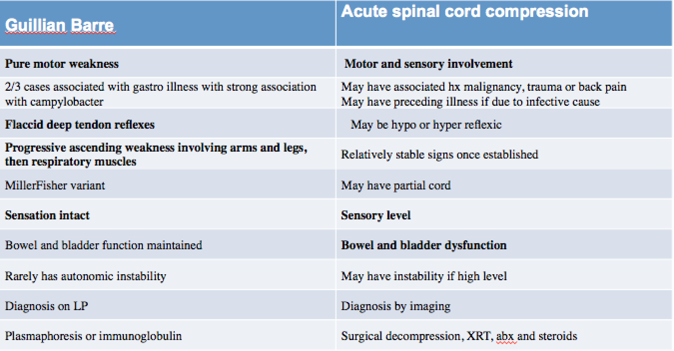

Q2
- Acute spinal cord compression at level of T4 (or upper thoracic)
- One mark for correct diagnosis, must include a level

Q3
- Malignancy (primary or secondary)
- Infection (epidural abscess or discitis)
- Vascular (appropriate description of vascular cause eg dissection leading to ischaemic spinal artery)
- Demyelination (not strictly due to compression)
- Trauma (but should qualify statement to relate to a progressive weakness)
- Degenerative
- Marks: Must include malignancy, score = zero if not included. 5 appropriate responses = 3/3, 3-4 responses = 2/3, 1-2 responses = 1/3

Errors
Q1
- Weak descriptors
  - “Recent illness” vs “No recent illness”
  - “may or may not be prominent”
  - Variable neurology depending upon level affected”
- Vague descriptions
  - “sensation affected”
  - “ascending weakness” vs “descending weakness”
- Some confusion between Cord compression and Cauda Equina
- Need to ensure each point differentiates the two conditions

Q2
- Wrong diagnosis
- Not including a sensory level
Q3
- Not including malignancy
- Not qualifying statements regarding trauma

SAQ 12

A 35 year old woman presents to the emergency department with fever, rigors and vomiting. She is 5 days post chemotherapy (4th cycle) for breast cancer.
On examination her observations are as follows:
Temp 39 ºC
HR 120 /min
BP 80/60 mmHg
RR 28 /min
Sats 96% on 3L O₂ by nasal prongs

1. Describe your four (4) treatment priorities

2. List 5 investigations and give justification for each

Investigation | Justification

3. List four (4) factors that influence antibiotic choice

SAQ 12 (Jason Harney)
Thematic flaws in people's answers were as follows:

not treating vomiting
IV access listed as a treatment (I would consider this an intervention but without fluids or antibiotics is not a treatment)
a oncology consult listed as a treatment - not really a treatment
U&ECr as 'baseline' - one of my pet hates - patient was vomiting so and has had recent chemotherapy so good chance of electrolyte imbalance renal impairment abnormal calcium
some wanted to lead to intubation which I thought was a bit of overkill for this question
a good answer for investigation would have been a 5th more encompassing - other tailored to source identification and control of the sepsis
SAQ 13

A 47 year old man presents with a sudden severe headache and confusion.

A single slice of his non contrast CT scan is shown.

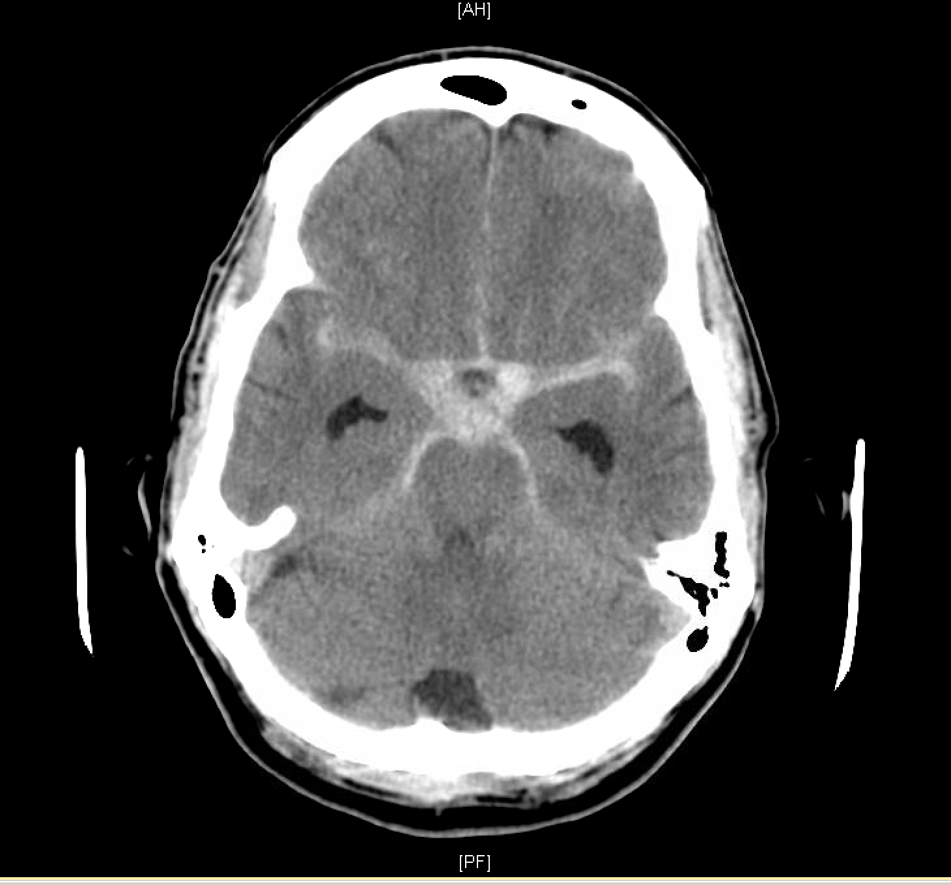

SAQ 13 continued

1. Describe four (4) relevant findings on his CT scan.

2. What is the most likely diagnosis?

3. List four (4) important measures for neuroprotection in the emergency department.

4. His BP is 200/100 mmHg. What antihypertensive will you use, include dose and route.

5. What systolic BP range are you aiming for in mmHg?

SAQ 13 Feedback – David Lightfoot

Describe four (4) relevant findings on his CT scan!
- Only first 4 items marked!
- Must be relevant!
- Out of 4 marks total!
- SAH and description plus 3 others

What is the most likely diagnosis?!
- Out of 2!
- Subarachnoid haemorrhage (1)!
- PLUS gradation/classification/cause/size estimate

List four (4) important measures for neuroprotection in the emergency department?!
- First 4 only marked!
- Out of 4!
- Nimodipine, BP control, others!
- Max of 2 from others.

His BP is 200/100 mmHg. What antihypertensive will you use, include dose and route!
- Out of 2!
- Appropriate Drug (1)!
- Dose AND route (1)

What systolic BP range are you aiming for in mmHg?!
- Range requires high and low value!
- Total of 2 marks

Cut mark 64% or 9/14

Feedback/advice
- Watch number of items requested
- Care with double point answers
- Show prioritisation
- Consultant level answer

SAQ 14

A 5 year old boy presents with an exacerbation of his known asthma.

1. What four (4) signs on physical examination would suggest a severe (but NOT life threatening) exacerbation?

2. List four (4) drugs with their doses, routes and indications for the use in the treatment of childhood asthma in the emergency department.

Drug | Dose | Route | Indication

3. List five (5) criteria for discharge.

q1 out of 3 – Anna Davis
agitated.distressed, mod to marked wob, tachycardia, marked limitation of ability to talk
q2 out of 3
02/salbutamol/ipratropium/pred
others
Mg/nebs/methylpred/aminophylline
q3 out of 4
adequate oxygenation, adequate oral intake, salbutamol weaned to 3-4 hourly, adequate parental education and ability to deliver salbutamol/appropriate fu eg gp

ECG SAQ 15
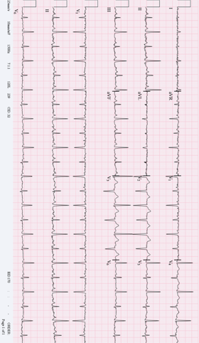
SAQ 15

A 45 year old man presents with vague symptoms of central dull chest pain and mild shortness of breath on exertion for the past 3 days.

His observations are:

Temperature 37 ºC
BP 120/70 mmHg
RR 18 /min
O₂ saturations 99% on room air

An ECG is taken and is shown on the opposite page

1. Interpret his ECG giving three (3) positive findings.

2. List four (4) differential diagnoses for this appearance on the ECG.

3. List three (3) features on assessment that would determine disposition.

Feedback – Pourya Pouryaha

READ the question first then START with the elephant on the ECG:
Things to consider before answering this question:

READ the Question and answer THE QUESTION
try to guess the sense (Flavour if you wish) of the question (what is it asking???—Ischemia/dysrhythmia/anything specific that I should know,…)
Consider it as a real patient in front of you or in this case a nurse showing you an ECG in a busy shift —> what’s your immediate response ? —> I hope it is ‘’ Where is this patient ?? ‘’
Have a systematic approach,don’t just look for findings (Always check calibration)
for higher Marks give appropriate informations (Extras) ie instead of Sinus tachycardia you can easily calculate rate and write ST ~138bpm

ELEPHANT here : Electrical alternans ,Low Voltage,Sinus Tachycardia 138 bpm
less important :prolong QTc ,poor R wave progression ,maybe non specific PR/ST-T changes

*** most candidate didn’t notice ‘’interpret ‘’ in part (a)
*** don’t make up signs (bigeminy/ashman phenomenon,…)
***answer the question and don’t waste your time
ie:
just positive findings are asked here,don’t write negatives
instead of : regular narrow complex tachycardia ,sinus wave with rate 138 bpm you can simply write: Sinus tachycardia Rate ~138 bp

***DDX for ECG appearance not Sinus tachycardia or cause of effusion;you can start from simple i.e. Obesity or more important ones for higher marks (here :pericardial effusion,…)

version A:

1 Pericardial effusion, Pleural Effusion
2 Emphysema
3 Pneumothorax or Pneumopericardium
4 Subcutaneous emphysema
5 Severe hypothyroidism (myxoedema)
6 End-stage dilated cardiomyopathy
7 Old large MI
8 Infiltrative/restrictive diseases such as amyloidosis or hemochromatosis.
9 Obesity

Version B:
• “Low Power/Weak Battery”
• Infiltrative diseases (Amyloid, Sarcoid, etc.)
• End stage cardiomyopathy
• Myxedema (severe hypothyroidism)
• Conduction blockage
• Fluid/Effusion (pericardial or pleural)
• Fat (obesity)
• Air (COPD, PTX)

for higher mark use scoring system,validated criteria etc as a frame work and list according to priority, also give disposition options (ICU/HDU/Ward with telemetry/Home,…); for example in this question :

disposition according to haemodynamic situation and Pericardial effusion scoring index based on :
1.Echocardiographic assessment of haemodynamics
2.effusion Size on echo
3. aetiology of effusion (not all relevant in this case)
a)infective - viral most common (coxsakie,CMV,Echo,HIV) - other: bacterial/ fungal /TB
b)Uremia
c) autoimmune (SLE,RA,..)
d)malignancy
Less relevant here but to consider:
e)MI
f)Trauma

score>4 —> will need pericardiocentesis

*** consideration of social circumstances and follow up

always consider discharge planning at the end,ie in this case if good F/u AND LOW Pericardial effusion scoring index <3 at initial presentation without haemodynamic compromise (clinically/radiologically)

SAQ 16

A 38 year old woman presents with right upper quadrant pain and jaundice for 3 days. She has a past history of cholelithiasis and a penicillin sensitivity producing a rash.

Her observations are as follows:
BP 95/70 mmHg
HR 125 /min
RR 24 /min
O₂ saturations 99% on room air
Temperature 39.2 ºC
GCS 15

1. What is the presumptive diagnosis?

2. List four (4) important investigations to obtain in this woman.

3. List four (4) management priorities.

4. The woman responds to your treatment and her vital signs normalise. You are asked to write ongoing orders for admission. List 4 orders and their doses.
SAQ 16 – K Cassidy

A 38 year old woman presents with right upper quadrant pain and jaundice for 3 days. She has a past history of cholelithiasis and a penicillin sensitivity producing a rash.

Her observations are as follows:
BP 95/70 mmHg
HR 125 /min
RR 24 /min
O₂ saturations 99% on room air
Temperature 39.2 ºC
GCS 15

1. What is the presumptive diagnosis?— 2points (ideally only 1 mark, but hard to split other sections…..)
Ascending Cholangitis

2. List four (4) important investigations to obtain in this woman. 2 points
Upper Abdominal Ultrasound – looking for stones/mass/dilated biliary tree
Blood cultures – for ID sensitivities.
LFT’s
Lipase Alternative - (glucose)

3. List four (4) management priorities. 4points
Fluid resuscitation
IV antibiotics
Analgesia
Surgical review for ?ERCP Alternative – Ensure U/O > 1ml/kg.

4. The woman responds to your treatment and her vital signs normalise. You are asked to write ongoing orders for admission. List 4 orders and their doses. 2 points
Ceftriaxone 1g bd (acceptable because of limited cross reactivity). Alternate non penicllin choices also acceptable.
Metronidazole 500mg tds
CSL 1litre 6/24
Morphine 2.5-5mg sc q3/24

Alternatives – Paracetamol, Maxalon,

Bare pass mark – 7/10

SAQ 17

A 22 year old man presents with facial pain and a rash.

A clinical photograph is shown below.

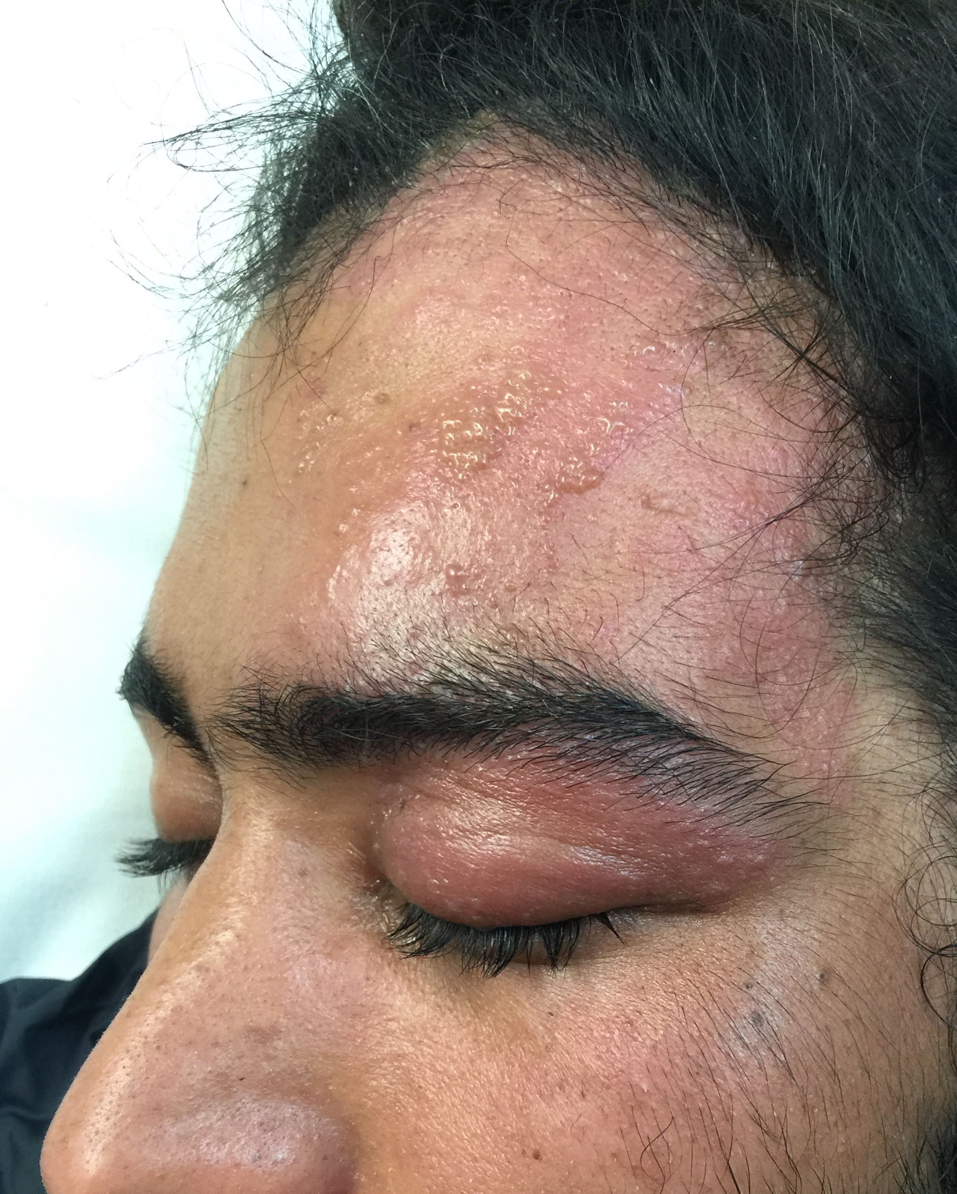

SAQ 17 continued

1. What is your provisional diagnosis?

2. Describe four (4) features on the clinical photograph that support this diagnosis.

3. List five (5) important complications of this presentation.

3. List three (3) key features on assessment that would mandate admission.

SAQ 17 Facial Rash
Peter Jordan
Overall a relatively straightforward question.
Picture quality – v good.
As expected nearly all gave correct diagnosis.
Expected standard with regards to identifying important complications (either serious or common or both) was high.
Features mandating admission – needed to be important and show perspective.

1) What is your provisional diagnosis– approx. 1 mark allocated – minimum – Herpes Zoster – facial
No marks for simply “shingles” – without additional qualification/ description.
No marks for Herpes Simplex.
Acceptable to state herpes zoster opthalmicus or Herpes Zoster V1 distribution.
Approx. 90% full marks

2) Describe four features supportive of this diagnosis
Approx. 3 marks allocated – No particular ranking
Clear majority of candidates answered this section well.
Most common error was to describe the vesicles as blisters.
A few stated the rash was painful or did not involve the scalp – neither can be inferred.
Expectation – minimum three of:
a) Vesicular (most stated this) ideally ‘clusters and/or typical and/ or small
b) Unilateral/ ipsilateral
c) Confined to V1 trigeminal dermatome (or description of this – forehead and eyelid.
No marks if stated rash involved nose (none visible)
One persons suggested erythema possible involved maxillary distribution (which I agree with but was not clear)
d) Absence of features suggestive of alternative pathology – bullae/ blisters/ bilateral involvement, exudate, Target lesions etc.
e) patchy underlying/ surrounding erythema

SAQ 17 (cont.)
3) Five important Complications – approx. 4 marks
Nearly all came up with five complications of varying importance or appropriateness. To differentiate possible responses were ranked as either important, somewhat important, of dubious importance or not a complication.
Those considered somewhat important attracted a half mark
Those of dubious importance or incorrect did not receive a mark.
Four marks allocated in total.
More common errors – referring to standard symptoms such as pain/ discomfort
Use of the term Zoster Opthalmicus (as this can refer to the common cutaneous form)
Infectivity – risk to pregnant patients
Use of vague/ incorrect terminology
Very rare complications – e.g. cavernous sinus thrombosis where risk is low due to extremely low probability.
Important complications:
Keratitis
Uveitis/ Scleritis
Acute glaucoma
Optic neuritis/retinitis
Progressive Outer Retinal Necrosis
Disseminated Herpes Zoster/ sepsis
Meningoencephalitis
Other Cranial nerve palsies
Ramsay Hunt syndrome
Recurrent Herpetic ulcers
Blindness resulting from one or more of above
Post herpetic neuralgia
Social/ employment complications
Analgesia dependence
Secondary bacterial infection

Others:
Ocular Zoster
Septic Shock
Orbital Cellulitis (this is very rare)

4) Three key features that would mandate admission.
Two key features were required s a minimum.
The least well addressed section
Many considered ocular involvement mandated admission – Ocular involvement (e.g. dendritic ulcer) mandates early ophthalmological review. Not necessarily admission.
Severe ocular involvement or involvement of globe was an appropriate answer.
Pain – requiring IV opiates – this is reasonable and not uncommon in elderly patients – they may require admission but not necessarily for IV opiates. (Many stated simply – pain requiring IV opiates)
Many only wrote two responses to what is a simple/ standard question.
Others: systemically unwell.
Suspicion of meningoencephalitis or disseminated infection
Immunocompromised
Significant superinfection (must qualify- limited/ superficial superinfection does not mandate admission)

SAQ 18

A 17 year old patient with severe spastic quadriplegia secondary to cerebral palsy is brought to the emergency department. The patient lives at home but is dependent on her parents for full care. She has been unwell for 48 hours with cough, fevers and increasing drowsiness.

1. Describe four (4) features on history that would determine that this patient requires inpatient admission.

2. The ambulance crew have been unable to obtain IV access despite multiple attempts. Describe three (3) options of obtaining access for administration of medication.

3. The patient is diagnosed with a severe pneumonia. The patient’s parents would like full resuscitation with intubation and intensive care if required.
Describe six (6) points to discuss with the family.

SAQ 18 (Andre Vanzyl)
- Standard setting – borderline candidate
  - Part 1
    - 4 features on history : 2/4 to pass
  - Part 2
    - Access for admin of meds : 2/3 to pass
  - Part 3
    - Discuss with family : 3/6 to pass
  - Therefore need 7/13 (5.38/10 to pass question)

1. Describe 4 features on history that would determine if this patient requires inpatient admission.
- Multitude of acceptable answers
  - Poor oral intake, reduced urine output, vomiting (unable to tolerate meds), rigors, aspiration, episodes of apnoea/cyanosis, increased WOB
  - Family not coping, parental request for admission
  - Advanced Care plan, Previous similar presentations/hospital admissions
  - Failed Rx at home (oral AB), comorbidities
  - Alternate diagnosis – meningitis
  - Hx of resistant organisms BC/sputum
PITFALLS
- 4 means 4 points, each point with one feature +/- clarification – SHOT GUN does not work. ONLY mark 1 feature on each point.
  - If you list 12 things in no particular order and the first 4 are wrong (ie examination findings rather than Hx) you will struggle even if points 8 to 12 are brilliant
- If the examiner can’t read it, they can’t mark it.

- 4 features on History Pitfalls
- HISTORY does not include:
  - Tachycardia, hypotension, hypoxia or any other clinical signs including dehydration
  - “Presence of sepsis” “severe sepsis” “septic shock” “patient’s wellbeing” “features of severe infection” “Infection requiring parenteral antibiotics”
  - Repeating the stem : quadriplegia, cough, fever, drowsy, cerebral palsy
  - NAI???
  - Consolidation/pulmonary infiltrates, biochem abnormality

The ambulance crew have been unable to obtain IV access despite multiple attempts. Describe three (3) options of obtaining access for administration of medication
  - Non IV – NGT, PR, IMI, subcut
  - IV
    - Peripheral: using USS, experienced operator, EJV
    - CVC, PICC
  - IO – with qualification
- Obtaining access pitfalls:
  - Consultant FACEM level answer required
  - IO as your first line without any qualification?? (and then discuss futility of Rx and inappropriate for ICU in part 3 of this question)
Obtaining access
- Good answer
  - Start simple (USS peripheral IV) then escalate
  - CVC if other options fail and need for IV access is confirmed
  - IO if no other option and time critical resuscitation deemed appropriate

The patient is diagnosed with severe pneumonia. The patient’s parents would like full resuscitation with intubation and intensive care if required. Describe six (6) points to discuss with the family
- Discuss with family
  - Diagnosis
  - Prognosis/reversible factors/returning to previous level of function
  - Current quality of life
  - Explanation of treatment options including ward level care
- Explanation of ICU care, ICU will consult and advise, no guarantee of admission
- Futile treatment concept, patient dignity, patient’s wishes
- Setting treatment limits
- Parent’s understanding of her condition, expectations
- Prolonged ventilation/trachy/in hospital death/complications of ICU level treatment
- Discuss with family Pitfalls
  - Writing nothing……..
  - Talking to parents about ICU resources and lack of a bed for their child
  - Raising organ donation
  - This was a question about points to discuss with parents, not about
    - Documenting your discussions
    - Empathy/compassion/non paternalistic approach

Final tips
- Read the question and answer what it asks
- Legible writing is important
- Shot gun will lose you marks and waste time
- FACEM level answers, think and then qualify/modify as required

SAQ 19

A 25 year old man is brought to your emergency department following a work place injury. He was cleaning equipment with a high pressure hose that snapped, striking him in the throat. He is seated upright on the ambulance stretcher, drooling and not talking. On examination he has a soft but audible stridor. His observations are all within the normal range.

1. List five (5) pieces of equipment you would like available for immediate management of his airway.

2. Describe pros and cons for three (3) different options for securing his airway.

Airway intervention | Pros | Cons

3. Describe five (5) steps in your preferred first option for securing his airway. Include drugs and doses.

The airway SAQ – Ian Summers

Perspective (don't write this!! It's not the old exam with15 minutes to write key issues but it explains my thinking to you)

A scary situation
Blunt trauma plus possible penetration of neck and injection of high pressure air, water or even solvent. Oh dear.
Currently alive but partially obstructed- big potential to deteriorate
Big potential to kill him with an RSI too!
safest option would be rapid awake fibre- optic requires anaesthetist
Downside is delay- RSI May become more difficult with time

The pass mark was 5/10. This is core ED stuff and a chance to kill.

Part A

List 5 pieces of equipment you would like available for management of his airway.

This was done universally well.
You could almost name any 5 bits of equipment.
Don't just put 4.

Examples:

Video or normal laryngoscopes variations of blades
Bougie
LMA
Surgical airway scalpel, boogie, artery forceps, size 6 cuffed ETT
Fibre optic scope and anaesthetist

I accepted others
A poor discriminator

Worth about 2/10 but less if you made bad errors overall!

Part B

You had to put an awake option to pass the question overall. Anyone who didn't mention this option started with a 4/10

Awake fibre- optic in theatre ENT back up

Pros: no need to RSI less risk of can't incubate/ ventilate, can back off if poor view, best option
Cons: needs anaesthetist with special skills, cause delay may deteriorate

RSI with surgical airway back up

Pros- familiar and rapid
Cons: May fail, causing worsening

Surgical airway

Pros- overcomes supraglottic obstruction, can pass cuffed tube
Cons- invasive, airway may be distorted, unfamiliar, failure

Others could have been gas induction, awake in ED.
LMA was a poor option to secure an airway
Applying oxygen or " doing nothing" was even worse- a waste of time and poor perspective

Part 3

This was done relatively poorly
The request for drug doses forced people into the RSI they said was NOT their preferred option. The question asked you for your preferred option therefore describe it!

As few of us routinely do awake scopes I was very forgiving of local anaesthetic techniques and doses

5 steps mean 5 steps. A line goes through numbers 6 to 10.

- Sit up, explain, consent
- Senior anaesthetist as proceduralist, RSI and surgical airway back up
- Local anaesthetic cophenylcaine 6 sprays or 2% lignocaine nebulise or even Ketamine low dose 10-30 mg accepted
- View cords through scope ETT preloaded and passed
- Sedate ( accept anything! Accept paralysing too if you wanted it) and secure and check tube position
What wasn't accepted:

Straight to surgical airway
RSI drugs then straight to surgical airway
Standard RSI ( most common). Slightly better if you said if anaesthetist not available do not delay and had surgical airway as back up

Avoid:

IV access team approach- just used up points
Standard RSI- dangerous and out gestalt marking sheet penalises the deadly harshly. Reassuring for the public really.

A 25 year old lady presents with severe epigastric pain and vomiting.

Her biochemistry results are shown below.

Biochemistry

Reference range

Na 132 mmol/L 135 - 145
K 3.9 mmol/L 3.5 - 5.0
Cl 101 mmol/L 101 - 111
HCO3 24 mmol/L 22 - 32
Urea 4.6 mmol/L 2.5 – 7.8
Creat 60 umol/L 40 - 80
ALP 248 U/L 30 - 120
GGT 309 U/L 7 - 64
AST 27 U/L 10 - 50
ALT 55 U/L 7 - 56
Bilirubin 43 umol/L 0 – 20
Lipase 448 U/L 0 - 60

SAQ 20 continued

1. What is your diagnosis?

2. What are the two (2) most likely underlying causes and why?

3. List four (4) complications of this condition.

4. List five (5) features that will help determine prognosis on admission?

Feedback SAQ 20 – George Braitberg

Distribution of scores

Why?
- I judged this as a good final year medical student question
- Most candidates answered Qs 1, 2,3 well, so question 4 became the discriminator:
- “List 5 features that will help determine prognosis on admission”
- At the FACEM exit level I wanted:
  - An indication of whether a prognostic value went up or down, hence glucose was not enough
  - A value assigned to a prognostic indicator,
    - e.g. a bad prognosis is when the blood glucose >10 mmol/L
Who got an 8?
- 1,2,3 answered well.
- Q3 teased out the main IMPORTANT complications (not low glucose or low calcium)
  - e.g. local complications of pancreas such as psudocyst or necrosis
  - systemic complications such as SIRS or sepsis
Lessons learnt
- If you don’t know the abnormal values turn the prognosis question into defining the normal state.
  - i.e. state that the best prognosis is a normal LDH and you may get away without having to recall the Ranson criteria for an abnormal LDH (>350)
- If you don’t know the abnormal values avoid listing them - state "acute renal injury" rather than state a creatinine, if this works for the question

SAQ 21

You have been asked to write a protocol for chemical restraint in the emergency department.

1. List five (5) key stakeholders.

2. List five (5) essential generic elements of any written protocol document.

3. List three (3) drugs to be included in the protocol. Include doses and route.

4. List three (3) indications for chemical restraint in the emergency department.

SAQ 21 (Tony Kambourakis)
- List 5 key stakeholders 5 (3/5)
- List 5 elements generic protocol 5 (3/5)
- List 3 drugs 6 (3/6)
- List 3 indications 6 (3/6)
22 (12/22)
Need 12/22 (55%) to pass

Stakeholders
- ED medical
- ED nursing
- Pharmacy
- Mental health
- General medicine
- Patient/ consumer
- Aged care
- Toxicology
- Security
- Paediatrics/
adolescent medicine

Elements of a generic protocol
- Title
- Who must comply
- Setting applicable
- (Background – indications)
- Precautions & Contraindications
- Equipment
- Procedure / Outline steps
- Tools & resources
- Document management – author, review

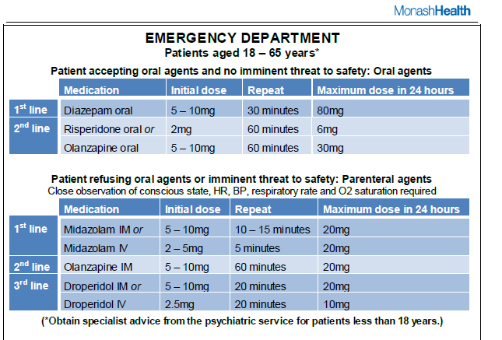

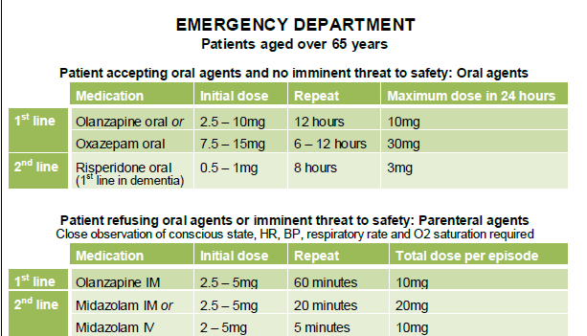

Indications
- Actual or high-risk of harm to:
  - self
  - others
  - property
- Verbal de-escalation inappropriate or ineffective
- Requires assessment & management
  - Mental illness (compulsory order)
  - Delirium / organic illness (capacity impaired)
  - Drug / alcohol intoxication (capacity impaired)

Tips
- Read the question!
- Answer all sections
- Only list the number of items asked for
- Stakeholder vs governance
- Elements vs development of protocol
- Know your medications
- Indications – clinical reason

ECG SAQ 22
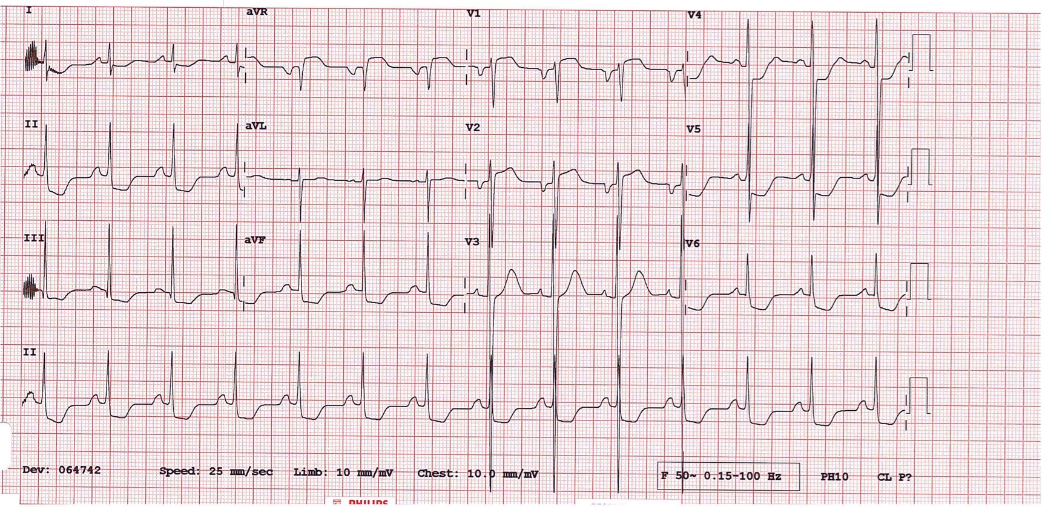
SAQ 22

A 13 year old boy has a syncopal episode while playing sport. There was no trauma. He is unconscious for one minute and there is no seizure activity during this time, nor evidence of a post-ictal phase.

His observations are as follows:

BP 105/70 mmHg
HR 90 /min
RR 18 /min
O₂ saturations 99% on room air
GCS 15

An ECG is done and is shown on the page opposite.

1. List four (4) relevant findings on the ECG.

2. What is the diagnosis?

3. List two (2) of the most important complications associated with this diagnosis.

4. List three (3) important management priorities during this current admission.

SAQ 22 Dr Pascal Gelperowicz Dr Victor Lee

- List four (4) relevant findings on the ECG.
- Left ventricular hypertrophy
- Non-specific global ST-segment depression (?c/w LVH/LMCA but age 15)
- aVR, V1, V2 ST segment elevation (?c/w LMCA but age 15)
- P-wave abnormalities (large P-waves globally/retrograde P-wave V2)
- PR interval normal (i.e. no short PR)
- Sinus rhythm (i.e. no arrhythmia)
- Non-specific T-wave changes especially laterally (?c/w LVH)

2. What is the diagnosis?
Hypertrophic Cardiomyopathy

3. List two (2) of the most important complications associated with this diagnosis.
- Ventricular arrhythmia
- Sudden death
- Risk to offspring (genetic transmission)
- Abnormal coronary arteries (ischaemia risk increased)

4. List three (3) important management priorities during this current admission.
- Telemetry/monitoring for arrhythmia*
- Exclusion of valvular pathology/LVOT(echo)*
- Parental counseling
- Patient counseling re sport/activity
- Beta-blocker
- Consideration for electrophysiological studies
- Consideration for implantable defibrillator

SAQ 23

A 68 year old man presents 2 days after a prostate biopsy with fever and rigors.

His observations are as follows:

HR 120 /min
BP 90/50 mmHg
RR 16 /min
O₂ saturations 98% on room air
Temperature 39 ºC

1. What is the most likely organism?

2. What antibiotic and dose will you administer?

3. What was the conclusion of the ARISE trial on sepsis and EGDT?

4. List four (4) potential uses of bedside ultrasound in this patient.

SAQ 23 feedback – Debbie Leach

1. E. coli – 1 mark
Issues
- Easy question
- NB commonest infection in this setting is urosepsis NOT prostatitis
Pitfalls:
- Not specifying the ORGANISM eg just a comment eg “sepsis”, prostatitis

2. Initial ED management
- Scope to display knowledge and high level considerations
  - Eg special situations:
    - Impaired renal function
    - Penicillin allergy
    - Multi-drug resistance suspected
- PASS
- IV
- G/M 4-5mg/kg modify if reduced Cr Cl
- Ampicillin 2g 6/24
- Extra marks:
- G/M as single agent if allergic to penicillin
- If can’t use G/M: ceftriaxone
- If multi-drug resistance: meropenem
2+2 marks
Issues
- Not done as well as expected
- Only one candidate did very well
Pitfalls:
  - Doses G/M 12mg/kg
  - Oral antibiotics only
  - No consultant level considerations eg renal impairment, allergy, multi-drug resistance

3. In critically ill patients presenting to the emergency department with early septic shock, EGDT did not reduce all-cause mortality at 90 days.
- (noted in the study: early antibiotics of benefit)
- 2 marks
Issues
- Big Australian study
- Responding to a controversial issue
- NEJM
- Many of the hospitals you work in will have been involved
- Can’t read any journal at present without seeing something about this study!

4. PASS:
- IV access (peripheral / central)
- +1 other sensible use
- IVC measurement: intravascular volume status
- Cardiac function: sepsis
- Hydronephrosis
- Bladder localisation
- Art line
- Extra marks
- brief (2-3 words description how it would be useful)
- 3 marks
Issues
- Bedside US implies an emergency physician use
- Think about ED practice and what we actually do
Pitfalls
- Ordering of lists:
  - Don’t put cholecystitis, FAST, prostate examination at the start of your list
- What to include in a list – think about THIS patient:
  - Prostate examination?
  - Looking for vegetations?
  - Looking for cholecystitis?

General Issues
- Carefully consider your terminology – only get a brief opportunity to express your knowledge
- Limited ability to redeem yourself with the new format
- Eg “expectant” management vs “conventional” management

SAQ 24

A 22 year old man presents with a hand injury after coming off a motorbike. He is complaining of pain in his left wrist and has no other injuries.

An xray is taken and is shown below.

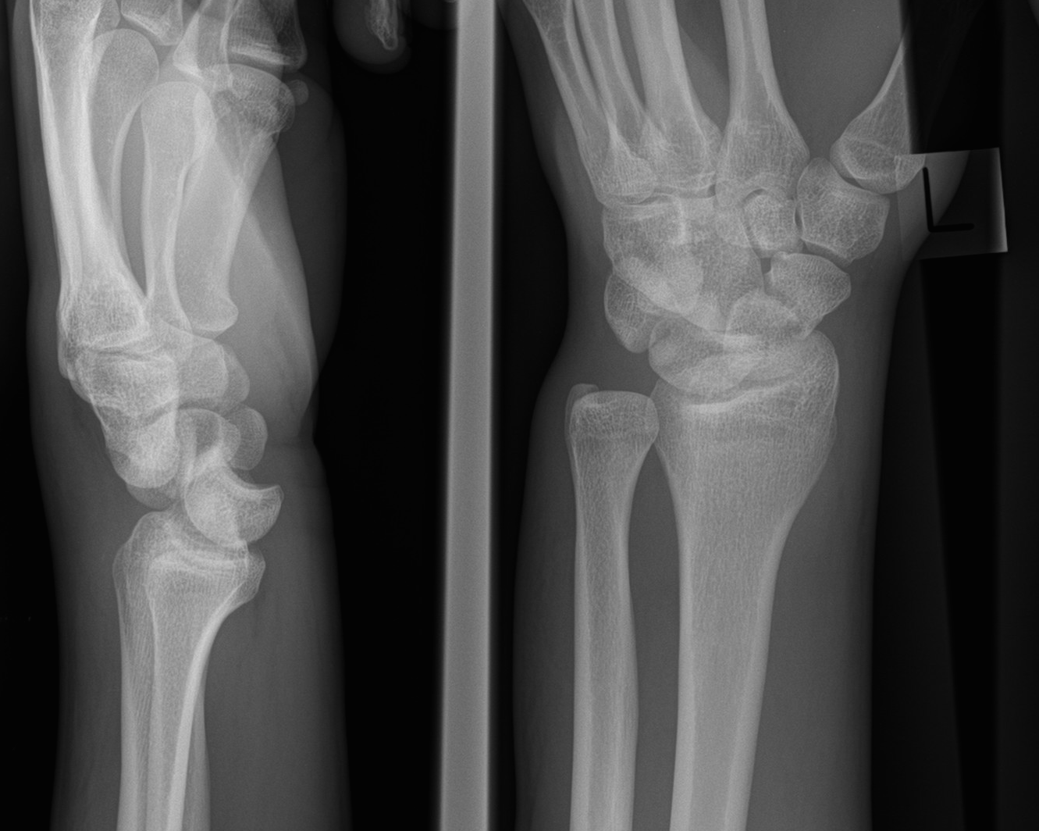

SAQ 24 continued

1. Describe his xray giving three (3) relevant findings.

2. List 3 short term and 3 long term complications of this injury.

3. Describe four (4) steps in your management.

SAQ 24 – C.Winter

1. Describe his xray giving three (3) relevant findings. 3
Perilunate dislocation
Transscaphoid fracture
??? either a relvatn negative (ie no radial Fracture) or further explanation of there being a midcarpal posterior dislocation. (which is really a perilunate)

2. List 3 short term and 3 long term complications of this injury. 3
Short:median nerve injury, pressure necrosis of skin, compartment syndrome, pain, loss of function.
Long: carpal instability, avascular necrosis of proximal fragment of scaphoid, chronic pain, complex regional pain syndrome, osteoartritis

3. Describe four (4) steps in your management. 4
Analgesia (IV narcotic)
Keep fasted until definitive procedure
Splint and orthopaedic referral
Urgent reduction (in OT, or ED (closed reduction may not be successful without ORIF).
(Acceptable alternative (careful and repeated neuro assessment for median nn)

Bare pass mark – 7/10

SAQ 25

A 35 year old lady presents to your emergency department via ambulance. She delivered a healthy term baby 2 hours ago at home but has had significant PV bleeding since. She is conscious but her BP is 70/40.

1. What are the four (4) categories of causes for post partum haemorrhage? Give 2 examples of each.

Category | Example

2. Describe six (6) steps you would take to stop this woman’s bleeding.

Your attempts at stopping the bleeding in the emergency department are unsuccessful. You contact the O&G registrar who states he is busy in theatre for the next 2 hours and is unable to attend.

3. Describe your response.

SAQ 25 (Graeme Thomson)

Q1.
To pass:
For the 4 categories of causes of PPH; Tone plus 2 of the 3 others (Trauma, Tissue, Thrombin).
Then 2 examples for each of those, giving 6/8 examples.
I allowed 5/8 if the categories were correct.
Better answer:
All 4 categories with 2 examples from each. There are many examples to choose from.

Q2.
To pass:
An oxytocic plus 4 other steps that could reasonably be expected to reduce bleeding in ED.
I discounted multiple similar steps, like multiple oxytocic drugs.
Better answer:
6 steps, especially the most important ones (deliver remaining placental tissue, massage uterus, oxytocic, empty bladder, control bleeding point, replace clotting factors).

Q3.
To pass:
Escalation to an O&G consultant.
Better answer:
To include continuing resuscitation of the patient.

Altogether there were 16 points that I wanted for a top answer (8 in Q1, 6 in Q2 and 2 in Q3).
To get a 5, a candidate needed to get around 11 points but scores varied up and down if the most important points were included or missed.
SAQ 26

A 2 year old boy is brought to your emergency department by his grandparents having found him unresponsive at their home. He has no significant past medical history.

On examination he is very drowsy with a GCS of 7 (E2, V1, M4) and has the following observations:

HR 140 /min
BP 80/50 mmHg
RR 18 /min
O2 saturation 100% on 2L/min O2 via nasal cannulae
Temperature 36.5 oC

His initial blood results are shown:

Venous blood gas
Reference Range

pH 7.1 7.35 – 7.45
pO2 50 mmHg
pCO2 37 mmHg 40 – 52
HCO3- 11 mmol/L 24 – 32
Lactate 8.8 mmol/L 0.5 – 2.0

Na+ 143 mmol/L 135 – 145
K+ 3.8 mmol/L 3.5 – 4.8
Cl- 110 mmol/L 95 – 110
Glucose 1.8 mmol/L 3.0 – 6.0

SAQ 26 continued

1. List five (5) significant abnormalities on the blood gas

2. What is the acid/base disturbance? Show your calculations.

3. List five (5) relevant differential diagnoses.

SAQ 26 Mark Smith

This question was deemed controversial in the end by the examiner who marked it

These are comments:

I spent a lot of time trying to come up with causes for the clinical situation of this 2 year-old with little success . The combination of his presentation and the biochemistry is almost impossible to explain .

Inherited disorders of gluconeogenesis , which are rare , can produce the combination of hypoglycaemia and lactic acidosis
Inherited disorders of the mitochondria ( respiratory chain ) can produce hypoglycaemia and lactic acidosis but are very rare
A prolonged seizure from hypoglycaemia could explain the lactic acidosis but it would have to be very prolonged and it has not been seen by the grandparents or in his transport to hospital or in hospital

Looking at some of the answers:
Sepsis - he is afebrile
Hypoperfusion - there is no evidence in the stem of blood loss , vomiting/diahrroea
Toxic ingestion - I searched extensively and cannot find any single ingestion that produces hypoglycaemia and lactic acidosis . A combination of sulphonylurea and metformin could possibly do this .

As a result I have ignored part (3) as it is not a realistic question with what is given in the stem . Also for 6 minutes it is too much to ask . On the first two sections I just marked as pass or fail .
SAQ 27

A 78 year old woman from a nursing home presents with generalised abdominal pain and vomiting for the past 24 hours.

Her observations are as follows:

BP 165/82 mmHg
HR 90 /min
RR 20 /min
O₂ saturations 96% on room air
Temperature 36.2 ºC
GCS 14 (E4, V4, M6) normal for patient

An AXR is taken and shows no obstruction.
Her CXR is shown below:

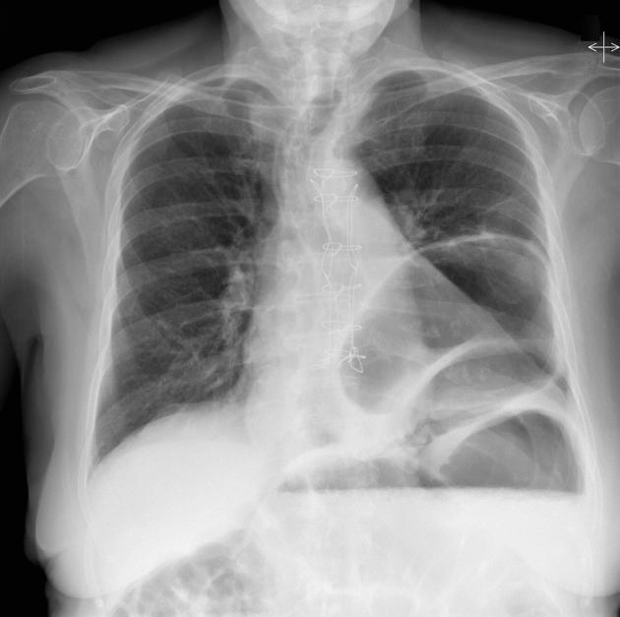

SAQ 27 continued

1. What is the presumptive diagnosis?

2. List five (5) important features demonstrated on this xray. Include three (3) positive and two (2) negative findings.

3. List four (4) immediate management priorities.

4. What is the role of a nasogastric tube in this patient?

SAQ 27 Dr Pascal GelperowiczDr Victor Lee

- What is the presumptive diagnosis?
Gastric volvulus (diaphragmatic hernia w/ obstruction)

2. List five (5) important features demonstrated on this x-ray. Include three (3) positive and two (2) negative findings.
+ Hiatus hernia
+ Multiple loops seen intrathoracic suggestive of volvulus
+ Air-fluid level seen within lower loop suggestive of obstruction
+ Some rightward mediastinal/tracheal shift suggestive of mass effect
- No gas under diaphragm - No mediastinal gas - No PTx

3. List four (4) immediate management priorities.
- Ascertaining advanced care directives/NFR orders
- Analgesia – Opiate with appropriate dosing, e.g. Morphine 2.5 mg IV prn
- Antiemetic – Ondansetron 4-8mg IV TDS or Metoclopramide10-20mg IV QID
- IV fluids, correction of electrolytes
- Surgical intervention
    - accept conservative – gastroscopy
    - accept aggressive - laparotomy if comment about nursing home

4. What is the role of a nasogastric tube in this patient?
Diagnostic but not therapeutic – unable to pass

SAQ 28

An 80 year old lady from home presents with sudden onset of shortness of breath and right sided pleuritic chest pain.

Her observations are as follows:

Temperature 37.5 ºC
HR 120 /min
BP 90/60 mmHg
RR 30 /min
O₂ Saturations 92% on 10L O₂ via Hudson mask

Her CXR is normal. You suspect a pulmonary embolism.

1. What is the utility of a d-dimer this this patient?

2. Discuss three (3) possible radiological investigations for this patient. Include two (2) pros and two (2) cons for each.

Investigation | Pros | Cons

3. The use of thrombolysis in PE is controversial. List 3 possible indications for thrombolysis in PE.

SAQ 28

An 80 year old lady from home presents with sudden onset of shortness of breath and right sided pleuritic chest pain.
Her observations are as follows:

Temperature 37.5 ºC
HR 120 /min
BP 90/60 mmHg
RR 30 /min
O₂ Saturations 92% on 10L O₂ via Hudson mask

Her CXR is normal. You suspect a pulmonary embolism.

1. What is the utility of a d-dimer this this patient? 1
D dimer is of NO use. Pretest probability – high - therefore definitive test is required

2. Discuss three (3) possible radiological investigations for this patient. Include two (2) pros and two (2) cons for each. 6

Investigation | Pros | Cons
CTPA | - Widely available. | Risk of contrast nephropathy
 | - Quick  - Excludes some other pathological causes  - Exposure to radiation irrelevant in 80 year old | This patient may become unstable in scanner which may be distant from ED  Risk of contrast allergy.
TOE | - Bedside test | Skilled Operator dependent
 | - Information re right heart strain obtained  - No radiation | Less helpful in segmental PE - may still see indirect evidence
V/Q Scan | Lower radiation dose?  ?similar sensitivity to CTPA for mpd – large sized PE | May be delay in obtaining scan- patient unstable
 | May be able to compare with prev VQs for this patient | Interpretation may be difficult in 80 yo lungs  - Doesn’t’ diagnose alternate causes.  - May receive an indeterminate result.
Other alternative - ?Doppler US of legs…. | Indirect evidence of PE  No radiation  Bedside test | Needs credentialed operator.  Indirect evidence only.

3. The use of thrombolysis in PE is controversial. List 3 possible indications for thrombolysis in PE. 3
Cardiac arrest – CPR will need to be prolonged..
Massive PE - Hypotension –systolic <90 for > 15 minutes
Right heart strain.on echo, or cardiac markers. (PEITHO study)
Moderate PE (right and left main pulm trunks or > 2 lobes with >70% involvement) (MOPPETT study) (either 1 of 2 study criteria as 3rd option)

Bare pass mark – 7/10

SAQ 29

A 14 year old male presents after ingesting “GHB” (gammahyroxybutyrate) one hour earlier. There are no co-ingestants. A venous blood gas shows normal acid-base status and electrolytes.

1. List four (4) important complications of a GHB overdose.

2. List four (4) indications for intubation of this patient.

3. Ten hours later the patient is GCS 14 (E4, V4, M6) and states he wants to leave. He moves towards the emergency department exit. List three (3) interventions in sequence to manage this scenario.

SAQ 9 – Julia Fischer

- List 4 important complications of a GHB overdose. (3 marks)
  - coma/sedation
  - agitation/confusion/behavioural disturbance/fluctuating conscious state
  - respiratory depression/hypoxia/respiratory failure
  - loss airway reflexes/airway obstruction
  - vomiting/aspiration
  - hypotension
  - secondary injury/trauma/sexual assault
  - Didn’t give marks for
    - bradycardia – unless specified hypotensive – rarely needs treatment, not “important”
    - seizures – GHB causes myoclonus, but not seizures
  - Show consultant level thinking by prioritizing your answers
  - Not a random list of symptoms

2. List 4 indications for intubation of this patient. (4 marks)
- Inability to maintain own airway/stridor
- Hypoxia
- Resp failure
- Aspiration
- Severe agitation/behavioural disturbance
- Concern for head injury/requiring CT brain
- Did not give marks for:
  - Coma/sedation – not an indication by itself without impaired oxygenation/ventilation, expect short recovery time
  - Co-ingestants – read the question(!)
  - Transfer – unlikely, assumed to be in an ED with FACEM

3. Ten hours later the patient is GCS 14 (E4 V4 M6) and states he wants to leave. He moves towards the ED exit. List 3 interventions in sequence to manage this scenario.
(3 marks)
- Call security/Code Grey
- Talk to patient/verbal de-escalation
- Enlist help of friends/family
- Physical restraint
- Chemical restraint
- Did not give marks for:
  - Assess competence/obtain consent to leave
  - A confused 14 yr old is not competent!
- Wrong sequence

Tips
- Read the question – underline important words
- Write clearly
- Writing lists is easy - show consultant level thinking by prioritizing your answers/show perspective

SAQ 30

A 24 year old male presents with confusion after competing in a half marathon event.

His observations are as follows:
BP 95/60 mmHg
HR 118 /min
RR 24 /min
O₂ saturations 98% on room air
Temperature 40.8 ºC
GCS 13 (V3, E4, M6)

1. What is the most likely diagnosis?

2. List four (4) important investigations for this diagnosis. Include a justification for each.

Investigation | Justification

2. List four (4) temperature control strategies.

3. List four (4) other immediate management priorities for this patient.

SAQ 30 Dr Pascal Gelperowicz Dr Victor Lee

- What is the most likely diagnosis?
Heat stroke

2. List four (4) important investigations for this diagnosis. Include a justification for each.
Total CK (rhabdomyolysis)*
Glucose (significant changes with heat stroke)
Coags (INR correlated to outcome)
VBG/ABG (electrolytes in particular + glu)
FBE (thrombocytopaenia/leukocytosis)
LFTs (significantorgandysfunction)
Urinalysis (with myoglobin)
U&Es (hyperkalaemia, renalfailure)
ECG (arrhythmias)
CTB (exclude intracranial cause)

3. List four (4) temperature control strategies.
- Remove clothing
- Reduce ambient temperature (AC, lights off etc)
- Cooled IV fluids
- Cold misted spray / fans
- Ice packs to axillae / groin, etc.
- Ice water bath (beware airway)
- IDC cold washout
Focus on initial (sensible approach, i.e. not to start with ICC cooling!).

4. List four (4) other immediate management priorities for this patient.
- Protect airway
    - accept open airway / lateral position / airway adjuncts
    - no need to intubate this patient but not error if choose this
- Glucose management to normoglycaemia
- IV fluid resuscitation(CSL/NS) – aggressive fluid therapy essential*
- IDC insertion with UO > 2-3 ml/kg
- Establish NOK and communication
- Early aggressive renal replacement therapy especially if ARF/UO low
- ICU referral – recognition of high mortality
- May require ECMO

Key messages
- Order in your head before committing to paper
- Scatter gun approach won’t work
- Scores can be aggregated down to 10
- If miss essential response then may only get max of say 2/4
- Pass score determined by standard setting

