Small group and Fellowship teaching 27th August
Lower Limb injuries

This session will be run as a single group, with a rapid turn over of x-rays. For each x-ray, Registrars will be asked for:
- Diagnosis
- Brief description
- Management options and/or complications.
For those sitting the Fellowship exam in 2015, please refer to the stems below as an example of how these are likely to be asked.

- A 45-year-old presents with a sore foot after falling off a ladder, landing directly onto his feet. An x-ray is performed (see below)
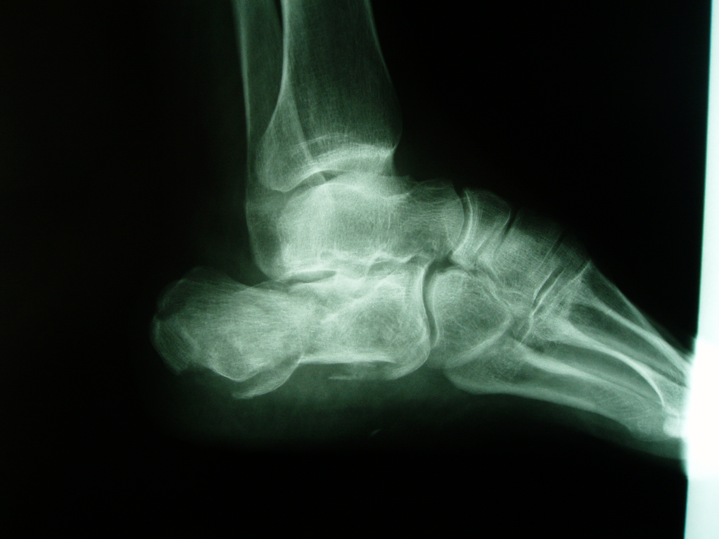
- What is the diagnosis? (1 mark)
- What associated injuries would you assess for (3 marks)
- What are the expected complications of this injury (5 marks)

- A 45-year-old man is brought to the ED after falling off a ladder. His ankle is shown below. He has no other injuries.
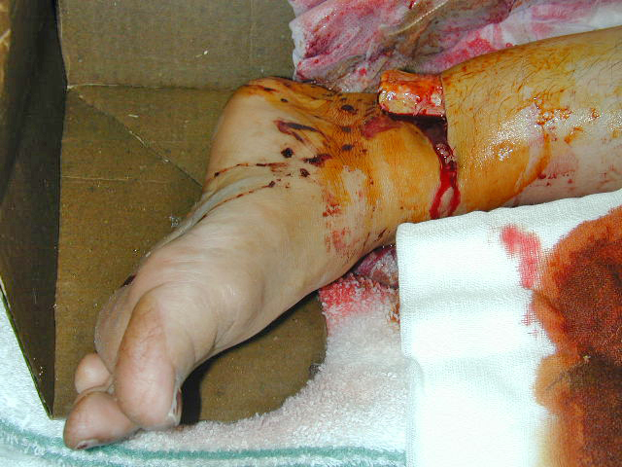
- What is the likely diagnosis (1 mark)
- What are the immediate and delayed complications of this injury (5 marks)
- List 5 treatments this patient should receive in the ED. Please provide details of each, and justify your reasons (5 marks)

- 3. A 45-year-old presents with a sore foot after falling off a ladder, landing directly onto his feet. X-rays are performed (see below – 2 images)

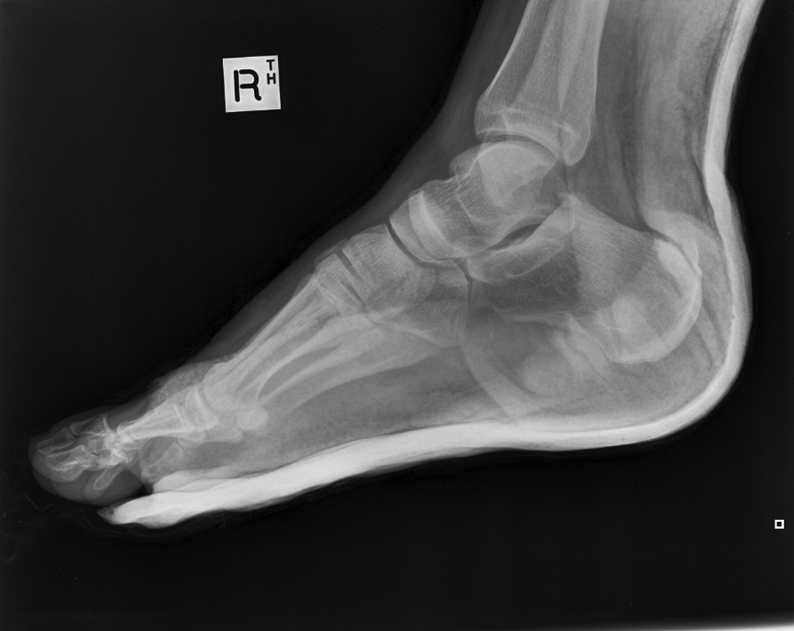
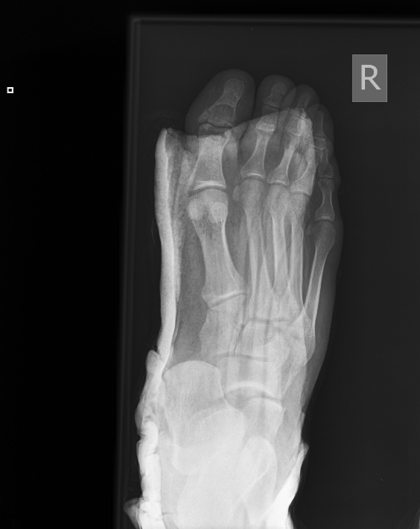

- What are the injuries (2 marks)
- What aspects of the x-rays help you justify this diagnosis (3 marks)
- What are the immediate complications of the most significant injury? (2 marks)
- What are the main factors of assessment that determine whether this injury should be reduced in the ED (3 marks)
- The patient is fasted for 2 hours and is otherwise well. Describe and justify 3 options for procedural sedation in this patient (3 marks)

