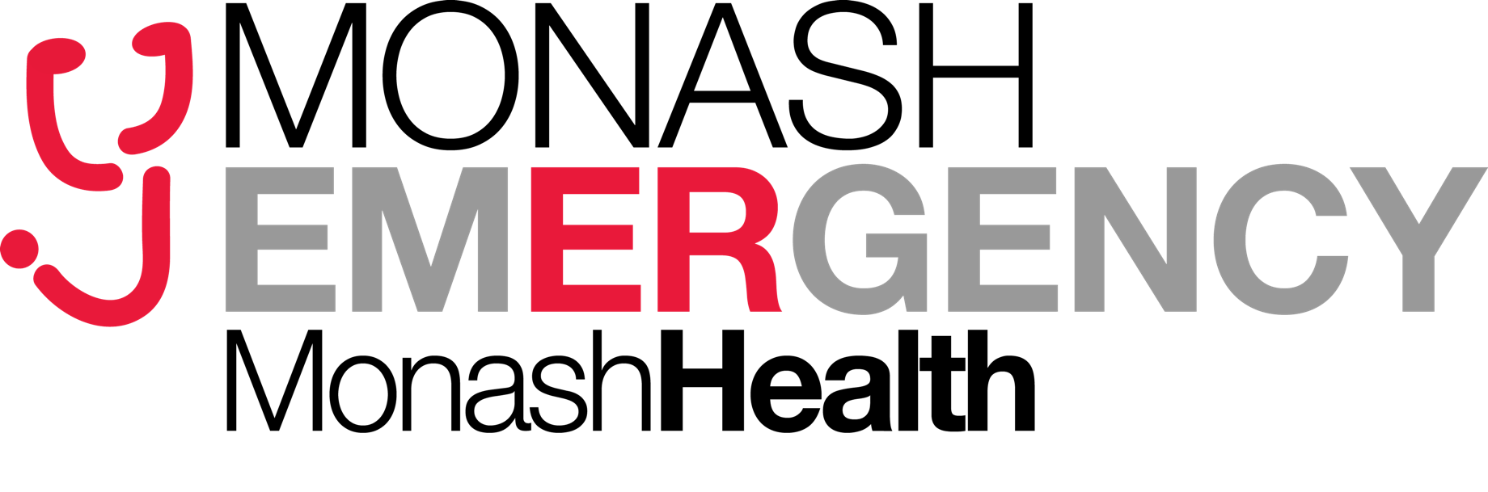
MONASH HEALTH FELLOWSHIP WRITTEN PRACTICE EXAM
2024.1
Monash Health are running a practise SAQ exam for the ACEM fellowship written exam (3-hour exam).
- Open to Victorian candidates planning to sit the fellowship written exam in May 2024
- Exam Date: Wednesday 21st of February
- Time: Two sessions (9am-12 and 1-4pm)
- Venue: Cliftons Melbourne - 1/440 Collins St, Melbourne
The Exam will be marked by a combination of actual Victorian examiners and educators with a feedback session held 3 weeks later.
- Feedback date: Wednesday 13th of March: 1000 to 1400
- Format: Zoom Webinar (will be recorded to allow later viewing)
Numbers will be limited to 40. If oversubscribed, the priorities are:
- Candidates from a Hospital that is assisting with the exam
- Candidates in their final year of training who have not sat the practice exam before
- Other candidates in time order of application received
Please complete the attached form and email to: Ananth.sundaralingam@monashhealth.org
- Cost $200 (payment instructions TBA)
- Closing date for applications February 4th
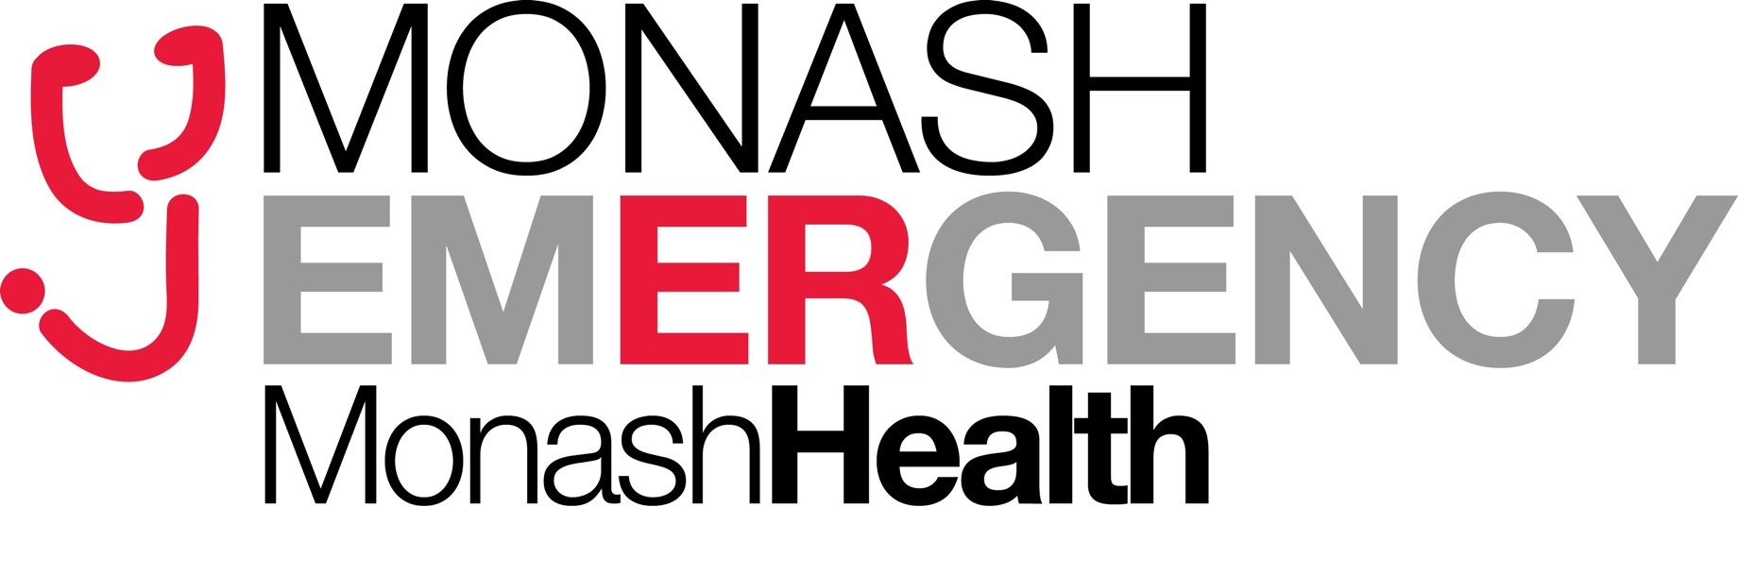
Practice ACEM Fellowship Exam

Application form
(DEMT and Candidate to sign)
Candidate name: __________________________________________
Name of Hospital / health service: ______________________________

I certify that our Dept is assisting with setting/marking questions and the above candidate is eligible to sit the fellowship examination in May 2023.
This candidate is in their final year of training (required for prioritisation)
YES NO (please circle)
DEMT name: ______________________________________________
DEMT email address: ______________________________________________
DEMT signature: __________________________
Exam Candidate:
I have sat the Monash Health Practice exam previously
(Required for prioritisation if exam oversubscribed)
YES NO (please circle)
Candidate signature: ___________________________________________
Candidate email address: _______________________________________

