Dane Horsfall -Monash Practice SAQ 12 (12 Marks):

You are managing a 5 year old girl with fevers, her mother has been reading about Kawasaki’s disease and is concerned she may have it. Below is a photo of her hand.

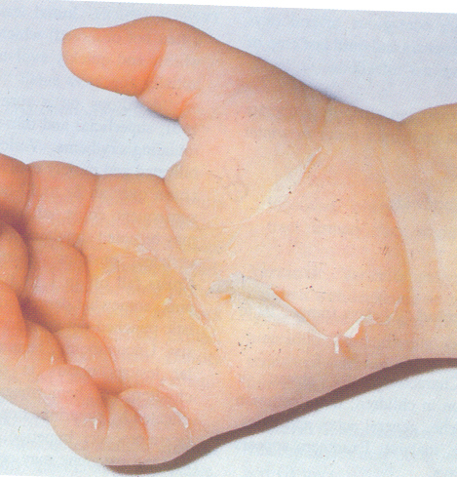

- Other than Kawasaki’s Disease, list three (3) diagnoses for this rash (3 Marks)
1.
2.
3.

- List six (6) diagnostic criteria for Kawasaki’s Disease (6 marks)
1.
2.
3.
4.
5.
6.

- Describe three (3) specific treatments for Kawasaki’s Disease (3 Marks)
1.
2.
3.

ANSWERS:

A. Other than Kawasaki’s Disease, list 3 diagnoses for this rash (3 Marks)

- Staph scalded skin syndrome or toxic shock, can be strep
- Drug induced – Stevens-Johnsons or similar
- Consider traumatic burn, neglect, (?NAI), although stem not suggestive
- Gonococcal/syphilis
-desquamation post hand foot and mouth disease (0.5 if just list HF and M without mentioning desquamation post)
-exfoliative dermatitis
-erysipelas
-scarlet fever
-other reasonable answers

Don’t accept erythema multiforme since limited desquamation

B. List the Diagnostic criteria for Kawasaki’s Disease (6 marks)

C onjunctivitis
R ash
A denopathy
S trawberry tongue
H ands and feet

And Burn fever > 5/7

C. Describe 3 specific managements for Kawasaki’s Disease (3 Marks)

- INTRAVENOUS IMMUNOGLOBULIN (IVIg): 2g/kg as a single IV infusion on diagnosis.
- given within the first 10 days of the illness
- second dose of 2g/kg IVIg should be given to patients who do not respond to the first dose
Don’t require dose for full mark
- CORTICOSTEROIDS: use controversial. Consider for high risk patients in discussion with local paediatric team. High risk as suggested by: 0.5 marks for steroids, 0.5 marks for drug name and dose or ‘for high risk’
  - Signs of shock.
  - Patients < 12 months of age.
  - Asian ethnicity.
  - ALT > 100 IU/L
  - Albumin < 30 g/L
  - Any patient with evidence of cardiac involvement on echocardiography at time of presentation.
Prednisolone 2mg/kg (max 60mg) orally daily for a minimum of 5 days and until CRP normalises. (Evidence for optimal dose/duration is limited)
IV methylprednisolone 1 mg/kg/dose BID x 5 days then taper

A steroid course of >10 days will require weaning and consideration of concurrent proton pump inhibitor or H2 receptor blocker.
-ASPIRIN: 3-5mg/kg as a daily dose until normal echo on follow up (minimum 6 weeks).
The association of Reye syndrome with aspirin remains a consideration, thus risks must be balanced against clinical benefit.

-Plasmapheresis need to qualify that it is used for IVIG resistant KD

Ref: https://www.rch.org.au/clinicalguide/guideline_index/Kawasaki_disease/

Results:

Pass mark > 10
Passed 15/29 = 52%
Range 5.5 – 12

