Paediatric Surgical SAQ (12 Marks, 6 Minutes):
You are assessing a 1 year old infant with intermittent abdominal pain and vomiting.
Her abdominal X-ray is shown:
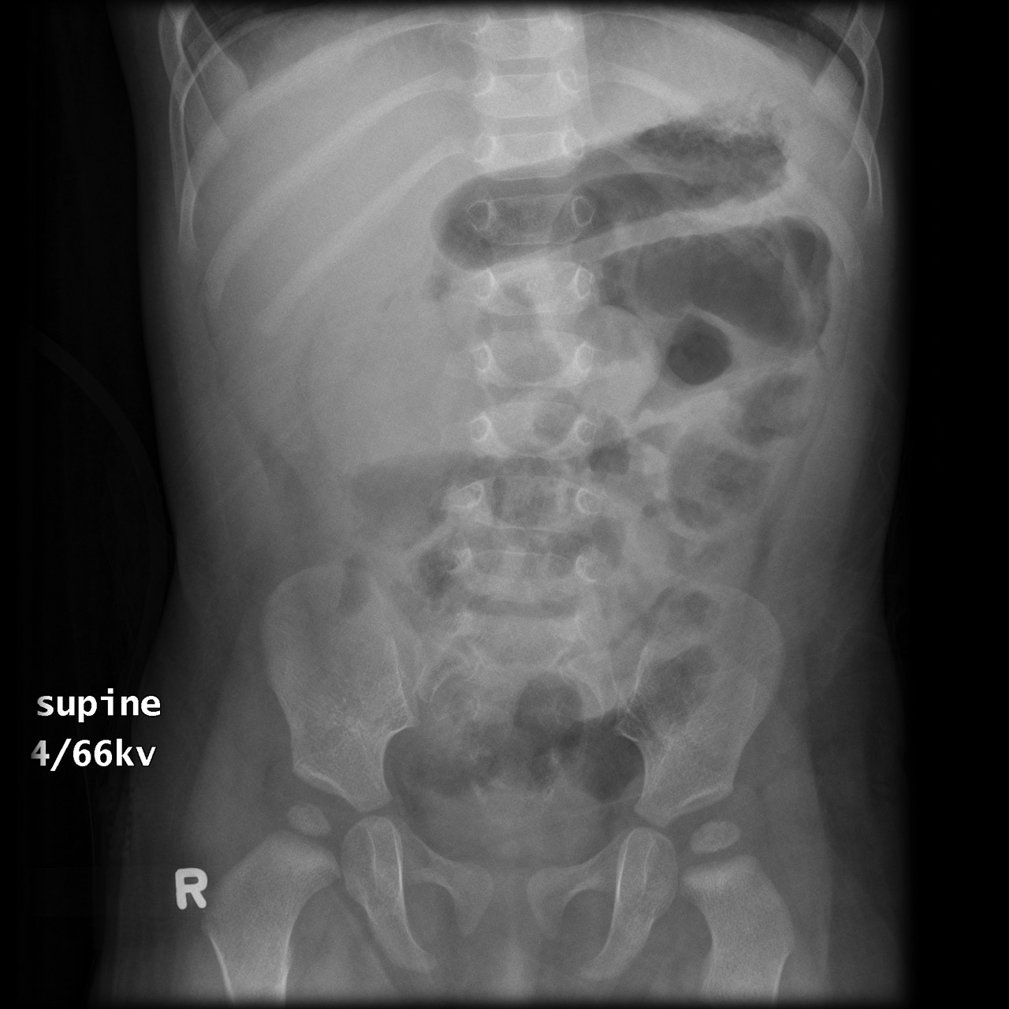
Case courtesy of A.Prof Frank Gaillard, Radiopaedia.org, rID: 6502
A.List 3 pathological features seen on this AXR. (3 marks)
- Absence of air in right upper quadrant,
- Soft tissue density in right upper quadrant
- Dilated loops small bowel consistent with a small bowel obstruction
- thickened wall SB
- Concealed liver margin
- Absence of gas in large bowel aka no gas in rectum
maybe - Crescent sign - soft tissue density projecting into the gas of the large bowel

Not present - Target sign - Two concentric radiolucent circles superimposed on the right kidney, -thumb printing (large bowel oedema)
B.What is the most likely diagnosis and how would you confirm it? (2 marks)
Intussusception, Ultrasound

C. List 3 other possible diagnoses. (3 marks)
- Appendicitis
- Meckel Diverticulum
- Volvulus/Malrotation
- Incarcerated hernia
- Abdominal trauma (NAI)
- Constipation
- Ovarian Torsion
-gastroenteritis
-FB SBO

Don’t accept Mesenteric adenitis, pyloric stenosis, Testicular torsion, Necrotising enterocolitis, Hirschprung enterocolitis, DKA, HSP

D.List 4 key steps in her management. (4 marks)

- Analgesia fentanyl, morphine, iv access
-antiemetic ondansetron 2mg
- IV resuscitation Normal Saline 10-20mls/bolus and repeat
- Urgent Paediatric Surgical Consultation
- Urgent contrast/gas enema in radiology with Paediatric surgeon present
- Explanation to parents
- Antibiotics if signs sepsis/perforation – antibiotics Amp/gent/metronidazole or equivalent

Results:
18 passed out of 33, 55% pass rate

Themes
- details lacking eg analgesia or antiemetics
- didn’t mention gas/contrast enema, again vague- ‘urgent surgical consult’ as FACEMs need to know next step and request it from inpt colleagues
- listing 4 answers when asked for 3
- too vague – ‘abnormal bowel gas pattern’
-repeating the same statement eg Malrotation and Volvulus for DDx
-writing things that weren’t there that the candidate wanted to be there eg ‘multiple air/fluid levels’

Reference:
https://www.rch.org.au/clinicalguide/guideline_index/Intussusception_Guideline/

