SAQ – Retrieval
A 9yo boy collapsed at home with a headache. He is transported to your rural ED and intubated on arrival. An image of his CT brain is shown below. He has no other injuries.
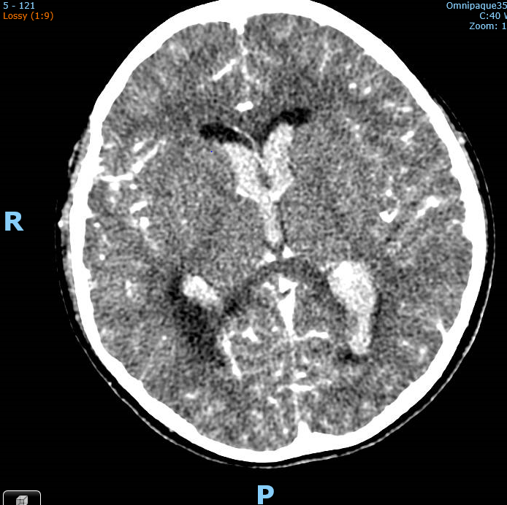
What are your priorities to prepare this patient for aeromedical retrieval to a tertiary centre (12 marks)

Real case from MMC ED.
Why are they asking this question?
Why 9yo – does that change likely pathology/vital parameters?
Why rural ED?
ALREADY ETT, NO OTHER INJURIES

What are your PRIORITIES – at FACEM level?
Part 3 - SPECIFIC measures for this patient’s PRIMARY PROBLEM

System | Action | Justification
Airway/breathing | Ensure ETT secure, adequate oxygenation  Ventilate normal/low PCO2  CXR, Cuff saline, NGT | Risk of dislodgement during transfer, CNS oxygenation  Reduce ICP by reduced cerebral vessel dilation
Circulation | 2 peripheral IV lines, SECURED  Maintain MAP 65  - Fluids/pressors/antiHT  - Artline | Risk of dislodgement  Needs IV sedation/BP control  Maintain Cerebral blood flow
Specific measures for this patient’s primary problem | 30deg head up, neck ties  Mannitol  Hypertonic Saline  Seizure prophylaxis  Sedation/paralysis | Improve venous drainage  Reduce cerebral oedema  Risk of seizure, inc O2 req  Manage vent/BP/blunt reflexes

Burr hole = fail
Nifedipine – not acutely, not a priority
Specific aims for ventilation and why
“adequate IV access” ?? CVC?!?!?, >3 accesses??
MAP 65 not >85 , no aim SBP <165 in 9yo.
Not permissive hypotension
30deg head up to improve venous drainage, not just improve CPP. “neuroprotective” – in what way?
Tranexamic acid – maybe?
Antiemetics not priority in ETT/sedated/paralysed patient
Seek and treat coagulopathy?
Temp and glucose reasonable general things but not specific for his primary problem

