Part 1 (8 marks) – must have bold points: RAGMA, Resp comp, K deplete for pH

Finding | Explanation
Severe life-threatening RAGMA | Anion gap = 139-7-103 = 29  Delta ratio = 29-12/24-7 = 17/17 = 1
Compensated respiratory alkalosis | Exp CO2 = 8 + [1.5 x 7] = 18.5
Total body potassium deplete | Expected potassium = For every drop in pH of 0.1 below 7.4, K should rise 0.5 above 5.0  Expect K = 5 + [0.5 x 4] = 7  Expect for pH of 7.03 K+ would be 7.0, diarrhoeal loss a likely cause
+1 Other:
Mild hyperlactataemia | Severe hypovolaemia, potential evolving shock from underlying cause of illness
Euglycaemia | Pharmacological action of Empagliflozin: SGLT-2 inhibitor increasing urinary glucose excretion.

Part 2 (4 marks) – must have insulin+dextrose = 2, but insulin or dextrose only = 0/2 as BSL is 6, need dextrose support for an insulin infusion, and need insulin to halt the ketoacidotic metabolism & close the anion gap.

Other 2 marks from any of fluid/K/analgesic/antiemetic/antibiotics.
SAMPLE ANSWERS – varied rates etc but all had AIMS/end points and were succinct.
- IV crystalloid (Hartmanns), 1L over 4 hrs, Aim UO at least 0.5ml/kg/hr
- IV Insulin, commence at 0.05units/kg/hr
- IV glucose 10%, running at 100mls/hr, aim BSL > 6
- IV K replacement at 10mmol/hr, aim K > 4
- IV Actrapid 0.1units/kg/hr
- concurrent 10% dextrose 100mL/hr (titrate to aim BSL > 8mmol/L)
- IV CSL 1L STAT, likely ongoing fluids based on re-assessment (aim SBP > 100mmHg)
- IV KCl 10mmol over 1hr, repeat as required (aim maintain K 3.5-4.5)

SUMMARY

Euglycaemic DKA is a clinical triad:
- RAGMA, pH < 7.3, bic < 15mmol/L and AG > 12
- Blood ketones >0.6 (urinary ketones may be normal or raised)
- Normal Glu < 14mmol/L

Symptoms:
- Drowsiness
- Abdominal pain
- N&V
- Fatigue
- Unexplained deterioration or acidosis

Diagnosis:
- difficult as it is primarily a diagnosis of exclusion.
- Other forms of ketoacidosis like starvation ketoacidosis have to be ruled out.
- Also, other causes of increased anion gap metabolic acidosis like lactic acidosis, increased toxic serum alcohols (methanol, ethylene glycol, etc.), drug toxicity, paraldehyde ingestion and renal failure should be excluded.

Useful facts:
- It’s rare
- Euglycaemia masks the underlying DKA – beware it’s easily missed!
- Blood pH and blood or urine ketones should be checked in unwell diabetic patients regardless of blood glucose levels
- sepsis, surgery, fasting, dehydration & insulin pump failure are all precipitants
- TYPE II patients on SGLT-2 inhibitors are particularly at risk when unwell from any cause, and/or in the perioperative period.
- One possible mechanism is that SGLT-2 inhibitors blunt insulin production in the face of stress hormones, leading to increased ketotic metabolism.

Treatment:
- Once diagnosed, mx of EDKA is simple and is very similar to the mx of DKA.
- The mainstay of treatment involves correction of dehydration using IV fluids.
- The second most important step is the use of an insulin infusion along with a dextrose containing solution until the anion gap and bicarbonate levels normalize.
- Monitoring and maintenance of K+ level is important.
- Hourly VBG analysis re Na/K/glu/pH/HCO3 until resolution of the ketoacidosis will likely determine disposition to HDU/ICU.
- Don’t forget to cease the SGLT-2 inhibitor(!!) and to treat any underlying cause of the illness – for this patient the underlying cause is wide - could include hypovolaemic or haemorrhagic shock from a GI cause, sepsis (from any cause), AMI, ischaemic bowel, uremic renal failure, hepatic or pancreatic disease, aspirin toxicity, effect of metformin or other drugs...
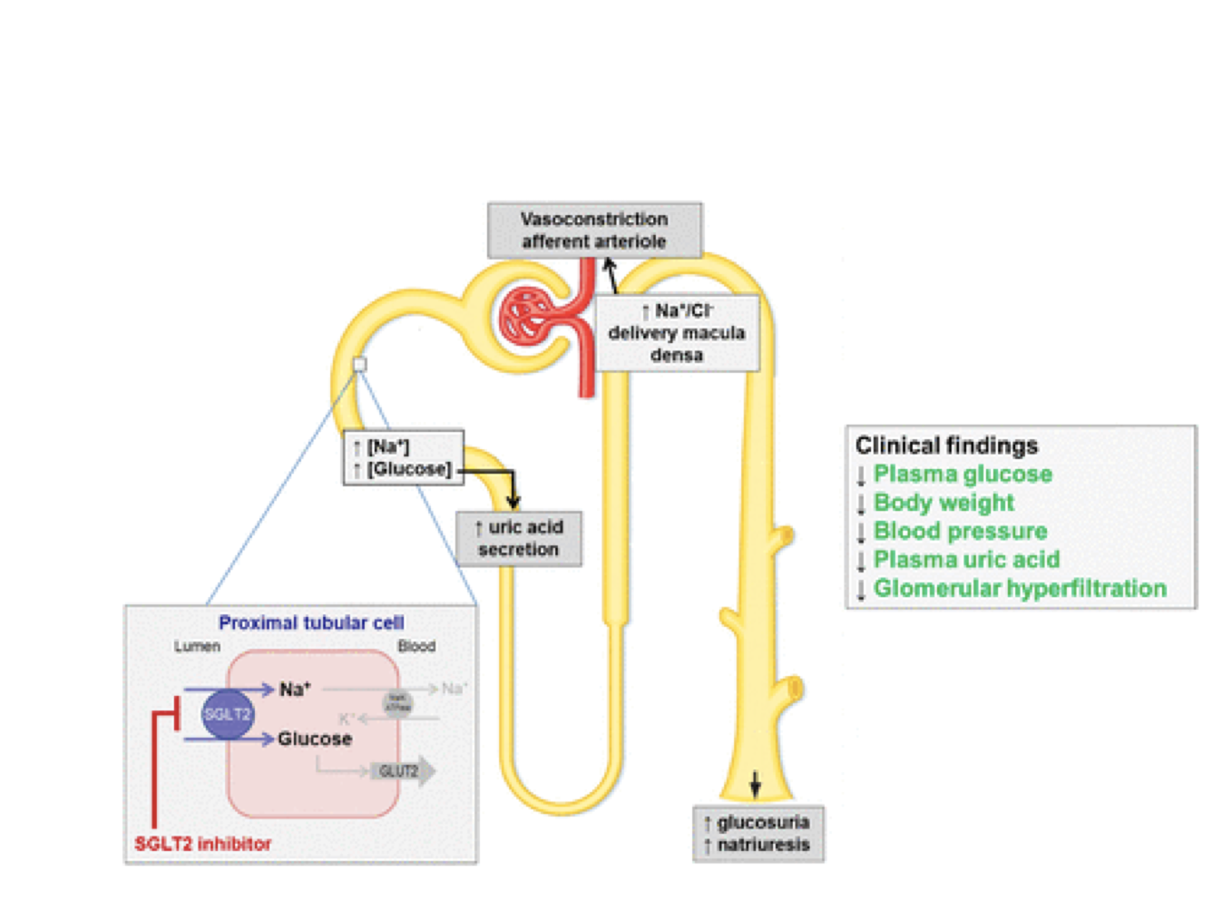
SGLT2 inhibitor actions:

References:

Rawla P, Vellipuram AR, Bandaru SS, Pradeep RJ. Euglycemic diabetic ketoacidosis: a diagnostic and therapeutic dilemma. Endocrinol Diabetes Metab Case Rep. 2017;4:2017.

UpToDate: Sodium-glucose co-transporter 2 inhibitors for the treatment of hyperglycemia in type 2 diabetes mellitus -> adverse effects -> DKA and also DKA -> Treatment

