Question 22 (14 marks)
A 64 year old alcoholic man presents with shortness of breath. His vital signs are:
BP 105/70 mmHg
RR 32 bpm
Sat 91% RA
Temp 39 oC
GCS 15
His CXR is shown below
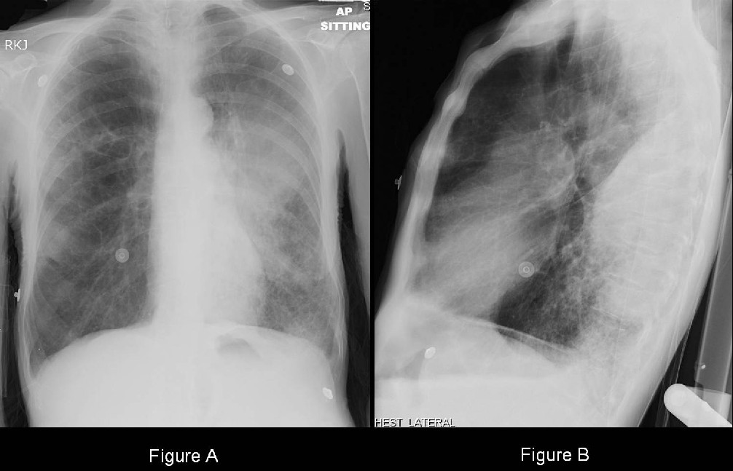

a) List three (3) abnormal findings on his CXR. (3 marks)
- Left upper lobe consolidation
- Left lower lobe patchy consolidation
- Rounded opacity at lateral margin of lower region of right middle lobe
- Hyperinflation – 10 posterior ribs seen, flattened hemidiaphragms
- Small right sided pleural effusion

b) List three (3) organisms you would be concerned about in this patient. (3 marks)
- Strep. Pneumoniae
- Klebsiella pneumoniae
- Staph Aureus
- Haemophilus influenzae
- Anaerobes
- Tuberculosis
- Legionella

c) SMART-COP and CURB-65 are two pneumonia scoring systems. Complete the table below listing two (2) pros and two (2) cons for each system. (8 marks)
SMART-COP
(Systolic BP, Multilobar CXR involvement, RR, Tachycardia >125, Confusion, Oxygen low, Aterial pH <7.35)
Pros
- Can help stratify which patients require ICU admission
- More sensitive than CURB-65
- Includes age adjusted cut offs for RR and 02 levels
- Assist in early recognition of of most seriously ill patients
- Can be used in collection of data for research
- Easy to calculate

Cons
- Does not estimate mortality
- Does not explicitly include patient age as a variable
- Accuracy can be affected by extremes of age
- Low specificity
- Requires ABG and albumin

CURB-65
(Confusion, Urea >7, RR >30, BP <90, Age >65)
Pros
- Simple to remember and use
- More specific than SMART COP
- Possibly improved ability to predict mortality
- Uses results of basic bloods

Cons
- Includes confusion and urea which in elderly could be due to a variety of factors
- Does not assign points for co-morbid illness and nursing home residence
- May not identify patients requiring ICU admission, respiratory support or vasopressor requirements
- Accuracy can be affected by extremes of age
- Low sensitivity

A few references:

MD Calc

Life in the fast Lane

http://www.elsevier.pt/en/revistas/revista-portuguesa-pneumologia-320/artigo/psi-curb-65-smart-cop-or-scap-and-winner-is--S0873215913001268

https://academic.oup.com/cid/article/47/3/375/315583

