MONASH SAQ 2023.2 – Question 10 (18 MARKS)

A 43 year old woman arrives via ambulance in your regional ED at 8pm.
She had a sudden worsening of a 2 day long headache with associated conscious collapse and vomiting while at a restaurant. Her friend thought she may have anaphylaxis so administered her own epipen to the patient.

On initial assessment, her vital signs are within normal limits. She appears agitated and is continuing to vomit profusely.

Question 1: (4 marks)

Aside from Ondansetron and Metoclopramide, list two other antiemetics you could use for this patient – include dose and route. For each one list a potential dangerous side effect.

Drug/Dose/Route of administration | Side effect
Droperidol 0.625mg IV | Drowsiness/sedation  Drooling  Extrapyramidal side effects – akathisia, uncontrolled movements of the body, esp face and neck  Tachycardia  Hypotension
Cyclizine 25-50mg IV | Sedation  Tachycardia  Psychomotor impairment  Anticholinergic side effects
Dexamethasone 4-8mg IV | Blood glucose instability  May increase agitation
Prochlorperazine 5-10mg IM or 2.5-10mg IV | Sedation  Extrapyramidal side effects  Anticholinergic side effects
Chlorpromazine 25mg IM or 12.5mg IV | Sedation  Extrapyramidal side effects  Anticholinergic side effects  Hypotension

Question 2: (2 marks)

The patient undergoes urgent CTB. List two findings seen on this single view of a non contrast CTB.

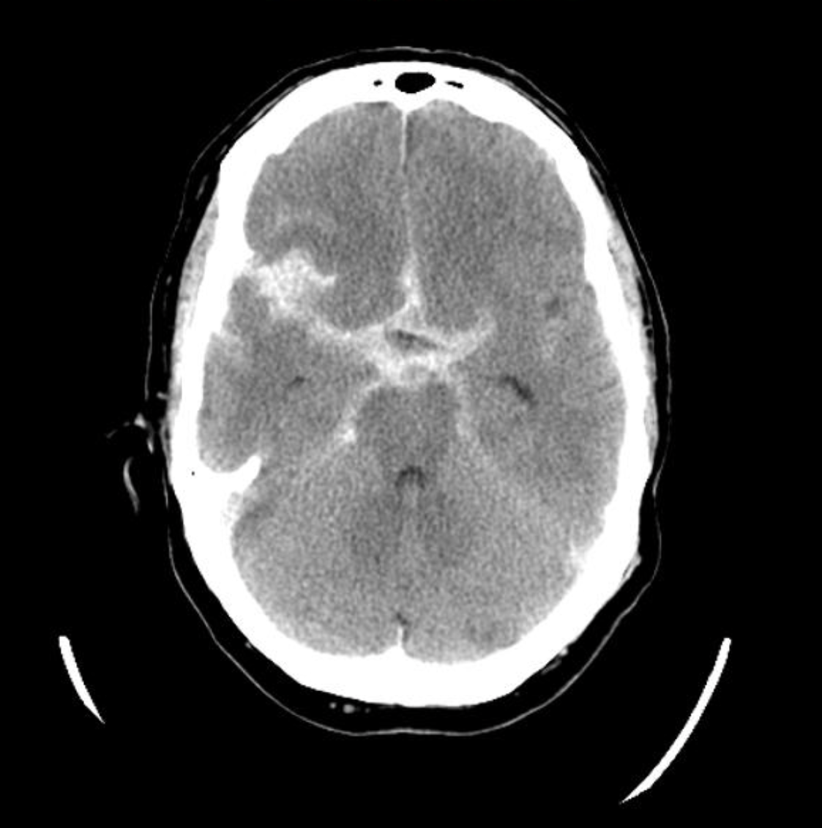

- SAH
- Hyperdense expansion at MCA – likely rupture of aneurysm
- Sulcal effacement

Question 3: (8 marks)

The patient has a drop in GCS to 6/15 and decision is made to intubate her. List four potential complications that could occur during intubation, given her diagnosis. For each one, list a measure you would take to prevent the potential complication.

Potential complication | Prevention measure
Hypotension | Have IV fluid hanging and ready to bolus.  Metaraminol drawn up ready to bolus as needed  Use cardiac stable drugs for induction eg ketamine, fentanyl (as compared with propofol)
Hypoxia | Pre oxygenate with 15L via face mask  Apnoeic oxygenation via NP
Aspiration | Suction ready at bedside  Antiemetics pre intubation  Head up slightly for intubation
Seizure | Propylactic load with Levetiracetam  Have Midazolam drawn up to give if acute seizure
Incorrect placement of ETT | Use videolaryngoscopy +bougie or introducer to enable placement  Most experience operator to intubate
Raised ICP | Ensure adequate sedation and paralysis prior to intubation  Blunt laryngeal response
Hypertension | Ensure adequate sedation and paralysis prior to intubation to avoid increased agitation and spikes in BP  Have ongoing sedation ready
Anaphylaxis to medications | Check allergies carefully pre induction

Question 4: (4 marks)

The patient has been accepted for transfer by road to a neurosurgical centre that is 45 minutes away. List four priorities in the preparation of this patient for transfer (as long as all of the below was covered, you could score 4 marks – could combine equipment/drugs or communication/documentation)

- Prepare patient – nurse head up to 30 degrees, maintain normal BP, Na, Glucose, Na. Ensure all tubes/lines taped and secured.

- Prepare equipment - enough battery/cords for pumps and ventilator. BVM, laryngoscope in case of need for re-intubation, intubation equipment.

- Prepare drugs to take – sedation, vasopressors, mannitol, IV fluids, intubation drugs.

- Ensure communication with receiving team – bed available, where in the hospital, relevant accepting team members – and with family

- Documentation, films/disc with images – provide copies to take to receiving hospital

If you have any questions or comments about my question or about the exam in general or about special consideration applications, given my role on STAC, please feel free to email me at anoushka.perera@barwonhealth.org.au

