Question 9:

Pass Mark: 12/18
Average: 10.5
Median: 11

Overall part a well answered, b and c poorly answered.
Some exam tips
- don’t write multiple answers/facts – you will only be marked for your first answer.
- Address key issues in stem and subsequent parts of qn. Relate your answers to the patient presented unless it asks a generic qn.
- Read whole qn quickly first before answering as you may have clues as to where you need to go/what to answer in each box.
- If you are asked for doses/targets put them in!
- If your stem mentions you’re not a trauma centre then please have retrieval or transfer as one of your priorities.

A 76yo male who is independent from home, presents to your urban district Emergency Department after a fall from standing height. There was head strike with 3 minutes of loss of consciousness. You are 1 hour away from the nearest Major Trauma Centre.

Patient’s past medical history: Atrial fibrillation, hypertension, gout, osteoarthritis and mild chronic renal impairment.
Current medications:
- Apixaban 5mg BD
- Irbesartan -Hydrochlorothiazide 300mg/12mg daily
- Allopurinol 100mg BD
- Paracetamol 1g TDS

- In the assessment and management of geriatric trauma, complete the following table by listing 1 important difference an older patient has compared to younger adults, and 1 strategy you could employ to mitigate the effects of this: (8 marks) (Pass 6/8)

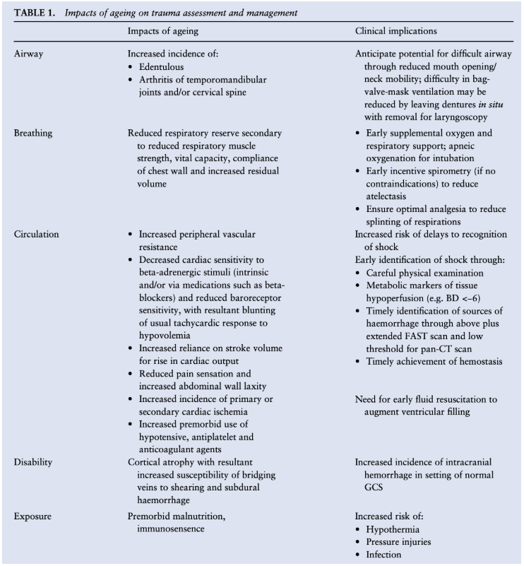

This question is testing your knowledge of special population in trauma. The strategy aspect of this question is testing your ability to mitigate this impact of ageing or strategies to prevent deteriorating due to this impact.
There are lots of answers you could have put for this. Some were great, others were not so great.

If you put down 3 things for airway – you will only get marked for 1. Don’t waste your time putting more.

On arrival to the ED the patients’ vital signs are
- BP 220/105mmHg
- HR 110 bpm – Irregular. AF on monitor.
- O2 Saturation 95% (3L Nasal prongs).
- GCS at scene was 14 (E3, V5, M6) but is now GCS 6 (E1, V2, M3).

The patient is in your resuscitation bay with monitoring and bilateral large bore IV access.
Primary survey identifies only a large occipital haematoma and laceration with profuse active bleeding. Their C-spine is immobilised. Chest and pelvic X-rays are normal

- Outline 1 urgent treatment priority for THIS patient in each system below. (Please include aims and/or medication doses if appropriate) (5 marks) (Pass 3/5)
 | Urgent treatment
Immediate life threats | Life threats: Control bleeding from scalp wound – direct pressure/deep sutures/pack. (Staples won’t work). CABC!
Airway | Secure airway – neuroprotective intubation (bag through apnoeic period), something sensible re drugs (Prop/midaz + Fentanyl + Rocc). Not large doses of ketamine – note BP of 220.
Breathing | Ventilation strategy - Aim low normal CO2 35-40 unless signs of herniation. Avoid hyperoxia, low PEEP
Circulation | AIM BP < 160 systolic (MAP > 80) – adequate sedation (ie propofol 50mg/h), sedation boluses, last line beta blocker or hydralazine
Disability | neuroprotective strategies – loose ties, tilt bed, normothermia, avoid noxious stimuli

This question is testing your ability to prioritise and manage a patient after your initial primary survey with a severe TBI who is anticoagulated and hypertensive. Initial priorities should be controlling the external haemorrhage, airway management and institution of neuroprotective strategies before moving onto CT for definitive Dx and Mx

- This is not the sort of patient you’d put a Guedel in and hope for the best.
- Please don’t activate a MTP if you have controlled their external bleeding and their BP is over 200.
- Deep Sedation and analgesia should be first line for BP control initially then boluses of antihypertensives.
- Big headings work well with small expansion here.
- Downfall for a lot of people was the fact they put a lot of answers that should have been in the next section in above that whilst important do not fit into the urgent Rx priority category and can be sorted whilst pt having a CT.
- Whilst there are signs of raised ICP there are no lateralising signs so I would not give mannitol/3% saline in this instance or in answer below.

- Outline 5 additional ongoing management priorities for THIS patient. (5 marks) (Pass 3/5)

- CT Pan Scan – to identify ICH, risk of other injuries/spine injury
- Reverse anticoagulation – Early Haematology consult, 50u/kg four-factor prothrombin complex concentrate, 5mg intravenous vitamin K, TXA 1g
- Referral to major trauma centre/neurosurgical centre
- Package patient for inter-hospital transfer: insertion of arterial line, haemodynamic monitoring in an inter-hospital transfer, infusions
- Discussion with family re. goals of care and patient wishes.

This question is your chance to outline ongoing Mx priorities
- CT head/Cspine was written by a lot of people but in an unconscious pt who has fallen a pan scan or trauma scan is required to identify other injuries.
- It is likely you will need to reverse the anticoagulation – please know the reversal options for common DOACS/Warfarin – just consulting haem is not an answer for a fellowship exam (although in reality its likely what you’d do).
- Referral to trauma centre with neurosurgeons key to ongoing good Mx of this pt
- You need to prepare pt for transfer
- Discussion with family also key here including identify pt wishes and goals -just because he is 76 please do not stop resuscitating him that wasn’t the point of this qn.

